2025 Minor Adaptations Requisition template
Prescriber Name: | Person’s Webelms code:
Prescribers PIN code: | Date of order:

DOOR THRESHOLD STRIPS
Door Strips are available in 3 different types and depths. Specify code of type required. Please indicate approximate positions of plug sockets / pipes if known, that are in close proximity to the doorway in other info section.
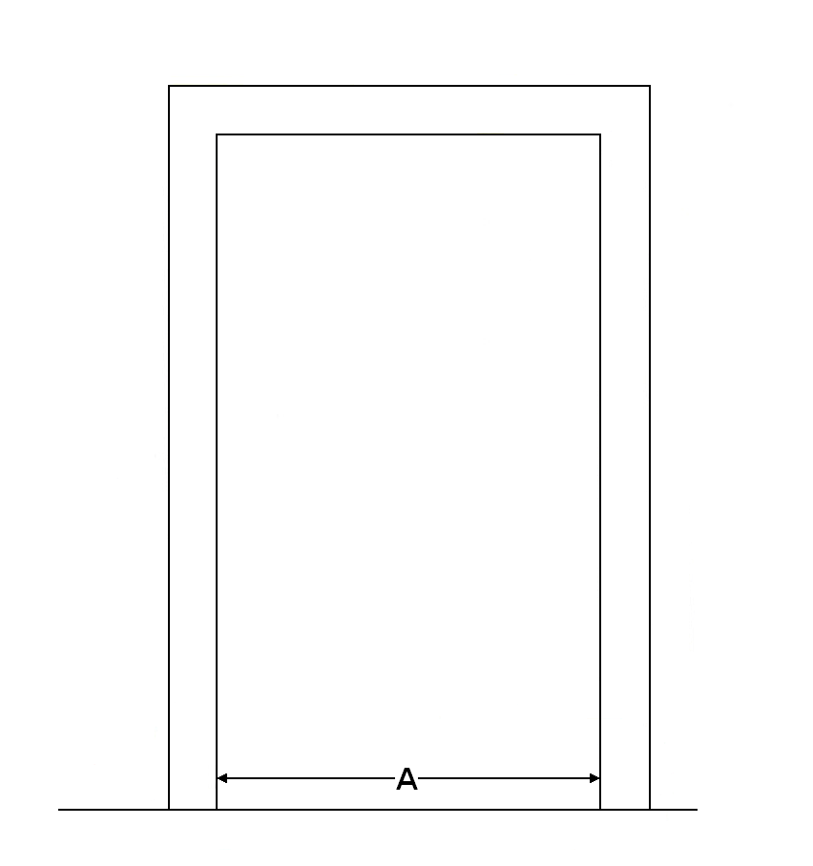
Floor Finishes:
- Carpet to Carpet
- Carpet to Vinyl
- Carpet to Laminate
- Carpet to Tiles
- Laminate to Vinyl
- Laminate to Laminate
- Laminate to Tiles
- Vinyl to Tiles
- Vinyl to Vinyl
- Wood floors
- Concrete Floors
Strip type codes:
MA0460 100mm/4” flat plate
MA0470 150mm/6” flat plate

Doorway 1 Location:
Door width (A):
Strip type code:
Floor Finish number:
Are floor levels less than 3mm difference?
Doorway 2 Location:
Door Width (A):
Strip type code:
Floor Finish number:
Are floor levels less than 3mm difference?
Doorway 3 Location:
Door Width (A):
Strip type code:
Floor Finish number:
Are floor levels less than 3mm difference?
Doorway 4 Location:
Door Width (A):
Strip type code:
Floor Finish number:
Are floor levels less than 3mm difference?

Remove existing raised threshold: | Yes
 | No

Any other information:

