2025 Minor Adaptations Requisition template
Prescriber Name: | Person’s webelms code:
Prescribers PIN code: | Date of order:
EXTERNAL WALL TO FLOOR/FLOOR TO FLOOR GALVANISED RAILS
Please draw the rail position on this template

Rail Location: |  |  |  | Which side of door?
Front door |  |  |  | Left
Side Door |  |  |  | Right
Back Door |  |  |  | Both
Other (Please state)
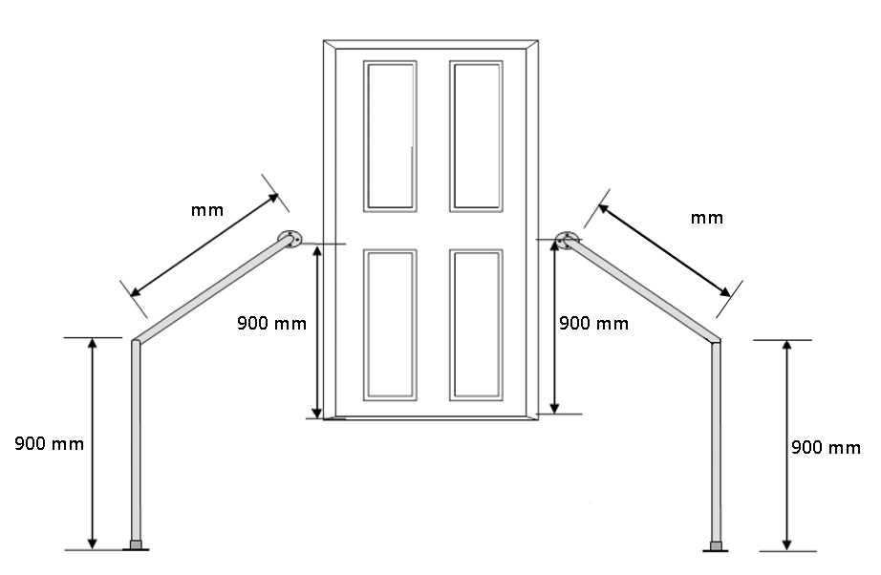
Wall to Floor …………………. Floor to Floor………………… Please specify
Length of galvanised rail required in cm or mm:
It is recommended that you include 300mm extension beyond the bottom steps where possible
All galvanised rails will be fitted at a height of 900mm above each step / floor level unless Prescriber requests otherwise.

