2025 Minor Adaptations Requisition template
Prescriber Name: | Person’s webelms code:
Prescribers PIN code: | Date of order:

HALF STEP FOR AMBULANT/WALKING STICK USER
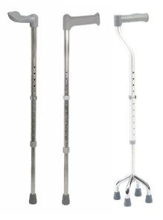
Are you completing the correct form?
This template can be used for individuals who are ambulant or are using walking sticks. This template can also be used for someone who only goes out with a carer who can take the walking frame down the step.

If rails are also needed, please attach separate templates for each minor adaptation required.
If a step is already in situ, please give dimensions
Does the existing step need to be removed?
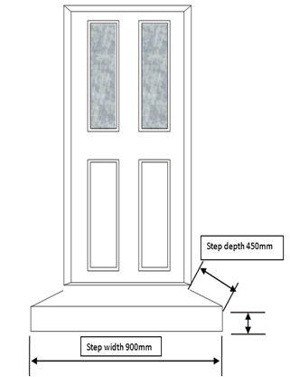
Step location (Choose one)

Front door
Side door
Back door
Other
Please give details

Are a series of steps required?

Please give details

Height of step required (Recommended height is between 100mm and 150mm)

Please give details

If this template is used, all steps will be installed at 900mm wide and 450mm deep, unless the prescriber requests otherwise

