2025 Minor Adaptations Requisition template
Prescriber Name: | Person’s webelms code:
Prescribers PIN code: | Date of order:

RECESSED DOORWAY – GRAB RAILS G
Please draw the rail position on this template
 |  | 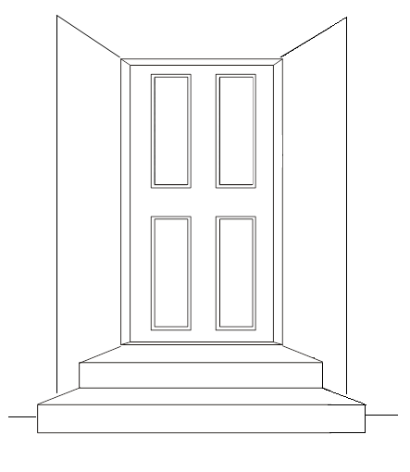
Rail Location: |  |  | Which side of door?
Front door |  |  | Left
Side Door |  |  | Right
Back Door |  |  | Both
Other
(Please state)

It is the Prescribers responsibility to ensure that the person is within the weight limit of any adaptation requested.
Length of rail required: | 450mm / 18 inch |  | 610mm / 24 inch
Measurement taken from | Top of step |  | Ground floor
Vertical measurement from centre point of rail in cm or mm:
Technician / Contractor will fit as close to doorframe as possible unless stated otherwise

