2025 Minor Adaptations Requisition template
Prescriber Name: | Person’s Webelms code:
Prescribers PIN code: | Date of order:

TOILET – GRAB RAILS LEFT SIDE
Please draw the rail position on this template

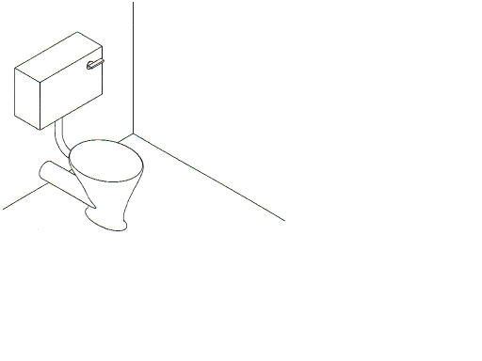 | Rail Position:
 | Vertical
 | Horizontal
 | Angled

Details of toilet equipment in situ:
Length of plastic rail required: |  |  | 300mm / 12 inch |  |  | 450mm / 18 inch
Measurement from centre point of rail in cm or mm: | A. Vertical
 | B. Horizontal (from back wall)
If drop down rail is required, please provide measurement to top of the rail
It is the Prescribers responsibility to ensure that the Person is within the weight limit of any adaptation requested.

