Contracted DPSS transferring to another contracted DPSS provider
Our contracted providers are;
Penderel’s, Purple, People Plus, Rosekel and SOLO
- Order form required for all contracted services from the above DPSS providers
- Notice to be given in writing to end contracted DPSS services (usually 4 weeks)
- For managed accounts, a new DP Agreement will be needed and signed by all required parties where there is a change to the DPSS provider managing the DP Account
- When moving from a contracted provider such as Penderels you will need to send an e-mail to Penderel’s with the subject being “Transfer contract” so that this is picked up as a priority.
- Can be completed on a Request care package amendment step with a care and support plan update form. Where the only change is DPSS provider, any changes to costs will need to be completed on a Review
For example, if the DP Recipient wishes to transfer from People Plus to Purple for payroll only, there will be no change in costs as all contracted providers have the same costs for services. You will need to update the provider’s name and the date of transfer on the care and support plan update form, usually this will be 4 weeks in the future from the date of transfer request as both DPSS providers will need time to close/set up the accounts.
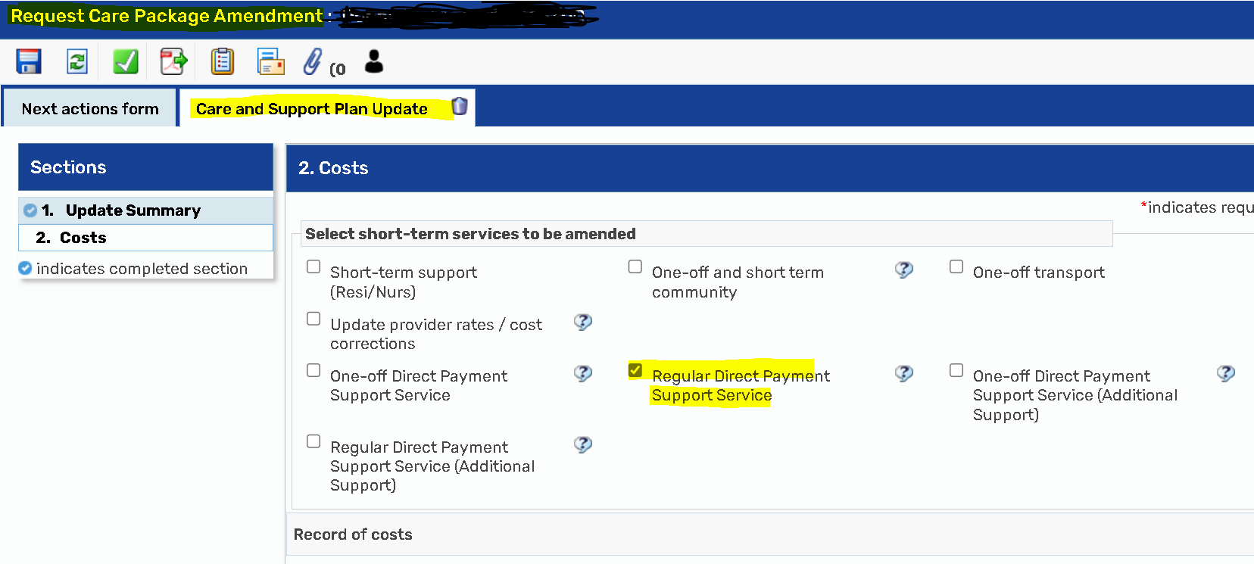
Where the support in place does not change, such as payroll only there will be no change to costs, if there is a change to the support provided then a Review step will be required as this will be a change in the costs of the DPSS services.
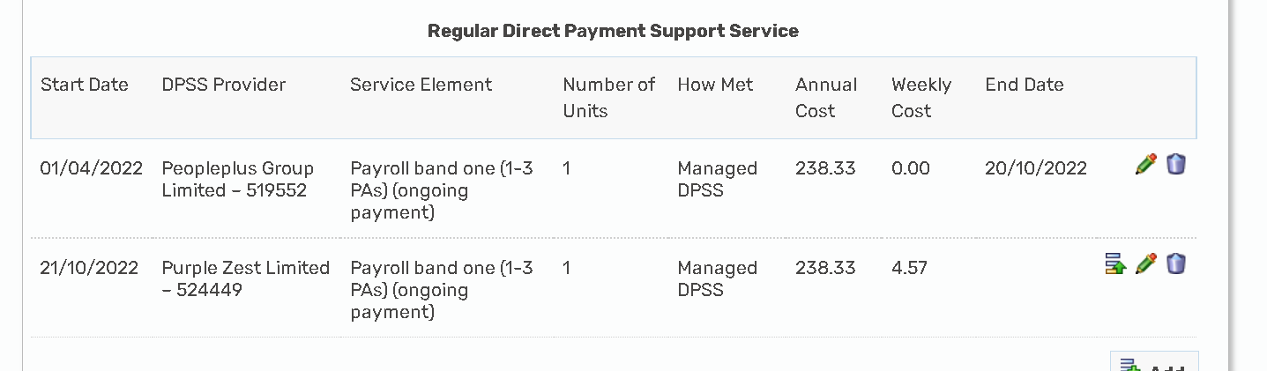
Please ensure you keep the old provider on the plan with an end date so SPT can clearly see what needs to end, and what will need to be commissioned with the new provider.
Contracted DPSS transferring to non-contracted DPSS provider
Examples of Non-contracted providers;
Pay packet, Rowan, David Hickman, family solicitors
- No order form required
- Notice to end support to be given in writing (usually 4 weeks)
- Must be completed on a Review due to a change in costs and commissioning elements
- Must have a DP Calculator for non-contracted DPSS costs to be included in the total DP weekly ongoing costs
- For managed accounts, a new DP Agreement will be needed and signed by all required parties

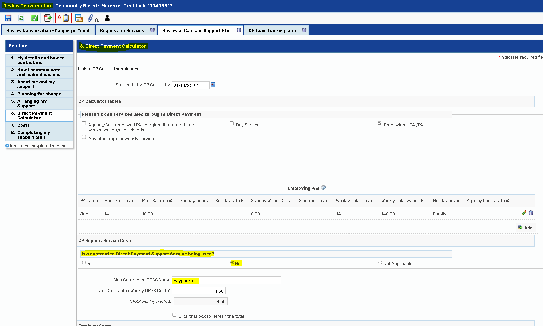
The total DP costs will show the non-contracted DPSS costs
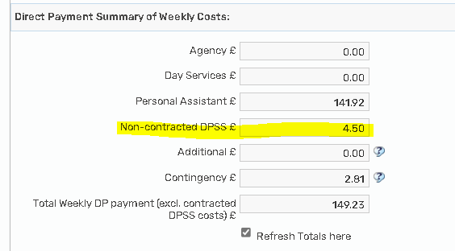
The costs then need to be copied into the cost section, making sure you have put an end date on the contracted support element;
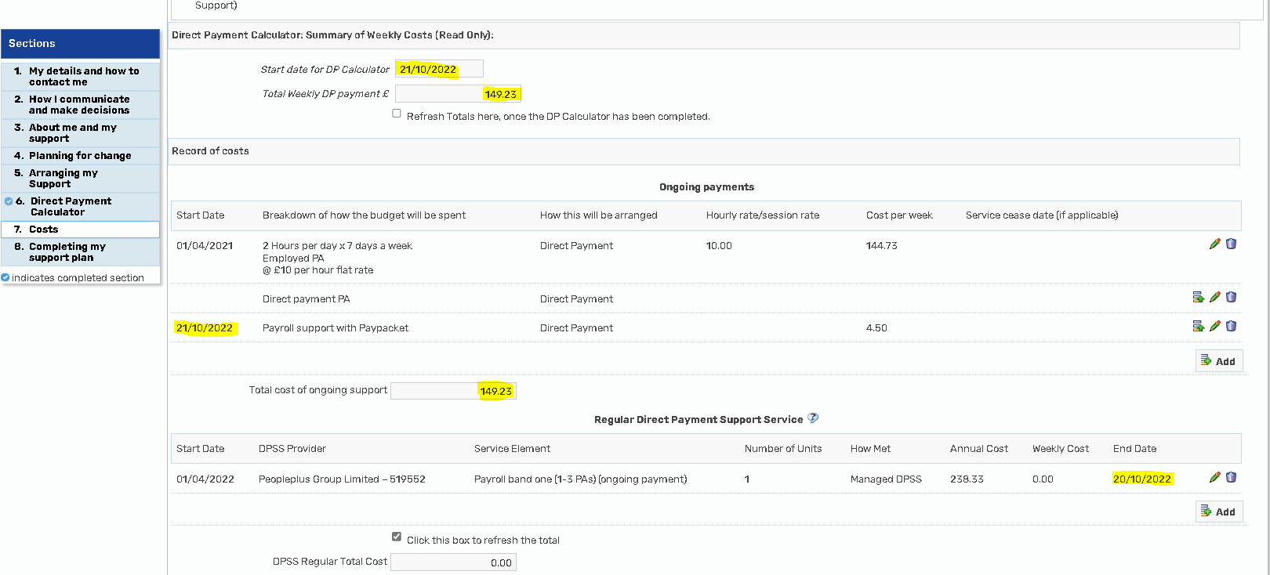

Non-contracted DPSS to Contracted DPSS support
- Order form required for new services with the contracted DPSS provider
- Notice period to be agreed with non-contracted DPSS provider to end services
- For managed accounts, a new DP Agreement will be needed and signed by all required parties
- Must be completed on a Review due to a change in costs and commissioning elements
Where a non-contracted DPSS is commissioned, there will be a DP Calculator completed as a part of the previous care and support plan which may pull though on your review. If the information is pulled through, you will need to manually delete the non-contracted information such as name and weekly cost, and then select the contracted option on the DP Calculator which will pull through from the DPSS sections, where completed in the cost section.
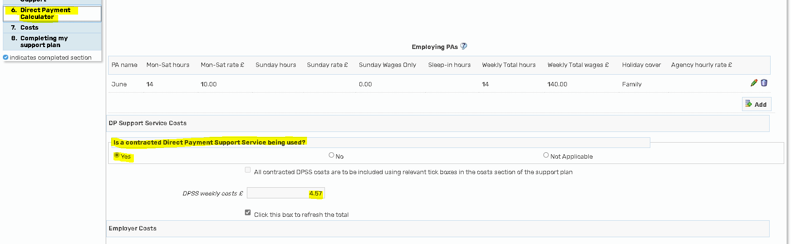

You will also need to make sure the start date of the DP matches the new ongoing DP costs, this will be the date the DPSS support has changed as this will have effected the total DP costs.
Make sure you remove the ongoing costs for the non-contracted DPSS and complete the regular DPSS element where all the providers and support options are on a drop-down menu with the costs imbedded.
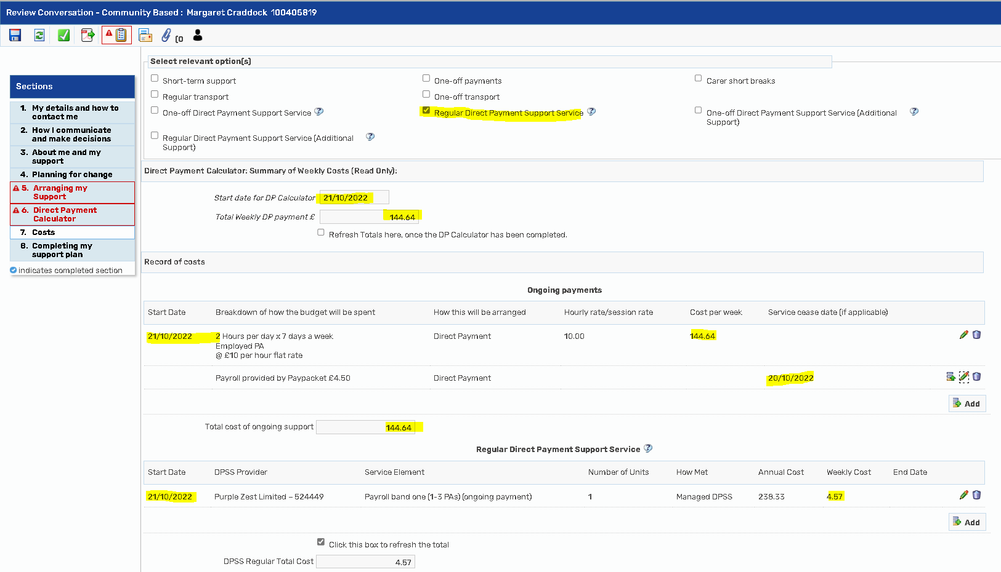

ACFS in house managed accounts – For Agencies only
Currently on hold for new packages due to the high volumes of requests
- No order from required
- New DP Agreement required
To transfer a DP package from ACFS managed account to any other DPSS provider please follow the above instructions for contracted/non-contracted DPSS providers.
ACFS will need to be made aware via e-mail of the request to change from an ACFS inhouse managed account. Direct Payments Acfs acfs.directpayments@nottscc.gov.uk
A new DP Agreement/ACM 39 will be required as ACFS are no longer managing the account and therefore will no longer need to sign the ACM39/ DP Agreement as the nominated party. The new DPSS provider will need to sign as the nominated party for any managed accounts.

