Group 2- Patrick Balcombe, Harry Austin, Devashish Bishnoi

**ECS615U-** **Laboratory Session 5**

# **Abstract**

**Method**

The first stage to create the devices was taken in ISE project navigator in which the VHDL code was written for the actual devices and their test benches. Through this we then also simulated the devices in ISim to gain timing diagrams for our test benches to confirm that the devices were working as expected according to the derived truth table. The constraints files were then created using a standardised UCF file created in a previous lab which were then altered for the I/O names of the specific devices in ISE. These constraints files map the inputs out outputs of the top level devise to the FPGM board that we later uploaded to the devices. We configure the FPGM board and upload the top level devises bit files, created in ISE, using iPACT after which the devices actual inputs and outputs where then tested.

The devices higher up in the design such as the Modulo-m counters use the functionality of the devises lower down in the design such as the half adder and d-flip flop to create a hierarchical design. Devices that are further down are port mapped, defining their connections within the device, into the higher level device so that it can be passed the signals necessary to carry out its function.

As in this lab clocks were now required for the devices a signal had to be supplied to the FPGA to act as the clock. We used the variable clock that is available on the FPGA board and connected it with wire connecting it from its pin to one of the board’s general IO pins.

In this lab the NI Elvis development board did not have enough switches to cover all the inputs to the top level devises so virtual switches provided by the NI software had to be used. A set of virtual switches were opened on the computer and then connected to the FPGA by connecting pins 1-7 of general purpose I/O (GPIO) to pins 1-7 of digital I/O (DIO).

# Simulation and FPGA Testing

In this section we individually run the test bench files for each device in Modelsim and on the physical FPGM board to check the timing diagram as well as actual results of the I/O matches its truth table. The Truth tables lists possible combinations of inputs and the relevant outputs which are compared to the results gained from the simulation and tests on the board.

**m x n-bit Static RAM cell array**

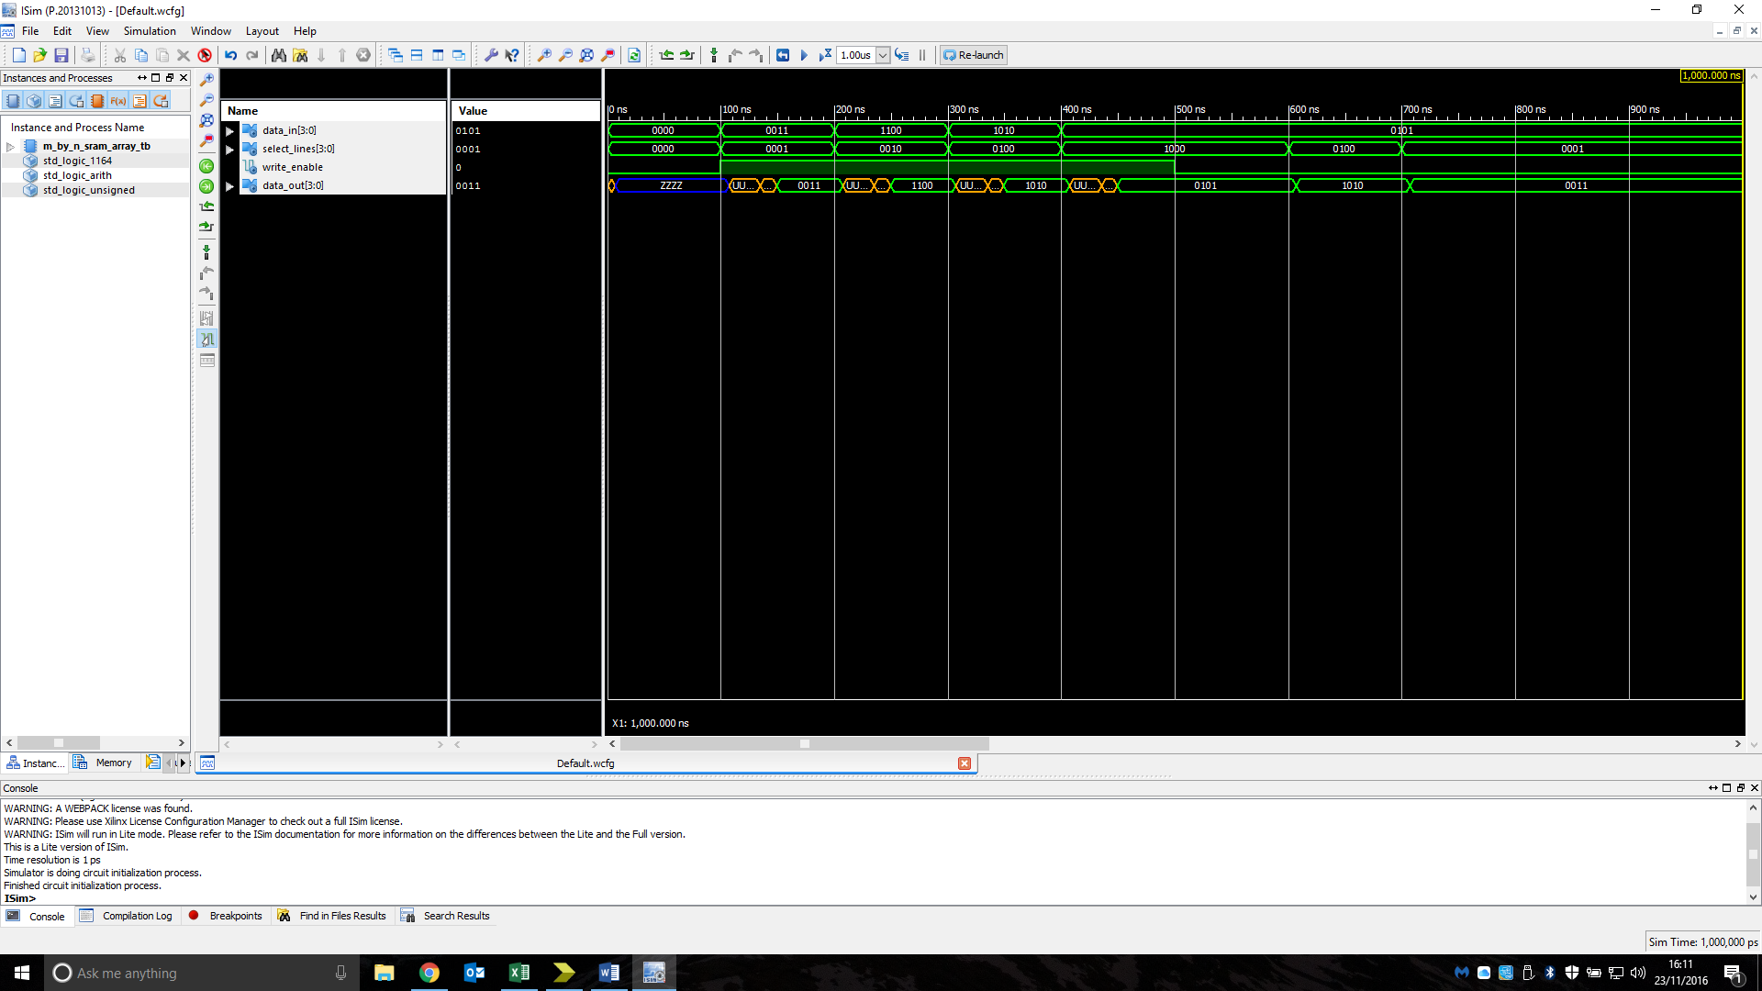Truth table:

|  |  |  |  |  |  |  |  |  |  |  |  |  |
| --- | --- | --- | --- | --- | --- | --- | --- | --- | --- | --- | --- | --- |
| DATA_IN | | | | SELECT_LINES | | | | WRITE_ENABLE | DATA_OUT | | | |
| 0 | 0 | 1 | 1 | 0 | 0 | 0 | 1 | 1 | 0 | 0 | 1 | 1 |
| X | X | X | X | 0 | 0 | 0 | 1 | 0 | 0 | 0 | 1 | 1 |
| 1 | 1 | 0 | 0 | 0 | 0 | 1 | 0 | 1 | 1 | 1 | 0 | 0 |
| X | X | X | X | 0 | 0 | 1 | 0 | 0 | 1 | 1 | 0 | 0 |
| 1 | 0 | 1 | 0 | 0 | 1 | 0 | 0 | 1 | 1 | 0 | 1 | 0 |
| X | X | X | X | 0 | 1 | 0 | 0 | 0 | 1 | 0 | 1 | 0 |
| 0 | 1 | 0 | 1 | 1 | 0 | 0 | 0 | 1 | 0 | 1 | 0 | 1 |
| X | X | X | X | 1 | 0 | 0 | 0 | 0 | 0 | 1 | 0 | 1 |

Figure1: Simulation timing diagram of an m x n-bit Static RAM cell array showing its behaviour when tested with a range of possible inputs.

Analysis: The output of the device is as expected for the simulation.

**64 x 4-bit Static RAM**

Truth table:

|  |  |  |  |  |  |  |  |  |  |  |  |
| --- | --- | --- | --- | --- | --- | --- | --- | --- | --- | --- | --- |
| ADDRESS | | | | | | READ/'WRITE | CHIP_SELECT | DATA_INOUT | | | |
| X | X | X | X | X | X | X | 0 | X | X | X | X |
| 0 | 0 | 0 | 0 | 0 | 1 | 0 | 1 | 0 | 1 | 0 | 1 |
| 0 | 0 | 0 | 0 | 0 | 1 | 1 | 1 | 0 | 1 | 0 | 1 |
| 1 | 0 | 0 | 0 | 0 | 0 | 0 | 1 | 0 | 0 | 0 | 0 |
| 1 | 0 | 0 | 0 | 0 | 0 | 1 | 1 | 0 | 0 | 0 | 0 |
| 1 | 1 | 1 | 1 | 1 | 1 | 0 | 1 | 1 | 1 | 1 | 1 |
| 1 | 1 | 1 | 1 | 1 | 1 | 1 | 1 | 1 | 1 | 1 | 1 |

Figure2: Simulation timing diagram of an n-bit asynchronous counter showing its behaviour when tested with a range of possible inputs.

Analysis: The output of the device is as expected for the simulation.

**64 x 8-bit Static RAM**

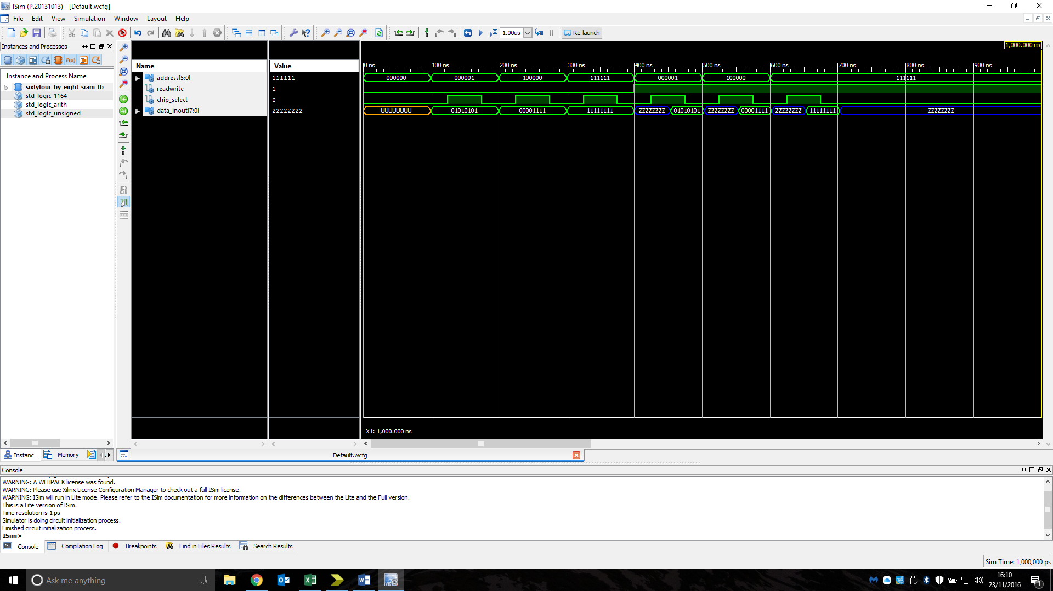Truth table:

|  |  |  |  |  |  |  |  |  |  |  |  |
| --- | --- | --- | --- | --- | --- | --- | --- | --- | --- | --- | --- |
| ADDRESS | | | | | | READ/'WRITE | CHIP_SELECT | DATA_INOUT | | | |
| X | X | X | X | X | X | X | 0 | X | X | X | X |
| 0 | 0 | 0 | 0 | 0 | 1 | 0 | 1 | 0 | 1 | 0 | 1 |
| 0 | 0 | 0 | 0 | 0 | 1 | 1 | 1 | 0 | 1 | 0 | 1 |
| 1 | 0 | 0 | 0 | 0 | 0 | 0 | 1 | 0 | 0 | 0 | 0 |
| 1 | 0 | 0 | 0 | 0 | 0 | 1 | 1 | 0 | 0 | 0 | 0 |
| 1 | 1 | 1 | 1 | 1 | 1 | 0 | 1 | 1 | 1 | 1 | 1 |
| 1 | 1 | 1 | 1 | 1 | 1 | 1 | 1 | 1 | 1 | 1 | 1 |

Figure3: Simulation timing diagram of a 64 x 4-bit Static RAM showing its behaviour when tested with a range of possible inputs.

Analysis: The output of the device is as expected for the simulation.

**Static RAM Cell**

Truth table:

|  |  |  |  |
| --- | --- | --- | --- |
| Data_in | Cell_select | Write_enable | Data_out |
| 1 | 1 | 1 | 1 |
| 0 | 1 | 0 | 1 |
| 0 | 1 | 1 | 0 |
| 1 | 1 | 0 | 0 |
| x | 0 | x | z |

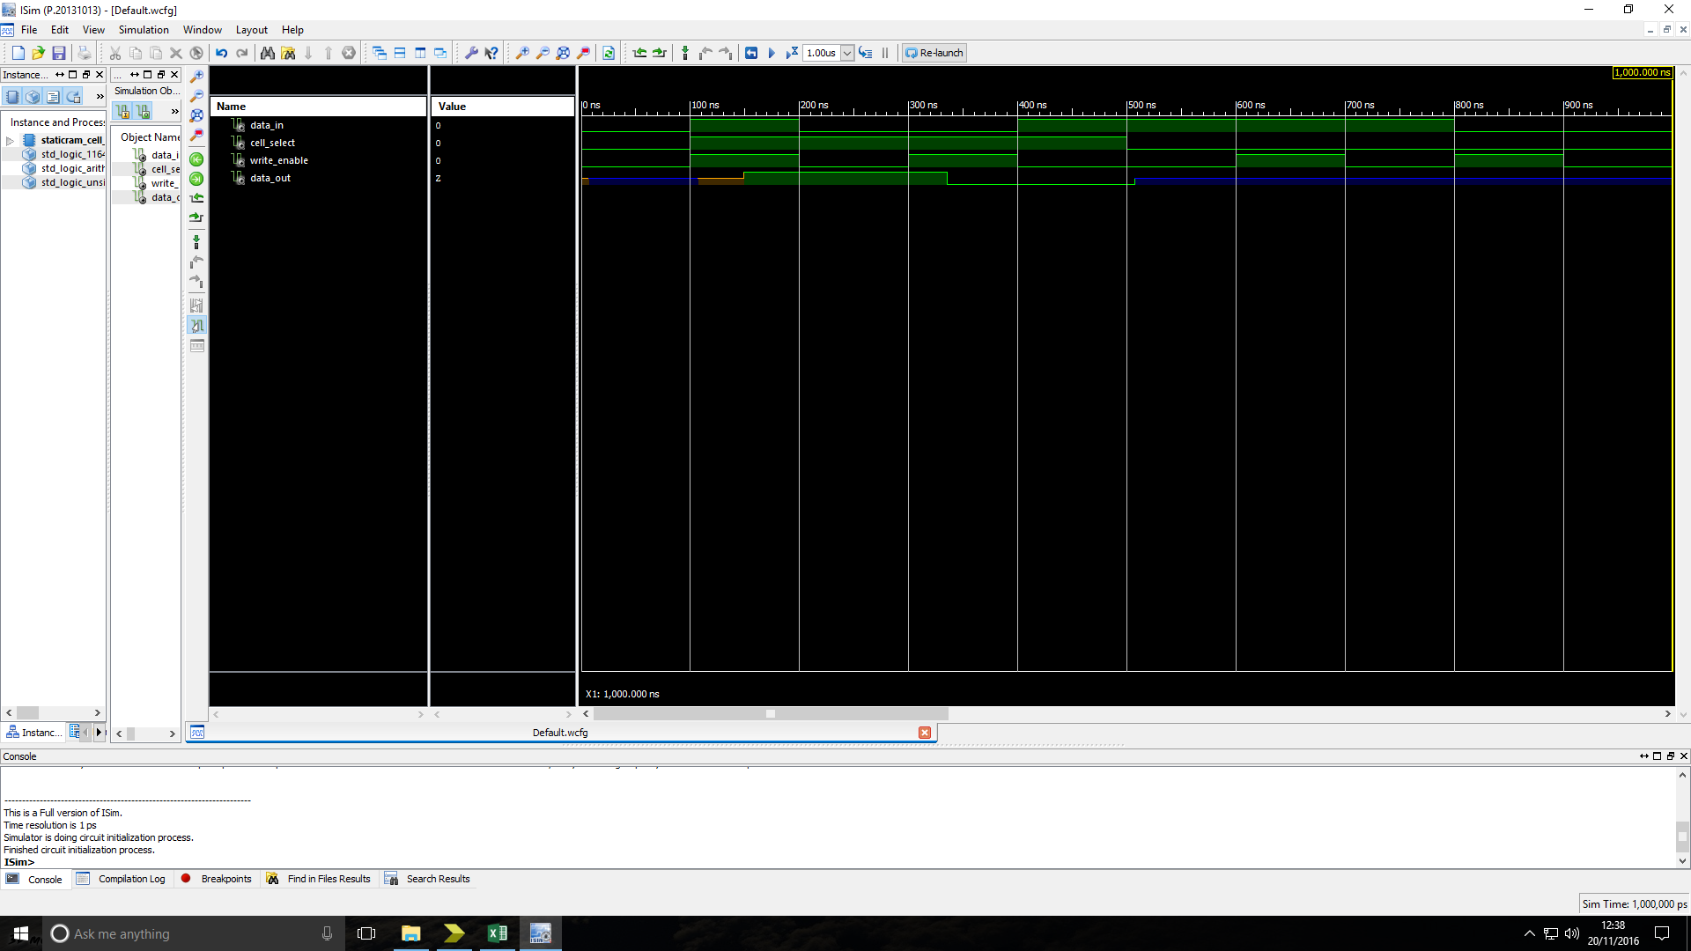Figure4: Simulation timing diagram of a Static RAM Cell showing its behaviour when tested with a range of possible inputs.

Analysis: The output of the device is as expected for the simulation.

**D-Latch**

Truth table:

|  |  |  |  |
| --- | --- | --- | --- |
| c | D | Q | Q-bar |
| 0 | 0 | last Q | last Q-bar |
| 0 | 1 | last Q | last Q-bar |
| 1 | 0 | 0 | 1 |
| 1 | 1 | 1 | 0 |

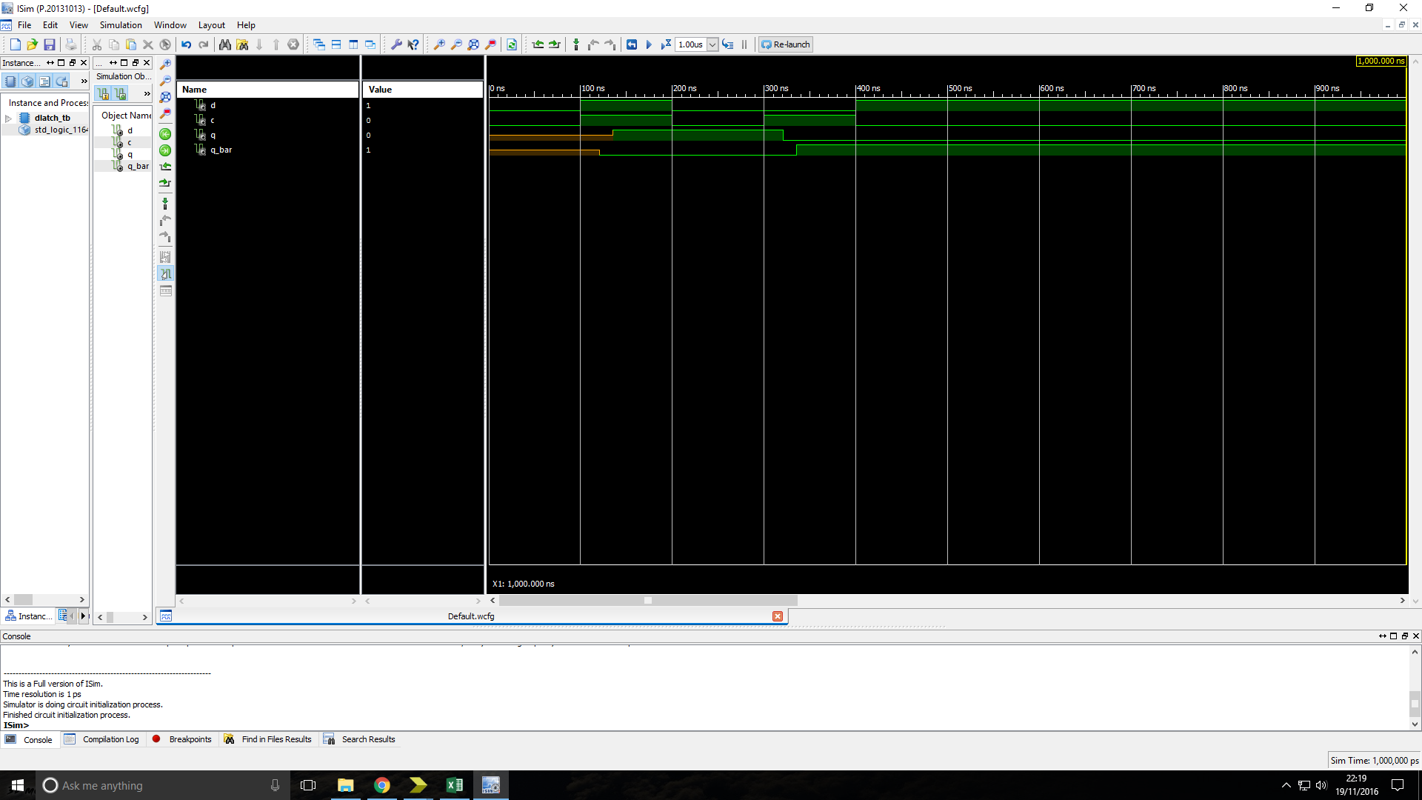Figure5: Simulation timing diagram of a D-Latch showing its behaviour when tested with a range of possible inputs.

Analysis: The output of the device is as expected for the simulation.

**Register File Cell (RFC)**

Truth table:

Figure6: Simulation timing diagram of an Register File Cell showing its behaviour when tested with a range of possible inputs.

Analysis: The output of the device is as expected for the simulation.

**n-bit RFC register**

Truth table:

Figure7: Simulation timing diagram of an n-bit RFC register showing its behaviour when tested with a range of possible inputs.

Analysis: The output of the device is as expected for the simulation.

**8 x n-bit Register File**

Truth table:

Figure8: Simulation timing diagram of an 8 x n-bit Register File showing its behaviour when tested with a range of possible inputs.

Analysis: The output of the device is as expected for both the simulation and test on FPGM board.

**16 x 7-bit ROM seven-segment display decoder**

Truth table:

|  |  |  |  |  |  |  |  |  |  |  |
| --- | --- | --- | --- | --- | --- | --- | --- | --- | --- | --- |
| Address | | | | Segment | | | | | | |
| A3 | A2 | A1 | A0 | A | B | C | D | E | F | G |
| 0 | 0 | 0 | 0 | 1 | 1 | 1 | 1 | 1 | 1 | 0 |
| 0 | 0 | 0 | 1 | 0 | 1 | 1 | 0 | 0 | 0 | 0 |
| 0 | 0 | 1 | 0 | 1 | 1 | 0 | 1 | 1 | 0 | 1 |
| 0 | 0 | 1 | 1 | 1 | 1 | 1 | 1 | 0 | 0 | 1 |
| 0 | 1 | 0 | 0 | 0 | 1 | 1 | 0 | 0 | 1 | 1 |
| 0 | 1 | 0 | 1 | 1 | 0 | 1 | 1 | 0 | 1 | 1 |
| 0 | 1 | 1 | 0 | 1 | 0 | 1 | 1 | 1 | 1 | 1 |
| 0 | 1 | 1 | 1 | 1 | 1 | 1 | 0 | 0 | 0 | 0 |
| 1 | 0 | 0 | 0 | 1 | 1 | 1 | 1 | 1 | 1 | 1 |
| 1 | 0 | 0 | 1 | 1 | 1 | 1 | 1 | 0 | 1 | 1 |
| 1 | 0 | 1 | 0 | 1 | 1 | 0 | 1 | 1 | 1 | 1 |
| 1 | 0 | 1 | 1 | 0 | 0 | 1 | 1 | 1 | 1 | 1 |
| 1 | 1 | 0 | 0 | 1 | 0 | 0 | 1 | 1 | 1 | 0 |
| 1 | 1 | 0 | 1 | 0 | 1 | 1 | 1 | 1 | 0 | 1 |
| 1 | 1 | 1 | 0 | 1 | 0 | 0 | 1 | 1 | 1 | 1 |
| 1 | 1 | 1 | 1 | 1 | 0 | 0 | 0 | 1 | 1 | 1 |

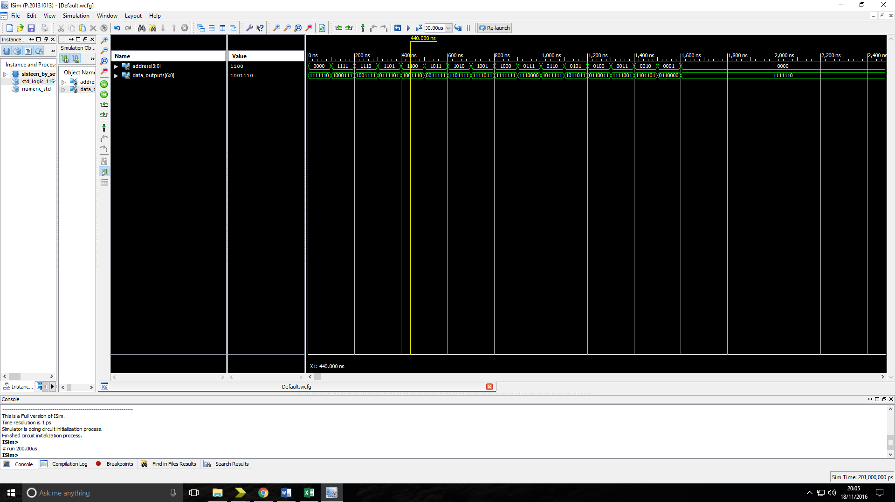Figure9: Simulation timing diagram of an 16 x 7-bit ROM seven-segment display decoder showing its behaviour when tested with a range of possible inputs.

Analysis: The output of the device is as expected for both the simulation and test on FPGM board. When testing in lab it was found that our initial design would not function on the physical board as output ports could only be assigned to one pin on the board meaning that data could only be written to one of the 7-segments from ‘data_outputs’. Whichever 7-segment constraint assignment came last in the UCF file would overwrite the previous one for the port. This issue was solved by writing the data for the two 7-segments to separate output lines that would no longer over write each other in the UCF file.

**TDM (Time-Division Multiplex) display circuit** Truth table:

|  |  |  |  |  |  |  |  |
| --- | --- | --- | --- | --- | --- | --- | --- |
| Value | reset | clock | InA | InB | Cathode A | Cathode B | Anode_outs |
| 1 | 0 | ↑ | 0110 | xxxx | 1 | 0 | 1 0 0 1 1 1 1 |
| 2 | 0 | ↑ | xxxx | 1110 | 0 | 1 | 1 0 1 1 1 1 1 |
| 3 | 0 | ↑ | 0000 | xxxx | 1 | 0 | 1 1 0 1 1 1 1 |
| 4 | 0 | ↑ | xxxx | 1010 | 0 | 1 | 1 1 1 1 1 1 0 |
| 5 | 0 | ↑ | 0011 | xxxx | 1 | 0 | 1 1 1 1 1 1 1 |
| 6 | 0 | ↑ | xxxx | 1000 | 0 | 1 | 1 1 1 1 0 0 1 |
| 7 | 0 | ↑ | 1001 | xxxx | 1 | 0 | 1 0 1 1 1 1 1 |
| 8 | 0 | ↑ | xxxx | 0110 | 0 | 1 | 1 1 1 1 0 1 1 |
| 9 | 1 | x | 1101 | xxxx | 1 | 0 | 0 1 1 0 0 1 1 |
| 10 | 1 | x | 1101 | 0100 | 1 | 0 | 0 1 1 1 1 0 1 |

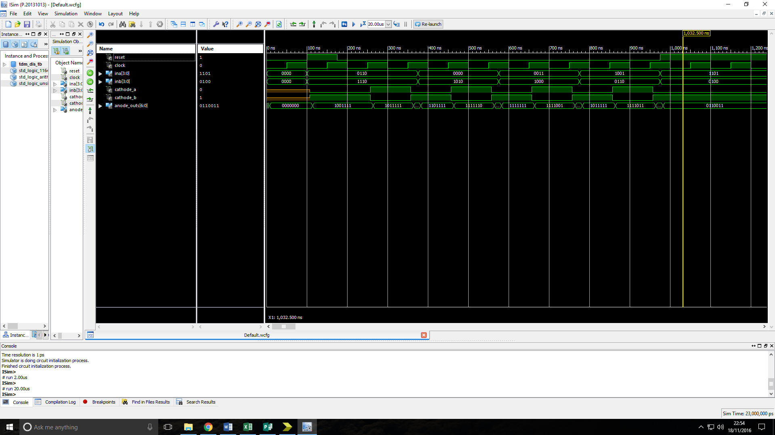Figure10: Simulation timing diagram of an TDM display circuit showing its behaviour when tested with a range of possible inputs.

Analysis: The output of the device is as expected for both the simulation and test on FPGM board. The TDM experienced the same assignment problem as the 16 x 7 ROM when being tested in the lab and so was solved in the same as discussed above.

**Additional Question**

**512 x 32 bit RAM Device**

Design:

Truth table:

Figure11: Simulation timing diagram of a 512 x 32 bit RAM Device showing its behaviour when tested with a range of possible inputs.

Analysis: The output of the device is as expected for the simulation.

**Discussion**

All devices that were tested matched their truth tables for all stimuluses’ input. The setup and hold times can be easily seen on the simulated timing diagram for the m x n RAM device as would be expected however on the timing diagrams for the 64 x 4 and 64 x 8 none can be seen. We would expect that as the number of address increased there would be an increase in the setup and hold time due to the increase in decoding logic required. These setup and hold times are only necessary for RAM devices as they are not clock synchronous, register files on the other hand are synchronous and so therefore do not require a hold time. In the lab there was a problem getting both 7-segments to work as it turned out that a single port could not be assigned to two pins on the NI Elvis board. This assignment problem was rectified by giving the device a second output that could be used to drive the other segment.

# Conclusion