Group 2- Patrick Balcombe, Harry Austin, Devashish Bishnoi

**ECS615U-** **Laboratory Session 2**

**Abstract**

# Timing Diagrams

**4-bit ALU:**

Truth table:

|  |  |  |  |  |  |  |  |  |  |  |  |  |  |  |  |
| --- | --- | --- | --- | --- | --- | --- | --- | --- | --- | --- | --- | --- | --- | --- | --- |
| Input | | | | | | | | | | | Output | | | | |
| F | | | InA | | | | InB | | | | Output | | | | C_out |
| 0 | 0 | 0 | 0 | 1 | 0 | 1 | x | x | x | x | 1 | 0 | 1 | 0 | X |
| 0 | 0 | 1 | 0 | 0 | 1 | 1 | 0 | 1 | 0 | 1 | 0 | 0 | 0 | 1 | X |
| 0 | 1 | 0 | 0 | 0 | 1 | 1 | 0 | 1 | 0 | 1 | 0 | 1 | 1 | 0 | X |
| 0 | 1 | 1 | 0 | 0 | 1 | 1 | 0 | 1 | 0 | 1 | 0 | 1 | 1 | 1 | X |
| 1 | 0 | 0 | 0 | 0 | 0 | 0 | x | x | x | x | 0 | 0 | 0 | 1 | 0 |
| 1 | 0 | 1 | 0 | 0 | 0 | 1 | 1 | 1 | 1 | 1 | 0 | 0 | 0 | 0 | 1 |
| 1 | 1 | 0 | 0 | 0 | 0 | 0 | x | x | x | x | 1 | 1 | 1 | 1 | 1 |
| 1 | 1 | 1 | 1 | 1 | 1 | 1 | 0 | 0 | 0 | 1 | 1 | 1 | 1 | 0 | 0 |

Analysis:

**4-bit Shifter:**

Truth table:

Analysis:

**4-bit Arithmetic Unit:**

Truth table:

(For results to be tested)

|  |  |  |  |  |  |  |  |  |  |  |  |  |  |  |
| --- | --- | --- | --- | --- | --- | --- | --- | --- | --- | --- | --- | --- | --- | --- |
| Inputs | | | | | | | | | | Outputs | | | | |
| InA | | | | InB | | | | Control | | Sum | | | | C_out |
| 1 | 1 | 1 | 1 | 1 | 1 | 1 | 1 | 1 | 1 | 0 | 0 | 0 | 0 | 1 |
| 1 | 1 | 1 | 1 | 1 | 1 | 1 | 1 | 1 | 0 | 1 | 1 | 1 | 0 | 1 |
| 1 | 1 | 1 | 1 | 1 | 1 | 1 | 1 | 0 | 1 | 1 | 1 | 1 | 0 | 1 |
| 1 | 1 | 1 | 1 | 1 | 1 | 1 | 1 | 0 | 0 | 0 | 0 | 0 | 0 | 1 |
| 1 | 1 | 1 | 1 | 1 | 1 | 1 | 0 | 1 | 1 | 0 | 0 | 0 | 1 | 1 |
| 1 | 1 | 1 | 1 | 1 | 1 | 1 | 0 | 1 | 0 | 1 | 1 | 1 | 0 | 1 |
| 1 | 1 | 1 | 1 | 1 | 1 | 1 | 0 | 0 | 1 | 1 | 1 | 0 | 1 | 1 |
| 1 | 1 | 1 | 1 | 1 | 1 | 1 | 0 | 0 | 0 | 0 | 0 | 0 | 0 | 1 |
| 1 | 1 | 1 | 1 | 1 | 1 | 0 | 1 | 1 | 1 | 0 | 0 | 1 | 0 | 1 |
| … | … | … | … | … | … | … | … | … | … | … | … | … | … | … |
| 1 | 0 | 1 | 0 | 0 | 0 | 1 | 0 | 1 | 1 | 1 | 0 | 0 | 0 | 1 |
| 1 | 0 | 1 | 0 | 0 | 0 | 1 | 0 | 1 | 0 | 1 | 0 | 0 | 1 | 1 |
| 1 | 0 | 1 | 0 | 0 | 0 | 1 | 0 | 0 | 1 | 1 | 1 | 0 | 0 | 0 |
| 1 | 0 | 1 | 0 | 0 | 0 | 1 | 0 | 0 | 0 | 1 | 0 | 1 | 1 | 0 |
| … | … | … | … | … | … | … | … | … | … | … | … | … | … | … |
| 0 | 1 | 0 | 0 | 1 | 0 | 0 | 0 | 1 | 1 | 1 | 1 | 0 | 0 | 0 |
| 0 | 1 | 0 | 0 | 1 | 0 | 0 | 0 | 1 | 0 | 0 | 0 | 1 | 1 | 1 |
| 0 | 1 | 0 | 0 | 1 | 0 | 0 | 0 | 0 | 1 | 1 | 1 | 0 | 0 | 0 |
| 0 | 1 | 0 | 0 | 1 | 0 | 0 | 0 | 0 | 0 | 0 | 1 | 0 | 1 | 0 |

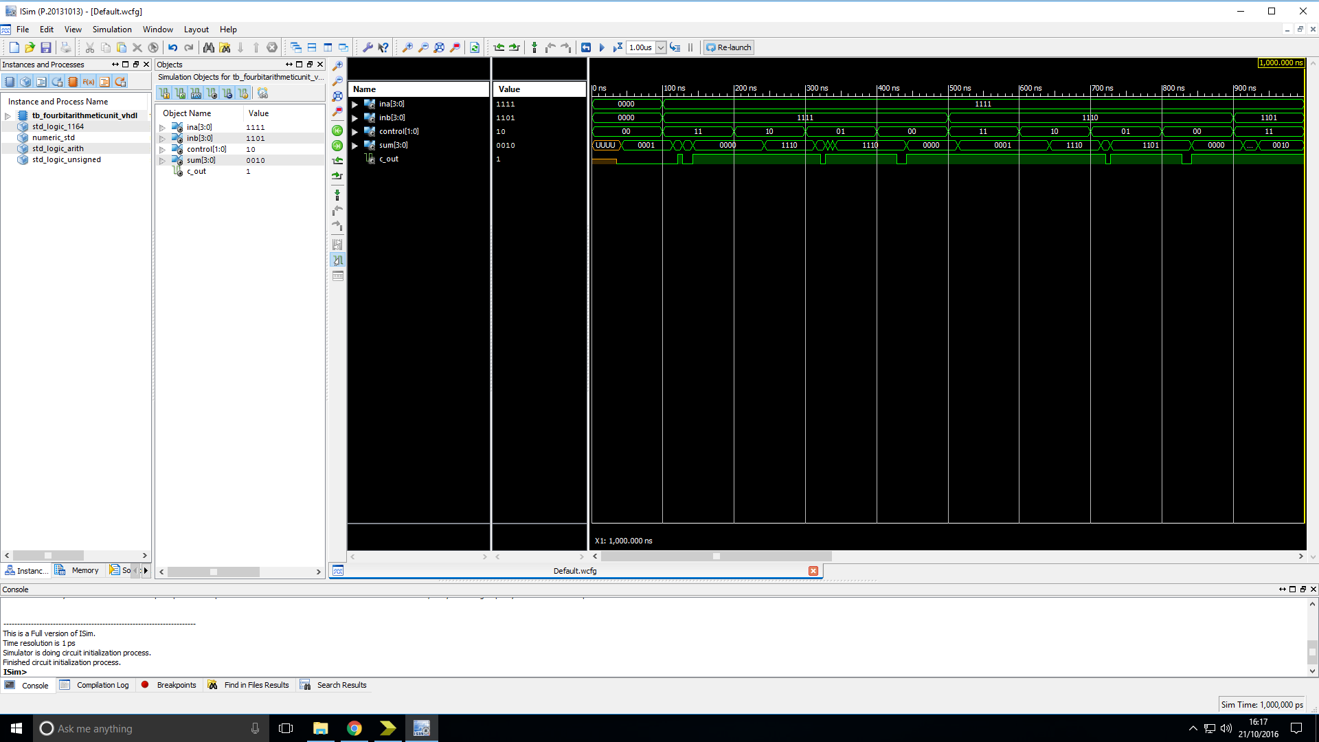

Analysis: The output of the device is as expected.

**Logic Unit:**

Truth table:

Analysis:

**n-bit 2-input multiplexer:**

Truth table:

|  |  |  |  |  |  |  |  |  |  |  |  |  |  |  |  |  |
| --- | --- | --- | --- | --- | --- | --- | --- | --- | --- | --- | --- | --- | --- | --- | --- | --- |
| Inputs | | | | | | | | | | | | Outputs | | | | |
| InA | | | | InB | | | | C_terms | | | | Sum | | | | C_out |
| 1 | 1 | 1 | 1 | 0 | 1 | 1 | 0 | 0 | 1 | 1 | 0 | 1 | 1 | 1 | 1 | 0 |
| … | … | … | … | … | … | … | … | … | … | … | … | … | … | … | … | … |
| 1 | 1 | 1 | 1 | 0 | 1 | 1 | 0 | 0 | 0 | 0 | 1 | 1 | 0 | 0 | 0 | 0 |
| … | … | … | … | … | … | … | … | … | … | … | … | … | … | … | … | … |
| 1 | 1 | 1 | 1 | 0 | 1 | 0 | 1 | 1 | 1 | 0 | 1 | 0 | 1 | 1 | 1 | 1 |
| … | … | … | … | … | … | … | … | … | … | … | … | … | … | … | … | … |
| 1 | 1 | 1 | 1 | 0 | 1 | 0 | 1 | 0 | 1 | 0 | 1 | 1 | 1 | 1 | 1 | 0 |
| … | … | … | … | … | … | … | … | … | … | … | … | … | … | … | … | … |
| 0 | 1 | 0 | 0 | 1 | 1 | 0 | 0 | 0 | 1 | 1 | 0 | 1 | 1 | 1 | 0 | 0 |
| … | … | … | … | … | … | … | … | … | … | … | … | … | … | … | … | … |
| 0 | 0 | 1 | 0 | 0 | 0 | 1 | 1 | 1 | 0 | 1 | 1 | 1 | 0 | 1 | 0 | 0 |
| … | … | … | … | … | … | … | … | … | … | … | … | … | … | … | … | … |
| 0 | 0 | 0 | 1 | 0 | 1 | 1 | 1 | 0 | 1 | 0 | 1 | 0 | 0 | 1 | 1 | 0 |

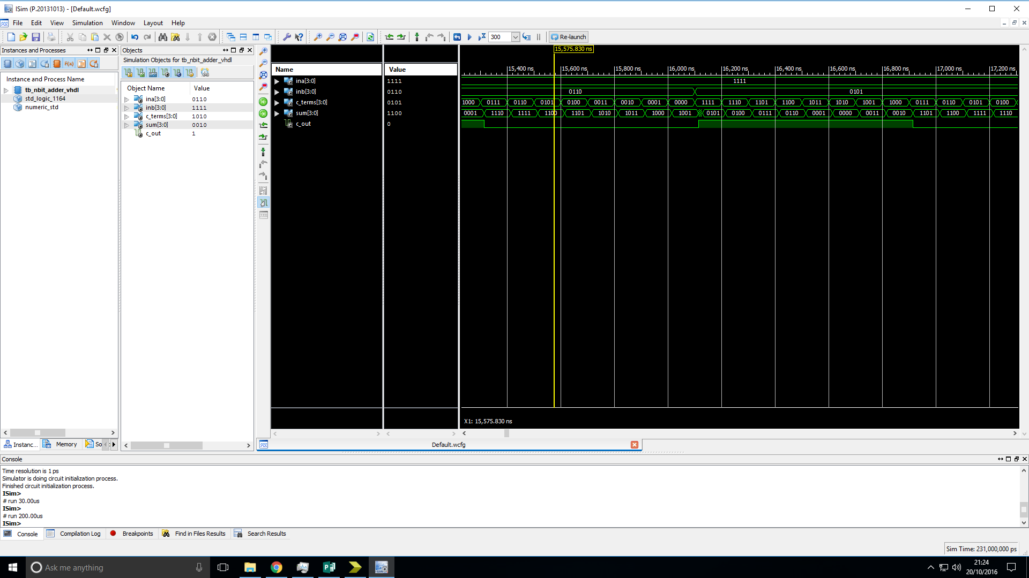

Analysis: The output of the device is as expected.

**4-bit Adder/Subtractor:**

Truth table:

|  |  |  |  |  |  |  |  |  |  |  |  |  |  |
| --- | --- | --- | --- | --- | --- | --- | --- | --- | --- | --- | --- | --- | --- |
| Inputs | | | | | | | | | Outputs | | | | |
| InA | | | | InB | | | | Control | Sum | | | | C_out |
| 0 | 0 | 1 | 0 | 0 | 0 | 1 | 1 | 0 | 0 | 1 | 0 | 1 | 0 |
| 0 | 0 | 1 | 0 | 0 | 0 | 1 | 1 | 1 | 1 | 1 | 1 | 1 | 0 |
| … | … | … | … | … | … | … | … | … | … | … | … | … | … |
| 0 | 0 | 1 | 0 | 0 | 0 | 0 | 1 | 0 | 0 | 0 | 1 | 1 | 0 |
| 0 | 0 | 1 | 0 | 0 | 0 | 0 | 1 | 1 | 0 | 0 | 0 | 1 | 1 |
| … | … | … | … | … | … | … | … | … | … | … | … | … | … |
| 1 | 1 | 0 | 0 | 0 | 1 | 0 | 1 | 0 | 0 | 0 | 0 | 1 | 1 |
| 1 | 1 | 0 | 0 | 0 | 1 | 0 | 1 | 1 | 0 | 1 | 1 | 1 | 1 |
| … | … | … | … | … | … | … | … | … | … | … | … | … | … |
| 1 | 1 | 0 | 1 | 1 | 1 | 1 | 1 | 0 | 1 | 1 | 0 | 0 | 1 |
| 1 | 1 | 0 | 1 | 1 | 1 | 1 | 1 | 1 | 1 | 1 | 1 | 0 | 1 |

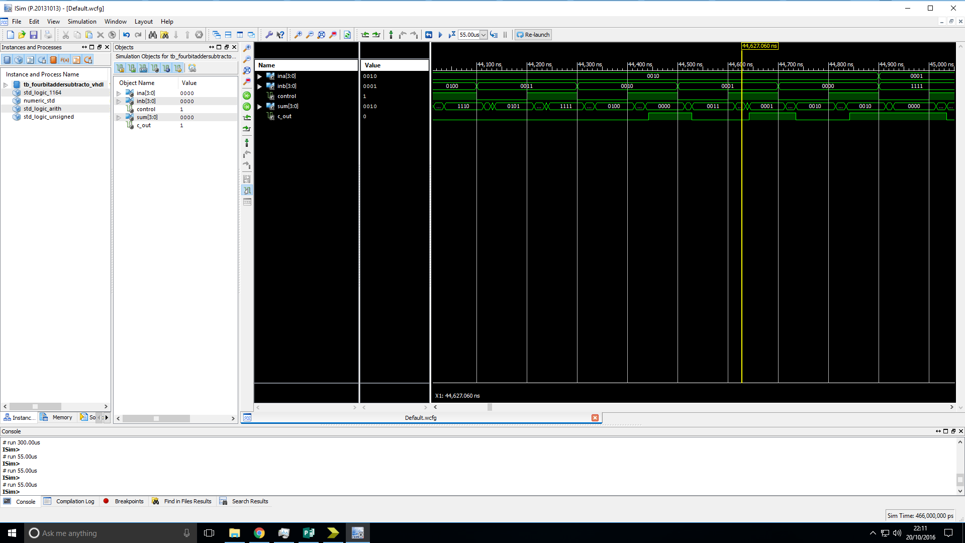

Analysis: The output of the device is as expected.

**4-bit LAC Adder:**

Truth table:

|  |  |  |  |  |  |  |  |  |  |  |  |  |  |
| --- | --- | --- | --- | --- | --- | --- | --- | --- | --- | --- | --- | --- | --- |
| Inputs | | | | | | | | | Outputs | | | | |
| InA | | | | InB | | | | Control | Sum | | | | C_out |
| 0 | 0 | 1 | 0 | 0 | 0 | 1 | 1 | 0 |  |  |  |  |  |
| 0 | 0 | 1 | 0 | 0 | 0 | 1 | 1 | 1 |  |  |  |  |  |
| … | … | … | … | … | … | … | … | … | … | … | … | … | … |
| 0 | 0 | 1 | 0 | 0 | 0 | 0 | 1 | 0 |  |  |  |  |  |
| 0 | 0 | 1 | 0 | 0 | 0 | 0 | 1 | 1 |  |  |  |  |  |
| … | … | … | … | … | … | … | … | … | … | … | … | … | … |
| 1 | 1 | 0 | 0 | 0 | 1 | 0 | 1 | 0 |  |  |  |  |  |
| 1 | 1 | 0 | 0 | 0 | 1 | 0 | 1 | 1 |  |  |  |  |  |
| … | … | … | … | … | … | … | … | … | … | … | … | … | … |
| 1 | 1 | 1 | 1 | 1 | 1 | 1 | 1 | 0 |  |  |  |  |  |
| 1 | 1 | 1 | 1 | 1 | 1 | 1 | 1 | 1 |  |  |  |  |  |

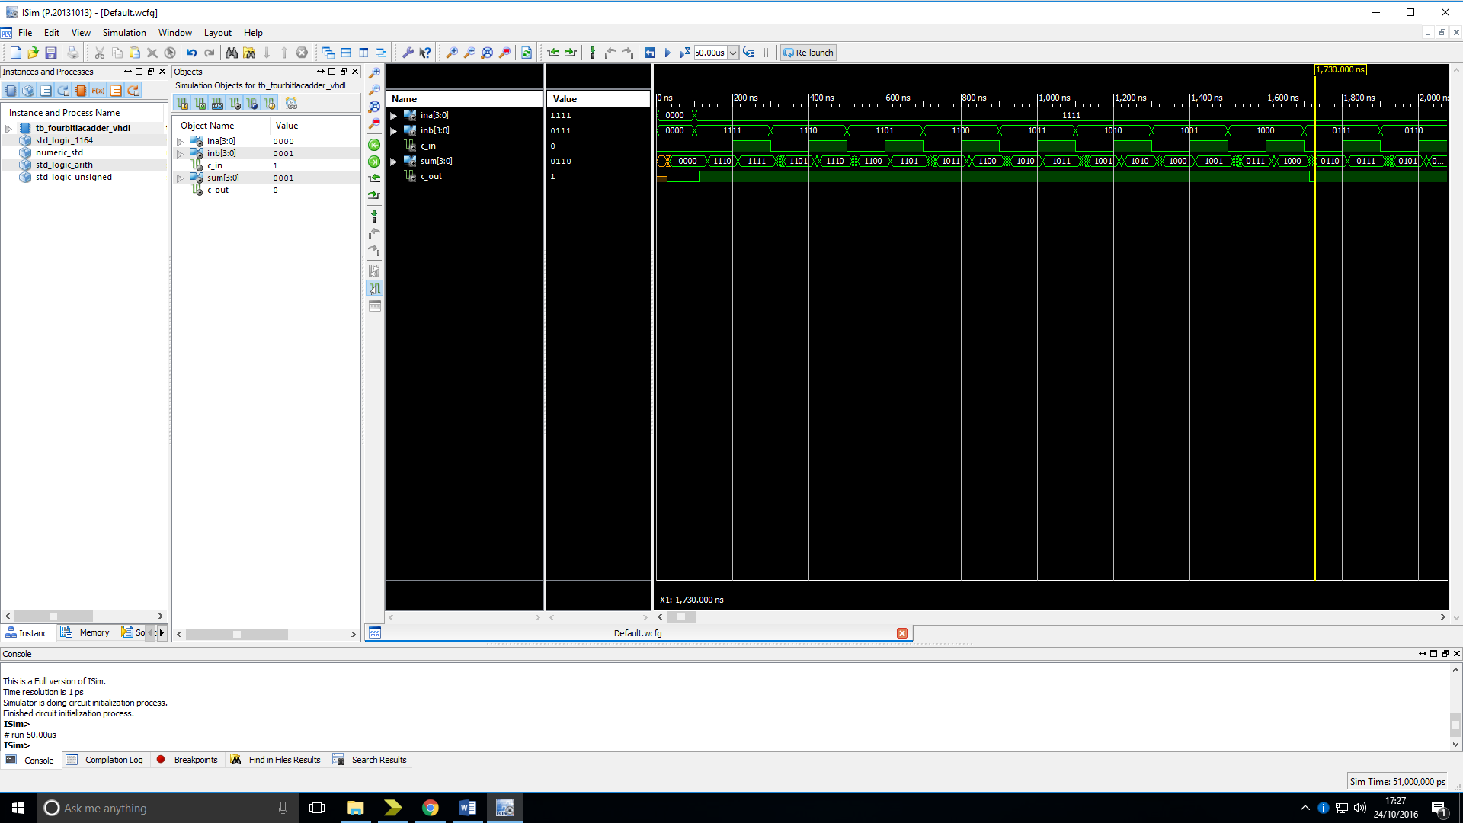

Analysis: The output of the device is as expected.

**n-bit Adder:**

Truth table:

|  |  |  |  |  |  |  |  |  |  |  |  |  |  |  |  |  |
| --- | --- | --- | --- | --- | --- | --- | --- | --- | --- | --- | --- | --- | --- | --- | --- | --- |
| Inputs | | | | | | | | | | | | Outputs | | | | |
| InA | | | | InB | | | | C_terms | | | | Sum | | | | C_out |
| 1 | 1 | 1 | 1 | 0 | 1 | 1 | 0 | 0 | 1 | 1 | 0 | 1 | 1 | 1 | 1 | 0 |
| … | … | … | … | … | … | … | … | … | … | … | … | … | … | … | … | … |
| 1 | 1 | 1 | 1 | 0 | 1 | 1 | 0 | 0 | 0 | 0 | 1 | 1 | 0 | 0 | 0 | 0 |
| … | … | … | … | … | … | … | … | … | … | … | … | … | … | … | … | … |
| 1 | 1 | 1 | 1 | 0 | 1 | 0 | 1 | 1 | 1 | 0 | 1 | 0 | 1 | 1 | 1 | 1 |
| … | … | … | … | … | … | … | … | … | … | … | … | … | … | … | … | … |
| 1 | 1 | 1 | 1 | 0 | 1 | 0 | 1 | 0 | 1 | 0 | 1 | 1 | 1 | 1 | 1 | 0 |
| … | … | … | … | … | … | … | … | … | … | … | … | … | … | … | … | … |
| 0 | 1 | 0 | 0 | 1 | 1 | 0 | 0 | 0 | 1 | 1 | 0 | 1 | 1 | 1 | 0 | 0 |
| … | … | … | … | … | … | … | … | … | … | … | … | … | … | … | … | … |
| 0 | 0 | 1 | 0 | 0 | 0 | 1 | 1 | 1 | 0 | 1 | 1 | 1 | 0 | 1 | 0 | 0 |
| … | … | … | … | … | … | … | … | … | … | … | … | … | … | … | … | … |
| 0 | 0 | 0 | 1 | 0 | 1 | 1 | 1 | 0 | 1 | 0 | 1 | 0 | 0 | 1 | 1 | 0 |

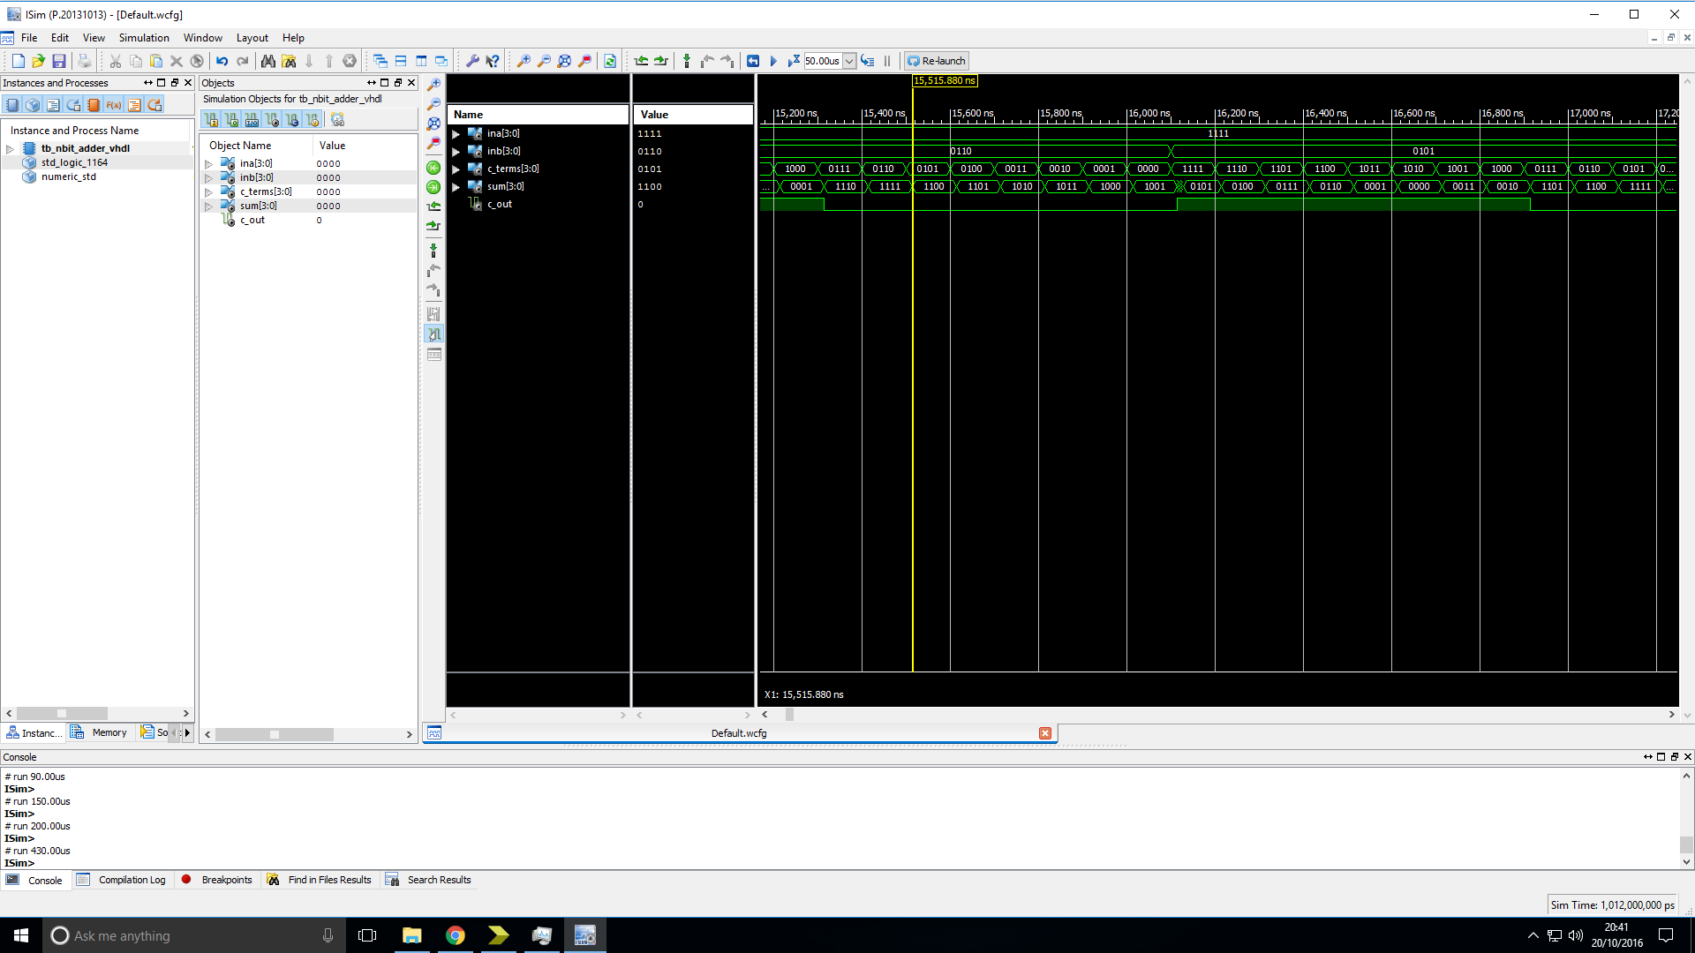

Analysis: The output of the device is as expected.

**1-bit logic function bit-slice:**

Truth table:

Analysis:

**n-bit Shift/Rotator:**

Truth table:

Analysis:

**4-input multiplexer:**

Truth table:

Analysis:

**Shift control logic:**

Truth table:

Analysis:

# Overall Analysis

# Conclusion