Group 2- Patrick Balcombe, Harry Austin, Devashish Bishnoi

**ECS615U-** **Laboratory Session 2**

# **Abstract**

In this lab we implement an ALU and shifter in VHDL code using several lower level devices. We then go on to test them using a test bench file that cycles through several possible combinations of inputs. Then using the Modelsim software to simulate the output results we confirm that the output is as expected for that particular device. Then finally we upload the devices to the physical board and verify that our devices and simulations are correct.

**Method**

The first stage to create the devices was taken in ISE project navigator in which the VHDL code was written for the actual devices and their test benches. Through this we then also simulated the devices in ISim to gain timing diagrams for our test benches to confirm that the devices were working as expected according to the derived truth table. Plan Ahead was then used to define user constraints files that map the inputs out outputs of the top level devise to the FPGM board that we would later upload the devices to. We configure the FPGM board and upload the devise using iPACT tools after which the devices actual inputs and outputs where then tested.

The devices higher up in the hieracky

# Simulation and Testing

In this section we individually run the test bench files for each device in Modelsim and on the physical FPGM board to check the timing diagram as well as actual results of the I/O matches its truth table. The Truth tables list all possible combinations of inputs and the relevant output which are compared to the results gained from the simulation and tests on the board.

# Timing Diagrams

**4-bit ALU:**

Truth table:

|  |  |  |  |  |  |  |  |  |  |  |  |  |  |  |  |
| --- | --- | --- | --- | --- | --- | --- | --- | --- | --- | --- | --- | --- | --- | --- | --- |
| Input | | | | | | | | | | | Output | | | | |
| F | | | InA | | | | InB | | | | Output | | | | C_out |
| 0 | 0 | 0 | 0 | 1 | 0 | 1 | x | x | x | x | 1 | 0 | 1 | 0 | X |
| 0 | 0 | 1 | 0 | 0 | 1 | 1 | 0 | 1 | 0 | 1 | 0 | 0 | 0 | 1 | X |
| 0 | 1 | 0 | 0 | 0 | 1 | 1 | 0 | 1 | 0 | 1 | 0 | 1 | 1 | 0 | X |
| 0 | 1 | 1 | 0 | 0 | 1 | 1 | 0 | 1 | 0 | 1 | 0 | 1 | 1 | 1 | X |
| 1 | 0 | 0 | 0 | 0 | 0 | 0 | x | x | x | x | 0 | 0 | 0 | 1 | 0 |
| 1 | 0 | 1 | 0 | 0 | 0 | 1 | 1 | 1 | 1 | 1 | 0 | 0 | 0 | 0 | 1 |
| 1 | 1 | 0 | 0 | 0 | 0 | 0 | x | x | x | x | 1 | 1 | 1 | 1 | 0 |
| 1 | 1 | 1 | 1 | 1 | 1 | 1 | 0 | 0 | 0 | 1 | 1 | 1 | 1 | 0 | 1 |

Analysis:

**4-bit Shifter:**

Truth table:

Analysis:

**4-bit Arithmetic Unit:**

Truth table:

(For results to be tested)

|  |  |  |  |  |  |  |  |  |  |  |  |  |  |  |
| --- | --- | --- | --- | --- | --- | --- | --- | --- | --- | --- | --- | --- | --- | --- |
| Inputs | | | | | | | | | | Outputs | | | | |
| InA | | | | InB | | | | Control | | Sum | | | | C_out |
| 1 | 1 | 1 | 1 | 1 | 1 | 1 | 1 | 1 | 1 | 0 | 0 | 0 | 0 | 1 |
| 1 | 1 | 1 | 1 | 1 | 1 | 1 | 1 | 1 | 0 | 1 | 1 | 1 | 0 | 1 |
| 1 | 1 | 1 | 1 | 1 | 1 | 1 | 1 | 0 | 1 | 1 | 1 | 1 | 0 | 1 |
| 1 | 1 | 1 | 1 | 1 | 1 | 1 | 1 | 0 | 0 | 0 | 0 | 0 | 0 | 1 |
| 1 | 1 | 1 | 1 | 1 | 1 | 1 | 0 | 1 | 1 | 0 | 0 | 0 | 1 | 1 |
| 1 | 1 | 1 | 1 | 1 | 1 | 1 | 0 | 1 | 0 | 1 | 1 | 1 | 0 | 1 |
| 1 | 1 | 1 | 1 | 1 | 1 | 1 | 0 | 0 | 1 | 1 | 1 | 0 | 1 | 1 |
| 1 | 1 | 1 | 1 | 1 | 1 | 1 | 0 | 0 | 0 | 0 | 0 | 0 | 0 | 1 |
| 1 | 1 | 1 | 1 | 1 | 1 | 0 | 1 | 1 | 1 | 0 | 0 | 1 | 0 | 1 |
| … | … | … | … | … | … | … | … | … | … | … | … | … | … | … |
| 1 | 0 | 1 | 0 | 0 | 0 | 1 | 0 | 1 | 1 | 1 | 0 | 0 | 0 | 1 |
| 1 | 0 | 1 | 0 | 0 | 0 | 1 | 0 | 1 | 0 | 1 | 0 | 0 | 1 | 1 |
| 1 | 0 | 1 | 0 | 0 | 0 | 1 | 0 | 0 | 1 | 1 | 1 | 0 | 0 | 0 |
| 1 | 0 | 1 | 0 | 0 | 0 | 1 | 0 | 0 | 0 | 1 | 0 | 1 | 1 | 0 |
| … | … | … | … | … | … | … | … | … | … | … | … | … | … | … |
| 0 | 1 | 0 | 0 | 1 | 0 | 0 | 0 | 1 | 1 | 1 | 1 | 0 | 0 | 0 |
| 0 | 1 | 0 | 0 | 1 | 0 | 0 | 0 | 1 | 0 | 0 | 0 | 1 | 1 | 1 |
| 0 | 1 | 0 | 0 | 1 | 0 | 0 | 0 | 0 | 1 | 1 | 1 | 0 | 0 | 0 |
| 0 | 1 | 0 | 0 | 1 | 0 | 0 | 0 | 0 | 0 | 0 | 1 | 0 | 1 | 0 |

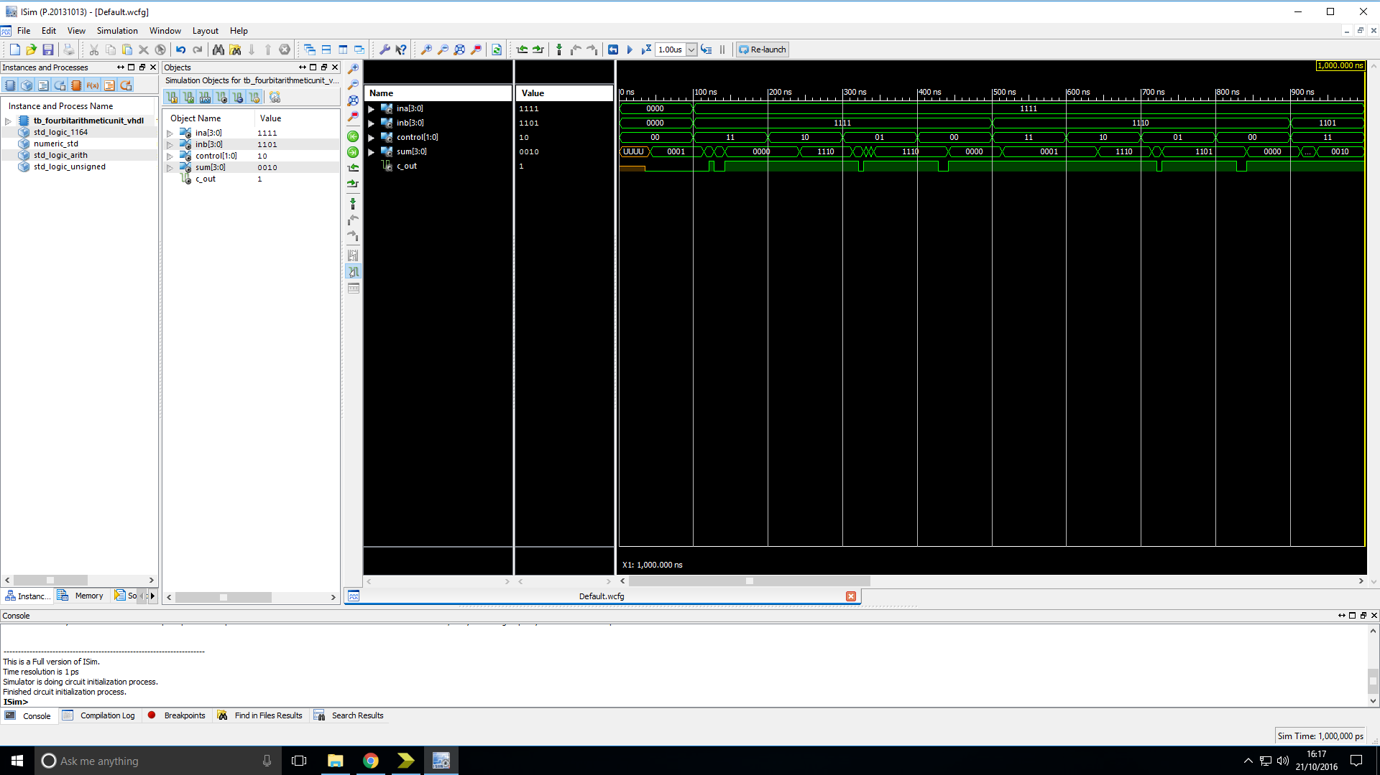

Analysis: The output of the device is as expected.

**Logic Unit:**

Truth table:

Analysis:

**n-bit 2-input multiplexer:**

Truth table:

|  |  |  |  |  |  |  |  |  |  |  |  |  |  |  |  |  |
| --- | --- | --- | --- | --- | --- | --- | --- | --- | --- | --- | --- | --- | --- | --- | --- | --- |
| Inputs | | | | | | | | | | | | Outputs | | | | |
| InA | | | | InB | | | | C_terms | | | | Sum | | | | C_out |
| 1 | 1 | 1 | 1 | 0 | 1 | 1 | 0 | 0 | 1 | 1 | 0 | 1 | 1 | 1 | 1 | 0 |
| … | … | … | … | … | … | … | … | … | … | … | … | … | … | … | … | … |
| 1 | 1 | 1 | 1 | 0 | 1 | 1 | 0 | 0 | 0 | 0 | 1 | 1 | 0 | 0 | 0 | 0 |
| … | … | … | … | … | … | … | … | … | … | … | … | … | … | … | … | … |
| 1 | 1 | 1 | 1 | 0 | 1 | 0 | 1 | 1 | 1 | 0 | 1 | 0 | 1 | 1 | 1 | 1 |
| … | … | … | … | … | … | … | … | … | … | … | … | … | … | … | … | … |
| 1 | 1 | 1 | 1 | 0 | 1 | 0 | 1 | 0 | 1 | 0 | 1 | 1 | 1 | 1 | 1 | 0 |
| … | … | … | … | … | … | … | … | … | … | … | … | … | … | … | … | … |
| 0 | 1 | 0 | 0 | 1 | 1 | 0 | 0 | 0 | 1 | 1 | 0 | 1 | 1 | 1 | 0 | 0 |
| … | … | … | … | … | … | … | … | … | … | … | … | … | … | … | … | … |
| 0 | 0 | 1 | 0 | 0 | 0 | 1 | 1 | 1 | 0 | 1 | 1 | 1 | 0 | 1 | 0 | 0 |
| … | … | … | … | … | … | … | … | … | … | … | … | … | … | … | … | … |
| 0 | 0 | 0 | 1 | 0 | 1 | 1 | 1 | 0 | 1 | 0 | 1 | 0 | 0 | 1 | 1 | 0 |

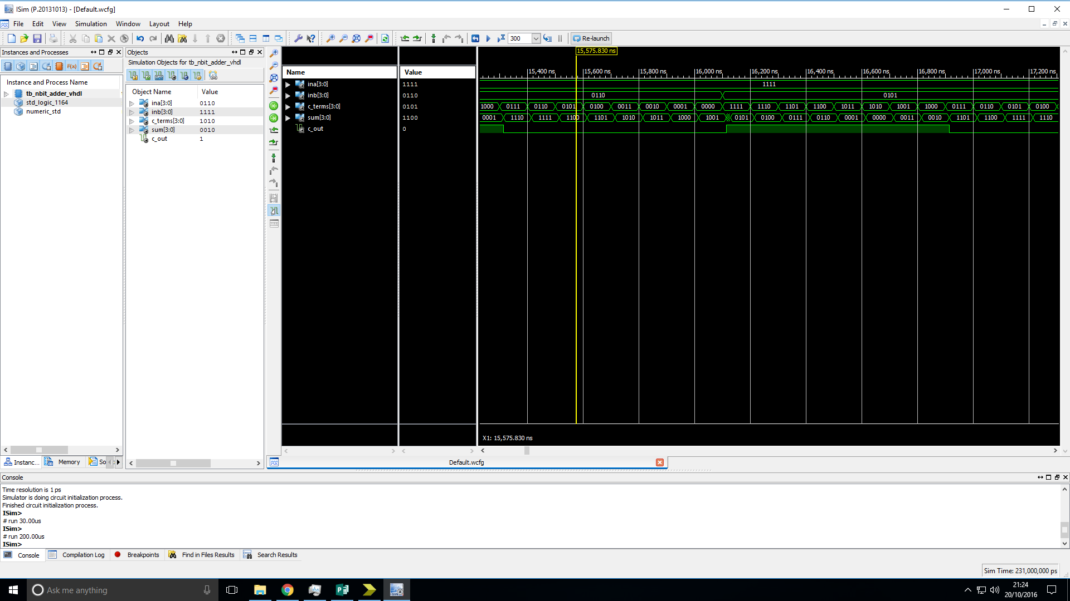

Analysis: The output of the device is as expected.

**4-bit Adder/Subtractor:**

Truth table:

|  |  |  |  |  |  |  |  |  |  |  |  |  |  |
| --- | --- | --- | --- | --- | --- | --- | --- | --- | --- | --- | --- | --- | --- |
| Inputs | | | | | | | | | Outputs | | | | |
| InA | | | | InB | | | | Control | Sum | | | | C_out |
| 0 | 0 | 1 | 0 | 0 | 0 | 1 | 1 | 0 | 0 | 1 | 0 | 1 | 0 |
| 0 | 0 | 1 | 0 | 0 | 0 | 1 | 1 | 1 | 1 | 1 | 1 | 1 | 0 |
| … | … | … | … | … | … | … | … | … | … | … | … | … | … |
| 0 | 0 | 1 | 0 | 0 | 0 | 0 | 1 | 0 | 0 | 0 | 1 | 1 | 0 |
| 0 | 0 | 1 | 0 | 0 | 0 | 0 | 1 | 1 | 0 | 0 | 0 | 1 | 1 |
| … | … | … | … | … | … | … | … | … | … | … | … | … | … |
| 1 | 1 | 0 | 0 | 0 | 1 | 0 | 1 | 0 | 0 | 0 | 0 | 1 | 1 |
| 1 | 1 | 0 | 0 | 0 | 1 | 0 | 1 | 1 | 0 | 1 | 1 | 1 | 1 |
| … | … | … | … | … | … | … | … | … | … | … | … | … | … |
| 1 | 1 | 0 | 1 | 1 | 1 | 1 | 1 | 0 | 1 | 1 | 0 | 0 | 1 |
| 1 | 1 | 0 | 1 | 1 | 1 | 1 | 1 | 1 | 1 | 1 | 1 | 0 | 1 |

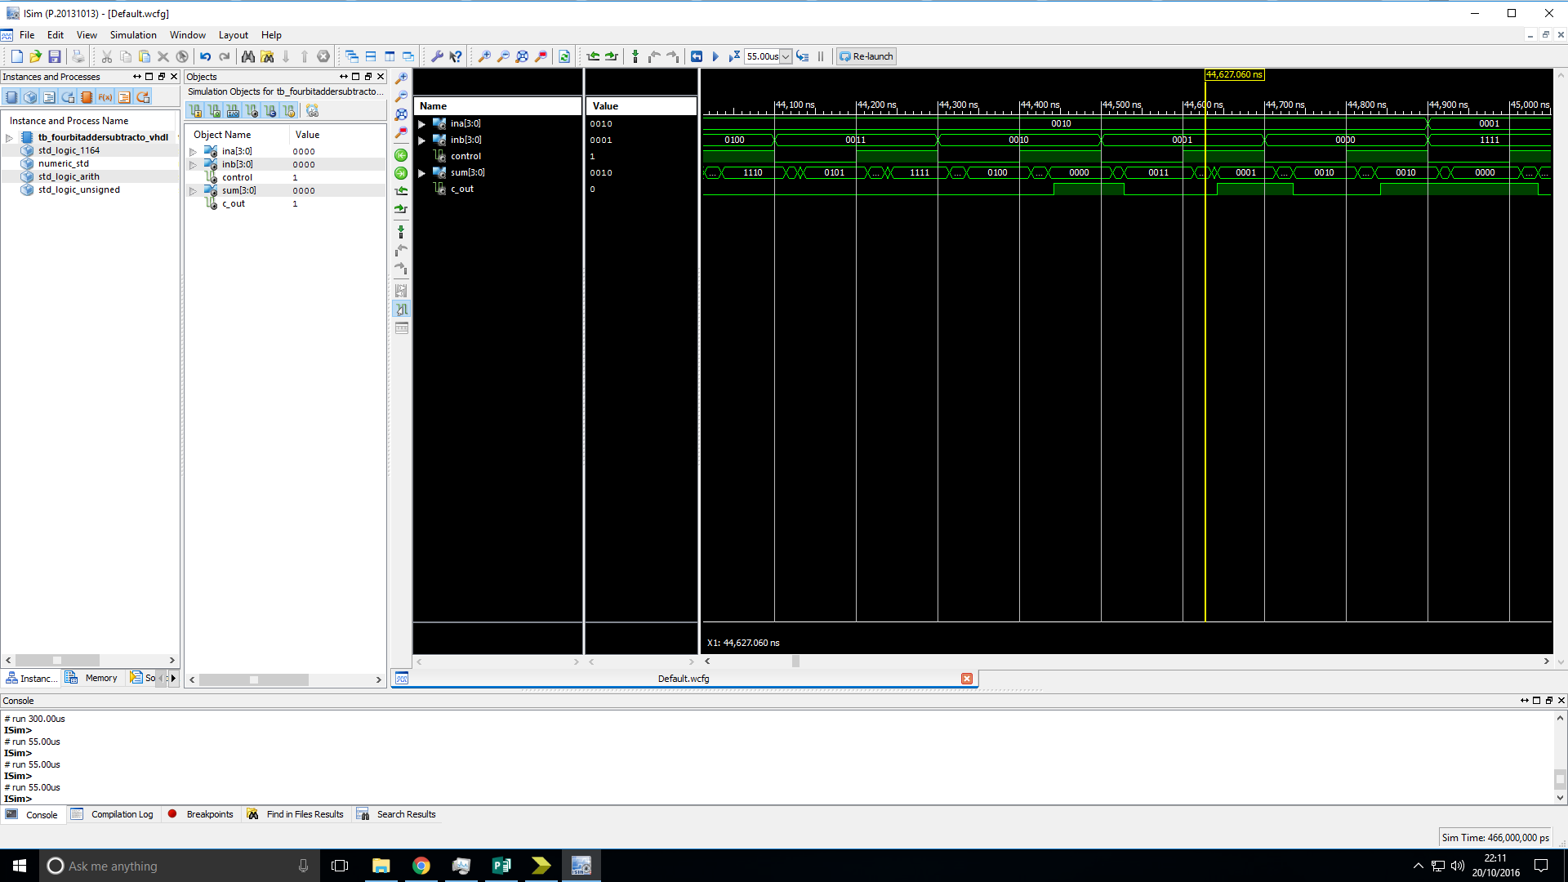

Analysis: The output of the device is as expected.

**4-bit LAC Adder:**

Truth table:

|  |  |  |  |  |  |  |  |  |  |  |  |  |  |
| --- | --- | --- | --- | --- | --- | --- | --- | --- | --- | --- | --- | --- | --- |
| Inputs | | | | | | | | | Outputs | | | | |
| InA | | | | InB | | | | Control | Sum | | | | C_out |
| 0 | 0 | 1 | 0 | 0 | 0 | 1 | 1 | 0 |  |  |  |  |  |
| 0 | 0 | 1 | 0 | 0 | 0 | 1 | 1 | 1 |  |  |  |  |  |
| … | … | … | … | … | … | … | … | … | … | … | … | … | … |
| 0 | 0 | 1 | 0 | 0 | 0 | 0 | 1 | 0 |  |  |  |  |  |
| 0 | 0 | 1 | 0 | 0 | 0 | 0 | 1 | 1 |  |  |  |  |  |
| … | … | … | … | … | … | … | … | … | … | … | … | … | … |
| 1 | 1 | 0 | 0 | 0 | 1 | 0 | 1 | 0 |  |  |  |  |  |
| 1 | 1 | 0 | 0 | 0 | 1 | 0 | 1 | 1 |  |  |  |  |  |
| … | … | … | … | … | … | … | … | … | … | … | … | … | … |
| 1 | 1 | 1 | 1 | 1 | 1 | 1 | 1 | 0 |  |  |  |  |  |
| 1 | 1 | 1 | 1 | 1 | 1 | 1 | 1 | 1 |  |  |  |  |  |

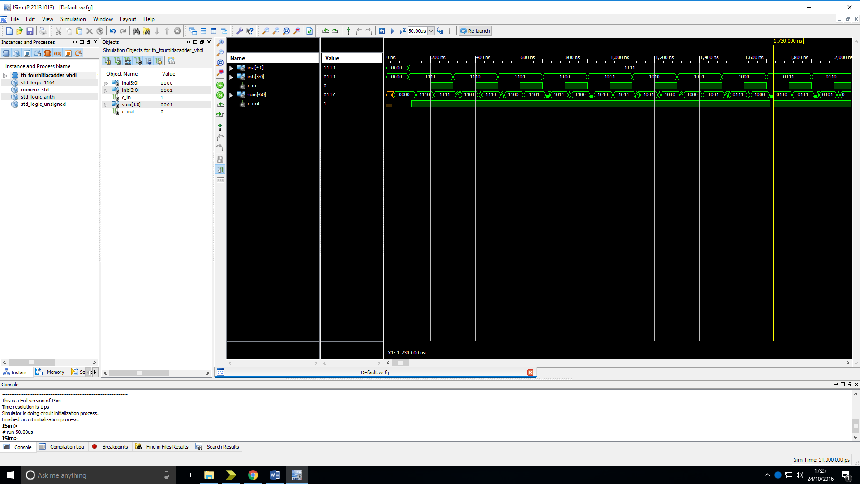

Analysis: The output of the device is as expected.

**n-bit Adder:**

Truth table:

|  |  |  |  |  |  |  |  |  |  |  |  |  |  |  |  |  |
| --- | --- | --- | --- | --- | --- | --- | --- | --- | --- | --- | --- | --- | --- | --- | --- | --- |
| Inputs | | | | | | | | | | | | Outputs | | | | |
| InA | | | | InB | | | | C_terms | | | | Sum | | | | C_out |
| 1 | 1 | 1 | 1 | 0 | 1 | 1 | 0 | 0 | 1 | 1 | 0 | 1 | 1 | 1 | 1 | 0 |
| … | … | … | … | … | … | … | … | … | … | … | … | … | … | … | … | … |
| 1 | 1 | 1 | 1 | 0 | 1 | 1 | 0 | 0 | 0 | 0 | 1 | 1 | 0 | 0 | 0 | 0 |
| … | … | … | … | … | … | … | … | … | … | … | … | … | … | … | … | … |
| 1 | 1 | 1 | 1 | 0 | 1 | 0 | 1 | 1 | 1 | 0 | 1 | 0 | 1 | 1 | 1 | 1 |
| … | … | … | … | … | … | … | … | … | … | … | … | … | … | … | … | … |
| 1 | 1 | 1 | 1 | 0 | 1 | 0 | 1 | 0 | 1 | 0 | 1 | 1 | 1 | 1 | 1 | 0 |
| … | … | … | … | … | … | … | … | … | … | … | … | … | … | … | … | … |
| 0 | 1 | 0 | 0 | 1 | 1 | 0 | 0 | 0 | 1 | 1 | 0 | 1 | 1 | 1 | 0 | 0 |
| … | … | … | … | … | … | … | … | … | … | … | … | … | … | … | … | … |
| 0 | 0 | 1 | 0 | 0 | 0 | 1 | 1 | 1 | 0 | 1 | 1 | 1 | 0 | 1 | 0 | 0 |
| … | … | … | … | … | … | … | … | … | … | … | … | … | … | … | … | … |
| 0 | 0 | 0 | 1 | 0 | 1 | 1 | 1 | 0 | 1 | 0 | 1 | 0 | 0 | 1 | 1 | 0 |

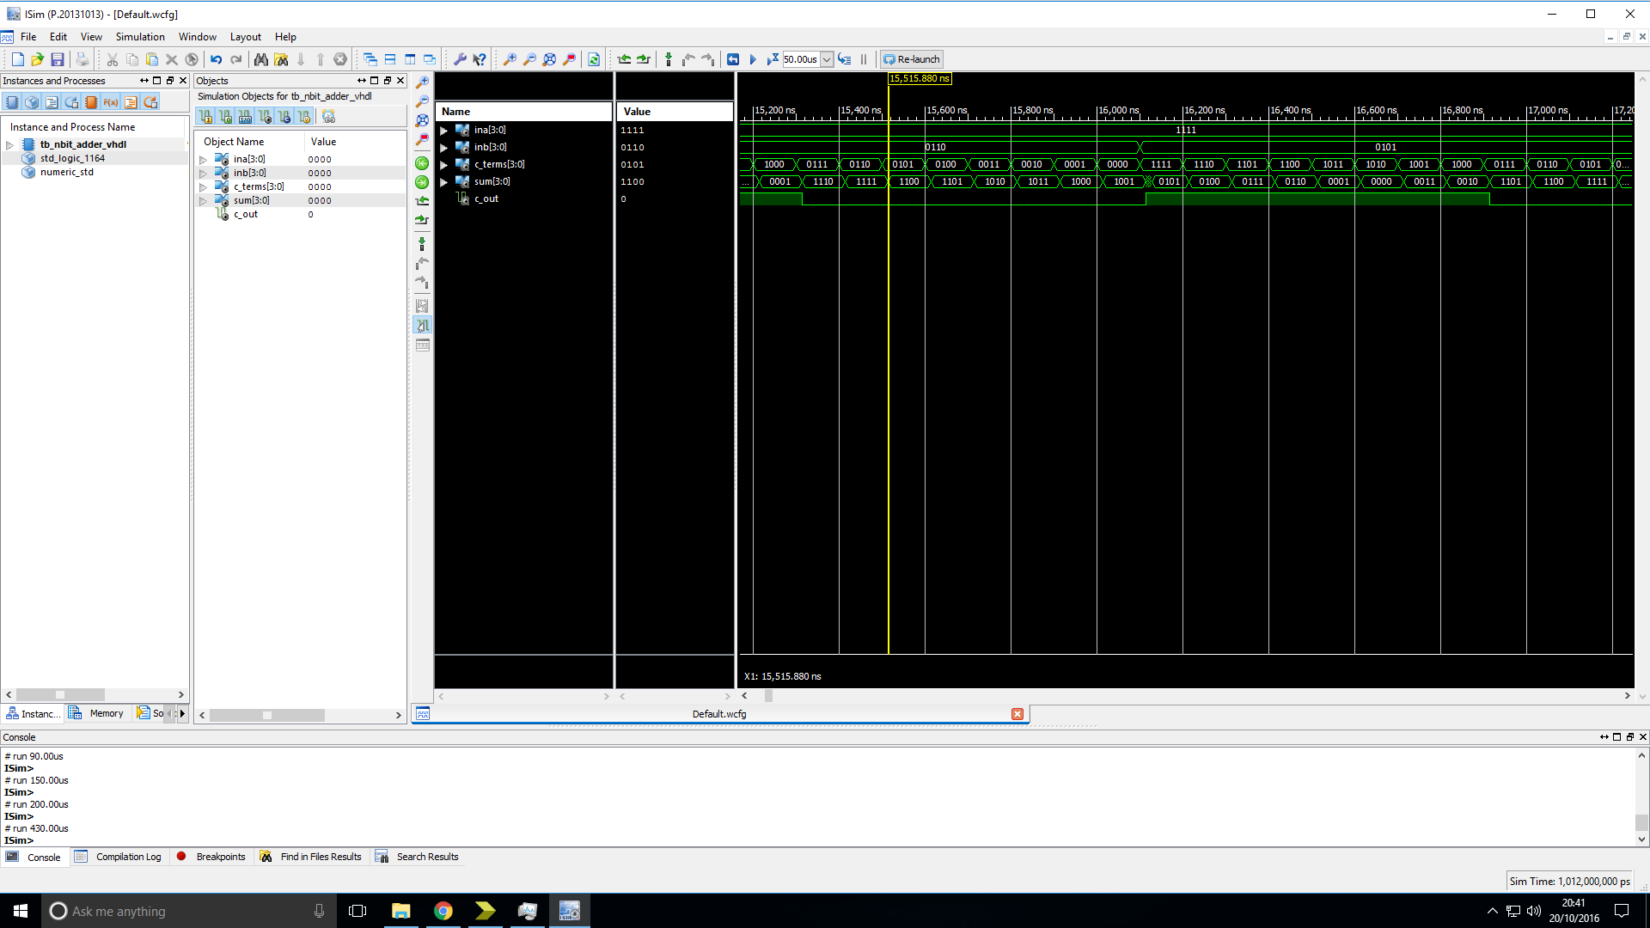

Analysis: The output of the device is as expected.

**1-bit logic function bit-slice:**

Truth table:

Analysis:

**n-bit Shift/Rotator:**

Truth table:

Analysis:

**4-input multiplexer:**

Truth table:

Analysis:

**Shift control logic:**

Truth table:

Analysis:

# Overall Analysis

# Conclusion