Group 2- Patrick Balcombe, Harry Austin, Devashish Bishnoi

**ECS615U-** **Laboratory Session 3**

# **Abstract**

In this lab we implement an XXXXXXX code using several lower level devices. We then go on to test them using a test bench file that cycles through several possible combinations of inputs. Then using the Modelsim software to simulate the output results we confirm that the output is as expected for that particular device. Then finally we upload the devices to the physical board and verify that our devices and simulations are correct.

**Method**

The first stage to create the devices was taken in ISE project navigator in which the VHDL code was written for the actual devices and their test benches. Through this we then also simulated the devices in ISim to gain timing diagrams for our test benches to confirm that the devices were working as expected according to the derived truth table. Plan Ahead was then used to define user constraints files that map the inputs out outputs of the top level devise to the FPGM board that we would later upload the devices to. We configure the FPGM board and upload the devise (which in this lab were the ALU and shifter) using iPACT tools after which the devices actual inputs and outputs where then tested.

The devices higher up in the design such as the ALU and Shifter use the functionality of the devises lower down in the design such as the Adder/subtractor to create a hierarchical design. Devices that are further down are port mapped, defining their connections within the device, into the higher level device so that it can be passed the signals necessary to carry out its function.

# Simulation and FPGA Testing

In this section we individually run the test bench files for each device in Modelsim and on the physical FPGM board to check the timing diagram as well as actual results of the I/O matches its truth table. The Truth tables lists possible combinations of inputs and the relevant outputs which are compared to the results gained from the simulation and tests on the board.

# Timing Diagrams

# D-flipflop:

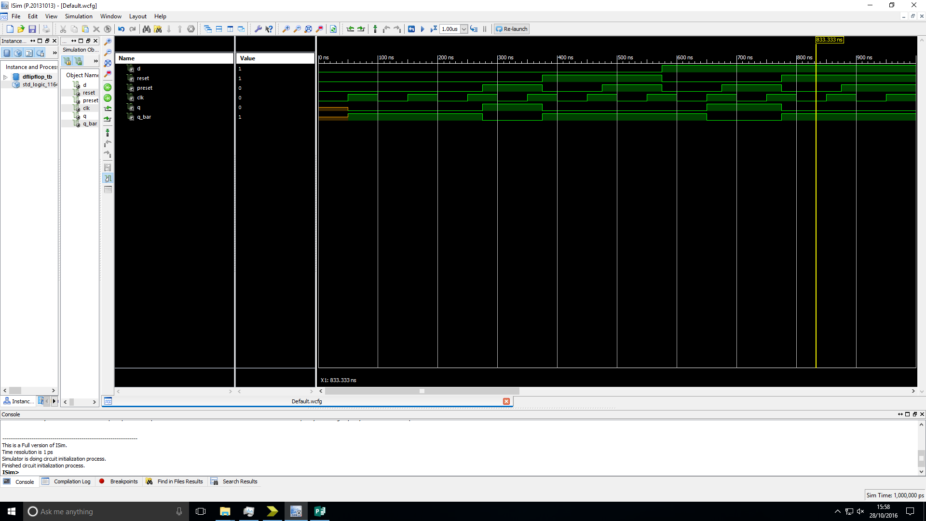Truth table:

|  |  |  |  |  |  |
| --- | --- | --- | --- | --- | --- |
| CLK | D | Preset | Reset | Q | Q_Bar |
| ↑ | 0 | 0 | 0 | 0 | 1 |
| ↑ | 1 | 0 | 0 | 1 | 0 |
| 0 | x | 0 | 0 | Last Q | last Q_bar |
| 1 | x | 0 | 0 | Last Q | last Q_bar |
| x | x | 1 | 0 | 1 | 0 |
| x | x | x | 1 | 0 | 1 |

Figure 1: Simulation timing diagram of a D-flipflop showing its behaviour when tested with a range of possible inputs.

Analysis: The output of the device is as expected for both the simulation and test on FPGM board.

# n-bit register:

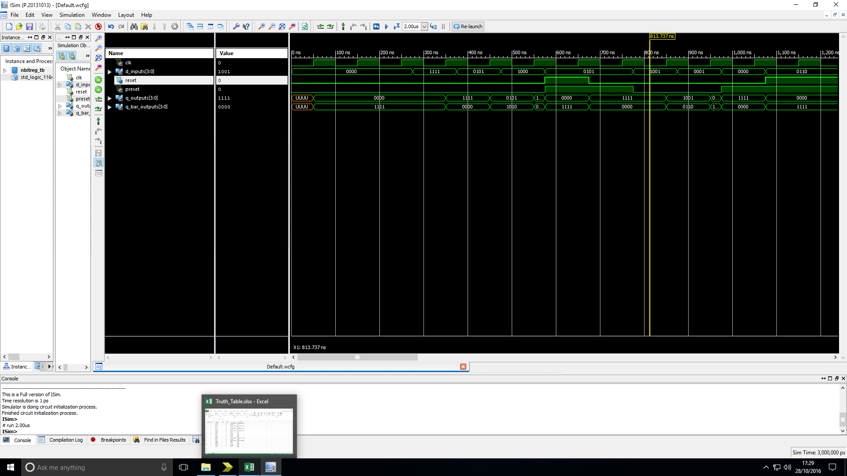Truth table:

|  |  |  |  |  |  |
| --- | --- | --- | --- | --- | --- |
| CLK | D_Input | reset | preset | Q_outputs | Q_bar_outputs |
| 0 | 0000 | 0 | 0 | last Q_outputs | last Q_bar_outputs |
| ↑ | 0000 | 0 | 0 | 0000 | 1111 |
| ↑ | 1111 | 0 | 0 | 1111 | 0000 |
| ↑ | 0101 | 0 | 0 | 0101 | 1010 |
| ↑ | 1000 | 0 | 0 | 1000 | 0111 |
| x | 0101 | 1 | 1 | 0000 | 1111 |
| x | 0101 | 0 | 1 | 1111 | 0000 |
| ↑ | 1001 | 0 | 0 | 1001 | 0110 |
| ↑ | 0001 | 0 | 0 | 0001 | 1110 |
| x | 0000 | 0 | 1 | 1111 | 0000 |
| x | 0110 | 1 | 0 | 1111 | 0000 |

Figure 2: Simulation timing diagram of an n-bit register showing its behaviour when tested with a range of possible inputs.

Analysis: The output of the device is as expected for both the simulation and test on FPGM board.

# n-bit register with LOAD/~HOLD control:

Truth table:

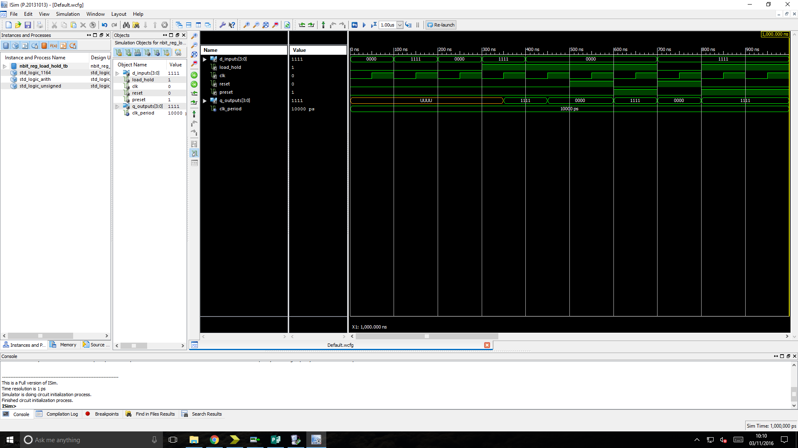

Figure 3: Simulation timing diagram of an n-bit register with LOAD/~HOLD control showing its behaviour when tested with a range of possible inputs.

Analysis: The output of the device is as expected for both the simulation and test on FPGM board.

# n-bit tri-state buffer:

Truth table:

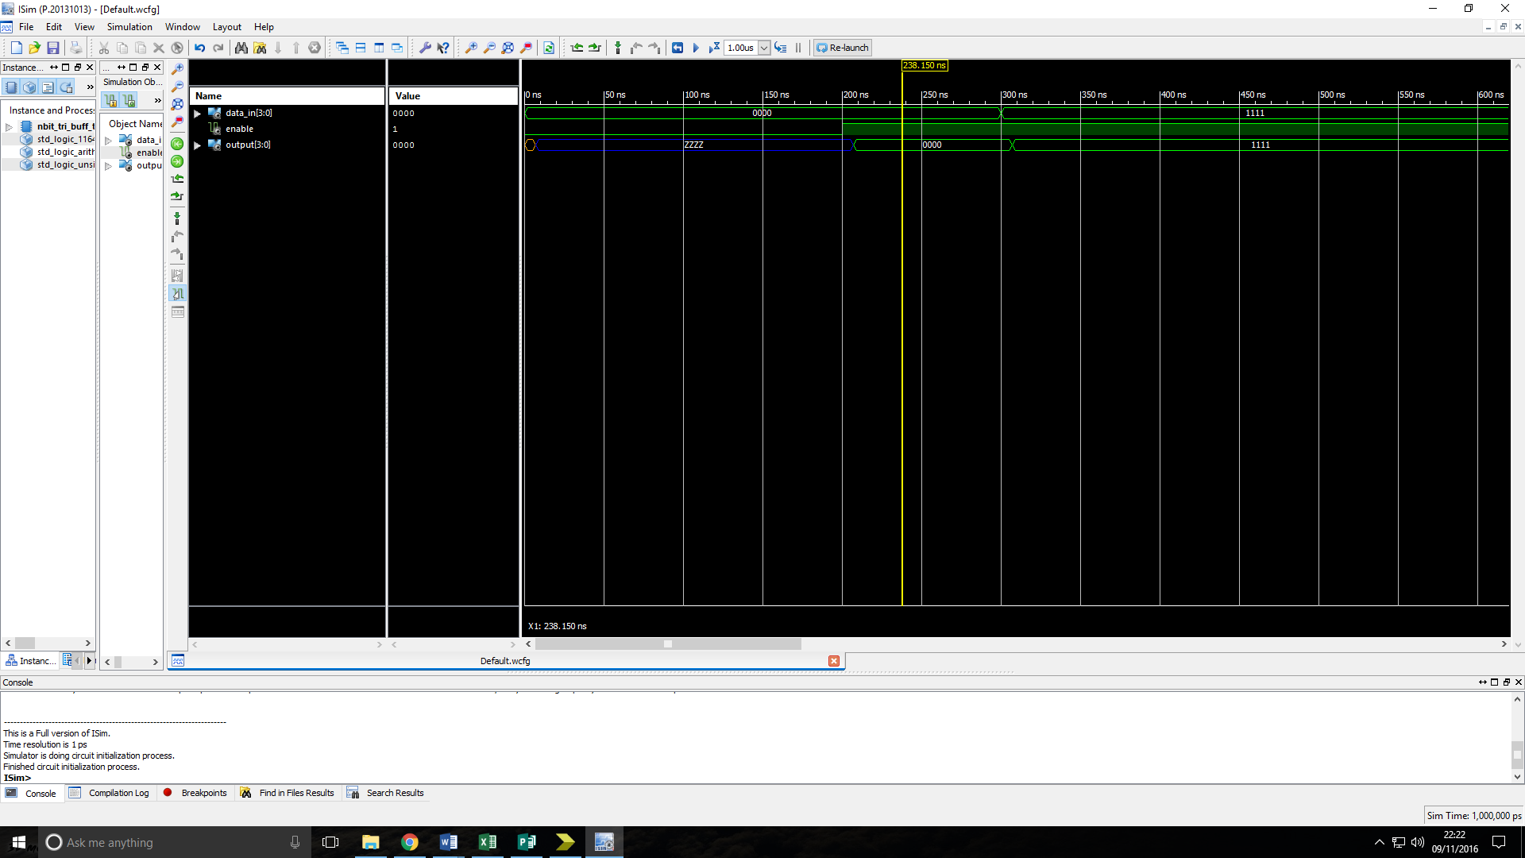

Figure 4: Simulation timing diagram of an n-bit tri-state buffer showing its behaviour when tested with a range of possible inputs.

Analysis: The output of the device is as expected for both the simulation and test on FPGM board.

# n-bit register with LOAD/~HOLD and tristate output enable:

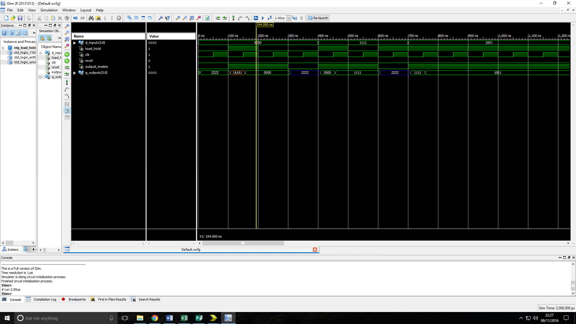Truth table:

Figure 5: Simulation timing diagram of an n-bit register with LOAD/~HOLD and tristate output enable showing its behaviour when tested with a range of possible inputs.

Analysis: The output of the device is as expected for both the simulation and test on FPGM board.

# n-bit shift register with parallel load input:

Truth table:

|  |  |  |  |  |  |  |
| --- | --- | --- | --- | --- | --- | --- |
| Shift in | D_inputs | load_shift | CLk | Reset | Preset | Q_outputs |
| x | x | x | x | 0 | 1 | 11111111 |
| x | x | x | x | 1 | 1 | 00000000 |
| x | x | x | x | 1 | 0 | 00000000 |
| 1 | x | 0 | ↑ | 0 | 0 | 00000001 |
| 0 | x | 0 | ↑ | 0 | 0 | 00000010 |
| x | 10101011 | 1 | ↑ | 0 | 0 | 10101011 |
| x | 01011010 | 1 | ↑ | 0 | 0 | 01011010 |
| 1 | x | 0 | ↑ | 0 | 0 | 10110101 |
| 0 | x | 0 | ↑ | 0 | 0 | 01101010 |

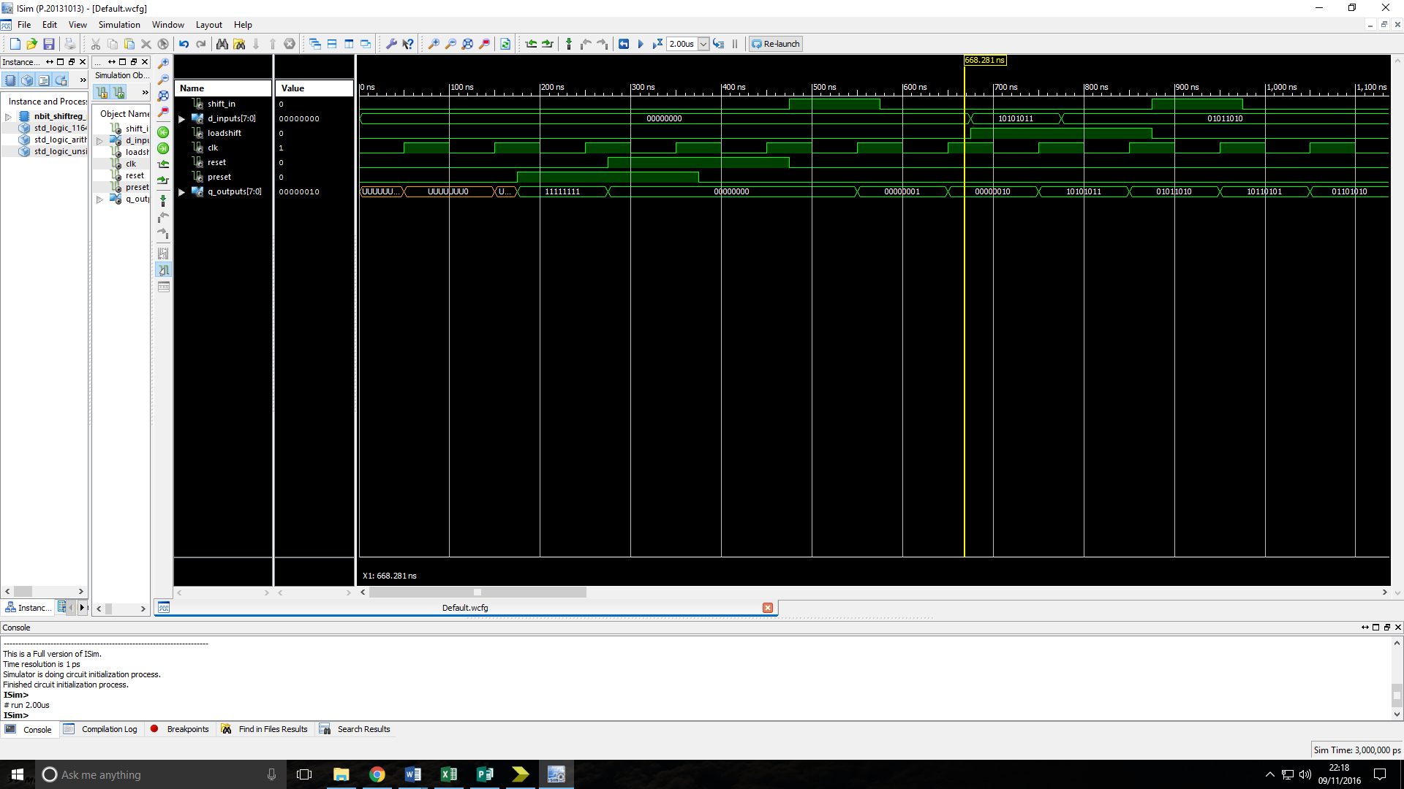Figure 6: Simulation timing diagram of an n-bit shift register with parallel load input showing its behaviour when tested with a range of possible inputs.

Analysis: The output of the device is as expected for both the simulation and test on FPGM board.

# n-bit Universal shift register:

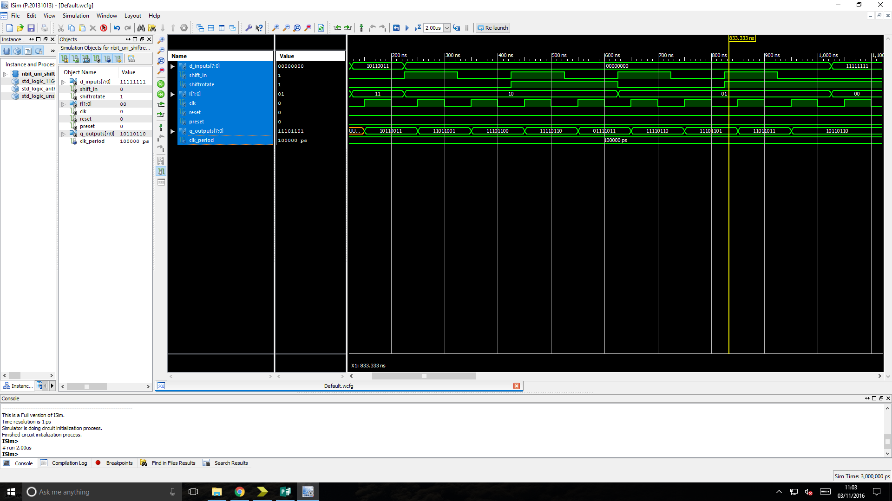Truth table:

|  |  |  |  |  |
| --- | --- | --- | --- | --- |
| F1 | F0 | Shift/~rotate | CLK | Operation |
| x | x | x | 0 | None |
| x | x | x | 1 | None |
| 0 | 0 | x | ↑ | Hold |
| 0 | 1 | 0 | ↑ | Rotate Left |
| 0 | 1 | 1 | ↑ | Shift Left |
| 1 | 0 | 0 | ↑ | Rotate Right |
| 1 | 0 | 1 | ↑ | Shift Right |
| 1 | 1 | x | ↑ | Load |

Figure 7: Simulation timing diagram of an n-bit Universal shift register showing its behaviour when tested with a range of possible inputs.

Analysis: The output of the device is as expected for both the simulation and test on FPGM board.

# n-bit twisted-ring counter:

Truth table:

|  |  |  |  |  |
| --- | --- | --- | --- | --- |
| CLK | reset | preset | Q_outputs(n-1) | Q_outputs(n) |
| ↑ | 0 | 0 | 0000 | 1000 |
| ↑ | 0 | 0 | 1000 | 1100 |
| ↑ | 0 | 0 | 1100 | 1110 |
| ↑ | 0 | 0 | 1110 | 1111 |
| ↑ | 0 | 0 | 1111 | 0111 |
| ↑ | 0 | 0 | 0111 | 0011 |
| ↑ | 0 | 0 | 0011 | 0001 |
| ↑ | 0 | 0 | 0001 | 0000 |
| x | 0 | 1 | XXXX | 0000 |
| x | 1 | 0 | XXXX | 1111 |

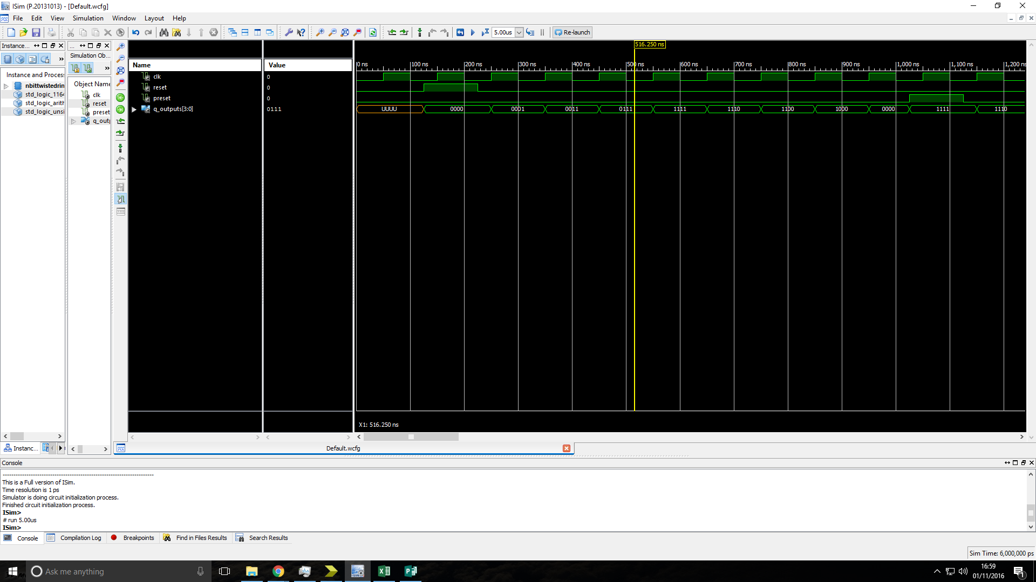Figure 8: Simulation timing diagram of an n-bit Universal shift register showing its behaviour when tested with a range of possible inputs.

Analysis: The output of the device is as expected for both the simulation and test on FPGM board.

# 4-bit linear feedback shift register:

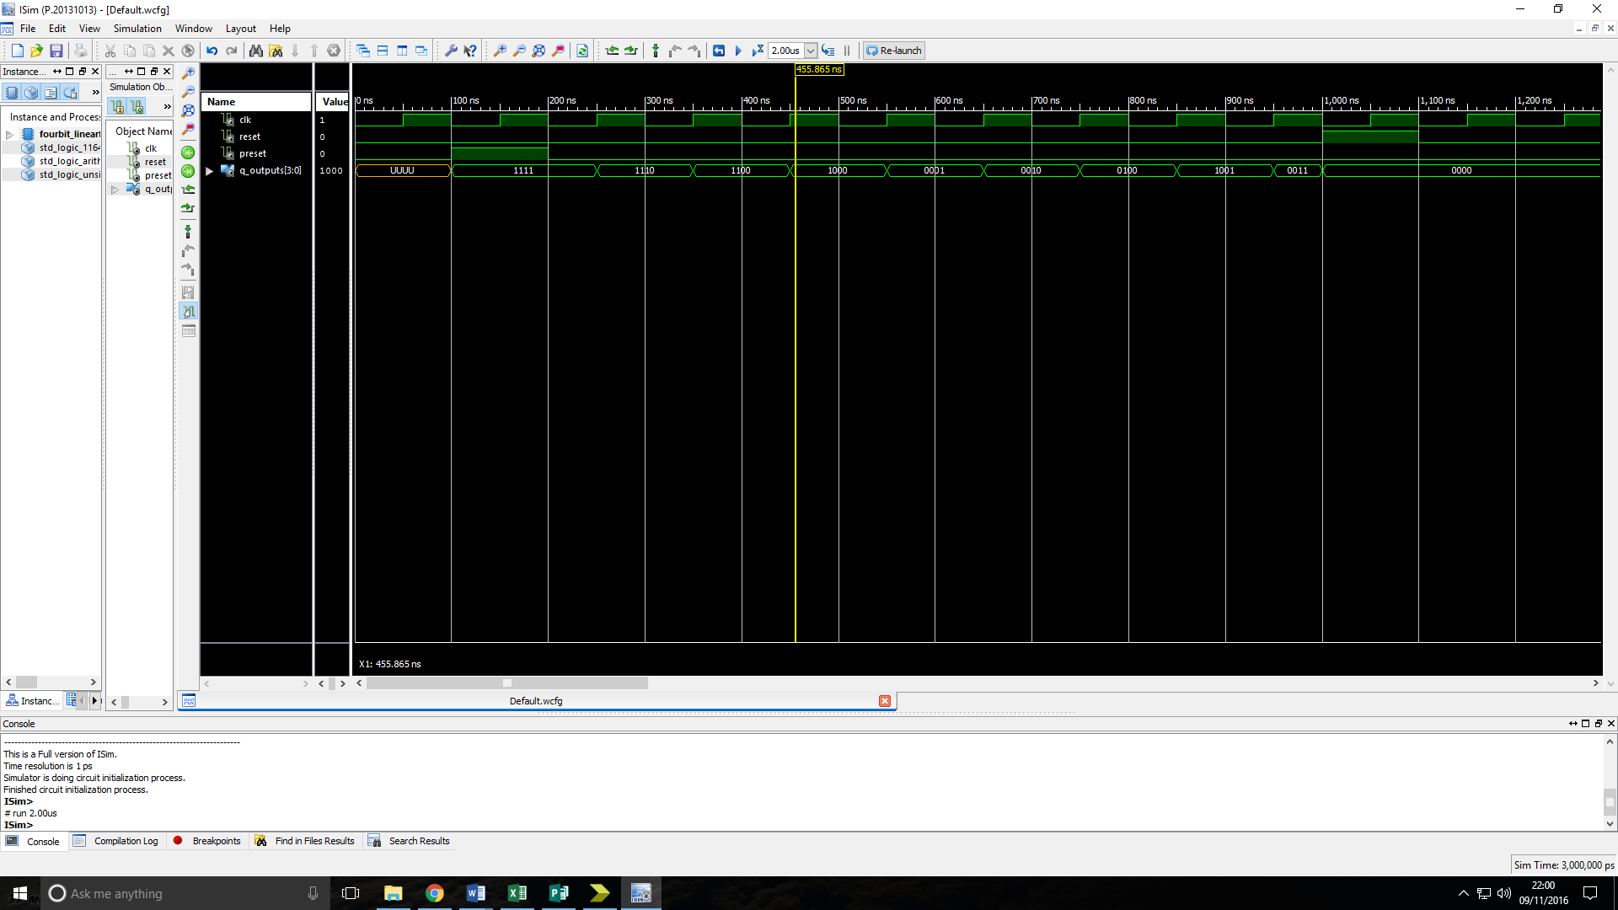Truth table:

|  |  |  |  |  |
| --- | --- | --- | --- | --- |
| CLk | Shift in (XOR of bits 2 & 3 of previous Q) | Reset | Preset | Q_Outputs |
| x | x | 0 | 1 | 1111 |
| x | x | 1 | 1 | 0000 |
| x | x | 1 | 0 | 0000 |
| x | x | 0 | 1 | 1111 |
| ↑ | 0 | 0 | 0 | 1110 |
| ↑ | 0 | 0 | 0 | 1100 |
| ↑ | 0 | 0 | 0 | 1000 |
| ↑ | 1 | 0 | 0 | 0001 |
| ↑ | 0 | 0 | 0 | 0010 |
| ↑ | 1 | 0 | 0 | 0100 |
| ↑ | 1 | 0 | 0 | 1001 |

Figure 9: Simulation timing diagram of a 4-bit linear feedback shift register showing its behaviour when tested with a range of possible inputs.

Analysis: The output of the device is as expected for both the simulation and test on FPGM board.