MOT Splines

Introduction
Here we show the R code that we used to reproduce the Matlab csaps() smoothing spline fit to the Allen Hills “long shapshot” in Shackleton et al. (2026), and to fit an alternative optimized smoothing spline R using the R smooth.spline() function. A smoothing splines is a cubic spline $f\left(x_{i}\right)$ that is fit to some data $y_{i}$ by minimizing a “penalized” residual sum-of-squares
$$RSS\left(f,λ\right)=\{\text{goodness of fit}\}+λ\{\text{roughness}\}$$
The first term represents the goodness-of-fit of the spline curve to the data, while the second “penalty” term describes the rigidity or local variability of the curve – its wigglyness. If λ = 0, the fitted spline simply interpolates between the $y_{i}$’s, while as λ → ∞ the penalty term increases and the optimal fitted curve becomes a least-squares straight line (Hastie and Tibshirani, Generalized Additive Models. Routledge, Boca Raton, 1990 https://doi.org/10.1201/9780203753781, sec. 3.5).
The specific objective function used by the Matlab csaps() function is
$$RSS\left(f,λ\right)=\left\{ p\sum_{i=1}^{n}{w_{i}{\left(y_{i}−f\left(x_{i}\right)\right)}^{2}}+\left(1−p\right)∫{\left[f^{′′}\left(x\right)\right]}^{2} dx\right\}$$
where $f^{′′}\left(x\right)$ is the second derivative of the spline curve, the $w_{i}$’s are possible weights for each data value, $p$ is the user-selected smoothing parameter, and $p=1/\left(1+λ\right)$. When $p=0$, a straight-line fit is obtained (i.e. as $λ→∞$, $p→0$), while if $λ=0$, then $p=1$ and the spline $(f\left(x_{i}\right))$ simply interpolates between points.
The objective function for the R smooth.spline() function is
$$RSS\left(f,λ\right)=\sum_{i=1}^{n}{w_{i}{\left(y_{i}−f\left(x_{i}\right)\right)}^{2}}+λ∫{\left[f^{′′}\left(x\right)\right]}^{2}dx,$$
Again, If $λ=0$, the fitted spline simply interpolates between the $y_{i}$’s, while as $λ→∞$ the penalty term increases and the optimal fitted curve becomes a least-squares straight line. The smoothing parameter is thus a measure of the “wiggliness” of the curve and can be set by a user at some fixed, scientifically based value, or it can be estimated by Generalized Cross Validation (GCV) (Wahba, G. Spline Models for Observational Data. (SIAM, Philadelphia, 1990) https://doi.org/10.1137/1.9781611970128, sec. 4.3) or some other approach. (GCV is a computationally efficient “leave-one-out” approach that is used to find an optimum trade-off between the goodness-of-fit and wigglyness of smoothing spline: an extremely smooth spline won’t fit the data very well, while an extremely wiggly spline can fit the data perfectly at the expense of being extremely non-smooth.) We use this approach below to obtain an “optimal” smoothing spline.
In the case of the R function, there are three ways of specifying or describing the amount of smoothing: via $λ$; via a spar value, a scaleless description of the amount of smoothing which generally varies between 0 and 1; and via the equivalent degrees of freedom, $df$ (Hastie and Tibshirani, 1990, p. 27), a general measure of the amount of fitting done by the spline. Low values of $df$ describe a fitted curve with fewer inflections while higher values describe a more wiggly curve.
Because the internal algorithms in the R and Matlab functions differ, there is no direct conversion between the methods (i.e. selecting the same value of $λ$ for both will not yield equivalent results). The R function can nevertheless be used to approximate the results of applying the Matlab function by iteratively varying the spar parameter, and minimizing the sum-of-squared differences between the R- and Matlab-fitted smoothing splines. We use this approach below to approximate the results of from the Matlab csaps() using the Rsmooth.spline()function.

Read data
Load the neccessary packages. {readxl} and {writexl} read and write Excel files, {Hmisc} adds supplemental tick marks and plots, and {matrixStats} is used to get the bootstrap confidence itervals.
library(readxl, writexl)
library(Hmisc)
library(matrixStats)
Read the Allen Hills “long” snapshot data, and add 0.5 °C to account for the bias in the MOT anomalies.
# Allen_Hills_long data
# columns Q, X, Y and Z from the "Data Summary" tab of
# AllanHills_XeKr_temp-recon_2026-pubData-2.xlsx
data_path <- "~/Projects/globalT/MOT_Splines/data/"
file_name <- "AH_long.xlsx"
xlxs_file <- paste(data_path, file_name, sep = "")
AH_long <- read_excel(xlxs_file)
head(AH_long); tail(AH_long)
## # A tibble: 6 × 9
## Age_ka AgeMa Rel_err_Myr Abs_err_Myr MOT_anomaly MOT_rel_err MOT_abs_err Snapshot seqnum
## <dbl> <dbl> <dbl> <dbl> <dbl> <dbl> <dbl> <chr> <dbl>
## 1 430 0.43 0.0909 0.102 -1.99 0.559 0.750 'long' 128
## 2 499. 0.499 0.104 0.118 -0.870 0.431 0.660 'long' 89
## 3 500 0.5 0.0909 0.106 -2.09 0.574 0.761 'long' 129
## 4 552. 0.552 0.0618 0.0866 -1.89 0.526 0.726 'long' 44
## 5 558. 0.558 0.0618 0.0871 -2.04 0.547 0.741 'long' 56
## 6 579. 0.579 0.0618 0.0888 -1.85 0.519 0.721 'long' 45
## # A tibble: 6 × 9
## Age_ka AgeMa Rel_err_Myr Abs_err_Myr MOT_anomaly MOT_rel_err MOT_abs_err Snapshot seqnum
## <dbl> <dbl> <dbl> <dbl> <dbl> <dbl> <dbl> <chr> <dbl>
## 1 2690 2.69 0.0909 0.310 -0.31 0.313 0.590 'long' 140
## 2 2848. 2.85 0.0532 0.318 0.495 0.268 0.567 'long' 81
## 3 2868. 2.87 0.0593 0.321 0.229 0.247 0.558 'long' 49
## 4 2891. 2.89 0.0593 0.323 1.03 0.319 0.593 'long' 83
## 5 2895. 2.90 0.0593 0.324 1.38 0.367 0.620 'long' 84
## 6 3065. 3.06 0.0618 0.343 0.229 0.275 0.570 'long' 82
# MOT_anomaly + 0.5C
AH_long$MOT_anomaly <- AH_long$MOT_anomaly + 0.5
Read Shackleton et al.’s fitted spline, and add 0.5 °C.
# spline from paper
# columns A-D from the "Splined Records" tab of AllanHills_XeKr_temp-recon_2026-pubData-2.xlsx
file_name <- "AH_long_spline_paper.xlsx"
xlxs_file <- paste(data_path, file_name, sep = "")
AH_long_spline_paper <- read_excel(xlxs_file)
head(AH_long_spline_paper); tail(AH_long_spline_paper)
## # A tibble: 6 × 5
## Age_ka AgeMa MOT_anomaly MOT_lower MOT_upper
## <dbl> <dbl> <dbl> <dbl> <dbl>
## 1 500 0.5 -1.79 -2.20 -1.39
## 2 505 0.505 -1.78 -2.19 -1.39
## 3 510 0.51 -1.78 -2.18 -1.40
## 4 515 0.515 -1.78 -2.17 -1.40
## 5 520 0.52 -1.78 -2.16 -1.41
## 6 525 0.525 -1.77 -2.15 -1.41
## # A tibble: 6 × 5
## Age_ka AgeMa MOT_anomaly MOT_lower MOT_upper
## <dbl> <dbl> <dbl> <dbl> <dbl>
## 1 2975 2.98 0.730 0.316 1.28
## 2 2980 2.98 0.721 0.306 1.29
## 3 2985 2.98 0.717 0.297 1.30
## 4 2990 2.99 0.710 0.286 1.31
## 5 2995 3.00 0.701 0.276 1.32
## 6 3000 3 0.691 0.263 1.34
# MOT + 0.5C
AH_long_spline_paper$MOT_anomaly <- AH_long_spline_paper$MOT_anomaly + 0.5
AH_long_spline_paper$MOT_lower <- AH_long_spline_paper$MOT_lower + 0.5
AH_long_spline_paper$MOT_upper <- AH_long_spline_paper$MOT_upper + 0.5
Plot the data, and the spline from the paper.
# Plot the data and spline from the paper
# data
plot(AH_long$MOT_anomaly ~ AH_long$AgeMa, type = "p", pch = 16, cex = 0.8, col = "blue",
xlim = c(3.5, 0), ylim = c(-3.0, 3.0), xlab = "Age (Ma)", ylab = "MOT anomaly (°C)",
font.main = 1, main = "Allen Hills (long) + 0.5 °C")
minor.tick(nx = 10, tick.ratio = 0.5)
# add spline from paper
lines(AH_long_spline_paper$AgeMa, AH_long_spline_paper$MOT_anomaly, lwd=2, col="blue")
lines(AH_long_spline_paper$AgeMa, AH_long_spline_paper$MOT_lower, lwd=1, col="blue")
lines(AH_long_spline_paper$AgeMa, AH_long_spline_paper$MOT_upper, lwd=1, col="blue")
leg_label <- paste("Spline from Shackleton et al. 2026 (Fig. 1)", sep="")
legend(3.5, -2.75, legend=c(leg_label), col="blue", lwd=2, bty="n")
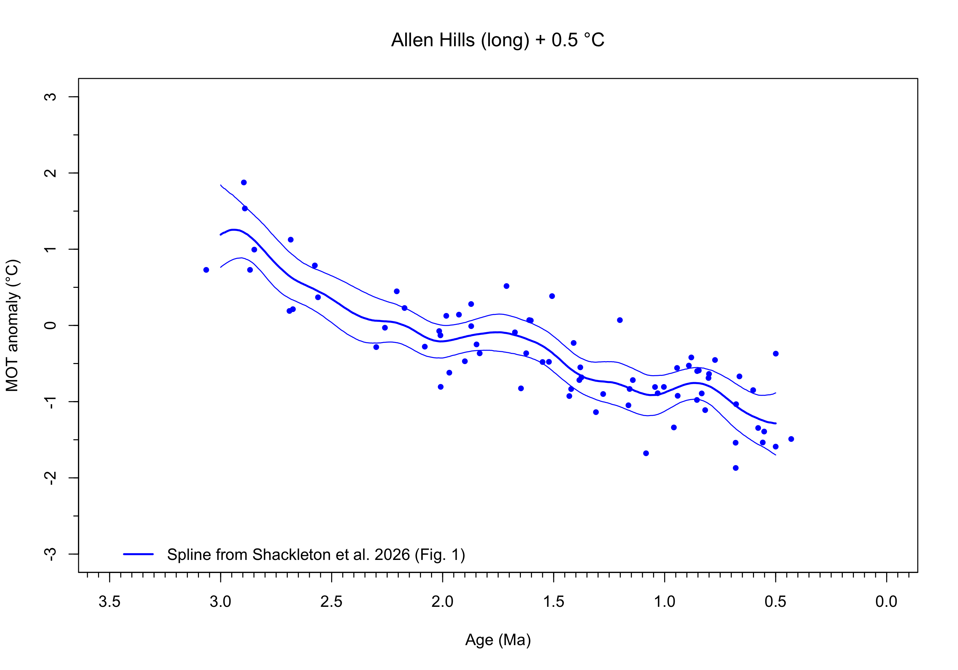
#dev.print(pdf, "AH_long_Shackleton_spline.pdf")

Set-up tasks
Set target points for fitted splines:
# target pts for fitted spline
nsamp <- length(unique(AH_long$AgeMa))
age_max <- max(AH_long$AgeMa)
age_min <- min(AH_long$AgeMa)
x_targ <- seq(age_min, age_max, by = 0.005)
head(x_targ); tail(x_targ)
## [1] 0.430 0.435 0.440 0.445 0.450 0.455
## [1] 3.035 3.040 3.045 3.050 3.055 3.060
nfits <- length(x_targ)
nfits
## [1] 527
Set weights. weights weigh each observation by its uncertainty. ones weigh each observation equally
# weights
weights <- 1/(AH_long$MOT_abs_err^2)
ones = rep(1, length(AH_long$AgeMa))
Set parameters for bootstrap estimates of uncertainty
# bootstrap estimates of fitted values
set.seed(1234)
nreps <- 10000
Three curves will be fit here: 1) the approximation of the Shackleton et al. spline, 2) a GCV-optimized spline, and 3) and OLS linear fit. Define arrays and vectors to hold results:
ncurves <- 3
# arrays and vectors
fits <- matrix(0, nrow = nsamp, ncol = ncurves)
residuals <- matrix(0, nrow = nsamp, ncol = ncurves)
fits_bootstrap <- matrix(0, nrow=nfits, ncol = nreps)
df <- as.numeric(rep(0, ncurves))
lambda <- as.numeric(rep(0, ncurves))
rss <- as.numeric(rep(0, ncurves))
tss <- as.numeric(rep(0, ncurves))
sigma2 <- as.numeric(rep(0, ncurves))
AIC <- as.numeric(rep(0, ncurves))
rsq <- as.numeric(rep(0, ncurves))
adj_rsq <- as.numeric(rep(0, ncurves))
F <- as.numeric(rep(0, ncurves))
model_colors <- c("black", "purple", "red")

Reproduction of the Matlab smoothing spline with the R smoothing spline
The R smooth.spline() equivalent of the Matlab csaps() spline in Shackleton et al. can be estimated by repeated fitting splines with different values of the span parameter, ranging from 0.0 to 2.0 by 0.1:
# brute-force optinmization of spar value
npts <- 201
spar_opt <- as.numeric(seq(0.0, 2.0, by = 0.01))
df_opt <- as.numeric(rep(0, npts))
lambda_opt <- as.numeric(rep(0, npts))
rss_opt <- as.numeric(rep(0, npts))
tss_opt <- as.numeric(rep(0, npts))
rsq_opt <- as.numeric(rep(0, npts))
for (k in 1:npts) {
curve_01 <- smooth.spline(AH_long$AgeMa, AH_long$MOT_anomaly, w = ones,
spar = spar_opt[k])
df_opt[k] <- curve_01$df; lambda_opt[k] <- curve_01$lambda
y_pred <- predict(curve_01, AH_long_spline_paper$AgeMa, deriv = 0)$y
resid <- y_pred - (AH_long_spline_paper$MOT_anomaly)
rss_opt[k] <- sum(resid^2 )
tss_opt[k] <- sum((AH_long_spline_paper$MOT_anomaly -
mean(AH_long_spline_paper$MOT_anomaly))^2)
rsq_opt[k] <- 1.0 - (rss_opt[k]/tss_opt[k])
}
Which value of spar produces the best fit?
match_paper <- data.frame(spar_opt, df_opt, lambda_opt, rss_opt, tss_opt, rsq_opt)
k_opt <- which.max(rsq_opt)
print(k_opt)
## [1] 70
print(match_paper[k_opt, ])
## spar_opt df_opt lambda_opt rss_opt tss_opt rsq_opt
## 70 0.69 12.4969 5.544198e-05 0.2163786 219.8993 0.999016
A spar value of 0.69 produces the best fit to published spline.
Refit the approximated spline and calculate the bootstrap confidence limits (while suppressing the individual fitted splines).
# Shackleton et al. spline
spar <- 0.69
curve_01 <- smooth.spline(AH_long$AgeMa, AH_long$MOT_anomaly, w = ones,
spar = spar, keep.stuff = TRUE) # Shackleton et al. specs. for lambda
y_pred_curve_01 <- predict(curve_01, x_targ, deriv = 0)$y
y_d1_curve_01 <- predict(curve_01, x_targ, deriv = 1)$y
y_d2_curve_01 <- predict(curve_01, x_targ, deriv = 2)$y
df[1] <- curve_01$df; lambda[1] <- curve_01$lambda; fits[, 1] <- curve_01$y
residuals[, 1] <- AH_long$MOT_anomaly - curve_01$y
sigma2[1] <- sum(residuals[, 1]^2)/(nsamp - 1.0)
rss[1] <- sum(residuals[, 1]^2 )
tss[1] <- sum((AH_long$MOT_anomaly - mean(AH_long$MOT_anomaly))^2)
# http://users.stat.umn.edu/~helwig/notes/smooth-spline-notes.html#aic-and-bic
max_log_lik <- (-1.0 / (2.0 * sigma2[1])) * rss[1] -
1.0 * (nsamp / 2.0) * log(sigma2[1]) - 1.0 * (nsamp / 2.0) * log(2 * pi)
AIC[1] <- - 2.0 * max_log_lik + 2.0 * df[1]
AIC[1] <- round(AIC[1], 2)
print(AIC[1])
## [1] 84.92
# R-sq values
rsq[1] <- 1 - (rss[1]/tss[1])
adj_rsq[1] <- 1 - (rss[1] / (nsamp - df[1])) / (tss[1] / (nsamp - 1))
rsq[1] <- round(rsq[1], digits = 3)
adj_rsq[1] <- round(adj_rsq[1], digits = 3)
rsq[1]; adj_rsq[1]
## [1] 0.759
## [1] 0.715
# bootsrap CL's -- calculate but do not plot
fits_bootstrap <- matrix(0, nrow=nfits, ncol = nreps)
k <- 0; j <- 1
for (i in 1:nreps) {
# print(i)
x_boot <- AH_long$AgeMa + rnorm(nsamp, mean = 0, sd = AH_long$Rel_err_Myr)
x_boot <- x_boot[order(x_boot)]
y_boot <- AH_long$MOT_anomaly + rnorm(nsamp, mean = 0, sd = AH_long$MOT_abs_err)
y_boot <- y_boot[order(x_boot)]
# points(x_boot, y_boot, pch = 16, cex = 0.5, col = "red")
fit_boot <- smooth.spline(x_boot, y_boot, w = ones, spar = spar ) # df = df[1])
if (length(x_boot) == length(fit_boot$y)) {
y_pred <- predict(fit_boot, x_targ, deriv = 0)$y
# if (i < 500) {
# lines(x_targ, y_pred, col=adjustcolor(model_colors[j], alpha = 0.05))
# # points(AH_long$AgeMa, y_pred, pch = 16, cex = 0.5, col = "red")
# }
k <- k + 1
fits_bootstrap[1:nfits, k] <- y_pred[1:nfits]
}
}
# get the various quantiles of the fitted splines
boot_cl_01 <- rowQuantiles(fits_bootstrap, probs = c(0.025, 0.16, 0.50, 0.84, 0.975))
head(boot_cl_01)
## 2.5% 16% 50% 84% 97.5%
## [1,] -2.118189 -1.644276 -1.225705 -0.8016999 -0.3295480
## [2,] -2.091171 -1.632063 -1.226045 -0.8133095 -0.3487568
## [3,] -2.064248 -1.623237 -1.226660 -0.8246394 -0.3747414
## [4,] -2.036599 -1.613022 -1.227134 -0.8337606 -0.3990829
## [5,] -2.015464 -1.602782 -1.225915 -0.8426400 -0.4202588
## [6,] -1.992610 -1.593298 -1.227111 -0.8539710 -0.4441156
plot(AH_long$MOT_anomaly ~ AH_long$AgeMa, type = "p", pch = 16, cex = 0.8, col = "blue",
xlim = c(3.5, 0), ylim = c(-3.0, 3.0), xlab = "Age (Ma)", ylab = "MOT anomaly (°C)",
font.main = 1, main = "Allen Hills (long) + 0.5 °C")
minor.tick(nx = 10, tick.ratio = 0.5)
# add spline from paper
lines(AH_long_spline_paper$AgeMa, AH_long_spline_paper$MOT_anomaly, lwd=2, col="blue")
lines(AH_long_spline_paper$AgeMa, AH_long_spline_paper$MOT_lower, lwd=1, col="blue")
lines(AH_long_spline_paper$AgeMa, AH_long_spline_paper$MOT_upper, lwd=1, col="blue")
leg_label <- paste("Spline from Shackleton et al. 2026 (Fig. 1)", sep="")
legend(3.5, -2.75, legend=c(leg_label), col="blue", lwd=2, bty="n")
# add now add the bootstrap CL's to plot
lines(x_targ, boot_cl_01[, 2], col = model_colors[1])
lines(x_targ, boot_cl_01[, 4], col = model_colors[1])
lines(x_targ, boot_cl_01[, 1], lty = "dotted", lwd = 2, col = model_colors[1])
lines(x_targ, boot_cl_01[, 5], lty = "dotted", lwd = 2, col = model_colors[1])
lines(x_targ, boot_cl_01[, 3], lty = "dotted", lwd = 2, col = model_colors[1])
lines(x_targ, y_pred_curve_01, lwd=2, col=model_colors[1])
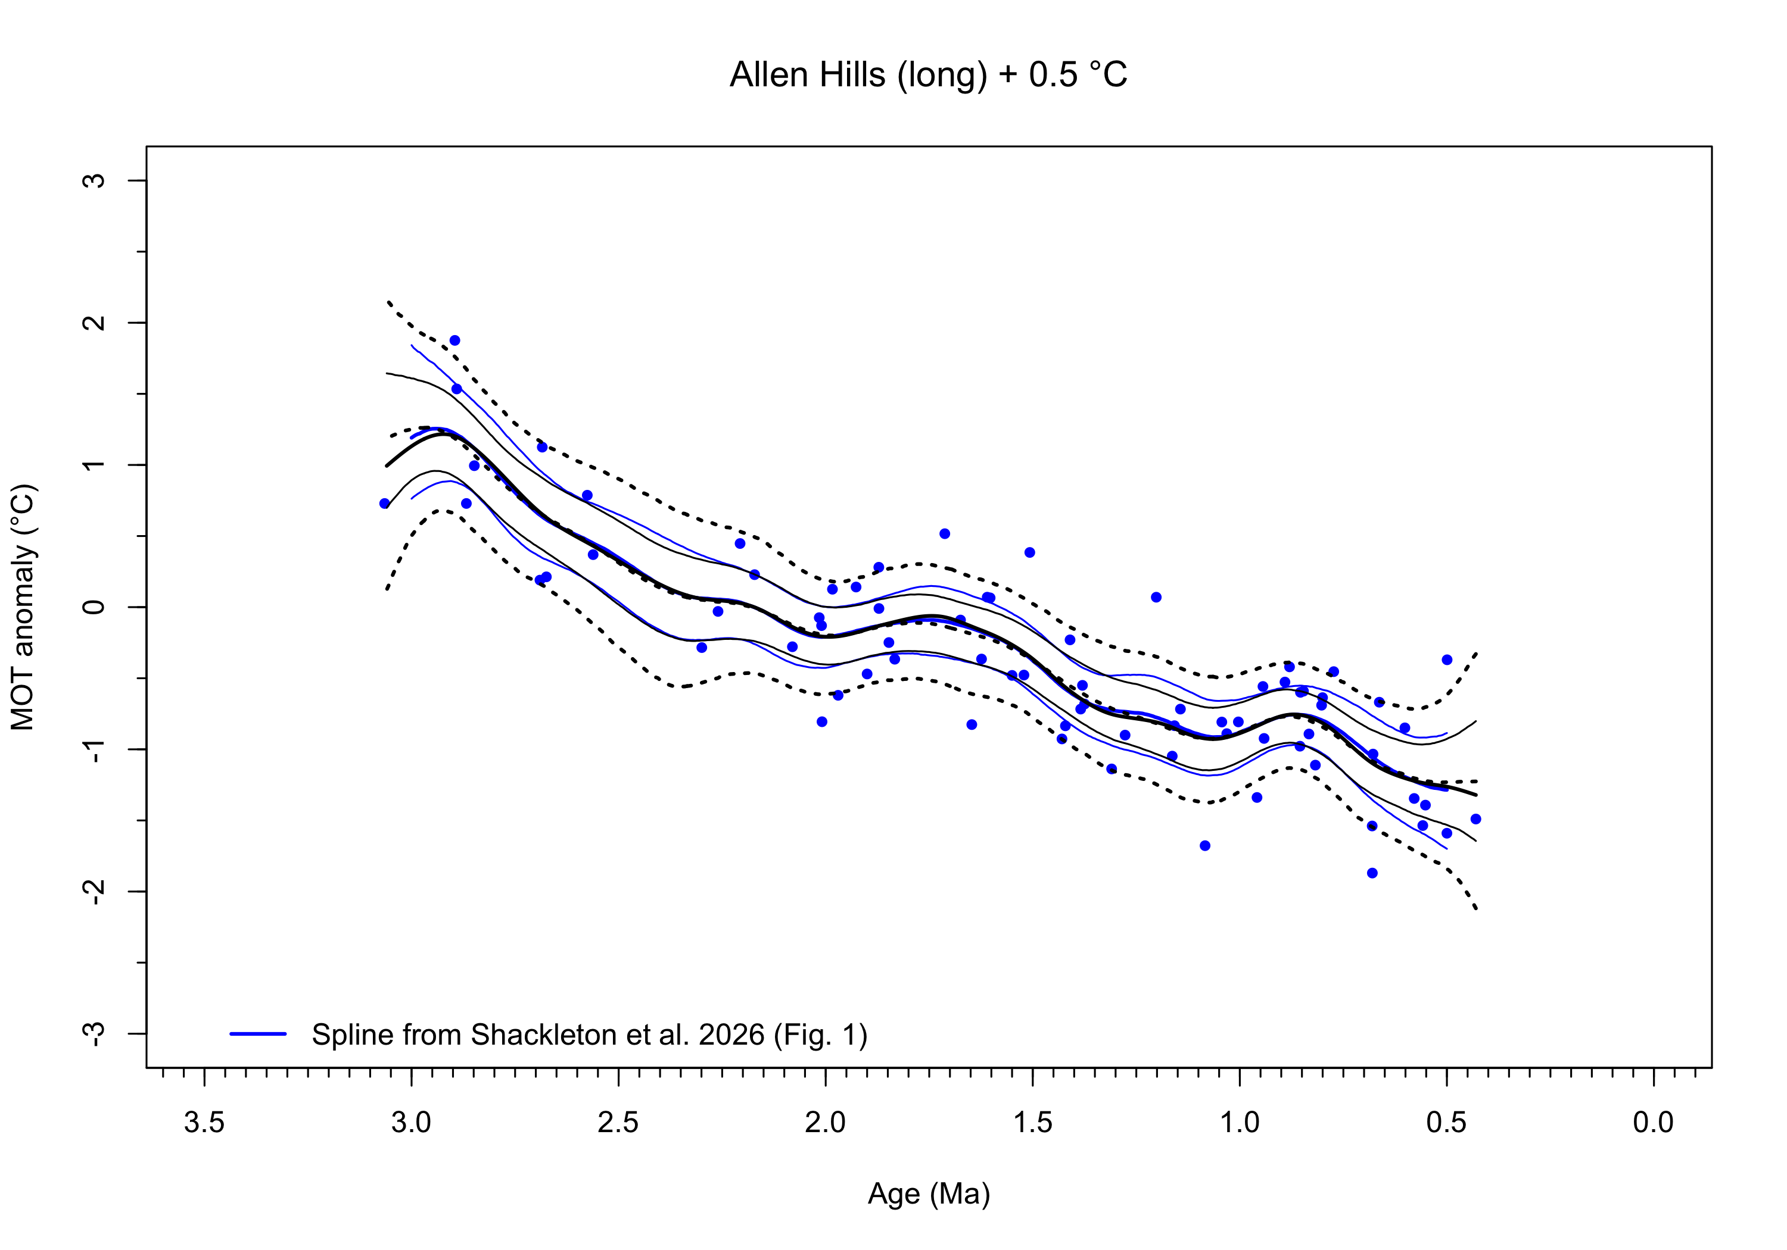
#dev.print(pdf, "AH_long_Shackleton_spline.pdf")
The blue solid line in the figure (mostly hidden, except at the ends) is the fitted spline from Shackleton et al. while the the thick black solid line is the approximated spline form spline.smooth(). The thin black lines are the median and 16th and 84th percentiles (plus or minus one standard error) of the 10,000 bootstrap replications, while the black dashed lines are the 2.5th and 97.5th percentiles (plus or minus two standard errors). The standard errors from the Shackleton et al.’s spline do not match the ones here because the bootstramp samples are not identical.
Now replot the approximated Shackleton et al. spline including the fitted splines for the first 500 bootstrap replications (a sufficient number for examiing the nature of the replications).
# replot with first 500 replicates shown
plot(AH_long$MOT_anomaly ~ AH_long$AgeMa, type = "p", pch = 16, cex = 0.8, col = "blue",
xlim = c(3.5, 0), ylim = c(-3.0, 3.0), xlab = "Age (Ma)", ylab = "MOT anomaly (°C)",
font.main = 1, main = "Allen Hills (long) + 0.5 °C")
minor.tick(nx = 10, tick.ratio = 0.5)
# bootstrap estimates of fitted values
set.seed(1234)
# bootsrap CL's
fits_bootstrap <- matrix(0, nrow=nfits, ncol = nreps)
k <- 0; j <- 1
for (i in 1:nreps) {
# print(i)
x_boot <- AH_long$AgeMa + rnorm(nsamp, mean = 0, sd = AH_long$Rel_err_Myr)
x_boot <- x_boot[order(x_boot)]
y_boot <- AH_long$MOT_anomaly + rnorm(nsamp, mean = 0, sd = AH_long$MOT_abs_err)
y_boot <- y_boot[order(x_boot)]
# points(x_boot, y_boot, pch = 16, cex = 0.5, col = "red")
fit_boot <- smooth.spline(x_boot, y_boot, w = ones, spar = spar ) # df = df[1])
if (length(x_boot) == length(fit_boot$y)) {
y_pred <- predict(fit_boot, x_targ, deriv = 0)$y
if (i < 500) {
lines(x_targ, y_pred, col=adjustcolor(model_colors[j], alpha = 0.1))
# points(AH_long$AgeMa, y_pred, pch = 16, cex = 0.5, col = "red")
}
k <- k + 1
fits_bootstrap[1:nfits, k] <- y_pred[1:nfits]
}
}
lines(x_targ, boot_cl_01[, 2], col = model_colors[1])
lines(x_targ, boot_cl_01[, 4], col = model_colors[1])
lines(x_targ, boot_cl_01[, 1], lty = "dotted", lwd = 2, col = model_colors[1])
lines(x_targ, boot_cl_01[, 5], lty = "dotted", lwd = 2, col = model_colors[1])
lines(x_targ, boot_cl_01[, 3], lty = "dashed", col = model_colors[1])
lines(x_targ, y_pred_curve_01, lwd=2, col=model_colors[1])
lines(AH_long_spline_paper$AgeMa, AH_long_spline_paper$MOT_anomaly, lwd=2, col="blue")
lines(AH_long_spline_paper$AgeMa, AH_long_spline_paper$MOT_lower, lwd=1, col="blue")
lines(AH_long_spline_paper$AgeMa, AH_long_spline_paper$MOT_upper, lwd=1, col="blue")
leg_label <- paste("Smoothing Spline, spar = ", as.character(round(spar, 3)),
", lambda = ", as.character(round(lambda[1],7)),
", df = ", as.character(round(df[1], 2)),
", AIC = ", as.character(round(AIC[1], 2)), sep="")
legend(3.5, -2.75, legend=c(leg_label), col=c(model_colors[1]), lwd=2, bty="n")
points(AH_long$MOT_anomaly ~ AH_long$AgeMa, pch = 16, cex = 0.8, col = "blue")
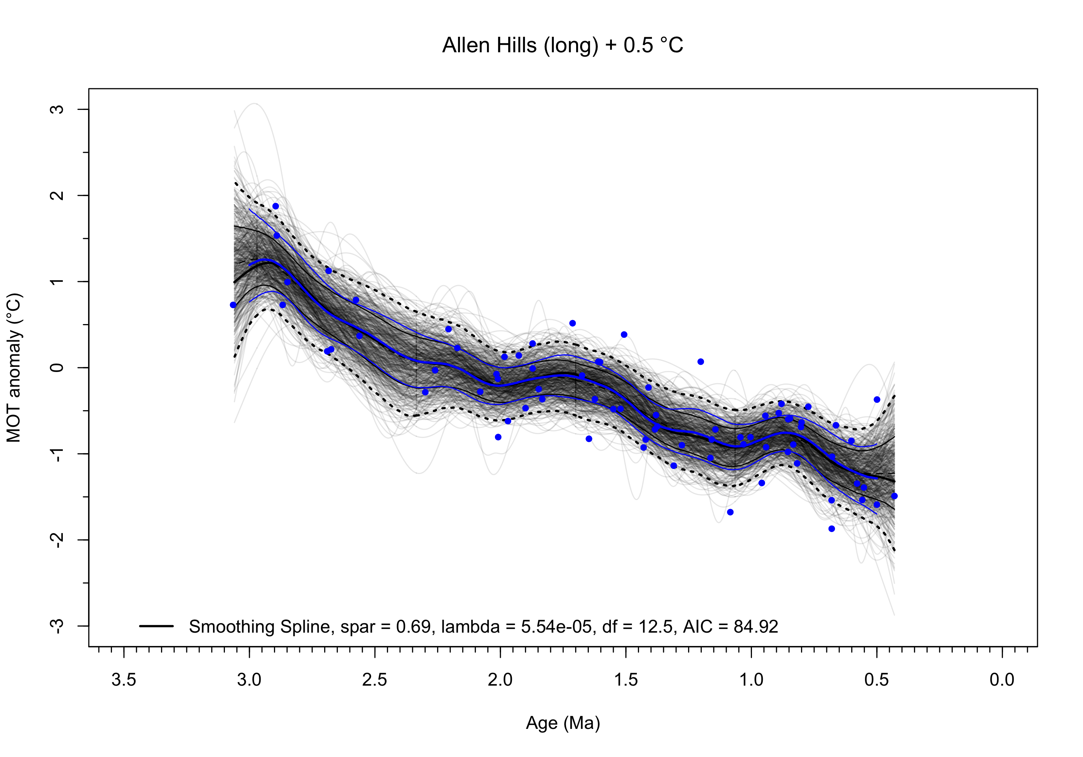
#dev.print(pdf, "AH_long_spline_comparison.pdf")
The fitted spline is quite wiggly, reflected by the effective-degrees-of-freedom value ($df$) of 12.5. The first 500 bootstrap replications are shown by the light lines on the figure. The individual plots show considerable variability and can be used to judge the robustness of the fit, which is not high. In a robust fit, the individual plots would be quite similar to one another, as will be seen in the subsequent optimally fit spline. Instead, few of the 500 replications show little similarity.

Optimally fit smoothing spline
An alternative approach to smoothing-spline fitting is to allow the data to choose the optimal value of the smoothing parameter $λ$ using generalized cross validation (GCV) (Wahba, 1990). GCV trades off the goodness-of-fit term against the smoothness of the curve:
# optimal smoothing spline
curve_02 <- smooth.spline(AH_long$AgeMa, AH_long$MOT_anomaly, w = ones) # estimate lambda, spar, df
df[2] <- curve_02$df; lambda[2] <- curve_02$lambda; fits[, 2] <- curve_02$y
y_pred_curve_02 <- predict(curve_02, x_targ, deriv = 0)$y
y_d1_curve_02 <- predict(curve_02, x_targ, deriv = 1)$y
y_d2_curve_02 <- predict(curve_02, x_targ, deriv = 2)$y
residuals[, 2] <- AH_long$MOT_anomaly - curve_02$y
sigma2[2] <- sum(residuals[, 2]^2)/(nsamp - 1.0)
rss[2] <- sum(residuals[, 2]^2 )
tss[2] <- sum((AH_long$MOT_anomaly - mean(AH_long$MOT_anomaly))^2)
# http://users.stat.umn.edu/~helwig/notes/smooth-spline-notes.html#aic-and-bic
max_log_lik <- (-1.0 / (2.0 * sigma2[1])) * rss[1] -
1.0 * (nsamp / 2.0) * log(sigma2[1]) - 1.0 * (nsamp / 2.0) * log(2 * pi)
AIC[2] <- - 2.0 * max_log_lik + 2.0 * df[2]
AIC[2] <- round(AIC[2], 2)
print(AIC[2])
## [1] 65.56
# R-sq values
rsq[2] <- 1 - (rss[2]/tss[2])
adj_rsq[2] <- 1 - (rss[1] / (nsamp - df[2])) / (tss[2] / (nsamp - 1))
rsq[2] <- round(rsq[2], digits = 3)
adj_rsq[2] <- round(adj_rsq[2], digits = 3)
rsq[2]; adj_rsq[2]
## [1] 0.698
## [1] 0.753
Plot the optimal spline, along with the bootstrap-estimated confidence limits and first 500 bootstrap replications.
plot(AH_long$MOT_anomaly ~ AH_long$AgeMa, type = "p", pch = 16, cex = 0.8, col = "blue",
xlim = c(3.5, 0), ylim = c(-3.0, 3.0), xlab = "Age (Ma)", ylab = "MOT anomaly (°C)",
font.main = 1, main = "Allen Hills (long) + 0.5 °C")
minor.tick(nx = 10, tick.ratio = 0.5)
# bootsrap CL's
fits_bootstrap <- matrix(0, nrow=nfits, ncol = nreps)
k <- 0; j <- 2
for (i in 1:nreps) {
# print(i)
x_boot <- AH_long$AgeMa + rnorm(nsamp, mean = 0, sd = AH_long$Rel_err_Myr)
x_boot <- x_boot[order(x_boot)]
y_boot <- AH_long$MOT_anomaly + rnorm(nsamp, mean = 0, sd = AH_long$MOT_abs_err)
y_boot <- y_boot[order(x_boot)]
# points(x_boot, y_boot, pch = 16, cex = 0.5, col = "red")
fit_boot <- smooth.spline(x_boot, y_boot, w = ones, df = df[2])
if (length(x_boot) == length(fit_boot$y)) {
y_pred <- predict(fit_boot, x_targ, deriv = 0)$y
if (i < 500) {
lines(x_targ, y_pred, col=adjustcolor(model_colors[2], alpha = 0.02))
# points(AH_long$AgeMa, y_pred, pch = 16, cex = 0.5, col = "red")
}
k <- k + 1
fits_bootstrap[1:nfits, k] <- y_pred[1:nfits]
}
}
boot_cl_02 <- rowQuantiles(fits_bootstrap, probs = c(0.025, 0.16, 0.50, 0.84, 0.975))
head(boot_cl_01)
## 2.5% 16% 50% 84% 97.5%
## [1,] -2.118189 -1.644276 -1.225705 -0.8016999 -0.3295480
## [2,] -2.091171 -1.632063 -1.226045 -0.8133095 -0.3487568
## [3,] -2.064248 -1.623237 -1.226660 -0.8246394 -0.3747414
## [4,] -2.036599 -1.613022 -1.227134 -0.8337606 -0.3990829
## [5,] -2.015464 -1.602782 -1.225915 -0.8426400 -0.4202588
## [6,] -1.992610 -1.593298 -1.227111 -0.8539710 -0.4441156
lines(x_targ, boot_cl_02[, 2], col = model_colors[2])
lines(x_targ, boot_cl_02[, 4], col = model_colors[2])
lines(x_targ, boot_cl_02[, 1], lty = "dotted", lwd = 2, col = model_colors[2])
lines(x_targ, boot_cl_02[, 5], lty = "dotted", lwd = 2, col = model_colors[2])
lines(x_targ, boot_cl_02[, 3], lty = "dashed", col = model_colors[2])
# optimal lambda
lines(x_targ, y_pred_curve_02, lwd=2, col=model_colors[2])
leg_label <- paste("Smoothing Spline, estimated lambda = ", as.character(round(lambda[2],7)),
", df = ", as.character(round(df[2], 2)), ", AIC = ", as.character(round(AIC[2], 2)),sep="")
legend(3.5, -2.75, legend=c(leg_label), col=c(model_colors[2]), lwd=2, bty="n")
points(AH_long$MOT_anomaly ~ AH_long$AgeMa, pch = 16, cex = 0.8, col = "blue")
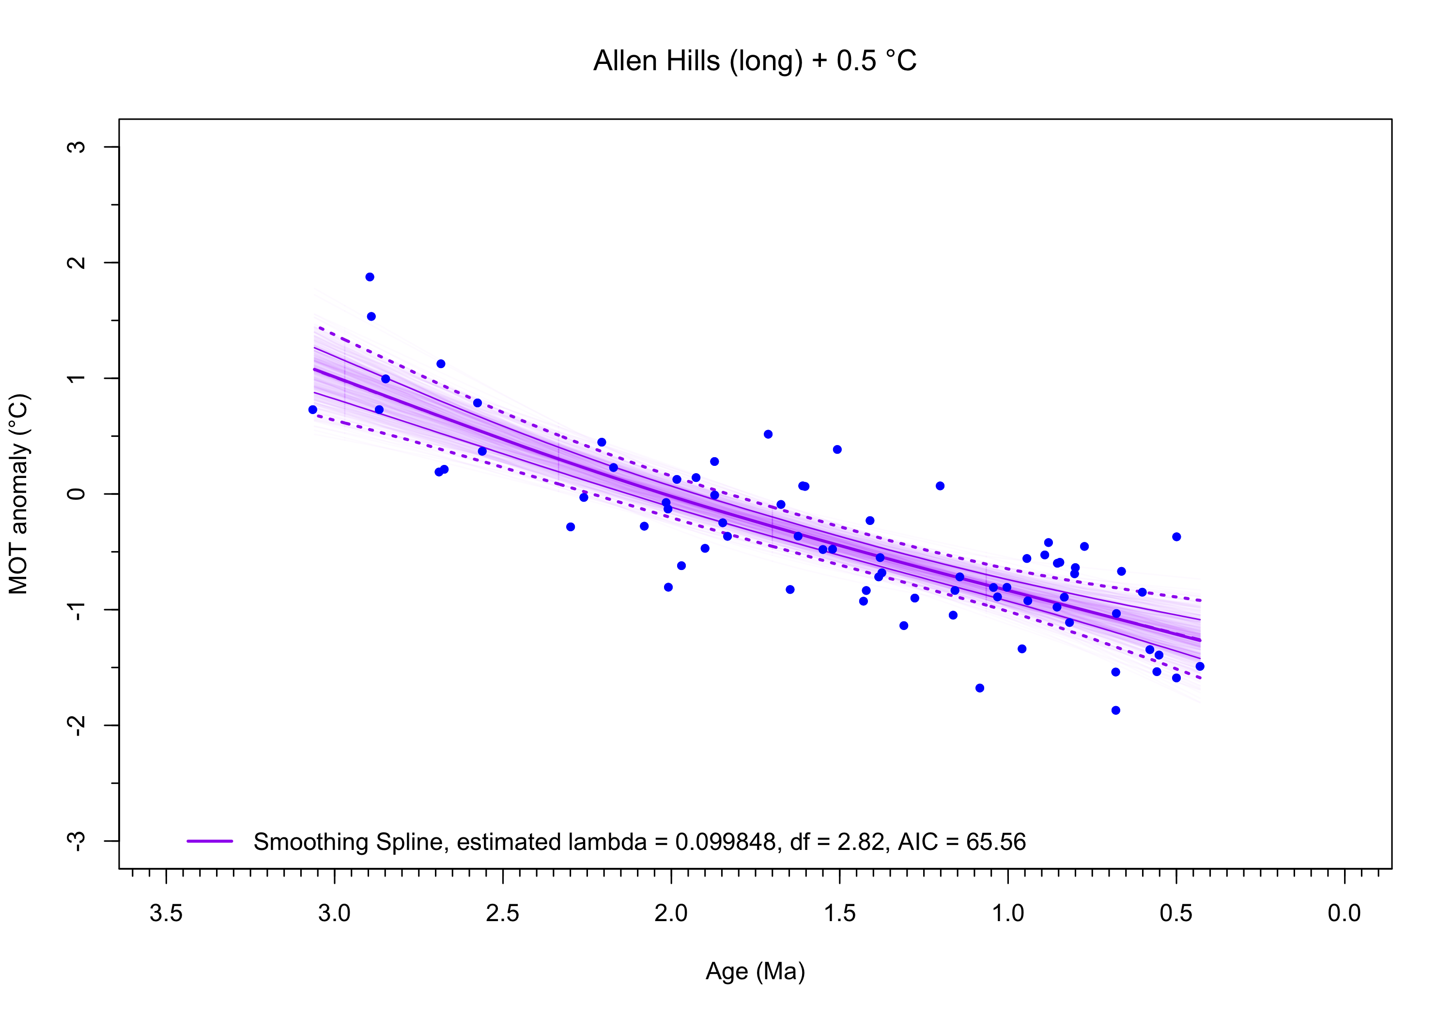
#dev.print(pdf, "AH_long_estimated_spline.pdf")
The GCV optimal smoothing spline fit to the Allen Hills “long” data is much smoother than the one in the Shackleton et al. (2026) paper. The EDF ($df$) value is low, close to 3, and the AIC value is smaller while the adjusted $R^{2}$ is higher, indicating that the optimal smoothing spline fits the data better (Burnham, K.P., & Anderson, D. R. (2004) Sociological Methods & Research, 33(2), 261–304. https://doi.org/10.1177/0049124104268644).
Note that the optimal smoothing spline is slightly concave upwards as are most of the first 500 bootstrap replications. There is very little difference in the shape of the replications, testifying to the robustness of the fit.

OLS linear fit
The smoothing parameter $λ$ is close enough to 2.0 (which would yeild a linear fit) that an ordinary least squares linear fit would be worth considering:
# OLS
curve_03 <- lm(AH_long$MOT_anomaly ~ AH_long$AgeMa) # OLS
summary(curve_03)
##
## Call:
## lm(formula = AH_long$MOT_anomaly ~ AH_long$AgeMa)
##
## Residuals:
## Min 1Q Median 3Q Max
## -0.91371 -0.29284 -0.04848 0.32180 1.07441
##
## Coefficients:
## Estimate Std. Error t value Pr(>|t|)
## (Intercept) -1.70023 0.11262 -15.10 <2e-16 ***
## AH_long$AgeMa 0.86403 0.06824 12.66 <2e-16 ***
## ---
## Signif. codes: 0 '***' 0.001 '**' 0.01 '*' 0.05 '.' 0.1 ' ' 1
##
## Residual standard error: 0.4169 on 73 degrees of freedom
## Multiple R-squared: 0.6871, Adjusted R-squared: 0.6828
## F-statistic: 160.3 on 1 and 73 DF, p-value: < 2.2e-16
y_pred_curve_03 <- curve_03$coefficients[1] + curve_03$coefficients[2] * x_targ
fits[, 3] <- curve_03$fitted.values
residuals[, 3] <- AH_long$MOT_anomaly - curve_03$fitted.values
rss[3] <- sum(residuals[, 3]^2 )
tss[3] <- sum((AH_long$MOT_anomaly - mean(AH_long$MOT_anomaly))^2)
AIC[3] <- round(AIC(curve_03), 2)
print(AIC[3])
## [1] 85.59
# R-sq values
rsq[3] <- 1 - (rss[3]/tss[3])
adj_rsq[3] <- 1 - (rss[3] / (nsamp - df[3])) / (tss[3] / (nsamp - 1))
rsq[3] <- round(rsq[3], digits = 3)
adj_rsq[3] <- round(adj_rsq[3], digits = 3)
rsq[3]; adj_rsq[3]
## [1] 0.687
## [1] 0.691
Plot the OLS line, along with the bootstrap-estimated confidence limits and first 500 bootstrap replications.
plot(AH_long$MOT_anomaly ~ AH_long$AgeMa, type = "p", pch = 16, cex = 0.8, col = "blue",
xlim = c(3.5, 0), ylim = c(-3.0, 3.0), xlab = "Age (Ma)", ylab = "MOT anomaly (°C)",
font.main = 1, main = "Allen Hills (long) + 0.5 °C")
minor.tick(nx = 10, tick.ratio = 0.5)
# bootsrap CL's
fits_bootstrap <- matrix(0, nrow=nfits, ncol = nreps)
k <- 0; j <- 3
for (i in 1:nreps) {
# print(i)
x_boot <- AH_long$AgeMa + rnorm(nsamp, mean = 0, sd = AH_long$Rel_err_Myr)
x_boot <- x_boot[order(x_boot)]
y_boot <- AH_long$MOT_anomaly + rnorm(nsamp, mean = 0, sd = AH_long$MOT_abs_err)
y_boot <- y_boot[order(x_boot)]
# points(x_boot, y_boot, pch = 16, cex = 0.5, col = "red")
fit_boot <- lm(y_boot ~ x_boot) # OLS
if (length(x_boot) == length(fit_boot$fitted.values)) {
y_pred <- fit_boot$coefficients[1] + fit_boot$coefficients[2] * x_targ
if (i < 500) {
lines(x_targ, y_pred, col=adjustcolor(model_colors[3], alpha = 0.02))
# points(x_targ, y_pred, pch = 16, cex = 0.5, col = "red")
}
k <- k + 1
fits_bootstrap[1:nfits, k] <- y_pred[1:nfits]
}
}
boot_cl_03 <- rowQuantiles(fits_bootstrap, probs = c(0.025, 0.16, 0.50, 0.84, 0.975))
head(boot_cl_03)
## 2.5% 16% 50% 84% 97.5%
## [1,] -1.594273 -1.459302 -1.324406 -1.184032 -1.044503
## [2,] -1.588877 -1.454758 -1.320192 -1.180102 -1.040831
## [3,] -1.583594 -1.450030 -1.315801 -1.176168 -1.037657
## [4,] -1.578460 -1.445256 -1.311541 -1.172433 -1.034193
## [5,] -1.573245 -1.440558 -1.307301 -1.168740 -1.030290
## [6,] -1.568285 -1.436139 -1.302963 -1.164837 -1.027053
lines(x_targ, boot_cl_03[, 2], col = model_colors[3])
lines(x_targ, boot_cl_03[, 4], col = model_colors[3])
lines(x_targ, boot_cl_03[, 1], lty = "dotted", lwd = 2, col = model_colors[3])
lines(x_targ, boot_cl_03[, 5], lty = "dotted", lwd = 2, col = model_colors[3])
lines(x_targ, boot_cl_03[, 3], lty = "dashed", col = model_colors[3])
lines(x_targ, y_pred_curve_03, lwd=2, col=model_colors[3])
leg_label <- paste("OLS Linear Model", ", AIC = ", as.character(round(AIC[3], 2)), sep="")
legend(3.5, -2.75, legend=c(leg_label), col=model_colors[3], lwd=2, bty="n")
points(AH_long$MOT_anomaly ~ AH_long$AgeMa, pch = 16, cex = 0.8, col = "blue")
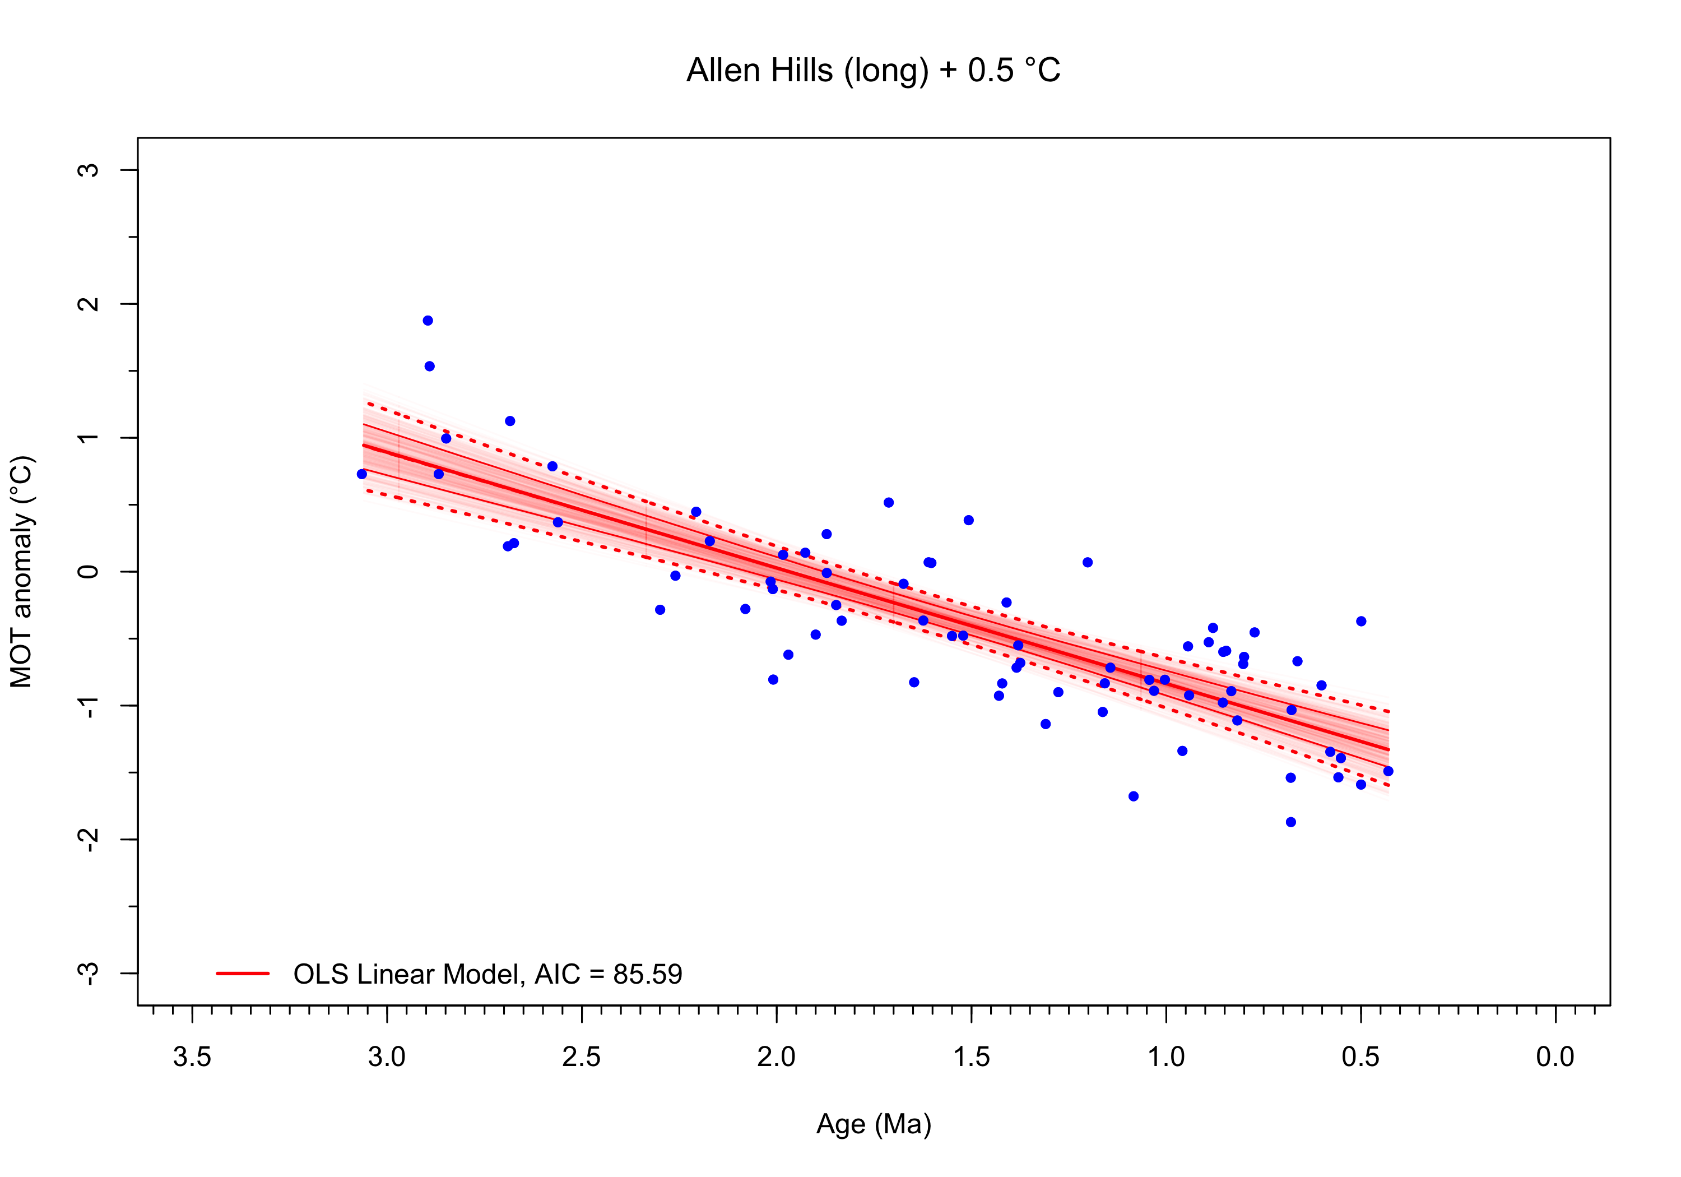
The AIC for the OLS fit is slightly higher than for the optimal fit, suggesting that the slight curvature of the latter is beneficial

