Post ERCP Pancreatitis Prediction Model

Daniek, Paddy, Philipp

2023-03-28

# bootstrapping  
val <- validate(model_rms, method="boot", B = 200)  
  
val

## index.orig training test optimism index.corrected n  
## Dxy 0.4118 0.4234 0.3987 0.0247 0.3870 200  
## R2 0.1034 0.1117 0.0967 0.0149 0.0885 200  
## Intercept 0.0000 0.0000 -0.1375 0.1375 -0.1375 200  
## Slope 1.0000 1.0000 0.9348 0.0652 0.9348 200  
## Emax 0.0000 0.0000 0.0420 0.0420 0.0420 200  
## D 0.0480 0.0521 0.0448 0.0073 0.0408 200  
## U -0.0008 -0.0008 0.0002 -0.0010 0.0002 200  
## Q 0.0489 0.0529 0.0446 0.0083 0.0406 200  
## B 0.0782 0.0779 0.0787 -0.0008 0.0789 200  
## g 0.8893 0.9238 0.8550 0.0688 0.8205 200  
## gp 0.0683 0.0707 0.0660 0.0046 0.0636 200

## Introduction

This is an example for a citation. Elmunzer et al. (2012)

## Methods

## Results

The area under the curve was 0.69%

## Discussion

# to obtain c statistic  
round(0.5 * (val[1 , ] + 1),2)

## index.orig training test optimism index.corrected   
## 0.71 0.71 0.70 0.51 0.69   
## n   
## 100.50

## Setting levels: control = 0, case = 1

## Setting direction: controls < cases

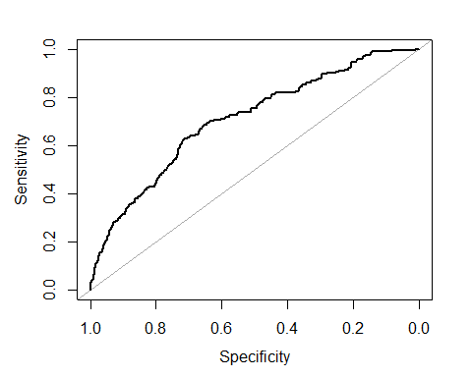

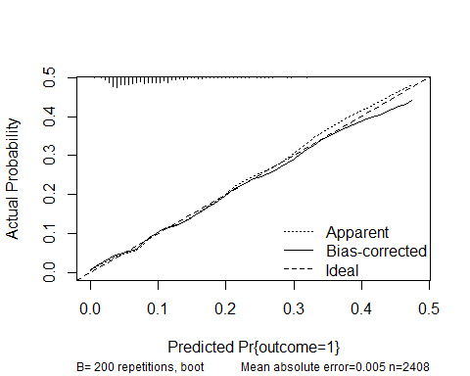

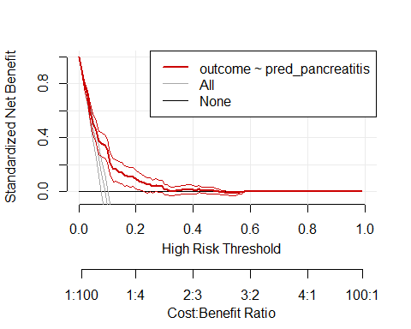

## Here is the data for model 2 containing 8 vars after backwardregression

# bootstrapping  
val <- validate(model_rms_bw, method="boot", B = 200)  
  
val

## index.orig training test optimism index.corrected n  
## Dxy 0.4616 0.4727 0.4546 0.0181 0.4435 200  
## R2 0.1298 0.1365 0.1242 0.0123 0.1175 200  
## Intercept 0.0000 0.0000 -0.0883 0.0883 -0.0883 200  
## Slope 1.0000 1.0000 0.9530 0.0470 0.9530 200  
## Emax 0.0000 0.0000 0.0276 0.0276 0.0276 200  
## D 0.0608 0.0640 0.0581 0.0059 0.0549 200  
## U -0.0008 -0.0008 0.0001 -0.0009 0.0001 200  
## Q 0.0616 0.0648 0.0580 0.0069 0.0548 200  
## B 0.0769 0.0761 0.0774 -0.0012 0.0781 200  
## g 0.9560 0.9791 0.9291 0.0500 0.9060 200  
## gp 0.0764 0.0777 0.0747 0.0030 0.0735 200

# to obtain c statistic  
0.5 * (val[1 , ] + 1)

## index.orig training test optimism index.corrected   
## 0.7307836 0.7363474 0.7273109 0.5090364 0.7217472   
## n   
## 100.5000000

# to obtain an ROC curve  
df_pred <- df_clean %>%   
 mutate(pred_pancreatitis = predict(model_rms_bw, type = "fitted"))  
  
plot.roc(df_pred$outcome, df_pred$pred_pancreatitis, asp = NA)

## Setting levels: control = 0, case = 1

## Setting direction: controls < cases

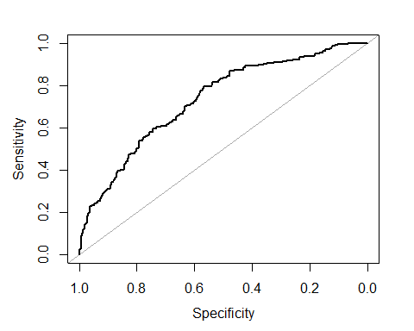

calibrate(model_rms, B = 200) %>%   
plot(.)

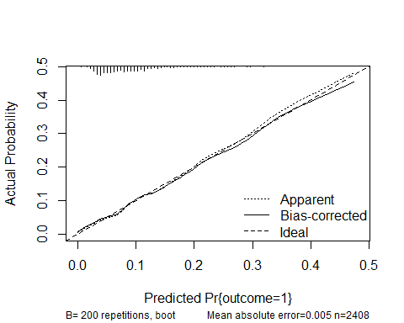

##   
## n=2408 Mean absolute error=0.005 Mean squared error=3e-05  
## 0.9 Quantile of absolute error=0.008

dca <- decision_curve(outcome~pred_pancreatitis, data=df_pred, fitted.risk = TRUE)  
plot_decision_curve(dca)

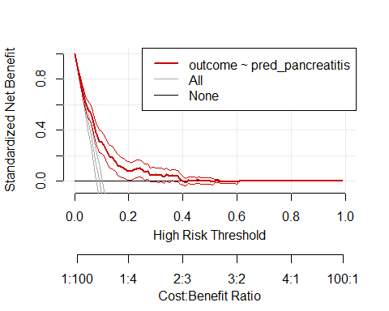

## References

Elmunzer, B. Joseph, James M. Scheiman, Glen A. Lehman, Amitabh Chak, Patrick Mosler, Peter D. R. Higgins, Rodney A. Hayward, et al. 2012. “A Randomized Trial of Rectal Indomethacin to Prevent Post-ERCP Pancreatitis.” *New England Journal of Medicine* 366 (15): 1414–22. <https://doi.org/10.1056/NEJMoa1111103>.