Republic of the Philippines

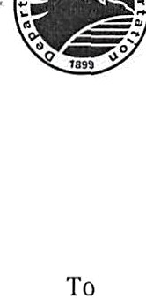

* “

**DEPARTMENT OF** TRANSPORTATION

**LOCAL TRAVELORDER**No.

Date

Subject

**Name**

**Position**

**Division**

**Agency**

**LOCAL TRAVELORDER**

1. Pursuanttotheprovision of ExecutiveOrder(EO)No.77*,*youareherebyauthorized to attend the **(what)** to be held at **(where) on (date/time).**
2. No government expense will be incurred relative to this travel.
3. All government officials/employees granted foreign/local travel orders are directed to promote high standard of ethics by observing the “no gift (in any form) policy” and are enjoined not to accept sponsored trips/meals outside the usualentitlements.
4. You are further directed to furnish/conduct thefollowing:
   1. Copy or your Certificate of Attendance/Certificate of Appearance (to be submitted to the Personnel Division).

______________________________________________________

***(Concerned Assistant Secretary/Undersecretary)***