January 5, 2021

**JUSTIFICATION**

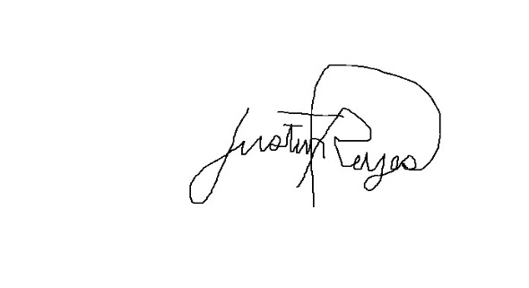The undersigned is one of the skeletal force that reported to work on December 11, 2020, Pampanga Day (holiday).

**JUSTIN JOHN T. REYES**

Computer Programmer I

Noted by:

**LOVELY KRISHA MENDIOLA**

*Director IV - OSEC*