Title: LC Filter Design and Analysis Using Scikit-RF
Content Type: White Paper
Author: Peter Matthews
Text:
Early-stage RF design benefits from fast, flexible tools that help engineers explore filter behavior before graduating to full electromagnetic (EM) simulation. Scikit-RF fills this role by providing a Python-based environment for constructing and analyzing lumped LC networks. Here, we demonstrate how to set up these models, perform simulations, and extend them to more realistic RF scenarios.
Scikit-RF is an open-source Python package designed for the analysis, simulation, and design of radio frequency (RF) and microwave networks. With Scikit-RF, you have access to predefined classes and methods for defining frequency ranges, ports, and elements (e.g., capacitors, inductors, resistors) and object-oriented tools for building and simulating RF circuits. This includes filter topologies like low-pass, high-pass, and band-pass filters.
With visualization tools, including S-parameter plots and circuit graphs, you can perform network analysis to understand signal integrity, impedance behavior, and overall system response. Scikit-RF is also compatible with industry-standard EM tools, so it’s easy to bring EM simulation data directly into your RF analysis workflow when you’re ready to do so.
Building Circuits in Scikit-RF
The process for building and connecting RF circuit networks in Scikit-RF requires creating individual network components and defining how they connect through a connections list that specifies the circuit topology involved.
Circuit Components and Connections
Before forming any circuit connections, you must start by:
- Creating the basic circuit elements and components
- Defining the frequency range and transmission line media
- Selecting the ports and grounds
When defining the frequency range, all components must share the same range:
Create the transmission media foundation, which serves as the basis for lumped elements using DefinedGammaZ0:
Then, generate individual circuit elements:
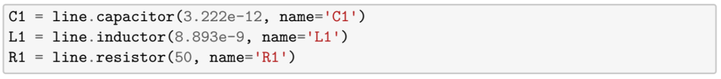
For ports and grounds, use the following code snippet to define circuit interfaces:
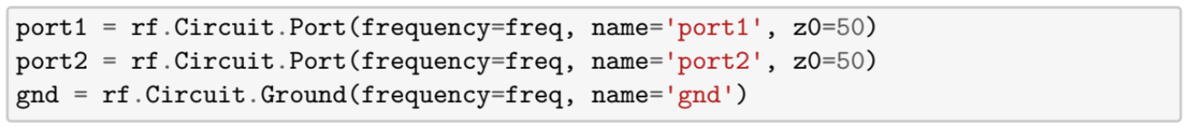
Building Connections
When it comes to connection syntax, focus on the connections list. Each connection is described as a list of tuples, and each tuple contains (network, port_number). Port numbering starts from zero.
Here’s a basic example of a connection:
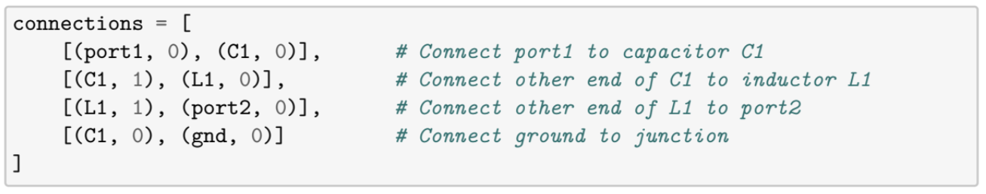
Here’s an example of what it looks like when you connect multiple components at the same node:
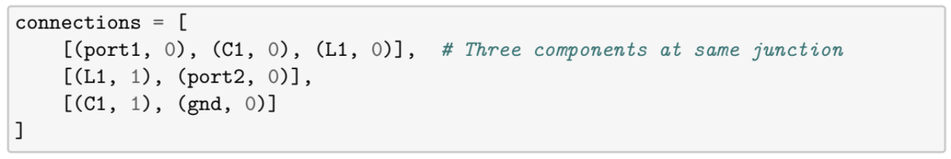
Once you’ve defined your connections, you can create the circuit object:
When you have an N-port network, defined as a circuit with N distinct RF ports, you can use it to simulate things like scattering parameters. Scikit-RF is particularly useful for modeling lumped LC filter designs in RF applications because it captures frequency-dependent impedance, losses, and element interactions for realistic results. Its ability to represent networks in modular, user-defined forms strengthens the connection between theoretical analysis and real-world circuit behavior.
Before simulating with an LC filter, you need to create a transmission-line medium in Scikit-RF. DefinedGammaZ0 is one of several media classes you can build circuits from, and it supplies the parameters needed for Scikit-RF to treat lumped elements as valid networks.
DefinedGammaZ0 in Scikit-RF
DefinedGammaZ0 is a core media class in Scikit-RF that offers a foundation for creating both distributed transmission lines and lumped-element models like capacitors, inductors, and resistors in RF circuit simulations. It represents a transmission medium with a specific characteristic impedance and propagation constant for a predefined frequency range. The characteristic impedance (Z) is the impedance that a wave “sees” as it propagates through an ideal, lossless transmission line. In DefinedGammaZ0, you set Z as a constant across all frequences, often 50 Ω.
The propagation constant defines how waves attenuate and phase-shift per unit length in the medium. DefinedGammaZ0 makes it possible to supply a custom propagation constant and characteristic impedance to any frequency-dependent array that matches your frequency object. For a lossless line:
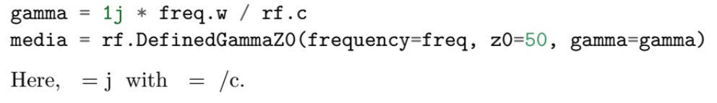
In this case, the following construction parameters apply:
- frequency: An instance of skrf.Frequency that defines the frequency points
- z0: Scalar or array of characteristic impedance values (Ω)
- gamma: Complex array of propagation constants (1/m) matching the frequency points
- name (optional): A string label for the media
With DefinedGammaZ0 set, you can return to the task of building an LC filter.
Modeling an LC Filter in Scikit-RF
Scikit-RF makes it easy to translate a lumped LC filter concept into a frequency-domain model for simulations. The following steps show how to define the filter’s components, connect them into a circuit, and analyze its response using S-parameters.
Begin by specifying the frequency span and resolution for your simulation:
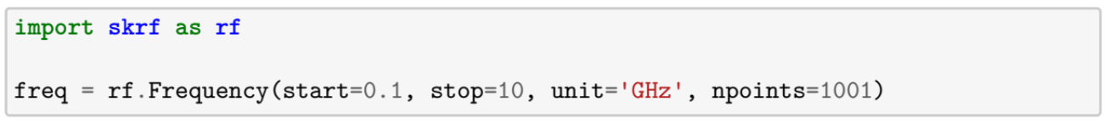
You can use the DefinedGammaZ0 class to represent lumped elements like capacitors and inductors:
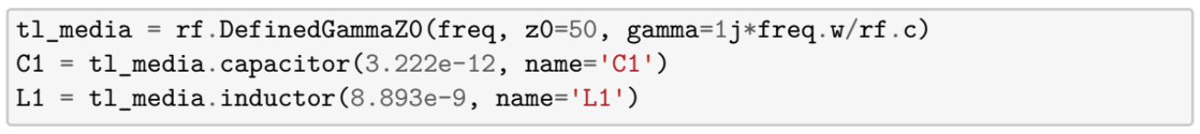
Define ports and grounds for network interfacing. Once these elements are established, you can connect them via the connections list:
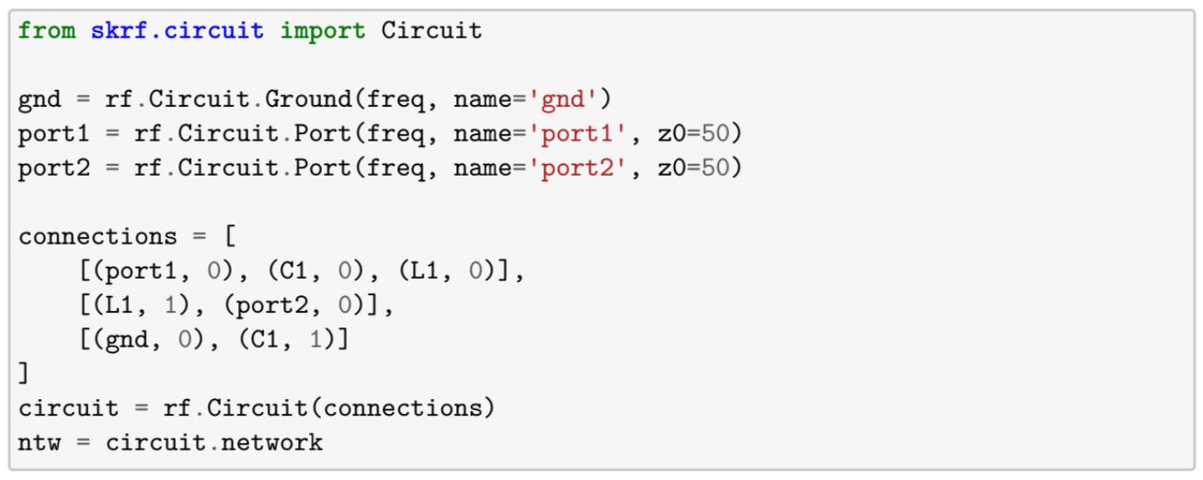
With the circuit built, you can plot its behavior, like S-parameters, using built-in Scikit-RF functions:
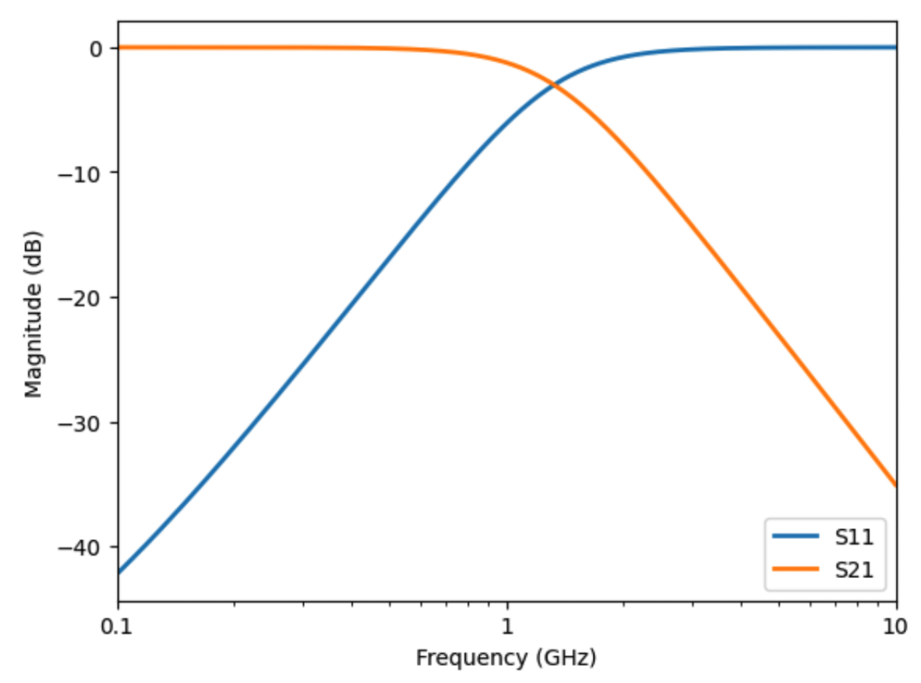
Advanced Considerations for LC Circuit Modeling in Scikit-RF
A simple LC model is sufficient for initial analysis, but real-world filter behavior depends on more than ideal inductors and capacitors. The following considerations help ensure your simulation reflects practical RF performance.
- Component Modeling Accuracy: At high frequencies, parasitics and layout effects can affect results. You can add parasitic elements to the model alongside the ideal components mentioned above.
- Cutoff and Bandwidth Calculations: Modify component values in the model to adjust these calculations as needed.
- Topology Flexibility: Scikit-RF supports T-section, -section, and custom topologies within the circuit builder.
- Visualization: You can use S-parameter plots, Smith charts, and circuit diagrams to better understand circuit performance.
- Tolerancing: If you’re looking to understand the impact of component tolerances on frequency domain performance, extend your analysis to include Monte-Carlo analysis of the component values.
[Add tolerancing section]
The techniques presented here demonstrate how Scikit-RF can be used to construct high-fidelity LC filter models that are suitable for RF analysis and early-stage design exploration. Once you understand how to define frequency ranges, create lumped elements, and build network connections, you can adapt the method to other RF topologies. For hands-on exploration, the accompanying Jupyter Notebook provides code examples so you can run and modify the model directly.
Scikit-RF modeling is a powerful way to explore concepts, but translating those insights into manufacturable, high-performance hardware requires advanced tools and specialized expertise. Reach out to our design team to evaluate your requirements and develop a solution.

