**DELHI TECHNOLOGICAL UNIVERSITY**

**Department of Computer Science and Engineering**



**Machine Learning**

**Python Programs**

Submitted By: Prajjwal Chittori 2K18/CO/249

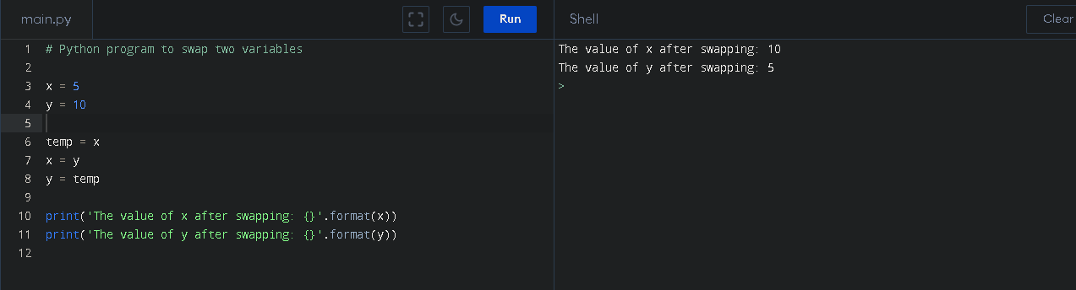Swap two Numbers

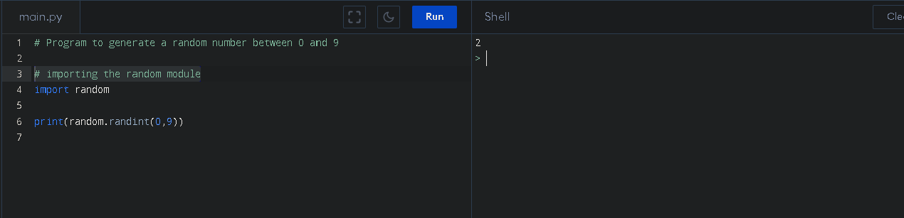Random number Generation

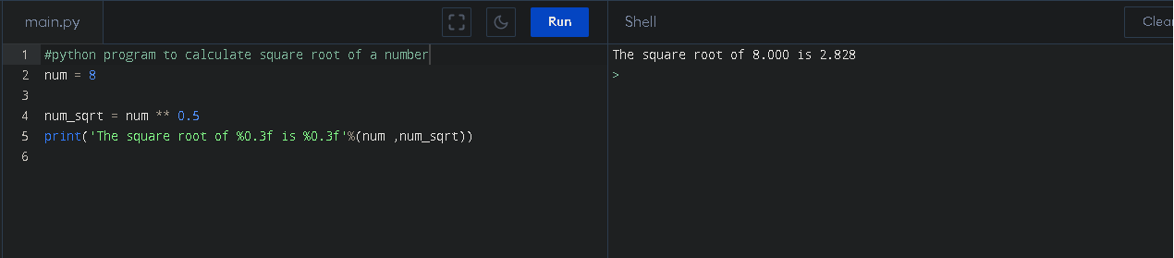Square root

Factorial of a number

