Amazon Seller Operations and Inventory Strategy
  - Virtual assistant delivery and workflow automation
Prepared by Philip Jeid Fabito | October 2026

Strategic recommendation
I recommend establishing a daily operating system for your Amazon store before expanding the catalog or increasing promotional activity. This strategy connects listing accuracy, inventory availability, fulfillment exceptions, customer service, and account health so that problems receive a clear owner and a verified resolution.
The initial scope is an existing branded physical product catalog in one primary Amazon marketplace, with FBA as the main fulfillment model and FBM handled separately where active. I will confirm your marketplace, catalog permissions, product categories, brand eligibility, fulfillment methods, and current tools in the opening audit.

The business problem
A seller can lose operational visibility when listing errors, stock decisions, buyer messages, and support cases are managed in separate places. A suppressed offer may stay unresolved, replenishment may overlook inbound delays, and a shipment exception may reach its deadline without an owner. These are the process risks the audit will test in your account.

How I will build the solution
I will create an exception queue, audit priority SKUs, establish inventory planning rules, document FBA and FBM handoffs, and build three monitored workflows. Seller Central and approved source systems will remain authoritative. Automation will collect supported data, identify exceptions, and assign tasks; commercial and account decisions will remain with the designated owner.

Intended outcomes
Your team will gain clearer daily priorities, more accurate listing maintenance, earlier stock risk visibility, and better tracking of order and account issues. Performance changes will be measured against the account baseline. The strategy does not promise ranking gains, a Featured Offer win, or account reinstatement.

01 Problems process and business outcomes
Problem to validate | Process I will build | Intended outcome
Listing issues lack follow through | SKU and ASIN issue queue with correction evidence and live verification | Faster identification and resolution of eligible issues
Inventory decisions use incomplete stock | Sellable inbound reserved and unsellable stock tracked separately | More realistic replenishment decisions
FBA and FBM tasks are mixed | Separate fulfillment owners and exception rules | Correct action for each order model
Customer cases have no next deadline | Case ownership with reply and resolution checkpoints | Fewer unattended customer commitments
Account alerts are reviewed late | Daily account health review with severity and due dates | Earlier escalation of material issues
Reports focus on sales alone | SKU availability return reasons fees and service outcomes | Better operational and commercial decisions

Audit baseline
I will review the previous 30 to 90 days of available sales, inventory, returns, account alerts, and customer cases. The baseline will record reporting periods, marketplace, currency, fulfillment method, and missing data. I will trace a selection of listing changes, inbound shipments, and order exceptions through to their actual outcomes.

Client decisions at kickoff
We will agree priority SKUs, supplier lead times, fulfillment promises, pricing boundaries, refund authority, support coverage, and the owner for compliance evidence. Your team will identify the authoritative warehouse and financial records and approve any third party access or software cost.

First implementation priority
The first build will focus on daily exception visibility and one replenishment cohort. Catalog expansion, advertising changes, and deeper integrations will follow after the operating data and responsibilities are reliable.

02 Daily Amazon VA operating process
Cadence | VA responsibility | Record and handoff
Start of staffed shift | Review account alerts listing issues buyer messages and order deadlines | Prioritized issue queue with owner and due date
During shift | Resolve permitted listing and service tasks coordinate warehouse and support cases | Case ID evidence and next action recorded
Daily inventory review | Check stock availability inbound progress stranded and unsellable units | SKU risk list and replenishment recommendations
End of shift | Recheck deadlines and overdue actions hand off unresolved work | Owner next action and promised update visible
Weekly | Review SKU outcomes recurring causes returns and workflow errors | Performance report and improvement decisions

The issue register
Each issue will have an internal ID, marketplace, seller SKU, ASIN or order ID, category, source date, severity, owner, due time, next action, case ID, and evidence link. New, Investigating, Waiting for owner, Waiting for Amazon or supplier, Verification, and Closed will describe the operating state.

Response and escalation rules
I will review urgent account notices when discovered and escalate according to the stated deadline. Buyer responses will follow the current marketplace requirement and staffed coverage agreed at kickoff. I will track the deadline displayed in Seller Central rather than assume every case has the same response window.

What the VA can change
Routine changes will follow written authority. Pricing, promotions, purchase orders, disposal or removal decisions, refunds outside delegated limits, and account appeals will need the designated owner. I will prepare facts and proposed actions so approvals are specific and easy to review.

03 Listing quality and issue resolution workflow
The workflow begins with a listing issue identified through Seller Central, an approved report, or a supported notification. The correction must address the actual issue and be verified after submission.
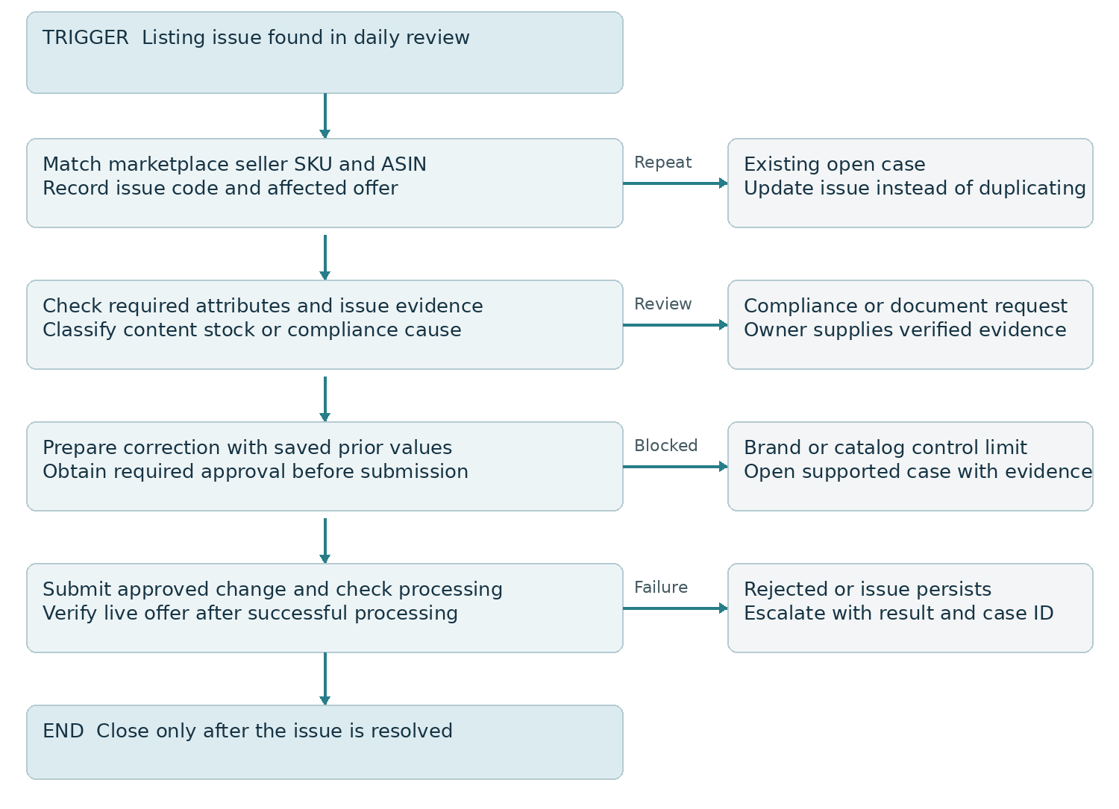
Figure 1 Listing issue handling with approval and live verification

Listing audit and correction
For priority SKUs I will check identifiers, product type, title, bullets, description, images, variant relationships, dimensions, and supported category attributes. Requirements will be verified for the actual marketplace and category. I will use your supplied product facts and brand assets and avoid unsupported claims or invalid variation relationships.

Catalog permissions and submission outcome
A seller contribution does not guarantee control of the shared detail page. I will distinguish an offer issue from catalog content ownership and document which changes can be made directly. A successful submission will not close the task until processing results and the relevant live offer or page have been checked.
Expected result: listing work follows a documented cause and correction, with fewer repeated submissions and clearer evidence for unresolved cases.

04 Inventory planning and replenishment workflow
The initial replenishment workflow will cover selected SKUs with usable stock and lead time data. It will produce recommendations and owner tasks, rather than automatically commit supplier spend.
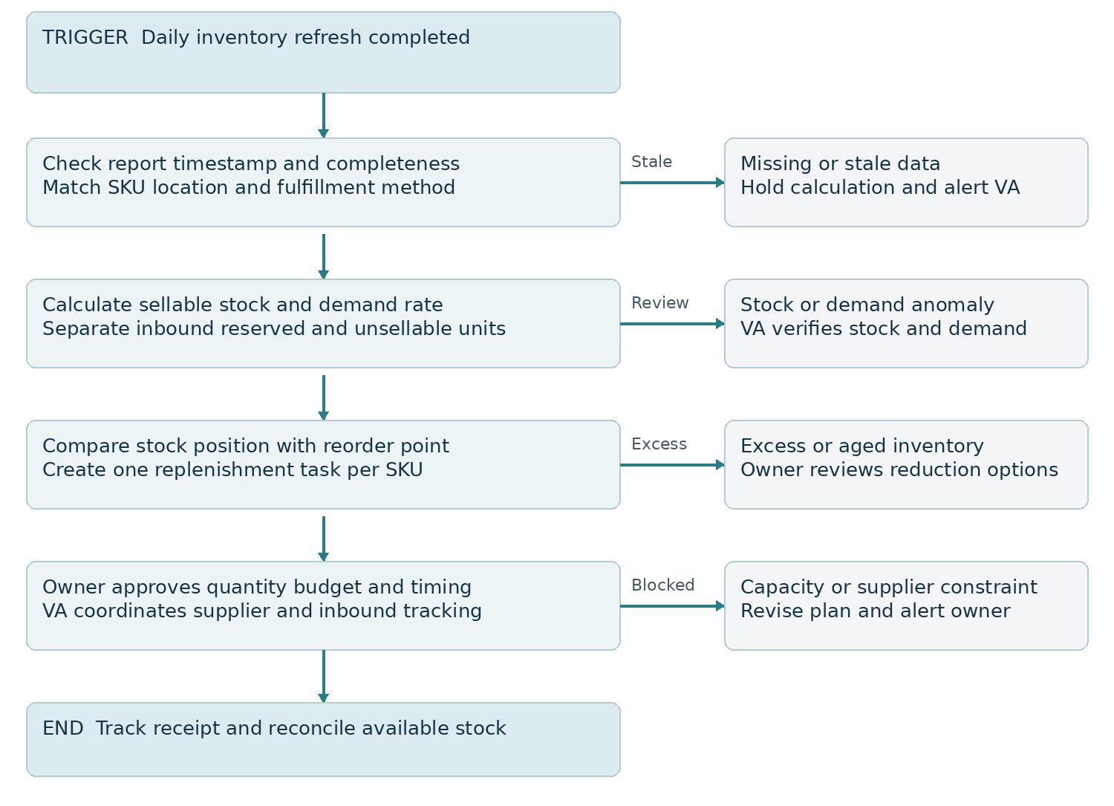
Figure 2 Inventory planning with data checks and owner approval

Calculation and source rules
Reorder point will equal average daily unit demand multiplied by total replenishment lead time, plus agreed safety stock. Lead time will include supplier production, transit, preparation, and expected FBA receiving time where relevant. The demand baseline will account for stockouts, promotions, seasonality, and unusually short history.
For comparison with the reorder point, the planning position will include usable sellable stock plus inbound units expected within the planning horizon, less relevant commitments. Uncertain inbound units will be disclosed separately. Reserved, stranded, unsellable, and warehouse units will not be counted twice as immediately sellable FBA stock.

Commercial decision and outcome
The owner will approve order quantity after checking budget, supplier minimums, current capacity, storage cost exposure, and demand assumptions. Expected result: replenishment decisions use visible assumptions and earlier warnings, while excess stock is reviewed before more units are purchased.

05 FBA and FBM fulfillment exception workflow
Fulfillment method determines the next action. FBA shipment and service issues will be handled through the relevant Amazon process; FBM dispatch remains the seller and warehouse responsibility.
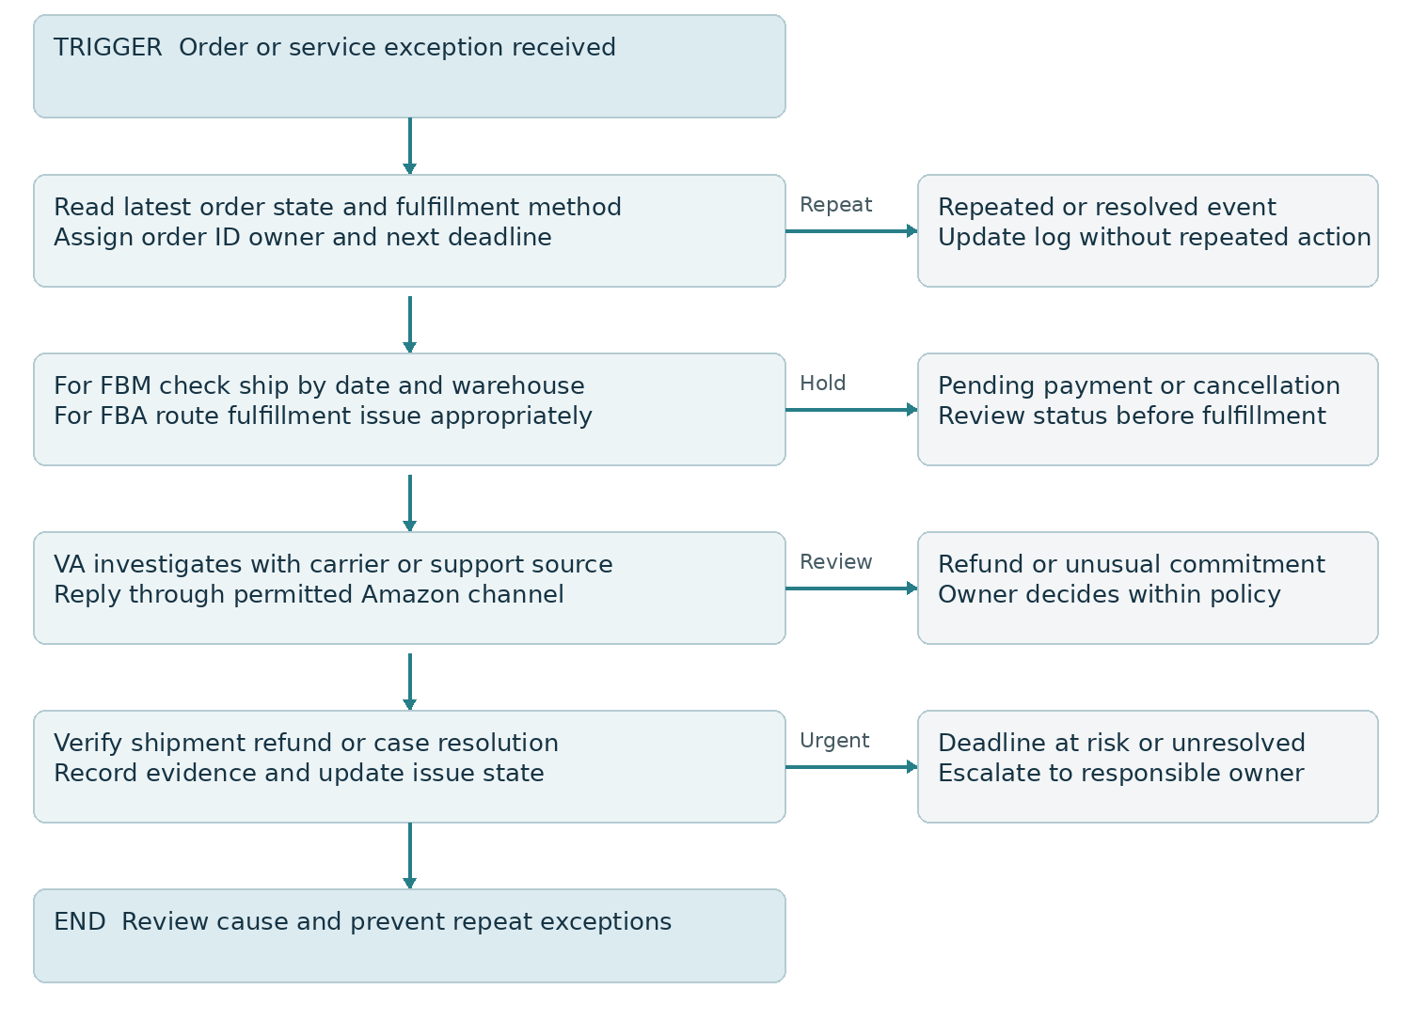
Figure 3 Order and service exceptions with fulfillment routing

FBA responsibilities
I will track inbound shipment status, receiving discrepancies, stranded inventory, customer issue patterns, and relevant case deadlines. Reconciliation and reimbursement requests will use eligible current procedures and evidence. A missing unit in an early receiving report will not automatically be treated as an approved reimbursement.

FBM responsibilities
I will monitor orders eligible for fulfillment, ship by dates, cancellation requests, carrier details, and shipment confirmation. Pending payment orders will not be released simply because an order record exists. Shipment confirmation will require actual dispatch evidence and correct tracking; an automated status update will never replace warehouse confirmation.
Expected result: each exception reaches the right owner, and shipment or refund statuses change only after the underlying event is verified.

06 Customer service returns and review requests
I will manage Amazon customer conversations through permitted Amazon channels and use order facts before making a commitment. Buyer information collected for an Amazon order will not be exported into GHL or an external promotional email list for off Amazon marketing.
Situation | VA process | Decision or limitation
Product question | Answer using verified listing and product information | Owner confirms uncertain specifications
Shipment issue | Check fulfillment model order state and tracking evidence | Use the correct Amazon or warehouse process
Return or refund | Review eligible procedure affected items and current status | Refund within delegated authority only
Negative feedback | Investigate cause and document service remedy | No pressure incentive or condition to change feedback
Review invitation | Use Amazon Request a Review for eligible orders | No duplicate request incentive or positive review filter

Communication boundaries
Customer messages will serve a permitted order or service purpose. I will avoid duplicating routine shipment messages Amazon already provides and will verify any proactive message against current Communication Guidelines. Marketing offers, newsletter invitations, and unnecessary external links will not be added to customer replies.

Review request process
I will check order eligibility in the approved Amazon process, record whether a request has already been made, and send at most one review request per order through the selected method. Any automation will require a supported authorized app or API and an eligibility check. Requests will use neutral treatment across eligible customers rather than target only satisfied buyers.

Returns as operational evidence
Weekly analysis will group returns and complaints by SKU and reason, such as fit, damage, inaccurate description, or shipment issue. Your team can then decide whether the correction belongs in the listing, packaging, warehouse process, or product itself.

07 Account health and automation architecture

Account health operating process
I will check the current Account Health dashboard and performance notifications daily during agreed coverage. Each relevant alert will be logged with the affected listing or metric, evidence requested, owner, and deadline. The account owner will decide appeals and provide verified supplier, product, and business documents; I will organize the record and follow the case.
Policy status, customer service metrics, shipping performance, and account health rating will be tracked in their proper context. Metric windows and thresholds will be read from the relevant marketplace dashboard. Improving one metric will not be described as resolving every account issue.
Layer | Responsibility | Implementation choice
Seller Central | Authoritative account listings orders and current notices | Daily review and official exports for the initial pilot
Approved source tools | Warehouse supplier and financial evidence | Keep ownership and reconcile discrepancies
Task and reporting system | Issue register owners due dates and weekly report | Store necessary operational fields and minimal buyer data
n8n Make or Zapier | Supported report processing notifications and task routing | Choose one after connector and permission validation
Selling Partner API | Authorized programmatic data and supported operations | Use approved app or registered authorized integration

Integration controls
I will confirm available reports, notification subscriptions, roles, marketplace coverage, and access requirements before implementation. An API notification will trigger a current state check; it will not be assumed to contain all facts required for the decision. Unsupported actions will remain in the VA queue rather than use unverified browser automation.
Workflows will keep persistent event and action keys, check source timestamps, log failures, and use bounded retries. Daily reconciliation will catch missed events. Any buyer data access will follow the authorized use and applicable Amazon data requirements, with restricted fields excluded from general logs and reports.

08 Implementation and performance measurement
Phase | Delivery | Evidence of readiness
Days 1 to 10 | Audit catalog stock order exceptions account alerts and access | Baseline approved priority SKUs and authority matrix
Days 11 to 30 | Build daily queue listing issue pilot and inventory model | Verified test cases and first weekly operating report
Days 31 to 60 | Refine FBA and FBM handoffs add supported report automation | Reconciled source data and documented exception ownership
Days 61 to 90 | Review recurring causes and evaluate controlled expansion | SKU results and next quarter action plan

Measure | Definition and review
Listing issue resolution | Time from issue detection to verified resolution report unresolved backlog separately
Stockout exposure | Days or observations with unavailable sellable offers for priority SKUs disclose reporting coverage
Inventory planning accuracy | Compare projected stock and arrival dates with actual demand and receipt by SKU
FBM dispatch performance | Orders actually dispatched by the required deadline divided by eligible FBM orders
Customer service timeliness | Cases answered within their applicable deadline divided by cases requiring a response
Automation reliability | Successful eligible runs divided by eligible runs include errors and manual corrections

Targets and commercial reporting
Targets will be agreed after baseline review. The first process target is complete ownership of pilot exceptions. Amazon calculated account metrics will be reported separately from internal measures, using Amazon definitions and time windows. SKU sales and returns will be reviewed with availability and promotion context.
A contribution estimate will state the available sales, refunds, Amazon fees, advertising spend, landed costs, and period assumptions. Missing costs will be disclosed. Sales revenue or settlement proceeds alone will not be described as profit, and currency or marketplace totals will not be mixed without a stated conversion method.

09 Validation handover and future strategy

Acceptance checks
I will test a normal listing correction, rejected submission, catalog control limitation, repeated issue, stale report, low stock alert, duplicate replenishment task, receiving discrepancy, pending payment order, cancellation request, partial shipment, expired authorization, failed connector action, restricted data exposure, and repeated review request. Each test will record expected and actual outcomes and corrective work.

Handover deliverables and roles
Your team will receive the daily operating checklist, issue register structure, SKU audit, inventory calculation assumptions, three workflow diagrams, permission map, case and escalation guide, test log, weekly metric definitions, and a training walkthrough. I will own the agreed VA queue and monitoring; your owner will approve commercial and account decisions; suppliers and warehouses will confirm stock and shipment facts.

Future improvements after the pilot
I will evaluate product specific seasonality planning, return reason reduction, aging stock decisions, and catalog expansion only where permissions and supply capacity support them. Brand content improvements will depend on eligibility and verified assets. Advertising optimization can become a separate workstream using inventory availability, conversion evidence, and actual contribution estimates.
Further automation can consolidate supported reports, alert on listing issue changes, and route order changes through an authorized integration. AI can assist with case summaries and draft replies using verified facts; final appeals, refunds, pricing changes, and material listing claims will retain the agreed human review.

Scope and operating costs
The pilot excludes advertising management, product sourcing commitments, legal or tax advice, and guarantees of reinstatement or reimbursement. Amazon selling and fulfillment fees, software subscriptions, API development, automation usage, and n8n hosting or maintenance will be confirmed separately before activation.

Official implementation references
Amazon listing management through SP API
https://developer-docs.amazon.com/sp-api/docs/manage-product-listings-guide
Supported notification types
https://developer-docs.amazon.com/sp-api/docs/notification-type-values
Amazon Communication Guidelines
https://sellercentral.amazon.in/gp/help/external/1701
Customer product reviews policies
https://sellercentral.amazon.com/help/hub/reference/external/G201972160
These references support the implementation checks. The applicable marketplace policy and your account configuration will be confirmed at kickoff and before live activation.

