Business Operations Automation Strategy
  - Inquiry handling client onboarding delivery and billing
Prepared by Philip Jeid Fabito | October 2026

Strategic recommendation
I recommend automating the handoffs that connect sales, client delivery, and billing before adding more isolated workflows. The first priority is a dependable path from a new inquiry to an assigned owner, from a confirmed engagement to a ready project, and from an approved milestone to a verified invoice.
This strategy is designed for a service business with a small team managing consultation based sales and project or recurring client work. The initial pilot covers one service offer and one delivery team. GoHighLevel or your existing CRM will manage the sales record; the project and billing systems will keep their own authoritative records.

The business problem
As work moves between forms, inboxes, CRM records, project boards, and billing tools, staff can repeat data entry and lose track of the next action. A sales win may reach delivery without a complete brief. A client may receive a welcome before access is ready. A completed milestone may wait for finance without an invoice task. I will test these handoffs during the opening audit.

How I will build the solution
I will map the current process, agree readiness rules and ownership, standardize the required fields, and build monitored workflows using the appropriate native tools and one selected automation platform. n8n, Make, or Zapier will be chosen according to connector support, complexity, cost, and the team responsible for ongoing maintenance.

Intended outcomes
Your team will gain less repetitive transfer work, clearer ownership, more consistent onboarding, earlier visibility into blockers, and a reliable connection between delivery and billing. Time savings and financial effects will be measured against the baseline rather than assumed in advance.

01 Problems process and business outcomes
Problem to validate | Process I will implement | Intended outcome
Inquiries wait without an owner | Validated intake assignment response deadlines and backup routing | Fewer unattended inquiries
Sales and delivery disagree on readiness | Agreement payment and scope checks before onboarding | Projects begin with required information
Projects need repeated manual setup | One approved project template with linked engagement ID | More consistent handoffs and less setup work
Milestones do not reach finance | Accepted milestone creates a reviewed billing task or draft | Clearer invoicing ownership
Different systems show different facts | Defined source ownership and daily reconciliation | Fewer hidden record mismatches
Workflow failures stay unnoticed | Incident alerts state checks and a manual fallback queue | Faster detection and controlled recovery

Discovery and baseline
I will trace recent inquiries, engagements, projects, and invoices through your existing systems. For each handoff I will record the trigger, information required, owner, waiting time, manual touches, failure points, and approval rules. The initial baseline will use the past 30 days where available, extending the period if transaction volume is low.

What we will agree before building
Your team will confirm the service offer, staffed response hours, ownership rules, agreement and payment requirements, project readiness criteria, milestone acceptance process, billing authority, and escalation contacts. I will separate documented requirements from assumptions that still need a decision.

Pilot boundaries
The first release will serve one offer, one project template, and one billing path. Payroll, broad data migration, complex subscription amendments, and new customer acquisition channels will be assessed separately so the pilot can be verified against a clear operating process.

02 System ownership and shared records
Every important business fact will have an authoritative source. Other systems can display or act on that fact, but they will not silently replace its owner.
Record | Authoritative source | Automation responsibility
Inquiry and sales status | GHL or existing CRM | Assign owner record source and track qualification
Accepted terms and scope | Approved agreement system | Read agreement ID version and accepted state
Project and delivery status | Existing project management tool | Create linked project tasks owners and milestones
Invoice and payment balance | Existing billing or accounting tool | Read current status and link billing records
Files and permissions | Approved document workspace | Create approved folders and restricted access
Workflow state and incidents | Persistent run and action register | Track completed actions errors and recovery

The identifiers that connect the process
The map will retain contact or company ID, inquiry ID, engagement ID, agreement ID, project ID, milestone ID, invoice ID, and workflow action key. One client can have several engagements and invoices; a contact tag alone will not stand in for those separate records. Dates will include a defined time zone, and financial records will include currency.

Data contract and exception queue
Required fields will include service, scope version, assigned owner, readiness state, start date, and next action. A missing field will route to correction rather than produce a guessed value. Each exception will show the source record, failed or blocked step, owner, due time, evidence, and resolution.

Synchronization direction
I will prefer a defined one way update for each field. Where two systems must edit a field, we will agree conflict rules and record versions. Updates will check source freshness and current state so an old event cannot overwrite a later cancellation, payment, or owner decision.

03 Platform selection and implementation design
I will select the platform after confirming the actual app actions and operational requirements. The initial design will use native capabilities where they meet the need, with one external orchestrator for the remaining cross system steps.
Platform | Good fit for this strategy | Decision to confirm
Native CRM and app automation | Same system reminders state changes and approved local tasks | Avoid overlapping native and external send sequences
n8n | Custom API logic reusable workflows and detailed data transformation | Cloud or self hosted ownership backups and maintenance
Make | Visual cross app routing and transformation with supported modules | Scenario ordering recovery settings and usage cost
Zapier | Common app handoffs and straightforward team managed workflows | Supported triggers actions replay settings and task cost

Proposed initial implementation
Where the required connectors are supported, I will propose Make for a managed visual pilot linking the CRM, project tool, and billing source. I will choose n8n instead where custom logic or API handling materially improves the design and ongoing ownership is agreed. Zapier is suitable when the required handoffs remain simple and its supported actions meet the acceptance criteria.

Connector checks before commitment
I will verify whether triggers are real time or scheduled, which fields and statuses each action exposes, how authentication is renewed, and what rate limits and subscription restrictions apply. If the connector cannot perform a required action, I will evaluate an authorized API or keep that action in a visible manual queue.

Volume and cost model
The usage estimate will include normal events, branches, lookups, retries, scheduled reconciliation, and peak volume. We will compare this operating cost with measured manual work and the value of fewer missed handoffs. Self hosted n8n will include hosting and maintenance responsibilities; it will not be treated as having no operating cost.

04 Inquiry intake and ownership workflow
The workflow begins with an inquiry from the selected form or supported source. It records a task and owner before relying on a follow up message to move the conversation forward.
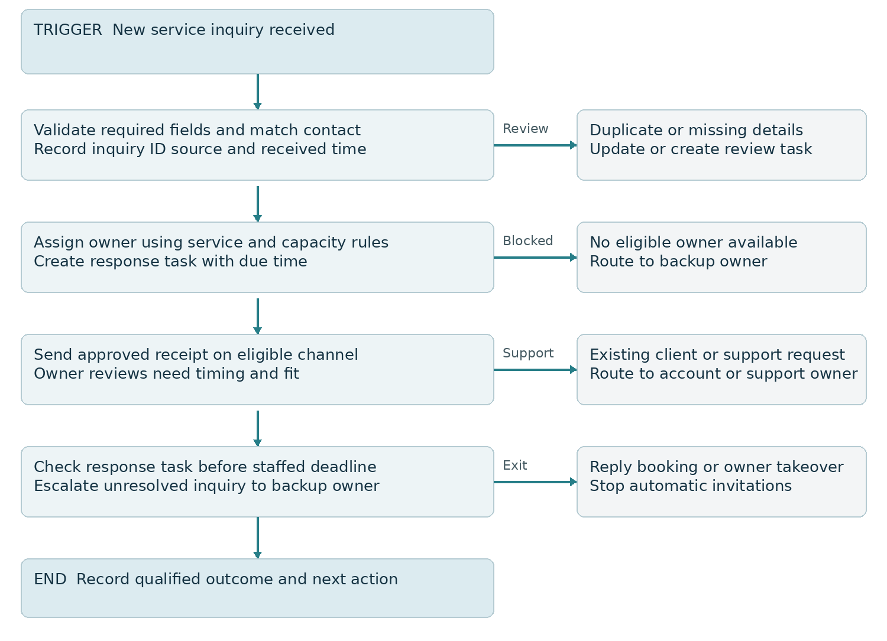
Figure 1 Intake validation assignment and escalation

Build process
I will configure the intake trigger, validate required fields, normalize contact details, and match the inquiry to its current record. Assignment will use the agreed service and capacity rules with a named backup owner. An approved acknowledgment will be sent only on an eligible channel; the assigned person will evaluate the need and next step.

Readiness and outcome
A form submission will not automatically mean qualified. The owner will record fit, timing, and outcome. A reply or booking will stop the relevant invitation sequence, while an existing customer issue will route to support. The proposed response target is one staffed business day, subject to coverage approval.
Expected result: each valid inquiry has a visible owner and next action, and unresolved tasks reach a backup rather than remain in an inbox.

05 Confirmed engagement and onboarding workflow
A sales status change requests a readiness check. Project creation requires the agreement and payment conditions defined for the selected offer; a Won status alone will not bypass those conditions.
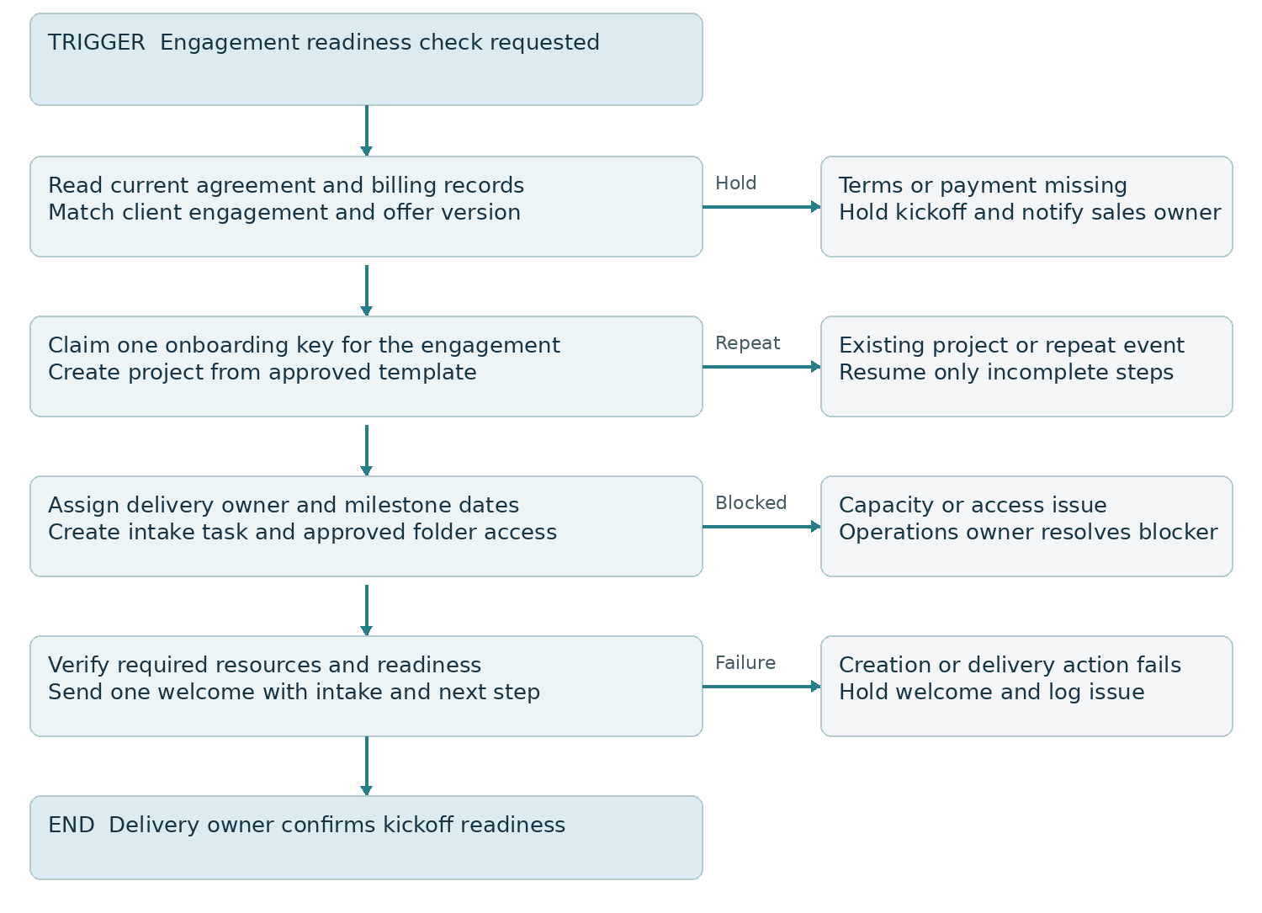
Figure 2 Engagement readiness and controlled project creation

Build process
I will link the agreement and billing records to the engagement, then define the readiness predicate. For an offer requiring an accepted agreement and cleared deposit, both must be true. Offers that use approved payment terms will have a separate explicit rule. The project template will create the appropriate tasks, owner, deadlines, and intake request.

Partial setup and duplicate prevention
Each create or send action will keep its own completion state. If project creation succeeds but folder access fails, recovery will resume the failed step rather than create another project. The welcome will wait until required resources are verified and will be recorded as a separate action.
Expected result: delivery receives a complete linked engagement, and the client is welcomed only when the promised next step is ready.

06 Delivery approval and billing workflow
Billing will begin with a verified approved milestone or another explicit contractual billing event. A task marked complete will not automatically establish customer acceptance or authorize an invoice.
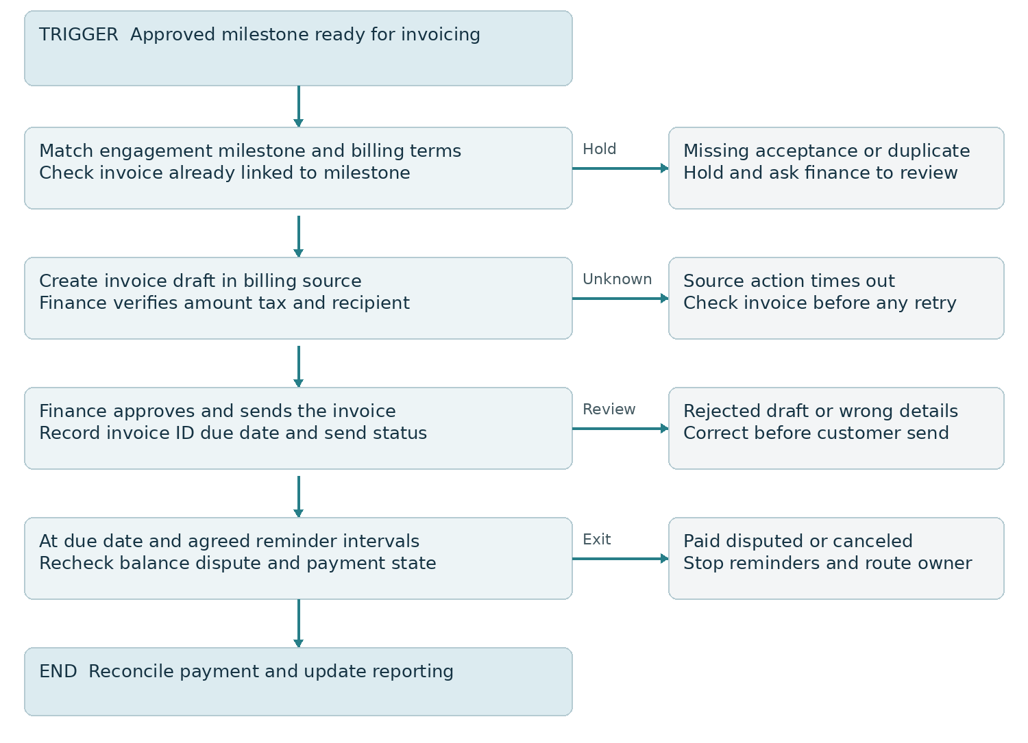
Figure 3 Milestone billing with draft approval and payment exits

Build process
I will map the approved milestone to the engagement and billing terms, check for an existing invoice, and prepare a draft where supported. Finance will verify amount, currency, tax treatment, recipient, and payment terms before sending. If draft creation is unavailable, the workflow will create a finance task with the required evidence.

Reminder rules
The proposed starting cadence is a due date check, followed by checks three and seven days after the due date. Before each eligible reminder the workflow will read the current unpaid balance and dispute or cancellation state. Part payments will change the balance used; a paid, disputed, or canceled invoice will exit reminders and receive the appropriate owner review.
Expected result: approved work reaches finance with the right details, and customer reminders reflect the actual billing state. The billing system remains responsible for financial records.

07 Failure recovery and daily reconciliation
Monitoring will be part of the first release. A successful trigger or green workflow run will not by itself prove that every required destination record and customer message is correct.
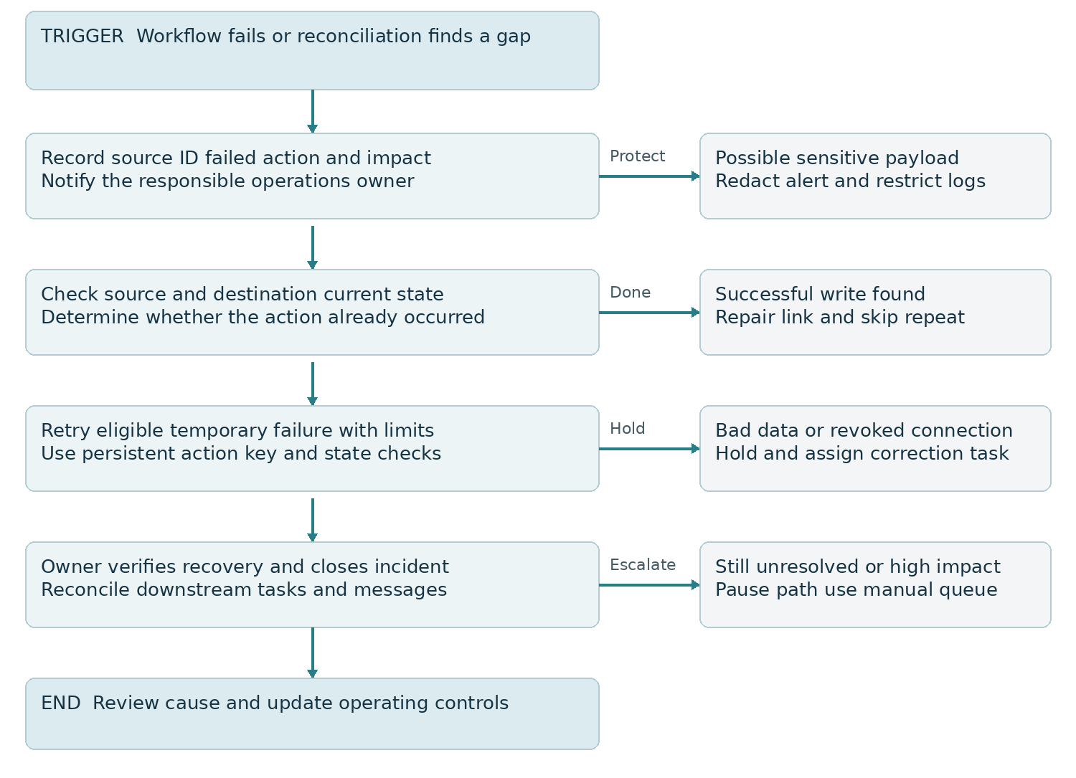
Figure 4 Failure investigation controlled retry and fallback

Recovery controls
Temporary failures such as rate limits will use provider guidance and bounded retries. Invalid data or revoked access will require correction. When a write times out, I will check whether it succeeded before retrying. Persistent action keys and destination links will prevent repeated project creation, invoice drafts, or welcome messages.

Reconciliation and continuity
A scheduled comparison will identify ready engagements without projects, approved milestones without billing records, and failures without owners. High impact issues will pause the affected path and move work to the manual queue. After recovery, the owner will verify downstream state and review the cause before closing the incident.
Expected result: missed events and uncertain outcomes become visible, with a practical way to continue work during an integration outage.

08 Access operating ownership and acceptance

Access and deployment controls
Connections will use business owned accounts, managed credentials, and only required permissions. I will separate test records from live operations, minimize customer data in logs, and define retention and access for operational evidence. Custom webhooks will use the source supported authentication or signature method before processing.
The pilot will begin with a limited cohort and a documented pause procedure. Workflow versions and field mappings will be recorded. A rollback will stop new enrollment and restore the previous workflow configuration where appropriate; records or messages already created will require reconciliation rather than being assumed reversed.
Role | Operating responsibility | Approval or response
Business owner | Service rules commercial authority and budget | Approve scope policy and material changes
Sales owner | Inquiry qualification agreement linkage and handoff | Resolve incomplete engagement details
Delivery owner | Project readiness milestones and customer delivery | Confirm readiness and milestone evidence
Finance owner | Invoice accuracy balance and payment decisions | Approve drafts and handle disputes
Automation specialist | Build monitoring recovery and documented changes | Investigate incidents and maintain runbook

Acceptance criteria
I will test a normal inquiry, duplicate inquiry, missing field, unavailable owner, existing customer issue, incomplete agreement, delayed payment, repeated engagement event, partial onboarding failure, unapproved milestone, existing invoice, part payment, dispute, stale event, revoked connection, rate limit, and timeout after a successful write. Each test will record expected and actual outcomes.
Release requires that normal and exception paths produce the expected records, owner tasks, and message exits; reconciliation identifies a deliberately missed event; and the team can pause the workflow and complete the manual fallback without creating duplicate actions.

09 Delivery roadmap and performance measures
Phase | Delivery | Review evidence
Days 1 to 10 | Audit handoffs agree source ownership and baseline | Approved process map and readiness rules
Days 11 to 30 | Build intake and onboarding pilot test exceptions | Verified records and trained operating owners
Days 31 to 60 | Add billing handoff monitoring and reconciliation | Balanced source comparisons and recovery log
Days 61 to 90 | Refine bottlenecks costs and expansion priorities | Outcome review and next quarter plan

Measure | Definition and interpretation
Manual touches per engagement | Count required manual transfer steps before and after for comparable engagements
Onboarding cycle time | Elapsed time from all readiness conditions met to verified kickoff readiness
Billing handoff time | Elapsed time from approved billing event to invoice ready for finance review
Exception resolution time | Time from issue detection to verified resolution report unresolved backlog separately
Workflow reliability | Eligible cases with verified required outputs divided by eligible cases include recovered failures
Reconciliation gaps | Source records missing required destination state plus age and owner of each gap

Measuring time and business effects
I will collect handling time from a representative baseline and compare it with the same task after the pilot. Monthly hours released will be estimated from the change in handling time multiplied by comparable eligible volume, with monitoring and exception work deducted. Released staff time will be reported separately from cash savings.
Faster invoice preparation does not by itself prove faster customer payment. Payment timing and overdue balances will be reviewed separately in the billing source. Targets will be set after the audit, and the first control target will be complete ownership of pilot exceptions.

10 Client handover and future strategy

What your team will receive
I will deliver the current and future process maps, field and source ownership map, workflow diagrams, build documentation, approved message copy, test log, incident register, pause and recovery guide, metric definitions, access ownership list, and a team walkthrough. The runbook will identify each trigger, required condition, action owner, exit rule, and manual fallback.

Ongoing operating routine
The designated operator will review failed and blocked runs during agreed coverage, check daily reconciliation, and verify outstanding incidents. Weekly review will assess recurring causes, volume, usage, and time released. Changes to source app fields, permissions, pricing plans, or service rules will trigger a mapping and regression check before rollout.

Future improvements after the pilot
Once the core handoffs are stable, I will evaluate recurring engagement renewals, capacity based project routing, supplier or contractor onboarding, and customer support classification. Renewals will use actual contract dates and owner approval; capacity routing will use maintained availability data rather than a static assignment list.
AI can assist with intake summaries, missing information checks, and draft internal updates using approved source facts. Confidence and evidence checks will route uncertain outputs to a person. AI will not independently change contractual scope, issue refunds, approve invoices, or promise delivery dates.

Expansion decision
Each proposed workflow will be assessed against volume, delay, effort, consequence of error, data readiness, and maintenance cost. We will prioritize repetitive handoffs with clear rules and usable source data. Multi platform orchestration will be added only where a concrete requirement justifies the extra ownership and failure paths.

Scope and operating costs
The pilot includes the agreed offer and four process paths shown in this strategy. Software subscriptions, premium connectors, API work, message sends, hosting, and ongoing monitoring are operating costs to approve before activation. Final delivery dates and support coverage will depend on access, app capability, and owner review turnaround.

Official implementation references
n8n error workflows and failure handling
https://docs.n8n.io/flow-logic/error-handling/
Make incomplete executions
https://help.make.com/incomplete-executions
Make scenario settings and ordering
https://help.make.com/scenario-settings
Zapier replay behavior
https://help.zapier.com/hc/en-us/articles/8496241726989-Replay-Zap-runs

