GoHighLevel Agency Growth and Operations Strategy
  - Sales follow up client onboarding and scalable delivery
Prepared by Philip Jeid Fabito | October 2026

Strategic recommendation
I recommend building a controlled sales-to-delivery system in GoHighLevel that gives every agency inquiry an owner, every open deal a next action, and every new client a defined launch process. The first priority is to reduce gaps between lead capture, discovery calls, proposals, and onboarding. The second is to make successful delivery processes reusable across client accounts.
This strategy is designed for a marketing or lead generation agency selling recurring services through discovery calls and proposals. It covers the agency’s own sales and client management process, followed by the deployment of lead management systems for its clients. The exact service mix, team capacity, and current tools will be confirmed during discovery.

The business problem
When sales follow-up and client onboarding rely on separate inboxes, spreadsheets, and memory, agency leadership has to chase updates. A qualified lead can wait without an owner, a proposal can sit without a decision date, and a signed client can enter delivery before access and expectations are clear.

What I will build
A dedicated agency operating sub-account, a documented sales pipeline, qualification and booking workflows, proposal follow-up controls, onboarding and retention tracking, and a tested deployment template for client accounts. Each automation will have a clear trigger, owner, exit condition, and exception path.

What your agency should gain
The intended result is a more reliable operating process: fewer unattended inquiries, clearer sales priorities, more consistent onboarding, and easier client account launches. Commercial gains will be measured against the agency’s baseline after implementation; the strategy does not assume a conversion rate or revenue uplift before evidence exists.
Delivery sequence: stabilize sales → control onboarding → standardize client delivery → improve retention and expansion.

01 Problems priorities and business outcomes
I will use the first discovery session to identify which operational gaps have the greatest impact on revenue and delivery capacity. The priorities below guide the initial build and the audit evidence needed to confirm them.
Problem to validate | Build response | Business outcome
New inquiries have no reliable owner or response deadline. | Source-specific intake, owner assignment, task due time, and overdue escalation. | Sales can see who owes the next response.
Discovery calls and proposals stall without a next action. | Qualification fields, appointment handling, decision dates, and proposal tasks. | Leadership can distinguish active deals from unresolved follow-up.
New clients are onboarded differently by each team member. | A separate onboarding pipeline with access and readiness gates. | Delivery starts with confirmed inputs and responsibilities.
Client accounts are rebuilt manually. | A versioned snapshot and destination setup checklist. | Reusable configuration reduces repeated setup work.
Client value and renewal risk are reviewed too late. | Monthly outcome reviews, renewal dates, and account manager tasks. | Retention conversations happen before the renewal deadline.

Audit evidence I will request
Review the last 30 to 60 days of inquiries, appointments, open proposals, won deals, and onboarding records. Trace a selection from first inquiry to outcome. Record unanswered leads, missing owners, absent source data, overdue next actions, and days between agreement and launch.

Priority decision
If response ownership is weak, fix intake and accountability before increasing lead volume. If sales is healthy but launches are delayed, prioritize onboarding gates. If both are stable, use the client deployment template and reporting process to support growth without rebuilding each account.

02 Account architecture and data design

Keep agency operations and client delivery distinct
I will use one sub-account for the agency’s own prospecting, sales, onboarding, and client relationship records. Each managed client gets a separate sub-account for that client’s leads, conversations, calendars, and automations. Agency-level administration manages access and reusable snapshots. Data does not automatically become shared across those accounts.

Build the data model before the workflows
Record or setting | Required information | Design rule
Contact and company | Contact identity, company, website, role, service interest, and communication preferences. | Link related stakeholders to the company; a company is not a substitute for a contact.
Sales opportunity | Service offer, owner, agreed deal value basis, next action date, proposal date, decision date, and loss reason. | Use one deal per active buying initiative. Preserve opportunity context in automation.
Onboarding record | Signed scope, payment confirmation, delivery owner, intake status, access status, kickoff date, and target launch. | Create a separate onboarding opportunity after the sales win gate.
Client management record | Account manager, start date, renewal date, review date, account health, and expansion interest. | Health is reviewed by a person; silence alone does not establish churn risk.
Account custom values | Agency name, booking link, sender details, support contact, and standard URLs. | Use values for account configuration; use fields for each prospect or deal.

Source tracking and duplicate control
I will preserve first and latest attribution where captured, standardize UTM naming, and record an operational source such as Referral or Partner separately. Contact Source and attribution are different fields. For imported or offline leads, source is entered explicitly. Unknown remains unknown rather than being credited to paid ads.
Before creating a deal, the workflow will locate the matching open opportunity using the agreed contact, pipeline, and offer rules. Repeat inquiries update the existing buying initiative; genuinely separate purchases can have separate deals. Workflows must act on the intended opportunity rather than whichever record is easiest to find.

03 Sales process mapping
The sales system qualifies the opportunity before it sends every prospect to the same calendar. Qualification uses the agency’s minimum engagement, service fit, decision-maker access, and delivery capacity. Budget thresholds are agreed with leadership rather than hard-coded without context.
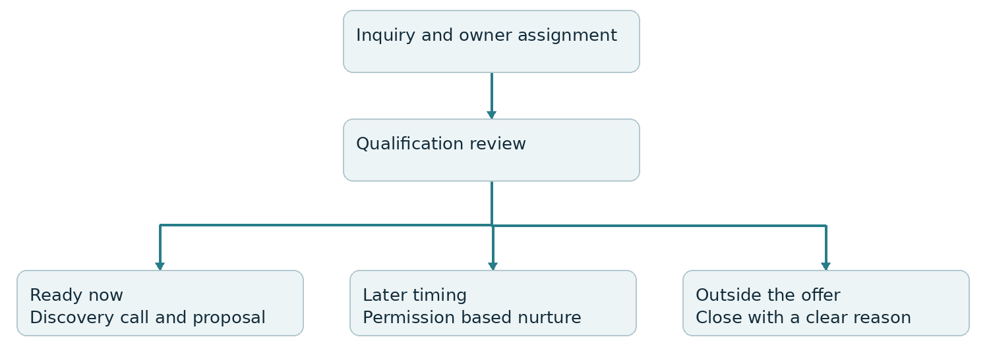
Figure 1 Qualification routes and the next business action
Sales stage | Entry evidence | Required next action
New inquiry | Valid inquiry captured with an assigned owner. | Review fit and respond within the agreed business-hours target.
Qualification review | Owner begins fit assessment; missing inputs are recorded. | Confirm scope, timing, budget range, and decision process.
Discovery booked | Appointment recorded on the discovery calendar. | Prepare the call and send the relevant reminders.
Discovery completed | Sales owner confirms the call outcome. | Qualify out or prepare an agreed next step.
Proposal sent | Proposal delivered with an owner and decision date. | Follow up on the buying decision and unresolved questions.
Decision pending | Prospect is actively reviewing scope or terms. | Keep a dated next action; record blockers.

Won is confirmed when the agreed acceptance and payment conditions are met. Lost requires a reason. Longer-term prospects enter a permission-based nurture route; they should not remain indefinitely in the active sales queue.

04 Sales workflows and response controls

Intake and first response
Workflow AG SALES 01 starts from the approved inquiry form or a verified connected lead source. It records the contact and source, finds or creates the correct opportunity, assigns the sales owner, and creates a response task. An acknowledgment confirms receipt and explains the next step. It does not substitute for a human sales response.
Initial operating target: a human response within one business hour for inbound inquiries during staffed hours. Outside working hours, acknowledgment can confirm when the team will respond. At the deadline, unresolved inquiries escalate to the sales lead. This is a proposed service target to confirm against staffing capacity.

Qualification and booking follow up
Workflow AG SALES 02 applies only to suitable prospects who have not booked or replied. Send a useful reminder after one business day and a final check-in after three business days. Check current booking, reply, opt-out, deal status, and owner takeover before every send. Unqualified prospects receive an appropriate human response and exit active booking follow-up.

Appointment handling
Workflow AG SALES 03 confirms the correct appointment, sends reminders 24 hours and 2 hours before the call where timing permits, and creates a preparation task for the sales owner. A cancellation removes obsolete reminders; a reschedule rebuilds timing around the new appointment. A no-show creates an owner task and one rescheduling invitation. A human records the outcome; the system must not mark a call completed merely because its scheduled time has passed.

Proposal follow up
Workflow AG SALES 04 starts only when the correct deal enters Proposal sent with a decision date. Create an owner task two business days after delivery and another on the agreed decision date. Use automated messages only when appropriate for the conversation. An open, click, or document view is an engagement signal, not agreement acceptance or a sales win.

Prevent conflicting automation
Configure re-entry and multiple-opportunity settings deliberately. Use pipeline and stage filters so opportunity updates do not repeatedly enroll unrelated deals. Stop on Response is a workflow-level control; combine it with explicit removal from relevant sequences and human takeover handling. Test the same contact with two deals so one deal’s activity does not corrupt the other.

05 Client onboarding and delivery handoff
A sales win should create a controlled handoff, not immediately launch a campaign. I will build a separate onboarding pipeline with one delivery owner and visible blockers. Existing project management tools can remain the task system for detailed campaign production; GHL tracks the customer milestones and communication.
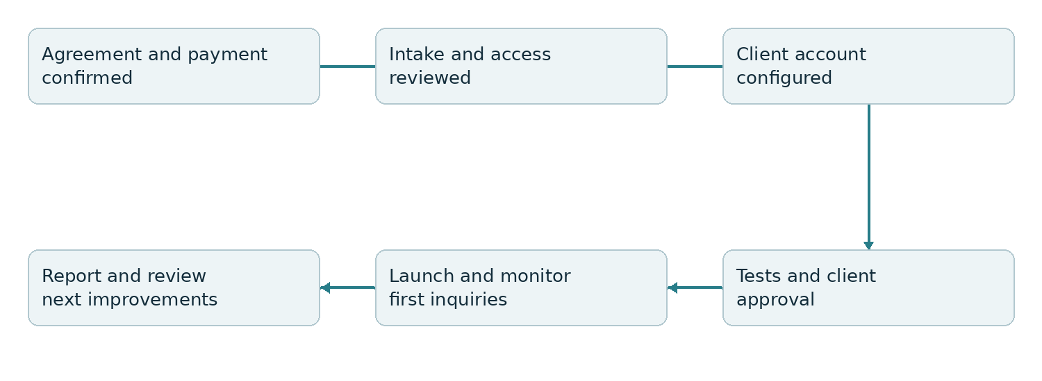
Figure 2 Gated client onboarding and launch process

Gate one confirm the commercial handoff
Create the onboarding record only after the agreement and required initial payment are confirmed under the agency’s policy. The handoff includes signed scope, promises made during sales, agreed milestones, primary stakeholder, and delivery owner. If agreement or payment data comes from another tool, use a verified integration event or a controlled manual confirmation.

Gate two collect intake and access
Send the intake form and kickoff link. Record missing assets and permissions as named blockers. Send reminders after two and five business days only for outstanding inputs, then escalate to the account manager. Request access through the relevant platform’s permission controls; do not ask clients to put account passwords into a general intake form.

Gate three approve launch readiness
The delivery owner confirms offer copy, calendar availability, sender configuration, lead routing, tracking, and message approvals. End-to-end tests must pass before publishing forms or enrolling live leads. Onboarding stages are Awaiting intake, Access pending, Configuration, Internal QA, Client approval, and Live. A blocked account remains at its true readiness stage.

Expected operating result
Your team can see why an account has not launched and who can unblock it. Measure days from commercial confirmation to kickoff and launch, separating agency work time from client input delays. This prevents a faster-looking onboarding metric from hiding incomplete setup.

06 Repeatable client account deployment

Build one tested reference account
I will assemble a reference sub-account containing the approved pipeline, form, calendar structure, custom fields, custom values, email templates, workflows, and reporting layout. The first deployment should serve one clearly defined client vertical. A lead generation process for home services should not be copied unchanged into a high-ticket consulting business.

Package the configuration as a versioned snapshot
Snapshots copy reusable configurations rather than live contacts, conversations, appointments, or account history. I will name each release by vertical and version, maintain a change log, and identify the assets included. Each client account will record its deployed version and any local changes so future updates do not overwrite a deliberate customization.
Deployment step | Checks before activation
Load configuration | Confirm destination account, expected assets, and conflicting existing names or workflows.
Adapt client settings | Update branding, service offer, custom values, links, availability, time zone, qualification rules, and owners.
Connect services | Configure domains, email and phone senders, calendars, and required integrations in the destination account.
Verify permissions | Give each user only the relevant account access and validate which client-facing data they can see.
Run acceptance tests | Test lead capture, matching, routing, replies, bookings, opt outs, reminders, and delivery failures.
Release and monitor | Publish only approved assets; review initial live inquiries and preserve the previous configuration for recovery.

Update without disrupting live accounts
Test each change in the reference account first, then pilot it in one destination account before wider rollout. Document what changes and how to disable the affected workflow if it behaves incorrectly. Review client-specific dependencies after loading; copied assets can still need connections and account-level configuration.

Expected operating result
The agency gains a repeatable launch method and a traceable configuration baseline. Measure build time, test failures, and post-launch support incidents per account. Reuse should reduce repeated work while preserving the rules that make each client’s process appropriate.

07 Client reporting retention and expansion

Report the customer journey rather than lead volume alone
For each client account, show captured inquiries, qualified opportunities, bookings, attended appointments, and confirmed wins. Establish who updates sales outcomes: the agency, the client’s team, or an integrated source. Missing outcome data should appear as a reporting gap, rather than being treated as lost revenue or zero sales.
Use first attribution for acquisition analysis and latest attribution for the most recent recorded touchpoint, with the choice stated in the report. Keep unattributed leads visible. Reconcile tracked wins with the client’s sales or payment source before reporting collected revenue. Cross-account summaries require an agreed reporting method; a snapshot does not consolidate live data.

Monthly account review
Create a review task and agenda for the account manager. Review delivery against scope, lead quality, response speed, booking friction, customer feedback, and outstanding client responsibilities. Each meeting ends with one named improvement, an owner, and a review date. The goal is to make the agency’s contribution and the client’s next actions clear.

Renewal and risk management
Record the contract renewal date and create review tasks 60 and 30 days before renewal. For rolling monthly arrangements, use a recurring account review instead of inventing an annual renewal date. Flag overdue approvals, unresolved complaints, missed review meetings, and declining outcomes for human assessment. A flag triggers contact from the account manager, not an automatic discount or cancellation message.

Expansion based on a verified bottleneck
Offer an additional service only after the review identifies a problem it can solve. If leads are arriving but appointments are weak, improve qualification and booking first. If leads convert and the delivery team has capacity, discuss additional acquisition channels. If setup work is slowing launches, invest in a stronger deployment template before selling more accounts.

Expected business result
Clients receive a clearer explanation of performance and next steps. The agency gains earlier renewal visibility and a record of expansion opportunities tied to client needs. Track renewal rate, reasons for cancellation, and expansion revenue separately so the effect of each initiative can be assessed.

08 Implementation roadmap and future strategies
Phase | Build and release criteria | Intended result
Days 1 to 10  Map and stabilize | Audit the journey, define fields and owners, agree baseline and scope, then release tested intake and response routing. | Every eligible inquiry enters a visible queue.
Days 11 to 30  Control sales | Implement qualification, calendars, proposal follow-up, exception handling, and the agency sales dashboard. | Sales priorities and next actions become reviewable.
Days 31 to 60  Standardize delivery | Build onboarding gates, reference account, snapshot, release checklist, and client reporting process. | Client launches follow a consistent tested process.
Days 61 to 90  Improve and expand | Review mature cohorts, improve one bottleneck, add renewal tasks, and pilot the next client deployment. | Expansion follows evidence and team capacity.

Future strategy one segmented reactivation
After the active sales process is stable, segment closed or deferred prospects by service interest, timing, and loss reason. Contact only eligible prospects with appropriate permission and a relevant new reason to talk. Exclude current active deals, opt outs, and poor-fit records. Judge success by qualified reopened opportunities and confirmed wins, not reply volume alone.

Future strategy two assisted qualification
If inbound volume exceeds staffed response capacity, pilot GHL conversation automation for approved questions and scheduling guidance. Define supported answers, escalation rules, channel permissions, and conversation limits. Route pricing exceptions, complaints, and uncertain answers to a person. Review transcript accuracy and handoff completion before expanding the pilot.

Future strategy three packaged vertical services
Once one client vertical has a stable process, package its configuration, onboarding requirements, reporting, and support scope into a repeatable offer. Validate demand, delivery cost, usage charges, and support capacity before considering a white-label software offering. Software resale should follow a workable service model rather than precede it.
Timing is planned from receipt of required access and approvals. Release gates take precedence over the calendar when tests fail or essential inputs remain missing.

09 Results measurement and acceptance
Before launch, I will establish a baseline and an agreed measurement window. Operational acceptance confirms that the system behaves correctly; business performance is assessed after enough leads have completed the sales cycle.
Measure | Definition and review | Result to evaluate
Response ownership | Eligible inbound inquiries assigned correctly; median first human response time measured in stated working hours. | Fewer unowned or overdue inquiries.
Qualified booking rate | Qualified inquiries that book ÷ qualified inquiries in the same source and intake cohort. | Whether qualification and booking improve progression.
Discovery show rate | Attended discovery calls ÷ calls due, with cancellations and reschedules handled consistently. | Whether reminders and preparation improve attendance.
Proposal win rate | Won deals ÷ sent proposals from a mature cohort; apply one consistent commercial win definition. | Whether follow-up supports buying decisions.
Onboarding cycle time | Median days from commercial confirmation to approved launch; track blocked days separately. | Whether launches become faster and more predictable.
Client retention | Renewed eligible contracts ÷ contracts due for renewal; analyze monthly clients separately. | Whether review and renewal work supports retention.

Acceptance tests before live release
Verify a new inquiry, repeat submission, two deals for one contact, missing owner, after-hours arrival, reply, manual takeover, booking, reschedule, cancellation, no-show, opt out, failed send, repeated win event, missing intake, and incomplete snapshot settings. Each test records the trigger, expected record changes, messages, owner tasks, and observed result. Block release if a test causes unwanted contact, duplicate onboarding, or incorrect deal updates.

Responsibilities and decision points
I will deliver the process map, field dictionary, pipeline definitions, workflow specifications, tested configuration, release checklist, reporting definitions, and handover guide. Agency leadership approves service thresholds, staffing targets, communication policy, commercial win conditions, and report definitions. Account managers own relationship decisions; sales and delivery owners keep their milestones current.
Platform subscriptions, message usage, advertising spend, and custom external integrations are scoped separately. Numeric performance targets will be agreed from baseline data and capacity, rather than presented as guaranteed results.

10 Technical references and next steps

Implementation references
The following official HighLevel documentation supports the platform design. Account configuration and available features will be checked during implementation. References reviewed 9 October 2026.

Workflow settings
Re-entry, multiple-opportunity journeys, response handling, time windows, and sender configuration.
https://help.gohighlevel.com/support/solutions/articles/48001239875

Opportunity change trigger
Filters and event handling for changes to the intended sales opportunity.
https://help.gohighlevel.com/support/solutions/articles/155000000886

Update opportunity action
Updating the correct opportunity using workflow context or a prior lookup.
https://help.gohighlevel.com/support/solutions/articles/155000004753

Snapshots overview
Reusable account assets and destination-specific setup requirements.
https://help.gohighlevel.com/support/solutions/articles/48000982511

Creating snapshots
Configuration packaging and the limits of what is transferred.
https://help.gohighlevel.com/support/solutions/articles/48000982512

Attribution traffic sources
First and latest attribution and the treatment of tracked traffic sources.
https://help.gohighlevel.com/support/solutions/articles/48001219997

Source field in forms
The distinction between Contact Source and attribution data.
https://help.gohighlevel.com/support/solutions/articles/155000001506

Start with the agency process review
The first working session will confirm your service offer, current lead sources, sales ownership, qualification criteria, proposal process, onboarding requirements, and reporting gaps. I will turn those inputs into the approved process map and first build scope. The initial release will focus on the highest-impact operational gap, then expand through the gates described in this strategy.

