GoHighLevel Coaching Business Strategy
  - Discovery calls enrollment onboarding and client retention
Prepared by Philip Jeid Fabito | October 2026

Strategic recommendation
I recommend building one connected prospect-to-client journey in GoHighLevel so qualified prospects know how to book, enrolled clients know how to start, and the coach can see which relationships need personal attention. The system will organize the repeatable administration around coaching while preserving the conversations and decisions that require the coach’s judgment.
The strategy is designed for a business or career coach selling a structured coaching program through an application and discovery call. The initial build supports a fixed-duration program with individual sessions and optional group sessions or learning resources. Program length, capacity, payment terms, and access rules will be confirmed before configuration.

The business problem
An interested prospect may submit an inquiry but never book. A booked call may lack reminders or context. After payment, a client may wait for intake, resources, and a first session link. These gaps create avoidable follow-up work and make the coaching experience feel less organized than the service itself.

What I will build
A program landing page and application, a defined sales pipeline, qualification routing, discovery-call booking and reminders, enrollment verification, onboarding automation, and a client review and renewal process. The following pages map each business problem to the workflow, the owner, and the result to evaluate.

Expected business outcomes
Qualified prospects receive a clear next step. The coach prepares for calls with relevant context. Paid clients receive the correct onboarding instructions and access. Progress reviews and renewal conversations occur at planned points. Conversion, attendance, and retention improvements will be measured against baseline data after implementation.

Delivery priorities
First, make inquiry and discovery-call handling reliable. Next, connect enrollment to onboarding. Then introduce structured client reviews, renewals, and segmented growth campaigns. The roadmap expands the system only after the core journey passes acceptance tests.

01 Problems and the coaching client journey
I will audit the current journey from the prospect’s perspective: what they see, what action they are asked to take, and how the coach knows the action happened. These priorities guide discovery and the first implementation scope.
Problem to validate | Process I will build | Outcome to evaluate
Inquiries are followed up inconsistently. | Program application, contact matching, owner tasks, and qualification routing. | Fewer prospects waiting without a next step.
Calls are booked by people outside the program’s fit. | Qualification criteria and approved booking route. | More relevant discovery conversations.
Booked prospects arrive unprepared or do not attend. | Calendar confirmation, preparation prompts, timed reminders, and no-show handling. | Better preparation and attendance.
Payment and onboarding are disconnected. | Program-specific enrollment gate, welcome, intake, and first-session scheduling. | Less uncertainty after purchase.
Renewals and client reviews depend on memory. | Start and end dates, review milestones, and coach-owned continuation tasks. | Earlier conversations about progress and next steps.

The journey I will map
Interest → application → fit review → discovery call → enrollment decision → confirmed enrollment → intake and first session → active coaching → progress review → completion or continuation. A lead magnet subscriber has expressed interest in a resource; that does not automatically mean they have applied or qualified for paid coaching.

Questions that shape the build
What problem does the program address? Who is suitable? What is outside the coach’s scope? How many clients can start in a month? Is enrollment rolling or cohort-based? Which sessions and resources are included? When is payment due, and who handles refunds, pauses, and missed sessions?

Audit evidence
Review 30 to 60 days of applications, discovery appointments, enrollment decisions, payments, and onboarding records. Record source completeness, unanswered applications, attendance outcomes, missing intake, and the delay between payment and the first session. If data is absent, establish a prospective baseline before judging performance.

02 Program offer and CRM structure

Make one program the first build scope
The landing page will explain the program’s intended audience, coaching format, duration, included support, and the purpose of the discovery call. It will direct prospects to one application. Where eligibility review is needed, booking follows approval rather than letting every visitor fill the coach’s calendar. Capacity and suitability remain explicit decisions.

Capture enough information to assess fit
The application asks for contact details, the prospect’s main goal, current challenge, desired start timing, and availability for the program’s format. Include an agreed budget or investment-readiness question when useful. Keep detailed coaching notes out of the marketing application and separate channel preferences from the coaching agreement.
Record | Key fields | Build rule
Contact | Name, email, phone if needed, time zone, source, channel permissions, and lifecycle status. | Use the person’s record for communication; avoid duplicate contacts.
Program opportunity | Program ID, sales owner, fit outcome, desired start, decision date, agreed value basis, and loss reason. | Keep one opportunity per buying initiative; identify the correct deal in every workflow.
Enrollment record | Enrollment ID, program, accepted terms, payment confirmation, start and end dates, intake status, and coach. | Keep program history distinct when a client purchases again.
Account settings | Program links, support contact, approved senders, working hours, and calendar configuration. | Use custom values for shared configuration; individual facts belong in fields.

Pipelines with clear meanings
Sales stages are Application received, Fit review, Discovery booked, Discovery completed, Offer discussed, and Decision pending. Won requires the agreed terms and initial payment conditions; Lost requires a reason. Client stages are Awaiting intake, First session pending, Active coaching, Progress review, and Completion review. Continue or complete based on the coach’s confirmed decision.
Onboarding can use a separate opportunity in a client pipeline. Link it to the originating program enrollment. Repeated payments must not create a new client journey for the same enrollment.

03 Application and booking automation
Workflow COACH SALES 01 begins at the program application. The diagram shows the trigger, actions, state checks, and exception paths that I will configure. Qualification is reviewed by the coach or approved team member before an invitation is sent.
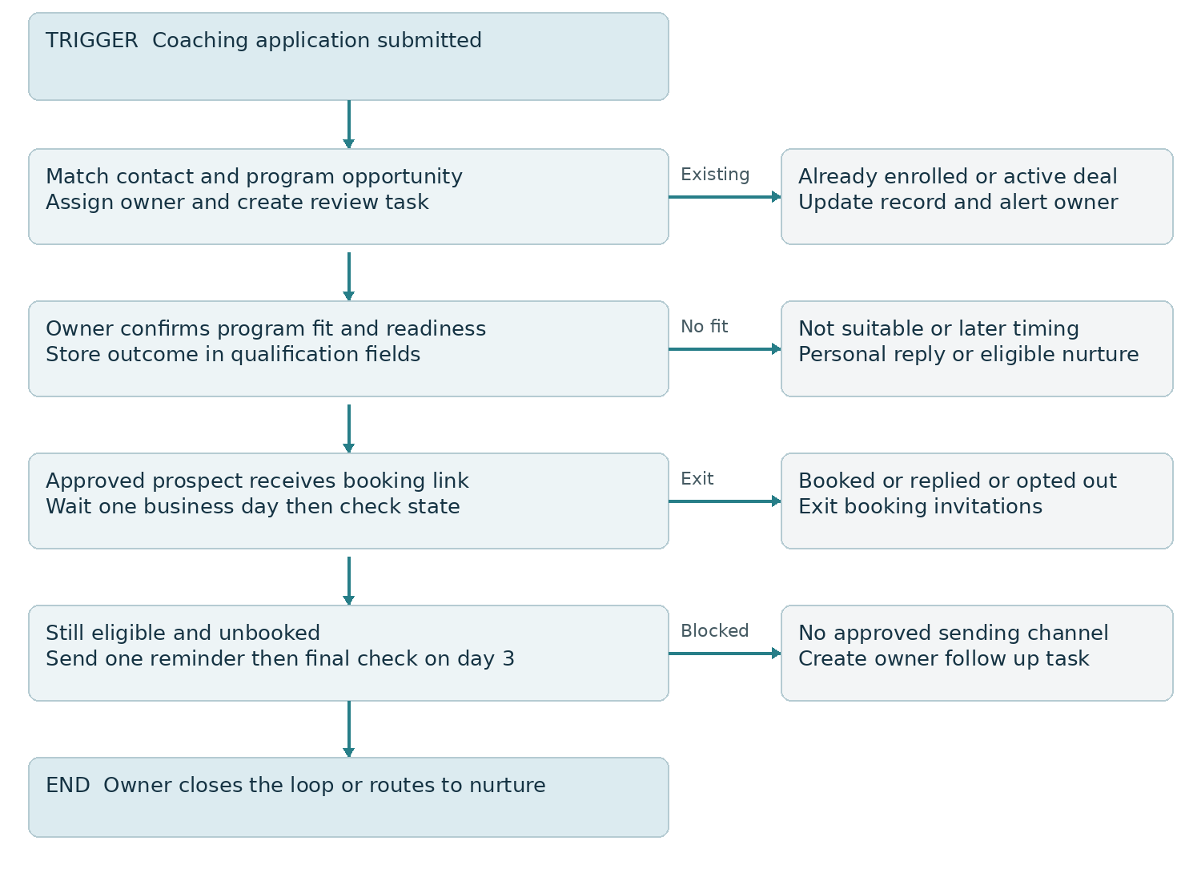
Figure 1 Application to approved discovery booking

Build rules and expected result
Record the application immediately and assign a review task due within one business day. Start booking follow-up only after suitability approval. Before each message, recheck booking, reply, opt-out, enrollment, and owner takeover. The reminder cadence is measured from the invitation, not from a form submitted days before approval.
Suitable prospects receive a clear booking route; unsuitable prospects receive a personal response or an agreed alternative. The coach can see unanswered applications and approved prospects who have not booked. Track application review time and qualified booking rate to evaluate the process.

04 Discovery call reminder automation
Workflow COACH CAL 01 applies only to the discovery calendar. Appointment-related actions use the appointment that triggered the workflow, so a discovery booking does not alter the client’s separate coaching sessions.
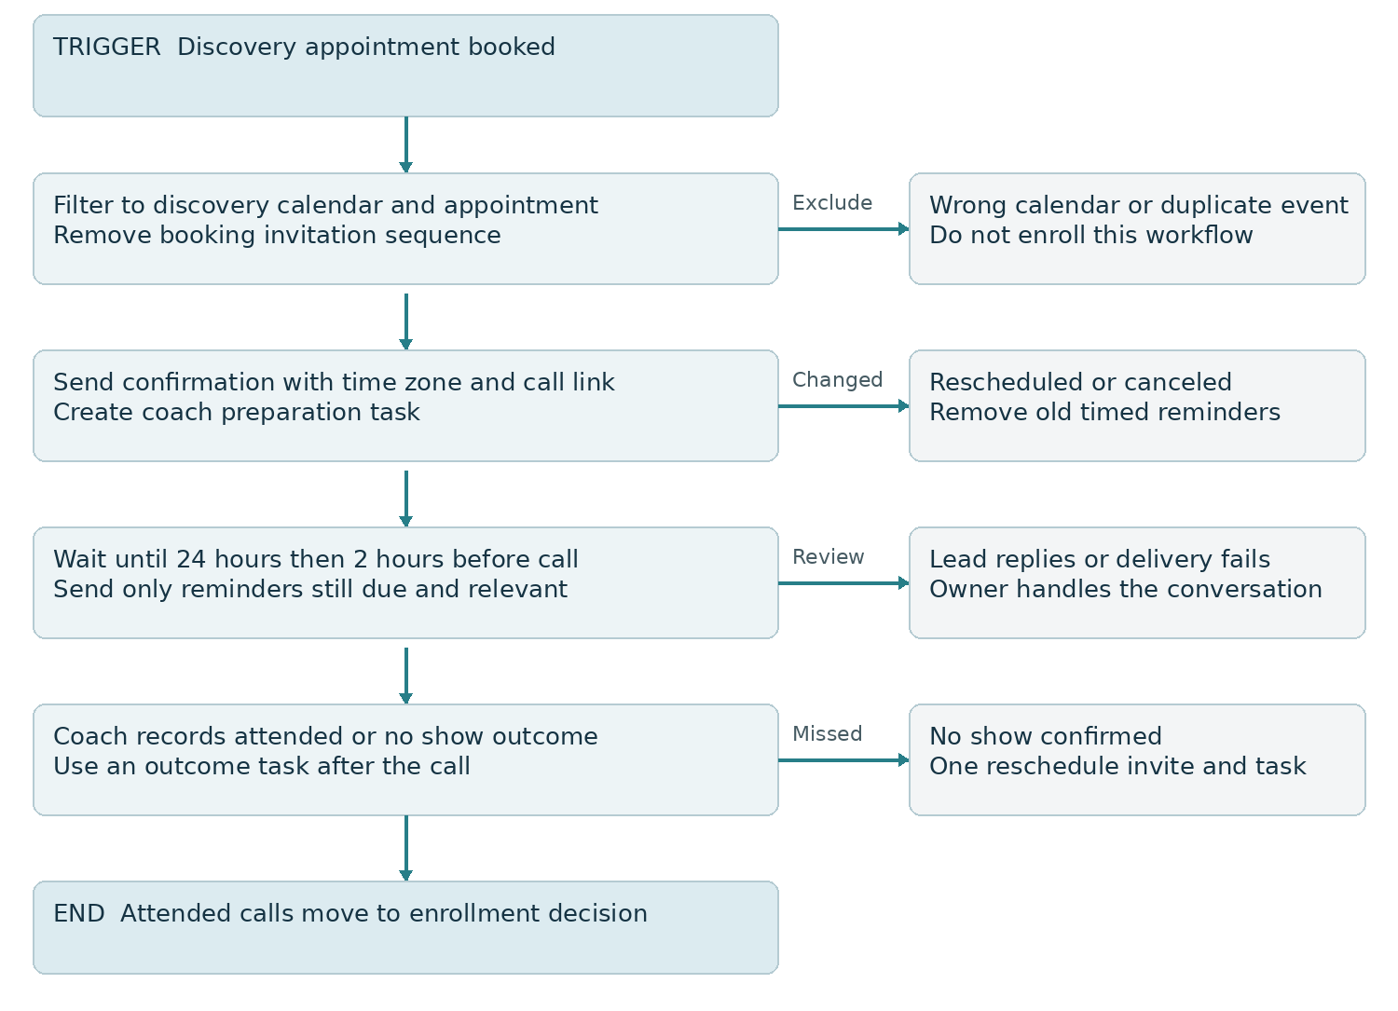
Figure 2 Discovery confirmation reminders and outcome routing

Timing and human handoff
Confirmation states the call’s purpose, duration, time zone, meeting link, and how to reschedule. Reminders are planned for 24 hours and 2 hours before the call; skip elapsed steps for last-minute bookings. Revalidate appointment status before every timed send. A reply creates an owner task and stops inappropriate automated chasing.
After the call, the coach records attendance, program fit, and the agreed next action. A no-show is confirmed by a person before the rescheduling route runs. Expected result: relevant reminders and accurate call outcomes, with attendance measured from appointments actually due rather than from all bookings ever created.

05 Enrollment and paid client onboarding
Workflow COACH CLIENT 01 starts from a verified successful payment filtered to the selected program. Payment confirms a transaction; access also depends on the agreed enrollment terms. External payments require a verified integration or controlled manual confirmation.
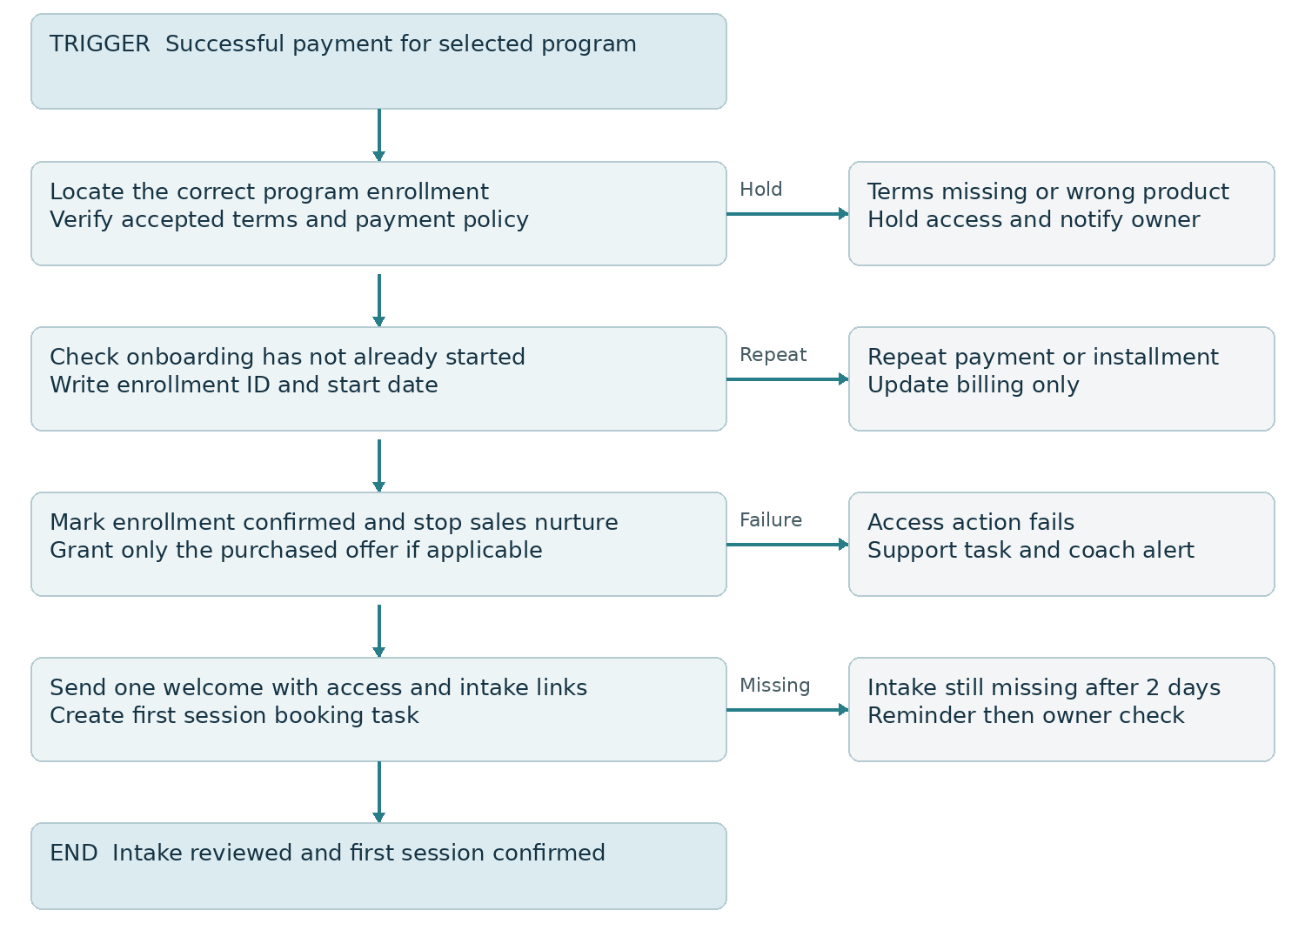
Figure 3 Verified enrollment to onboarding and first session

Enrollment controls
Map payment product or price identifiers to the correct program and enrollment. Check the agreement and initial-payment policy, then record that onboarding has started. Use a persistent enrollment marker to prevent duplicate welcomes on recurring installments or repeated events. Later installment payments update billing without starting the program again.
If resources are hosted in GHL, create the correct offer before using Course Grant Offer. Choose one source for the welcome and access instructions, and verify the portal link in a test purchase. If resources live elsewhere, use a tested integration or staff task rather than promising automatic access without a connection.

06 First sessions and ongoing client experience

Make onboarding complete when the client is ready
The welcome confirms what the client purchased, the start date, support boundaries, resource access, intake link, and first-session booking step. Track intake and the first booking independently. Intake reminders run only while intake is missing; session-booking reminders run only while the first session remains unbooked. The coach reviews intake before the first session.
After two business days, send one reminder for the outstanding step. After five business days, create a personal follow-up task instead of continuing a generic sequence. A client who cannot start is moved to a coach-approved hold state; reminders tied to the original start date are canceled or adjusted.

Separate client calendars from sales calendars
Use dedicated discovery and coaching calendars, with defined buffers, limits, availability, and time zones. Coaching-session reminders carry preparation details appropriate to enrolled clients. For group programs, distinguish the fixed group timetable from an individual scheduling link so clients are not asked to book sessions that already have assigned dates.

Support follow through without automating the coaching
Schedule a short reflection request after attended sessions when the coach considers it useful. Record the submission and create a review task. A missing reflection is a prompt for a check-in, not proof that the client has disengaged. Keep coaching decisions and detailed notes within the approved delivery process; CRM engagement data is only one operational signal.
Client event | System action | Human responsibility
Intake submitted | Record receipt and create preparation task. | Coach reviews context and clarifies missing details.
Session attended | Record attendance and send the approved reflection link. | Coach confirms next actions and session notes.
Repeated missed sessions | Flag attendance pattern and create a review task. | Discuss barriers and apply the program’s session policy.
Payment issue or pause request | Create billing or support task and suppress irrelevant renewal messages. | Apply agreed payment and access policies after review.

Expected client experience
Clients know where to start and whom to contact. The coach can distinguish an incomplete setup, a scheduling problem, and a coaching concern. Measure time from confirmed enrollment to intake review and first attended session, with approved deferrals tracked separately.

07 Progress reviews completion and renewals

Plan milestones from the actual program dates
I will build milestone tasks from the program start and end dates. For a 12-week engagement, a useful starting design is a week-2 onboarding check, week-6 midpoint review, and week-10 continuation discussion. The coach approves the schedule and questions; shorter programs use proportionate milestones rather than inheriting these dates unchanged.

Midpoint review automation
Workflow COACH REVIEW 01 checks that the enrollment is active, then sends an approved progress reflection and creates a coach review task. The form can ask what has changed, what remains difficult, and what support is needed. Submission completes the collection step, but a coach confirms the review itself. Paused or withdrawn clients do not receive an active-program prompt.

Renewal and continuation
Create continuation tasks 30 and 14 days before the planned end where the program length allows. The coach reviews goals, progress, client preference, and available capacity before proposing the next engagement. An open complaint, pending refund, pause, or unresolved billing issue routes to support first. Renewal messages stop when the client declines or makes a new decision.

Completion and feedback
At completion, send the approved summary or resource plan and request feedback. A testimonial request is separate and optional. Obtain permission for the exact wording and attribution before publishing. A survey submission or positive rating is not automatic consent to use a client’s story publicly.

Expected business result
The client receives a deliberate close or continuation conversation. The coach gains a timely view of upcoming program completions and unresolved support needs. Track completion, eligible continuation decisions, renewed enrollments, and reasons for decline; these measures explain the relationship more clearly than a count of automated messages.

Program changes must update the schedule
A changed start date, pause, or extended end date must cancel or recalculate existing milestone tasks and timed messages. Test these changes against the correct enrollment so a returning client’s old program does not trigger current renewal prompts.

08 Future growth strategies

Build a segmented education journey
After the paid-client process is stable, add a lead magnet or workshop aligned with one coaching problem. Deliver the requested resource first, then offer a short education sequence to eligible subscribers. Segment by stated interest and behavior without treating a download as purchase readiness. Invite qualified subscribers to the application when the next step matches their needs.

Introduce workshop follow up
Separate registered, attended, and missed participants using verified attendance data. Attendees can receive the replay or relevant follow-up plus an application invitation. Non-attendees receive the replay and another appropriate opportunity to engage. A click alone does not prove attendance. Suppress application promotions for clients already enrolled in that program.

Reactivate prospects at the right time
Use the recorded Not now reason and desired start timing to schedule an owner review before recontact. Check permission, current enrollment, and available capacity. Send a relevant invitation tied to the program’s next start date or an agreed follow-up, rather than a blanket campaign to every old contact. Evaluate qualified reopened opportunities and enrollments.

Grow group delivery with capacity controls
For cohort programs, add cohort ID, enrollment deadline, seat capacity, and start date. Keep a waitlist route when the program is full. If seats are sold through multiple sources, verify a shared capacity process; a simple form submission must not be treated as a reliable seat reservation. Confirm the place only after the enrollment gate passes.

Add assisted conversations only when useful
If lead volume creates a response bottleneck, pilot conversation automation for approved program information and scheduling. Define supported questions, message limits, and coach escalation. Keep suitability decisions, sensitive client disclosures, refunds, and outcome claims with a person. Review accuracy and completed handoffs before widening use.

Evaluate each expansion before adding another
Compare the lead source, application quality, call attendance, enrollment rate, support workload, and remaining delivery capacity. If calls are weak, improve qualification and preparation. If onboarding is slow, fix that process before adding traffic. Scaling should support a consistent coaching experience as well as a fuller calendar.

09 Implementation roadmap and measurable results
Phase | Build and release criteria | Expected operating result
Days 1 to 10 | Confirm program rules, audit current journey, define records, owners, permissions, and baseline. | Approved scope and measurable starting point.
Days 11 to 30 | Build application, fit review, discovery calendar, reminders, and enrollment follow-up. Test all exits. | Prospects receive the appropriate next action.
Days 31 to 60 | Connect verified payment, onboarding, correct offer access, first sessions, and client milestones. | Enrolled clients follow a clear start process.
Days 61 to 90 | Review mature cohorts, tune one bottleneck, activate continuation reviews, and pilot one growth strategy. | Improvements follow results and capacity.

Schedule begins when required access, program information, and approvals are available. Failed acceptance tests or missing inputs delay the affected release rather than allowing an incomplete client experience.
Metric | Definition | Decision it supports
Qualified booking rate | Qualified applications that book ÷ qualified applications in the same intake cohort. | Review suitability and booking friction.
Discovery attendance | Attended discovery calls ÷ calls due, with exclusions defined consistently. | Review reminders and preparation.
Enrollment conversion | Confirmed paid enrollments ÷ qualified attended discovery calls in a mature cohort. | Review fit and the enrollment conversation.
Time to first session | Median days from enrollment confirmation to first attended session; track agreed deferrals. | Find onboarding or scheduling delays.
Continuation rate | Renewed eligible enrollments ÷ enrollments eligible for continuation in the same completion cohort. | Evaluate continuation timing and client preference.

These are measurement definitions, not promised percentages. Compare equivalent programs and sources after enough time for decisions to mature. Do not report opportunity value as collected revenue; reconcile payments, refunds, and cancellations separately.

10 Validation responsibilities and next steps

Acceptance tests before live enrollment
Test a new application, duplicate submission, returning client, two program opportunities for one contact, missing owner, suitability rejection, last-minute booking, reply, opt out, canceled call, rescheduled call, no-show, failed message, wrong payment product, missing agreement, repeated payment, partial payment, failed offer access, incomplete intake, changed start date, pause, and renewed enrollment. Record expected messages, record changes, and tasks against each event.
Block release if an ineligible person receives access, an installment duplicates onboarding, an old appointment sends a reminder, or a paused client receives active-program prompts. Configure response and re-entry settings per workflow, and test explicit removal from overlapping sales sequences. A global tag alone is not a sufficient substitute for program-specific state checks.

Responsibilities and deliverables
I will provide the approved process map, field dictionary, pipeline definitions, configured workflows, message templates, calendar setup, test evidence, reporting definitions, and handover guide. The coach approves program eligibility, pricing and terms, response capacity, support boundaries, reflection questions, access policy, and client-facing copy. The coach remains responsible for suitability, coaching delivery, and relationship decisions.
Platform subscription, email and SMS usage, payment processing, advertising, and external integrations are scoped separately. The first working session confirms the program, current tools, lead sources, and the highest-priority gap so the build begins with a clear release goal.

Official implementation references
HighLevel documentation reviewed 9 October 2026. These sources support the platform capabilities; the workflow logic and proposed timing are the implementation design in this strategy.
Workflow triggers
https://help.gohighlevel.com/support/solutions/articles/155000002292
Payment Received trigger
https://help.gohighlevel.com/support/solutions/articles/155000003534
Course Grant Offer action
https://help.gohighlevel.com/support/solutions/articles/155000003378
Membership course access and welcome handling
https://help.gohighlevel.com/support/solutions/articles/155000002845
Appointment context for status actions
https://help.gohighlevel.com/support/solutions/articles/155000003364
Workflow settings and re-entry controls
https://help.gohighlevel.com/support/solutions/articles/48001239875

