GoHighLevel Service Business Strategy
  - Inquiry handling estimates job bookings and repeat business
Prepared by Philip Jeid Fabito | October 2026

Strategic recommendation
I recommend building a connected inquiry-to-job process in GoHighLevel that gives every service request an owner, every estimate a follow-up plan, and every completed job a clear payment and customer-care process. The system will organize communication and sales milestones so the team can spend less time reconstructing what happened and more time progressing the work.
This strategy is designed for a local home service business such as cleaning, landscaping, HVAC maintenance, or property services. The first build covers one selected service line and service area, using an assessment or estimate before a confirmed job booking. The company’s pricing model, urgency rules, crew capacity, and existing scheduling tools will determine the final configuration.

The business problem
An owner working on site may miss an inquiry. The office may send an estimate but never record the next follow-up. A customer may accept without knowing whether the job is actually scheduled. After completion, unpaid invoices and future service dates can become disconnected from the original job. These gaps affect the customer experience and the team’s ability to plan.

What I will build
A service inquiry form, lead and job records, service-area qualification, inquiry response workflows, estimate tracking, assessment and booking communications, completion and invoice follow-up, and repeat-service reminders. Three automation diagrams show the triggers, checks, actions, and exception routes.

Expected business outcomes
The office can identify unanswered requests and pending estimates. Customers receive relevant next steps and confirmed booking details. The business can distinguish accepted work, scheduled work, completed jobs, and paid invoices. Commercial improvement will be evaluated against the baseline after implementation, without assuming guaranteed sales or collection results.

Implementation priority
Stabilize inquiry ownership first, then estimate follow-up and booking confirmation. Add completion, billing, and repeat-service processes once job records and integration events are reliable.

01 Problems and the service customer journey
Problem to validate | Process I will build | Outcome to evaluate
Missed calls and inquiries have no clear owner. | Source-specific intake, permitted acknowledgment, office task, and overdue escalation. | Fewer requests sitting without a human response.
Unsuitable jobs consume office and estimator time. | Service-area, job-type, and capacity review before assessment. | A clearer queue of work the business can serve.
Estimates are sent without a decision date. | Estimate ID, version, owner, expiry, and follow-up checks. | Pending decisions become visible and actionable.
Acceptance is confused with a confirmed booking. | Deposit and readiness checks followed by office-confirmed scheduling. | Customers receive dependable booking information.
Payment and future service are handled from memory. | Job completion record, invoice state checks, and service-specific due dates. | Clearer outstanding balances and repeat-work opportunities.

The journey I will map
Inquiry → service fit review → assessment if needed → approved estimate → customer decision → booking readiness → confirmed job → service completion → payment reconciliation → customer care and future service. An assessment appointment and the actual job are separate milestones. An accepted estimate does not establish that a crew is available.

Discovery questions
Which services and locations are eligible? Which calls are urgent? Is pricing fixed or assessment-based? Who approves an estimate? Is a deposit required? Who schedules crews? Which system records job completion and invoices? What happens with access problems, weather delays, disputed work, repeat visits, and cancellations?

Baseline and audit evidence
Review 30 to 60 days of inquiries, call records, estimates, bookings, completed jobs, and invoices. Identify missing owners, unknown sources, unanswered inquiries, aging estimates, and gaps between accepted work and confirmed scheduling. If data is missing, establish a prospective baseline before judging the new process.

02 GHL architecture and job data design

Define where each business fact is recorded
GHL will manage customer records, inquiry routing, sales stages, reminders, and follow-up. If the business already uses field-service software for crew dispatch, route planning, inventory, job sheets, or accounting, keep that system responsible for those functions. Connect agreed milestones to GHL through verified integrations or controlled staff updates. Do not assume that an appointment calendar replaces a dispatch system.
Record | Required information | Design rule
Customer contact | Identity, phone and email, communication preferences, source, and relevant company if commercial. | One customer can have multiple properties and jobs.
Job opportunity | Job ID, service type, service address, area eligibility, urgency, owner, next action date, and quoted value basis. | Create one opportunity per distinct job; repeat inquiry about that job updates it.
Estimate reference | Estimate ID, version, sent date, expiry, accepted or declined state, scope approval, and decision date. | Follow up on the current version and correct job only.
Booking and delivery | Assessment ID, confirmed job date or window, scheduling owner, assigned crew reference, and completion state. | Dispatch or office confirmation establishes the real booking.
Billing and repeat work | Invoice ID, deposit requirement, paid and due balance, service completion date, and next service due date. | Deposit payment is distinct from final settlement.

Pipeline definitions
Sales stages are New inquiry, Fit review, Assessment booked, Estimate preparation, Estimate sent, and Decision pending. Mark Won when scope and the agreed commercial acceptance conditions are confirmed. Track delivery separately through Scheduling pending, Job confirmed, In progress, Completion review, and Closed. Won does not mean the job is completed or the invoice is paid.

Duplicate and source controls
Match repeat inquiries using contact and job details rather than the customer alone. One returning customer can have two legitimate open jobs. Preserve supported first and latest attribution, and enter referrals or offline sources explicitly. Unknown source remains visible; do not assign every inquiry to the latest advertising campaign.

03 Inquiry response and qualification automation
Workflow SERVICE INTAKE 01 begins from the approved form or a verified call event. Calls and forms may require separate entry workflows with common routing logic. The diagram maps the business rules rather than treating every inquiry as an automatic job booking.
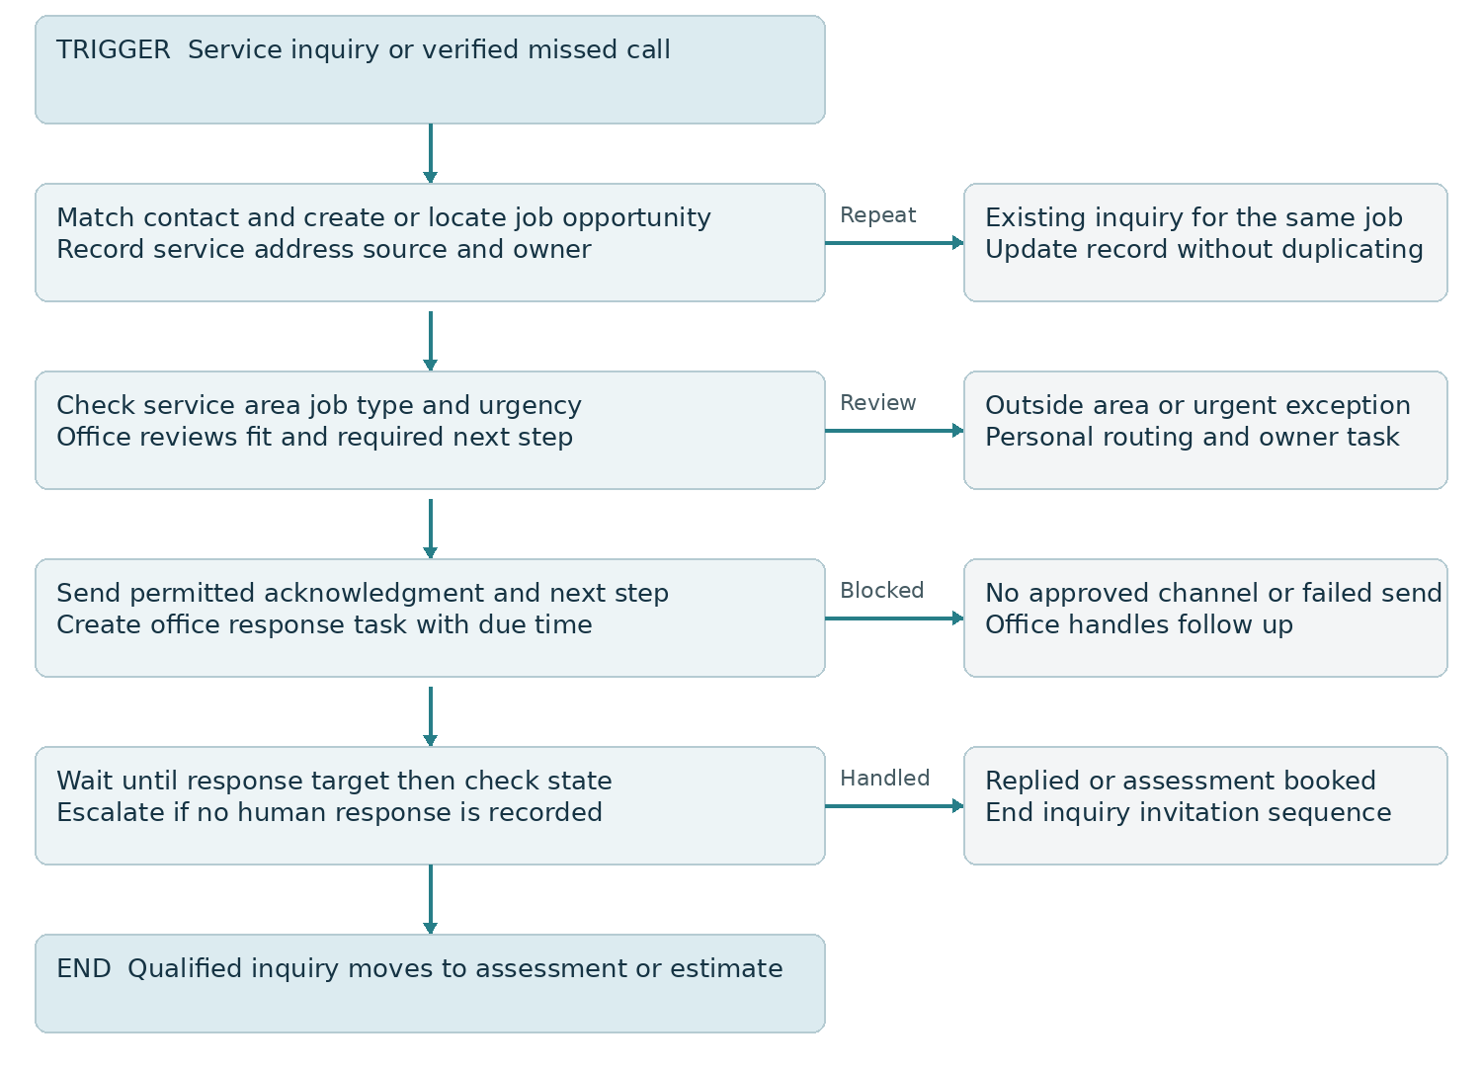
Figure 1 Service inquiry capture qualification and office handoff

Build rules and expected result
The form captures service type, address or service area, contact details, and a short description. Acknowledgment confirms receipt and states when the office will respond. For staffed hours, begin with a proposed 30-minute human response target; confirm that target against actual coverage. After-hours inquiries enter the next working-hours queue.
Missed-call acknowledgment uses a verified missed-call outcome and an approved sending rule. Prevent repeated texts from repeated calls within the agreed suppression window. Urgent requests are escalated to the designated person; automation must not promise emergency response or a specific arrival time without confirmation. Result: a visible, owned queue of requests and fewer unanswered inquiries.

04 Estimate follow up automation
Workflow SERVICE ESTIMATE 01 starts only after an approved estimate is sent for the intended job. The estimator remains responsible for scope, pricing, and revisions. Use draft review when the price or work scope needs human approval.
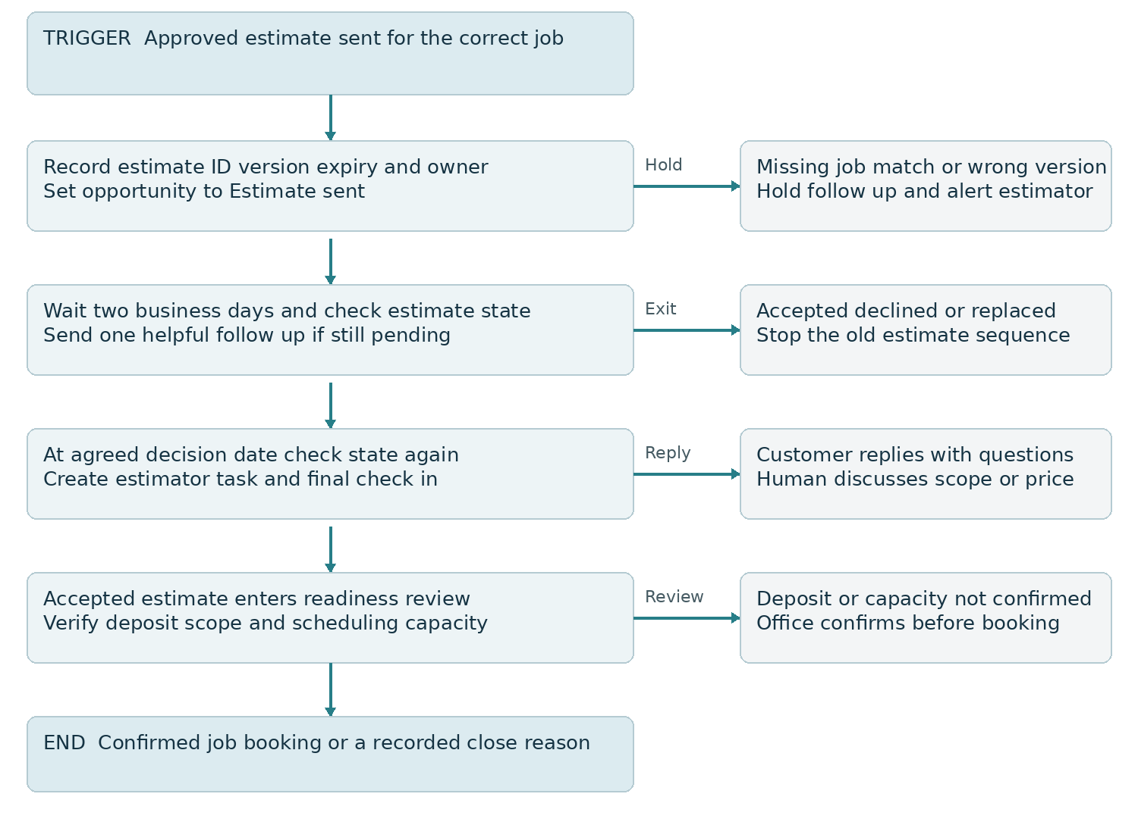
Figure 2 Estimate follow up acceptance checks and scheduling handoff

State checks and outcome
Check accepted, declined, expired, superseded, and replied states before every follow-up. The proposed cadence is one helpful message after two business days and an owner task at the agreed decision date. If the estimate expires sooner, the expiry rule takes precedence. A viewed estimate is an engagement signal, not acceptance.
Acceptance removes the old follow-up sequence and creates scheduling readiness tasks. Declines record a reason where known; silence is recorded as unresolved or closed without decision according to policy. Result: the estimator can prioritize pending opportunities without sending reminders about work already accepted or revised.

05 Booking readiness and service communication

Confirm readiness before reserving the job
After estimate acceptance, verify the agreed scope, required deposit, service address, access needs, crew availability, and expected duration. If any item is missing, create a scheduling-owner task and keep the job at Scheduling pending. The customer receives a confirmation only after the office or dispatch system has established the date or arrival window.

Keep assessments separate from jobs
Use separate appointment types and calendars for assessments and service visits where GHL is used for booking. A customer booking an assessment receives assessment preparation details, not a claim that the actual service is scheduled. For simple services with published pricing and reliable capacity, direct booking can be a later route after duration and availability rules are tested.

Booking and reminder workflow
Workflow SERVICE BOOK 01 starts from the confirmed job event or the correct service appointment. Send the date or arrival window, service address, preparation instructions, contact number, and rescheduling route. Plan reminders for 24 hours and 2 hours before the visit where appropriate, skipping elapsed steps for late bookings. Recheck job state before each send.
A reschedule cancels obsolete timed messages and rebuilds reminders around the new time. A cancellation stops service prompts and creates the appropriate deposit or refund review task. Weather, access, or crew delays generate an office-owned communication task. Messages must state confirmed information; a calendar reminder does not establish a technician’s real-time arrival.
Exception | System response | Human decision
Deposit still pending | Hold confirmation and create office task. | Apply the agreed deposit and cancellation terms.
Customer requests a change | Stop outdated reminders and notify scheduling owner. | Confirm revised scope and date.
Crew or weather delay | Flag job and create communication task. | Approve the new arrival window or reschedule.
Access problem or return visit | Keep the job in review and record the blocker. | Decide what work remains and what the customer needs to know.

Expected customer experience
Customers can distinguish a requested visit from a confirmed service booking. The office sees what prevents scheduling and who can resolve it. Measure the delay from acceptance to confirmation and the rate of avoidable schedule changes, with client-requested changes recorded separately.

06 Completion payment and customer care automation
Workflow SERVICE CLOSE 01 begins only when staff or the trusted job system confirms completion for the specific job. Appointment time passing, estimate acceptance, and deposit payment do not establish completion.
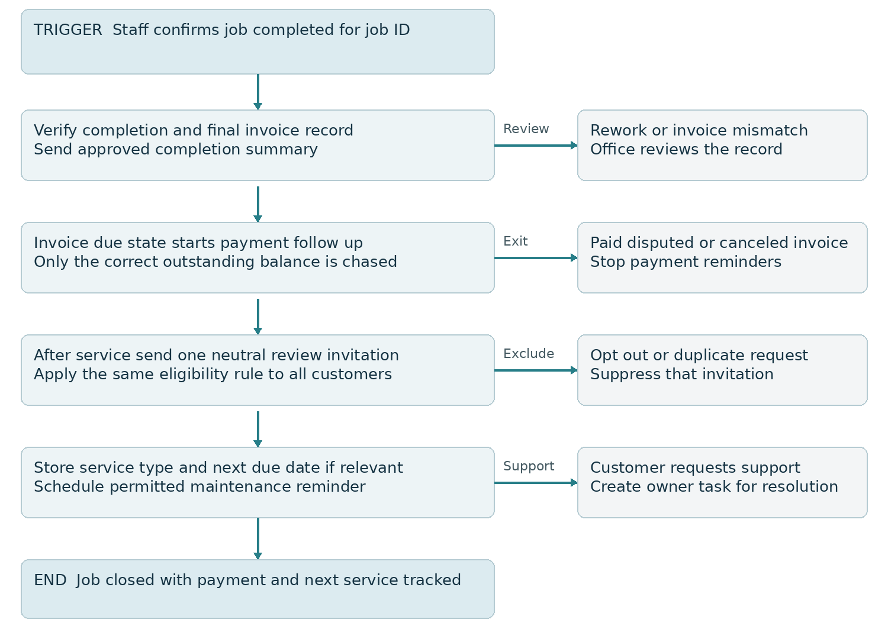
Figure 3 Job completion invoice checks and future service routing

Invoice and review controls
Billing follows the authoritative invoice state and remaining balance. Send reminders on the agreed due date and, if appropriate, three and seven days overdue. Stop when paid, canceled, or disputed, and route disputes to the office. External accounting events require a tested integration; do not assume a native GHL invoice trigger fires for every external payment.
Send a neutral review invitation after the completed service using consistent eligibility criteria. Do not use a satisfaction score to decide who may leave a public review. Keep support available to every customer. A review-link click is not proof a review was posted. Prevent duplicate requests when an accounting integration also sends them automatically.

07 Repeat work retention and future growth

Use service intervals that match the actual job
Record a next service date only when the service requires one or the customer has agreed a future visit. An HVAC maintenance plan may have a different interval from cleaning or landscaping. The interval comes from the business’s service policy and the customer’s plan; it should not be copied indiscriminately across every completed job.
Workflow SERVICE RETURN 01 checks that the reminder is due, the customer is eligible for the channel, and the next service is not already booked. Send a relevant invitation before the due date, then create an office task if the customer replies. A new booking cancels repeat invitations for that service cycle. Returning work creates a new job record rather than reopening the old completed job.

Recover undecided estimates selectively
After the active estimate sequence ends, segment prospects by service type, recorded reason, and desired timing. Review current estimate validity and capacity before contacting them with a relevant reason to reconsider. Exclude declined contacts who do not want further contact, active jobs, and opt outs. Reconfirm pricing before presenting an expired estimate as available.

Build recurring service plans
Once the core process is reliable, add a recurring-service offer for suitable customers. Define visit frequency, included work, payment schedule, pause rules, and renewal terms. Track each actual visit separately from the subscription. Successful recurring payment does not prove that a visit occurred, and cancellation must update both billing and future job scheduling.

Improve demand and capacity together
Compare lead sources by qualified jobs, estimate acceptance, completed work, and collected payments. If inquiries are healthy but estimates stall, improve response and follow-up before increasing spend. If crews are full, use an accurate waitlist or availability message instead of automating promises the team cannot fulfill.

Future assisted conversations
Pilot conversation automation for approved service information, area eligibility, and assessment scheduling only after routing is stable. Define when a person must take over for urgent requests, unclear scope, price exceptions, complaints, or safety concerns. Review answer accuracy and completed handoffs before expanding the pilot.

08 Implementation roadmap and measurable results
Phase | Build and release criteria | Expected operating result
Days 1 to 10 | Audit the journey, choose one service line, define areas, owners, job IDs, scheduling authority, and baseline. | A clear build scope and reliable starting definitions.
Days 11 to 30 | Build intake, qualification, assessments, estimate follow-up, and booking readiness controls. | Inquiries and pending estimates have visible next actions.
Days 31 to 60 | Connect completion, invoice states, customer care, and repeat-service dates. Test external event mapping. | Job and billing follow-up reflect actual business events.
Days 61 to 90 | Review completed cohorts, improve one bottleneck, and pilot one repeat-service or acquisition strategy. | Expansion follows results and available delivery capacity.

The schedule begins once required access and business inputs are supplied. An affected release stays on hold when essential integration events or acceptance tests fail.
Metric | Definition | Decision it supports
Human response time | Median inquiry-to-first-human-response time in agreed working hours. | Review office coverage and escalation.
Estimate acceptance | Accepted current estimates ÷ sent estimates for a mature job cohort. | Review scope fit and estimate follow-up.
Booking progression | Confirmed jobs ÷ accepted jobs in the same cohort, with readiness blockers recorded. | Identify deposit or scheduling friction.
Collection status | Open invoice balance and aging, reconciled to the authoritative billing system. | Prioritize overdue balances and disputes.
Repeat-service rate | Eligible customers booking the next service ÷ customers due for that service cycle. | Evaluate reminder timing and ongoing demand.

Set numeric targets from the baseline and staffing capacity. Report quoted value, accepted work, and collected payment separately. Compare equivalent service types and lead sources, allowing time for estimates and jobs to reach their outcomes.

09 Validation responsibilities and next steps

Acceptance tests before live release
Test a new form, repeat missed calls, duplicate inquiry, two open jobs for one customer, out-of-area request, after-hours arrival, urgent routing, missing owner, opt out, human reply, wrong estimate version, accepted estimate, declined estimate, expired estimate, partial deposit, capacity blocker, canceled job, reschedule, completion correction, invoice paid, disputed balance, and duplicate review request. Record expected messages, owner tasks, and job or invoice changes for each event.
Block release if an unrelated job changes, an accepted estimate still receives sales prompts, a deposit is treated as full settlement, a canceled visit sends a reminder, or an external payment is chased because synchronization failed. Test recovery and repeated events as well as the normal path.

Responsibilities and deliverables
I will deliver the process map, field dictionary, pipeline rules, configured workflows, message templates, calendar or integration setup, test record, reporting definitions, and operating guide. The business approves service areas, urgency routes, pricing authority, scheduling capacity, deposit policy, customer communications, and repeat-service rules. The office owns customer exceptions; estimators own scope and price; delivery staff confirm completion; finance confirms balances.
GHL subscriptions, messaging usage, advertising, payment processing, dispatch software, and custom integrations are scoped separately. The first working session confirms the chosen service line and the highest-impact gap so implementation starts with a concrete operating goal.

Official implementation references
HighLevel documentation reviewed 9 October 2026. Platform capabilities support the design; timings and business gates are the implementation recommendations in this strategy.
Estimate workflow events
https://help.gohighlevel.com/support/solutions/articles/155000003704
Send Estimate action and draft review
https://help.gohighlevel.com/support/solutions/articles/155000003705
Invoice state workflow trigger
https://help.gohighlevel.com/support/solutions/articles/155000002835
QuickBooks review automation and invoice trigger limits
https://help.gohighlevel.com/support/solutions/articles/155000004140
Review events and contact association limits
https://help.gohighlevel.com/support/solutions/articles/155000003873
Workflow settings and re-entry controls
https://help.gohighlevel.com/support/solutions/articles/48001239875

