Shopify Store Operations and Customer Retention Strategy
  - Virtual assistant delivery and automation implementation
Prepared by Philip Jeid Fabito | October 2026

Strategic recommendation
I recommend building a reliable daily operating process before expanding promotions. This strategy connects product accuracy, order review, fulfillment follow up, customer service, and customer retention so that each task has a clear owner and each automation responds to a verified store event.
The initial scope is a direct to consumer Shopify store selling physical products through one primary market, with a warehouse or fulfillment partner. I will confirm your product categories, fulfillment model, existing apps, policies, and operating hours during the opening audit. The implementation timings and workflow intervals below are proposed starting settings for your approval.

The business problem
As order volume grows, routine store work can become scattered across Shopify, supplier messages, spreadsheets, and customer inboxes. A paid order can wait without an owner, a product page can show outdated details, and a customer can receive a promotion while waiting for a service issue to be resolved. These are the process risks the audit will test in your store.

How I will build the solution
I will establish a daily VA queue, document fulfillment and support handoffs, clean priority product records, and pilot three workflows. Shopify will remain the source of truth for orders, products, payments, and inventory. Existing apps will retain responsibilities they already perform reliably.

Results the strategy is designed to produce
Your team will gain clearer order ownership, fewer manual transfers, more consistent customer follow up, and a measurable view of operational delays and repeat purchases. Revenue improvements will be evaluated against your store baseline rather than assumed in advance.

01 Problems process and business outcomes
Problem to validate | Process I will implement | Intended outcome
Orders wait for review | A paid order queue with risk and stock exceptions and a dispatch deadline | Orders reach the right fulfillment owner sooner
Product information is inconsistent | SKU based product checks with owner approval for commercial changes | More accurate pages and fewer avoidable questions
Support conversations lack ownership | One case record per issue with due dates and escalation | Clear response responsibility and fewer missed cases
Checkout recovery is inconsistent | One eligible recovery sequence with purchase and reply exits | Relevant follow up without duplicate reminders
Customers receive irrelevant promotions | Delivery based follow up and product specific repeat purchase segments | More appropriate retention opportunities
Owner reports omit operational delays | Weekly dashboard plus exception log and decision list | Earlier visibility into issues and workload

Audit before implementation
I will inspect the past 30 days of orders and support activity, extending the period where volume is low. I will review fulfillment delays, canceled orders, returns, top support reasons, product errors, and existing automated messages. I will trace several orders from payment through delivery to establish where records and responsibilities diverge.

Decisions needed from your team
We will agree the dispatch promise, staffed support hours, returns policy, refund approval authority, inventory source, primary communication channel, brand voice, and campaign budget. I will record which changes I can make independently and which require your approval.

02 Daily Shopify VA operating process
The daily work queue will rank active customer and order exceptions before routine catalog maintenance. I will leave an end of shift handoff showing unresolved issues, their owners, and the next promised action.
Cadence | VA activity | Evidence and handoff
Start of shift | Review new paid orders overdue dispatches failed workflows and urgent cases | Prioritized queue with order ID owner and due time
During each staffed shift | Review risk flags and stock exceptions coordinate fulfillment and respond to support | Shopify notes linked case and warehouse confirmation
Daily catalog block | Check approved product updates variant information images collections and stock mismatches | Change log with before and after records
End of shift | Recheck open cases and orders due today summarize blockers | Handoff with explicit owner and next action
Weekly | Review metrics audit workflow runs and verify a selection of catalog records | Performance report and improvement decisions

Catalog quality controls
Each product will have a consistent title, description, variant options, SKU, approved price, images, shipping details, and collection placement. I will verify material claims, sizing, specifications, and image rights against information supplied by your team. Bulk changes will start with a small approved batch and a saved export of the affected records.

Inventory and merchandising
I will reconcile discrepancies with the warehouse or designated inventory system, rather than overwrite stock based on an old spreadsheet. Low stock alerts will use variant and location information. Replenishment decisions will account for sales rate, supplier lead time, and safety stock agreed with the owner; an alert alone will not create a purchase order.

Operating targets
The proposed support target is a first human response within one staffed business day. Dispatch escalations will follow your published handling time. We will confirm staffing capacity before adopting these targets and track exceptions separately from resolved cases.

03 Systems data and automation ownership
I will use native Shopify capabilities first and select one external automation platform only when a cross system task needs it. This keeps workflow ownership and operating costs understandable.
System | Responsibility | Selection rule
Shopify and Shopify Flow | Products orders inventory statuses and native event routing | Use for store events and available native actions
Existing helpdesk and email app | Customer conversations approved campaigns and unsubscribe handling | Keep one sender and one case owner
Make or Zapier | Managed cross app tasks notifications and reporting | Choose one where supported connectors meet the requirement
n8n | Custom mappings branching and integration logic | Use when hosting maintenance and technical ownership are agreed
GHL if already required | Approved CRM follow up for a defined customer use case | Add only after a clear requirement and consent mapping

The records I will map
Orders will be keyed by store and Shopify order ID, with payment status, fulfillment status, location, tracking, cancellation and return state. Line item and fulfillment IDs will preserve partial shipment details. Customers will be linked using Shopify customer ID where available; guest orders will be handled without relying only on email as a unique identity.
The case queue will store case ID, related order ID, issue type, assigned owner, priority, next action, due time, and resolution. Marketing eligibility will remain channel specific. A purchase will never be treated as automatic permission to send every promotional message.

Platform availability and dependencies
Shopify Flow is available on Basic, Grow, Advanced, and Plus. Its Send HTTP Request action requires Grow, Advanced, or Plus. I will confirm your plan, app actions, connector permissions, event coverage, and usage limits before finalizing the build. Where a feature is unavailable, I will propose a supported connector or a manual queue rather than assume it exists.

04 Paid order review and fulfillment workflow
This workflow organizes operational review after payment. It will not mark an order shipped or delivered simply because payment was received. Warehouse confirmation and tracking must come from the fulfillment source.
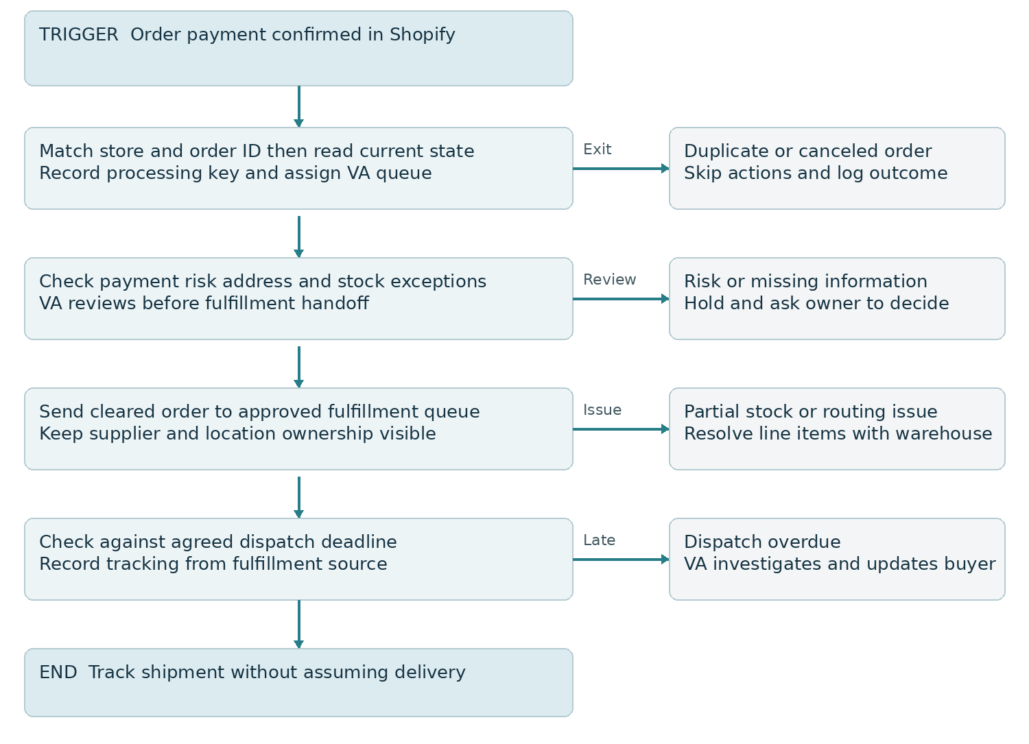
Figure 1 Paid order review with fulfillment exceptions

Build sequence and ownership
I will configure the paid order trigger, assign a queue owner, and define risk, stock, and address review rules. The VA will investigate flagged orders; the store owner will approve decisions outside the agreed policy. Cleared orders will follow the existing fulfillment process and be monitored against the dispatch deadline.

Checks before customer messages
I will audit Shopify and fulfillment app notifications to avoid sending a second confirmation or shipping message. Partial fulfillment will remain tied to the affected items. A fulfillment record indicates shipment processing; a delivered status requires a trusted delivery event or verified confirmation.
Expected result: your team can identify which paid orders are ready, blocked, or overdue and act on the right exception without changing financial or shipment statuses prematurely.

05 Abandoned checkout recovery workflow
I will audit existing recovery settings before enabling this sequence. One selected automation will own checkout recovery. The proposed 10 hour first wait and final reminder 24 hours later will be tested against your audience, existing messaging, and sending eligibility.
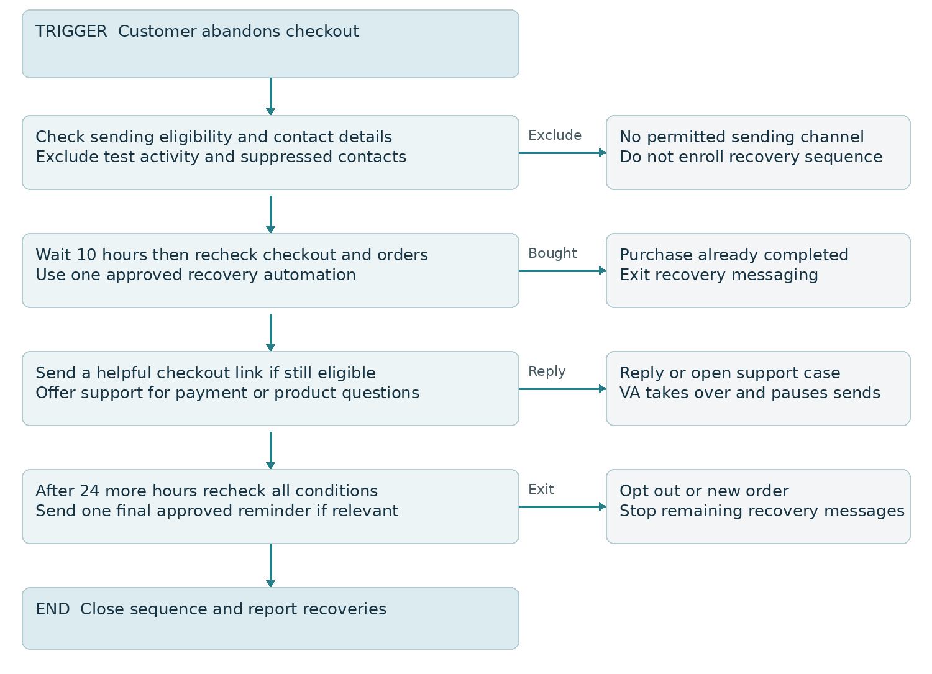
Figure 2 Checkout recovery with purchase and conversation exits

The message approach
The first message will offer the checkout link and help with payment, delivery, or product questions. I will begin without a blanket discount. A second message, if approved, will be the final reminder. Stock, pricing, discount validity, and the checkout link will be checked before launch.

Eligibility and measurement
Shopify abandoned checkout automation sends to email marketing subscribers by default. I will verify actual settings and suppression behavior in the chosen app. Purchase checks will use available checkout linkage and current order data; ambiguous matches will be reviewed rather than assumed. Replies will create a VA task and pause the relevant sequence.
Expected result: eligible customers receive a useful next step, completed buyers exit reminders, and recovery orders are reported with the attribution window and method stated.

06 Delivery follow up and repeat purchase workflow
Retention will begin with the customer experience after delivery. The initial scope is one product category with reliable delivery data. If tracking coverage is incomplete, I will use a manual review queue and avoid messages stating that an order has arrived.
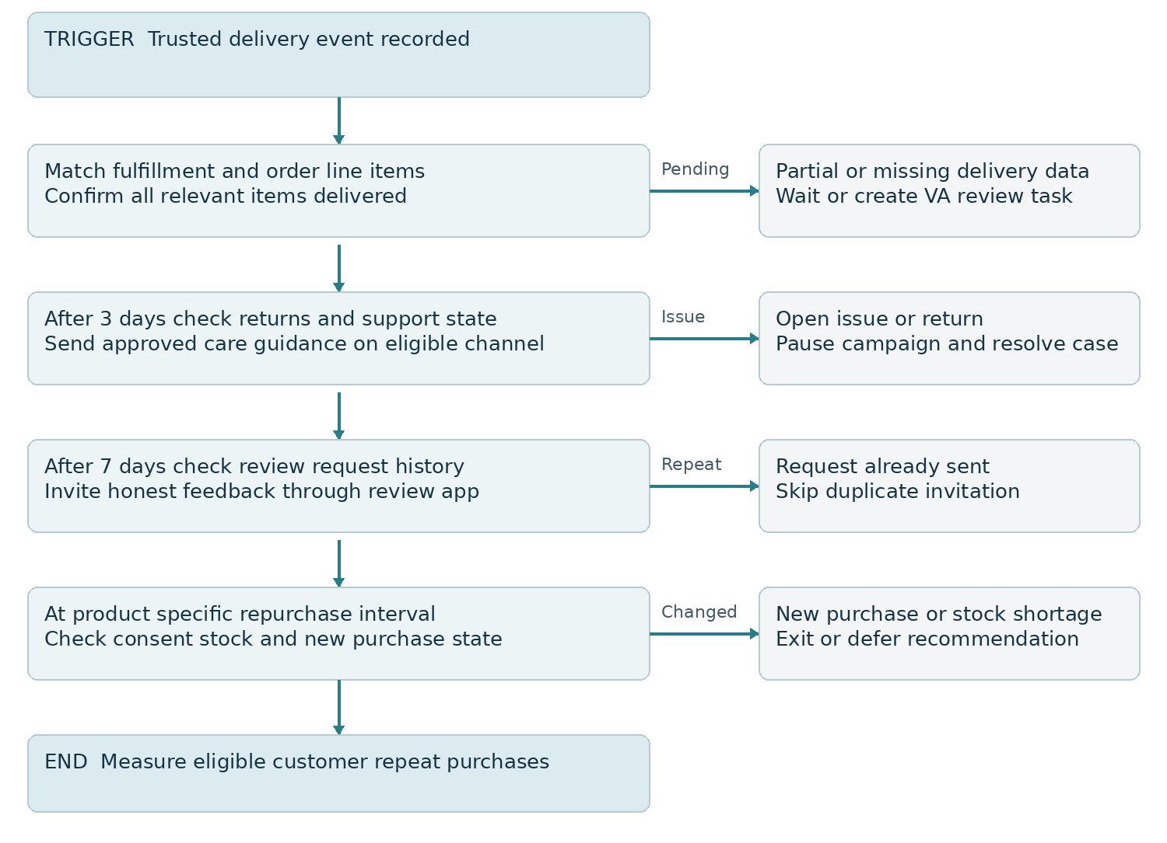
Figure 3 Delivery based care feedback and repeat purchase routing

Timing and campaign relevance
The proposed care message at day 3 and review invitation at day 7 will be adjusted for the product. A replenishment reminder will use a product specific interval agreed from purchase history and expected usage. Durable products will receive relevant accessory or care recommendations instead of an artificial replenishment schedule.

Exceptions and results
Open support cases and returns will pause promotional follow up. Review invitations will use neutral wording without filtering customers by satisfaction or making rewards conditional on positive reviews. I will coordinate with the existing review app so that one order receives one invitation. Repeat orders will exit the older recommendation sequence.
Expected result: follow up reflects what the customer bought and received, with fewer irrelevant messages and a measurable repeat purchase cohort.

07 Customer service returns and escalation
I will organize customer service around a case linked to its order, rather than a separate untracked reply in each inbox. The VA will check order history and prior promises before responding and use approved wording for delivery, product, cancellation, and return questions.
Issue | VA action | Escalation or authority
Shipment not received | Check tracking promise and warehouse evidence record investigation | Warehouse or carrier owner handles investigation deadline
Wrong or damaged item | Collect necessary evidence and confirm the approved remedy | Owner approves exceptions and replacement cost
Cancellation request | Check current fulfillment state before promising cancellation | Warehouse confirms whether shipment can be stopped
Return or refund | Check policy and record request reason and affected items | Refund only within written delegated authority
Payment dispute | Preserve relevant order and communication evidence | Owner handles financial decision and submission
Public complaint | Acknowledge and move order details to a private channel | Owner reviews sensitive or reputation critical response

Return status and payment status stay separate
A return request, received return, approved refund, and processed refund are different events. I will record each correctly and confirm restocking decisions with the warehouse. Promotional pauses will follow the unresolved case, while a resolved case can be reassessed for later eligibility.

Example customer response
“Thanks for contacting us about your order. I am checking the shipment with our fulfillment team. I will update you by the next agreed business day, even if the investigation is still ongoing. You can reply here if you have more information.” The final version will use your support hours and a specific update deadline.

The business outcome
Customers receive a clear next update, and your team can see unresolved promises. Weekly reporting will group the reasons behind support volume so product information, fulfillment, or policy issues can be corrected at their source.

08 Implementation plan and performance measures
Phase | Work to complete | Evidence of readiness
Days 1 to 10 | Audit app stack catalog orders support and consent agree access policies and baseline | Signed scope process maps and approved responsibilities
Days 11 to 30 | Build daily queue priority catalog cleanup and paid order workflow | Test log and limited live order pilot
Days 31 to 60 | Pilot recovery and delivery follow up for one category train the team | Verified exits suppression and weekly results
Days 61 to 90 | Refine segments reporting and repeat purchase timing | Cohort review and prioritized expansion plan

Timing depends on access, app capabilities, stock and fulfillment data quality, and approval turnaround. I will sequence work by impact and dependency; customer service and order visibility come before new campaign volume.
Measure | Definition | Review method
On time dispatch | Orders handed off by promised dispatch deadline divided by eligible orders | Weekly with holds and exclusions disclosed
First response time | Staffed hours from case arrival to first human response | Weekly median and overdue case count
Recovery conversion | Attributed recovered purchases divided by eligible messaged checkouts | Use one agreed window and deduplicate orders
Repeat purchase rate | First time customers who place another paid noncanceled order within 90 days divided by that cohort | Compare equally mature cohorts
Automation reliability | Successful eligible runs divided by all eligible runs | Include failures retries and manual corrections

Targets and interpretation
I will establish targets after the baseline audit. The first control target is complete ownership for every pilot exception. Revenue reports will distinguish gross sales, refunds, discounts, and shipping where relevant. Attributed recovery revenue will not be described as proven incremental revenue; a holdout test can estimate lift when volume allows.

09 Validation handover and future improvements

Acceptance tests before rollout
I will test a normal paid order, repeated event, unpaid order, risk flag, stock shortage, partial shipment, cancellation, missing delivery event, return, opt out, support reply, completed checkout, failed connector action, and repeated review request. Each test will record the expected action, actual result, owner, and any corrective work. A failed or uncertain write will be reconciled before retry to avoid a duplicate action.

Automation reliability and access
Cross system workflows will keep persistent event and action keys, recheck current Shopify state, log failures, and use bounded retries. Custom Shopify webhook endpoints will verify delivery signatures before processing. A daily reconciliation will compare eligible source records with workflow outcomes to find missed events. Your team will receive a pause procedure and manual fallback queue.
Access will use named users or eligible collaborator access with only the required permissions. Credentials will remain in managed connection settings. Refunds, pricing changes, app installs, and published theme changes will follow the approval authority agreed at kickoff. No automated risk decision will release a questionable order without the defined review.

Handover deliverables
I will provide the operating checklist, system and field map, three workflow diagrams, approved message copy, catalog change log, exception rules, test log, weekly report definitions, and a recorded or live walkthrough. Your store owner will approve commercial policies; the warehouse will confirm stock and shipment facts; I will own the agreed VA queue and workflow monitoring.

Future strategies after the pilot
Once the core process is stable, I will evaluate location specific replenishment alerts, product bundles based on purchase behavior, back in stock campaigns through an approved app, VIP service segments, and a replenishment or subscription offer where the product supports it. AI can assist with reply drafts and case classification after quality review; refunds and shipment commitments will remain governed by approved rules.
Recurring scope and fees will be agreed separately. Shopify subscriptions, third party apps, email or SMS sends, automation usage, and n8n hosting or maintenance are operating costs to approve before activation.

10 Implementation references
The following official references inform the platform checks in this strategy. Feature availability and your installed app configuration will be verified during implementation.
Shopify Flow and plan requirements
https://help.shopify.com/en/manual/shopify-flow
Flow triggers and event data
https://help.shopify.com/en/manual/shopify-flow/reference/triggers
Fulfillment event created
https://help.shopify.com/en/manual/shopify-flow/reference/triggers/fulfillment-event-created
Abandoned checkout automation eligibility
https://help.shopify.com/en/manual/promoting-marketing/create-marketing/migrate-abandoned-checkout
Managing users and roles
https://help.shopify.com/en/manual/your-account/users
Verifying webhook deliveries and handling duplicates
https://shopify.dev/docs/apps/build/webhooks/verify-deliveries

Next implementation milestone
The opening working session will confirm the store operating model, select the first product category and order cohort, and agree authority for customer resolutions. I will then finalize the process map and access requirements so the first build is tied to your actual store decisions.

