Social Media Lead Generation and Follow Up Strategy
  - Content community management and consultation booking
Prepared by Philip Jeid Fabito | October 2026

Strategic recommendation
I recommend connecting your social media content to a defined inquiry and consultation process. Posting will create opportunities for a conversation; community management and follow up will give those conversations an owner, a relevant next step, and an outcome that your team can measure.
This strategy is designed for a service business that sells through discovery calls or consultations. The initial pilot will focus on one offer, one primary audience, and Instagram with an adapted Facebook presence. I will validate the channel choice against your audience and account baseline before implementation.

The problem this strategy addresses
A business can publish consistently and still struggle to identify which posts create useful inquiries. Comments may go unanswered, direct messages may sit in different inboxes, and prospects may receive a booking link before anyone understands what they need. These are the process risks I will investigate during the audit.

How I will build the solution
I will define your offer and audience questions, create a content calendar, manage approved publishing and replies, and configure the inquiry process in GoHighLevel. Automation will support acknowledgment, routing, and eligible follow up. Your team will retain responsibility for qualification, sensitive conversations, and sales commitments.

Intended business outcomes
The result will be a more consistent publishing process, clearer inquiry ownership, relevant follow up, and visibility from content to qualified conversations and attended calls. Sales and audience growth will be assessed against the baseline; this strategy does not assume guaranteed revenue or follower increases.

01 Business problems and process design
Problem to validate | Process I will build | Intended outcome
Content topics change without direction | Audience questions mapped to one clear service offer | Content addresses relevant buying decisions
Posts attract attention but no next step | One appropriate call to action and working destination per post | Interested people know how to continue
Comments and messages lack ownership | Daily inbox review with assignment and due tasks | Fewer unattended inquiries
Leads receive generic follow up | Need based qualification and channel eligibility checks | More relevant conversations
Reports emphasize likes only | Track inquiries qualified leads bookings and attended calls | Business decisions tied to observable outcomes

Audit and discovery
I will review the previous 30 to 90 days of content, available account insights, inquiry volume, audience questions, and booking outcomes. I will also inspect profile links, pinned content, offer clarity, sender permissions, and existing messages. Results will be recorded with the date range and data gaps stated.

The initial audience and offer
We will identify who buys the selected service, the problem that triggers an inquiry, the information they need before booking, and the situations where the offer is unsuitable. Your team will confirm pricing boundaries, delivery capacity, service area where relevant, and the purpose of the consultation.

Ownership and response target
I will manage the agreed content and inbox queue. Your sales owner will decide qualification and close opportunities. The proposed initial target is a first human response within one staffed business day; urgent customer issues will be escalated according to your operating hours and policy.

02 Content strategy and monthly publishing plan
Each content item will have a business purpose, an audience question, and a next step. The following starting cadence is a proposed workload for a four week pilot, subject to your available assets and approval capacity.
Content purpose | Monthly starting volume | Direction and next step
Explain a customer problem | Four short videos | Describe one specific friction point and invite a relevant question
Explain your process | Four educational carousels | Show the service steps and direct readers to the offer page
Provide evidence | Two approved proof posts | Use verified outcomes with context and customer permission
Clarify the offer | Two service posts | State fit scope and what the discovery conversation covers
Maintain conversation | Stories on three days each week | Answer questions and share useful behind the scenes context

A practical campaign angle
For the first campaign, I will use the question “What should happen before you book this service?” Content will explain the problem, the process, and how to assess fit. A checklist can support the campaign if it genuinely helps the buyer prepare; the consultation remains the next step for suitable inquiries.

Creative formats and direction
A carousel will move from a recognizable problem to a process explanation and one next step. A short video will open with a customer question, demonstrate a useful answer, and invite a reply. Proof content will state the starting situation, the work completed, and the supported result without inventing testimonials or performance figures.

Publication decisions
The proposed 12 feed assets are original content items. Facebook adaptations will adjust the opening, crop, and links rather than create an unrelated second calendar. I will validate frequency using audience response and production capacity. Paid media, daily filming, and additional platforms will be scoped separately.

03 Content production and approval workflow
The content process will make review status visible. Scheduled publication will require an approved final version, and late changes will return the asset to review.
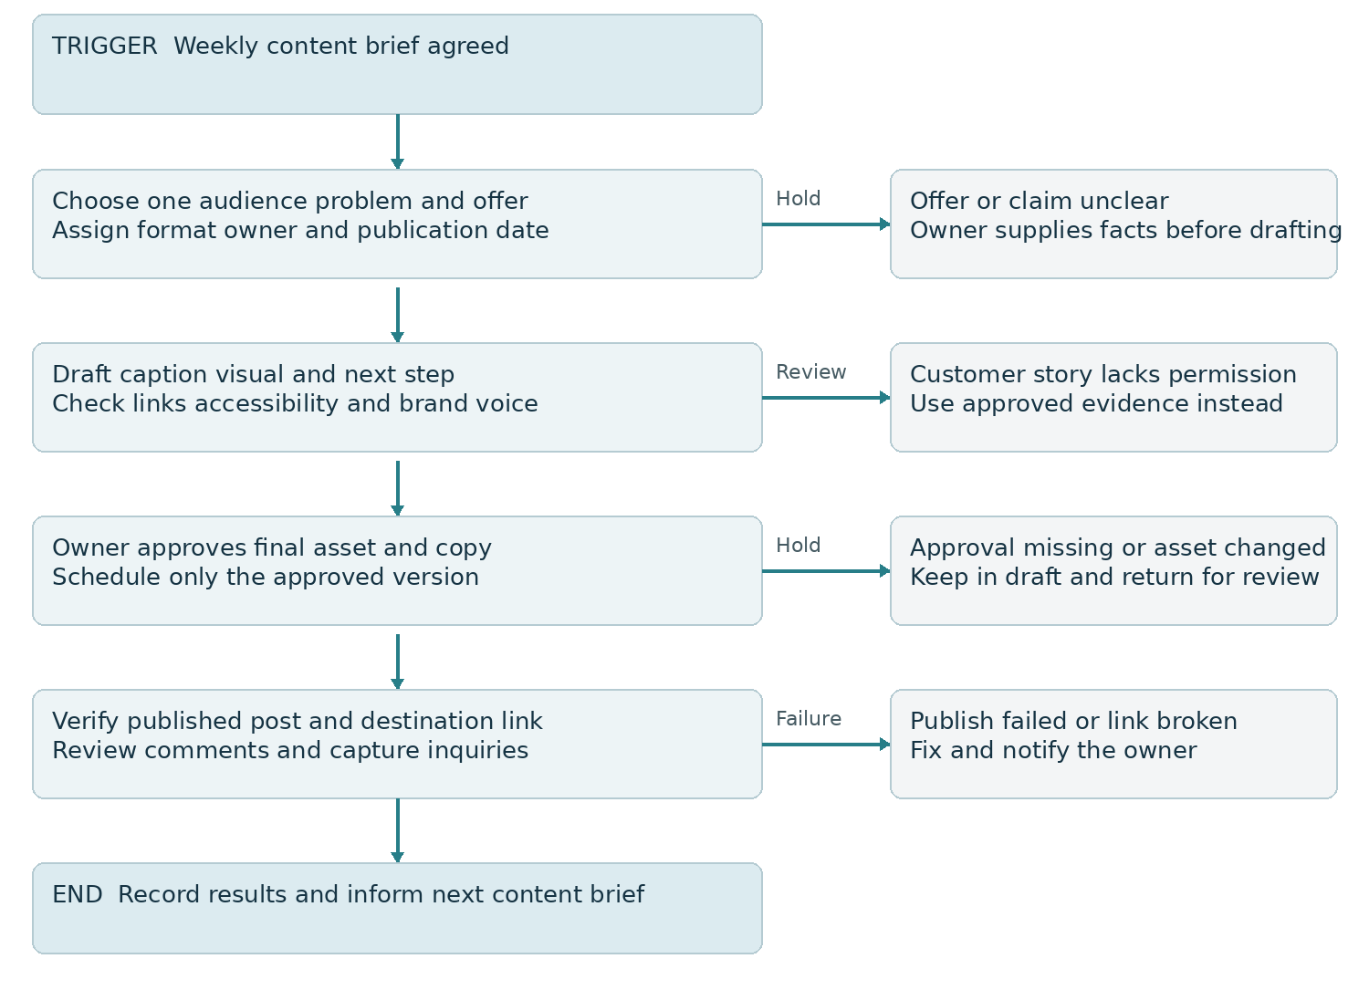
Figure 1 Content production with approval and publication checks

What the content calendar will record
Each entry will include content ID, audience problem, objective, format, draft link, caption, call to action, destination, responsible person, approval status, publication date, and live URL. Your team will see what is waiting for input and what is ready to publish.

Quality and approval controls
I will verify service details, factual claims, customer permissions, visual rights, readable captions, and destination links. The owner will approve commercial statements and final copy. If approval is delayed, I will adjust the schedule and use a previously approved evergreen asset only where appropriate.
Expected result: publication is consistent, brand decisions are traceable, and a failed post or broken link creates an action rather than disappearing from the workflow.

04 Social inquiry capture and qualification
The pilot will use selected campaign posts and inbound messages. A comment is an expression of engagement; it becomes a lead only when there is meaningful interest in the offer or a relevant request.
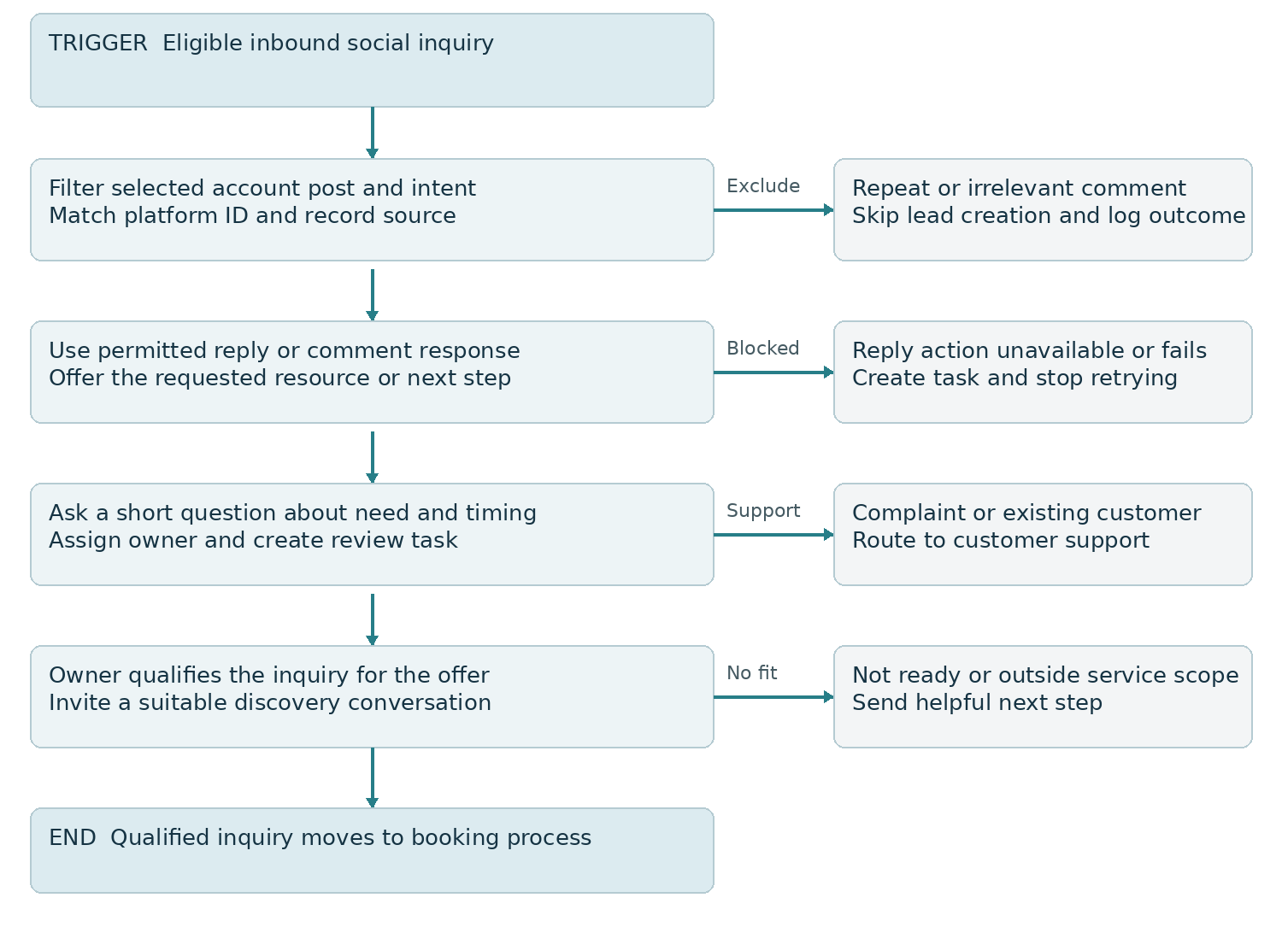
Figure 2 Inquiry capture with intent checks and human qualification

Build details
I will connect the authorized accounts, select the campaign posts and keyword conditions where supported, and test first level comments and customer replies. The record will retain account, post or content ID, campaign, platform contact ID, last interaction, owner, and next action. Repeated events will update the relevant conversation rather than create a new deal each time.

Qualification and conversation
The initial questions will establish the help needed, timing, and relevant fit criteria. Complaints and existing customer requests will go to support. Qualified prospects will receive the discovery invitation; people outside the service scope will receive a helpful response. A social identity will not be merged into an email record without a reliable match.
Expected result: genuine inquiries are assigned and reviewed, with fewer irrelevant pipeline entries and a clear handoff to the sales owner.

05 Booking and follow up automation
Follow up will depend on the lead state and the permitted channel at the moment of sending. The one and three business day timings below are proposed starting settings, not permission to send an automated social message outside an available reply window.
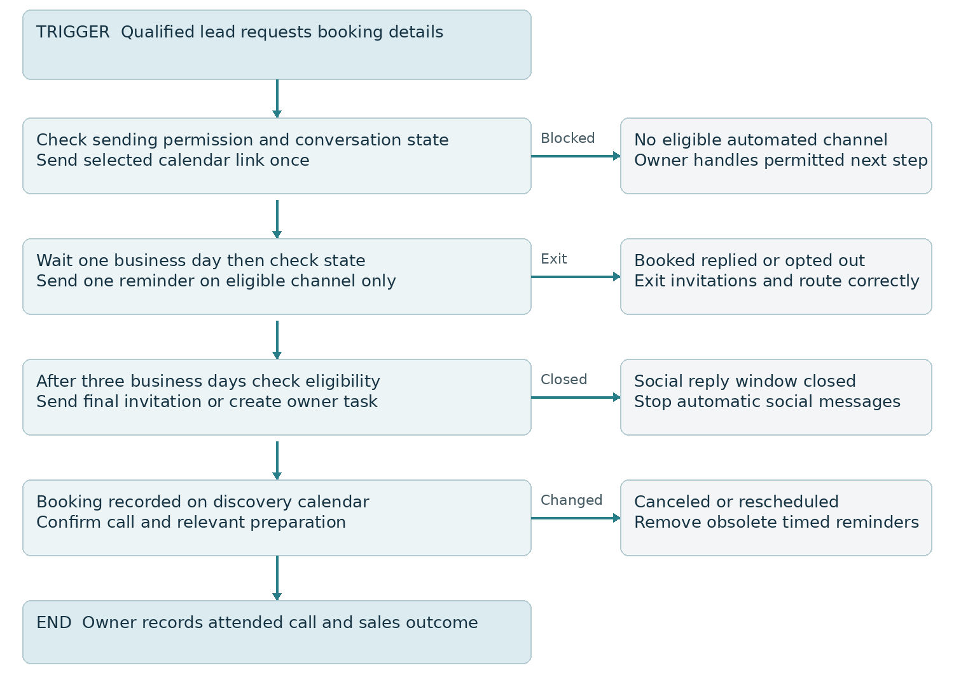
Figure 3 Booking invitations with state checks and channel exits

Channel rules and stop conditions
The GHL Instagram DM action requires a recent message to the connected account within its supported 24 hour window. A comment initiated private reply is a distinct action that must be configured with the correct trigger. I will test its availability separately. A resource request or social interaction will not be treated as consent for an email or SMS marketing sequence.
Before each invitation I will check booking, reply, owner takeover, suppression, and channel eligibility. Closed social windows will stop automatic social follow up. Where the person has separately provided eligible email permission, approved email follow up can continue. Failed sends will create a review task rather than an unrestricted retry loop.

Appointment outcomes
Confirmed bookings will end invitations. Reminders at 24 hours and 2 hours will be used only where still due and eligible. The owner will record attendance, no show, and sales outcome; cancellation and rescheduling will remove obsolete reminders.

06 Community management and customer experience
Community management will maintain the public conversation while keeping customer details private. I will review comments and messages during agreed coverage hours and leave a clear handoff for conversations that need the business owner.
Conversation | Response process | Responsible handoff
General service question | Use approved facts and ask one relevant follow up question | Social manager handles routine answers
Price or suitability inquiry | Clarify scope and route to qualification before commitments | Sales owner confirms commercial terms
Existing customer issue | Acknowledge and move identifying details to a private channel | Support owner receives case and due task
Negative feedback | Respond calmly verify facts and document the concern | Owner approves sensitive response
Spam or abusive content | Use the approved moderation policy and preserve evidence when needed | Owner reviews disputed moderation decisions

Message direction
An inquiry acknowledgment can say: “Thanks for asking about our service. What would you most like help with, and when are you hoping to get started? Our team will review your answer and guide you to the next step.” The final copy will use your brand voice and avoid promising immediate availability.

Conversations that require a person
Automation can deliver an approved resource and assign a task. It will not invent pricing, confirm outcomes, decide refunds, or make contractual promises. AI assisted drafts, if introduced, will use approved facts and human review for sensitive or uncertain answers.

Account access and resilience
Access will use assigned platform roles and authorized connections. I will document connection owners, permission dependencies, failure alerts, and the procedure for pausing automation. If an integration stops working, the manual inbox queue will preserve response ownership until the connection is restored.

07 Reporting and the 90 day delivery plan
Phase | Work | Review evidence
Days 1 to 10 | Audit audience offer content and inquiry flow confirm permissions | Baseline approved scope and campaign brief
Days 11 to 30 | Build calendar templates profile destinations and inquiry pilot | Approved assets tested workflows and first report
Days 31 to 60 | Run content and inbox process refine qualification and calls to action | Inquiry quality attended calls and response delays
Days 61 to 90 | Refine effective themes and evaluate controlled expansion | Cohort outcomes and next quarter priorities

Measure | Definition and interpretation
Qualified inquiry rate | Qualified unique inquiries divided by reviewed unique inquiries using agreed fit rules
Booking conversion | Qualified leads with a recorded discovery booking divided by eligible qualified leads
Attendance rate | Attended discovery appointments divided by appointments due excluding canceled calls
Response time | Staffed hours from inquiry arrival to first human response report median and overdue count
Content assisted outcomes | Inquiries bookings and wins linked to content IDs report attribution method and unknown sources
Publishing reliability | Approved scheduled assets published correctly divided by approved assets due

How I will evaluate results
The weekly report will connect content performance with inquiry quality, booking progression, and operational delays. Reach, saves, shares, and profile visits will help diagnose content response; they will not replace business outcomes. A qualified lead or sale will be counted once, even if the person engages with several posts.
I will record tagged links, campaign fields, and self reported sources where available. Social attribution will be described as directional where tracking is incomplete. Numerical growth targets will be agreed after baseline review, and reported revenue will require a confirmed sales record.

08 Validation handover and future strategies

Acceptance checks
Before rollout I will test an approved post, missing approval, failed publication, repeated comment, irrelevant comment, inbound inquiry, existing customer issue, missing contact identity, closed DM window, failed message, opt out, owner takeover, booking, cancellation, and rescheduling. The test log will compare expected and actual behavior and assign corrective work.

Client handover
I will provide the audience and offer brief, content calendar, editable creative templates, approved captions and replies, source field map, three process diagrams, automation settings, test log, weekly reporting definitions, and a team walkthrough. The operating guide will show how to assign conversations, record qualification and sales outcomes, pause workflows, and use the manual fallback queue.

Future improvements
After the initial pilot, I will evaluate repurposing the strongest educational content, an additional platform supported by audience evidence, customer referral content with permission, and a deeper email nurture sequence for separately opted in leads. Retargeting and click to message advertising can be scoped when creative evidence, tracking, response capacity, and budget justify a controlled test.
A content testing program will change one major variable at a time, such as the opening question or call to action, and assess lead quality alongside engagement. n8n, Make, or Zapier can support approved asset handoffs and reporting when native capabilities are insufficient; one external platform will be selected according to the workflow rather than connecting all three.

Scope and operating costs
The initial scope includes organic content and inquiry operations for the selected offer. Paid ad spend, extensive video production, influencer outreach, extra channels, and sales closing are separate scope items. Scheduling tools, GHL, messaging usage, and external automation subscriptions will be confirmed before activation.

Official implementation references
GHL Facebook and Instagram comment automation
https://help.gohighlevel.com/support/solutions/articles/155000002055
GHL Instagram DM action and sending eligibility
https://help.gohighlevel.com/support/solutions/articles/155000003298
GHL Instagram comment automation recipe
https://help.gohighlevel.com/support/solutions/articles/155000004658

