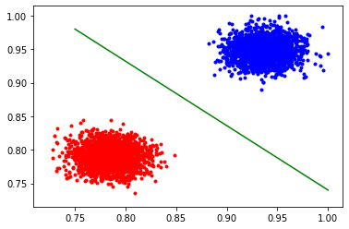

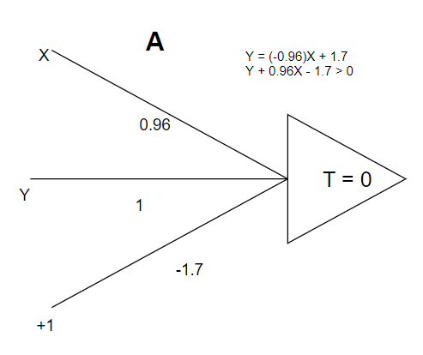

|  |  |  |  |  |
| --- | --- | --- | --- | --- |
| Group A |  |  |  |  |
| Classes | is_famale =yes | is_female =no | Total | Recognition |
| is_female =yes | 2000 | 0 | 2000 |  |
| is_female = no | 0 | 2000 | 2000 |  |
| Total | 2000 | 2000 | 4000 |  |

|  |  |  |  |
| --- | --- | --- | --- |
| **Group A** |  |  |  |
| ACC | 1 |  |  |
| Error | 0 |  |  |
| FP(M) | 0 | FPR | 0 |
| FN(M) | 0 | FNR | 0 |
| TP(M) | 2000 | TPR | 1 |
| TN(M) | 2000 | TNR | 1 |
| P(M) | 1 |  |  |

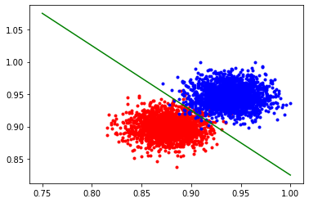

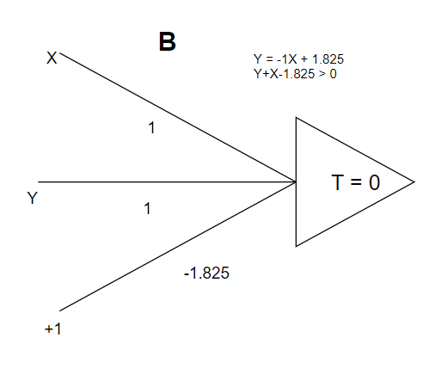

|  |  |  |  |  |
| --- | --- | --- | --- | --- |
| Group B |  |  |  |  |
| Classes | is_famale =yes | is_female =no | Total | Recognition |
| is_female =yes | 2000 | 0 | 2000 |  |
| is_female = no | 1912 | 88 | 2000 |  |
| Total | 3912 | 88 | 4000 |  |

|  |  |  |  |
| --- | --- | --- | --- |
| **Group B** |  |  |  |
| ACC | 0.522 |  |  |
| Error | 0.478 |  |  |
| FP(M) | 0 | FPR | 0 |
| FN(M) | 1912 | FNR | 0.956 |
| TP(M) | 88 | TPR | 0.044 |
| TN(M) | 2000 | TNR | 1 |
| P(M) | 0.51124 |  |  |

**Group C - Graph**

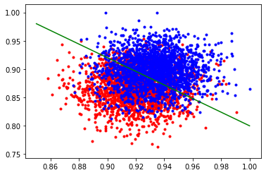

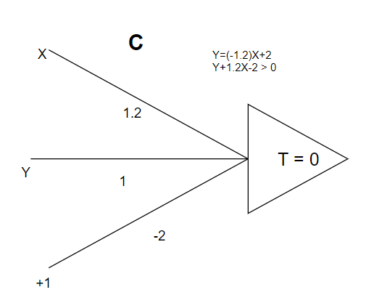

|  |  |  |  |  |
| --- | --- | --- | --- | --- |
| Group C |  |  |  |  |
| Classes | is_famale =yes | is_female =no | Total | Recognition |
| is_female =yes | 1994 | 6 | 2000 |  |
| is_female = no | 1845 | 155 | 2000 |  |
| Total | 3839 | 161 | 4000 |  |

|  |  |  |  |
| --- | --- | --- | --- |
| **Group C** |  |  |  |
| ACC | 0.53725 |  |  |
| Error | 0.46275 |  |  |
| FP(M) | 6 | FPR | 0.003 |
| FN(M) | 1845 | FNR | 0.9225 |
| TP(M) | 155 | TPR | 0.0775 |
| TN(M) | 1994 | TNR | 0.997 |
| P(M) | 0.51941 |  |  |