CMSC 409: Artificial Intelligence

Project No. 3

Due Tuesday, October 29th, 2019, noon

1. For this physical meaning of this neuron, the inputs (x) are the time (measured in hours); while the outputs are predicted energy usage (measured in volts).
2. The activation function that is used in the three architectures provided is a linear activation function. The linear activation function is being used because the neurons are predicting a line for the data to fall on using LMS learning.
3. Training, Testing, and Total Errors shown on following pages

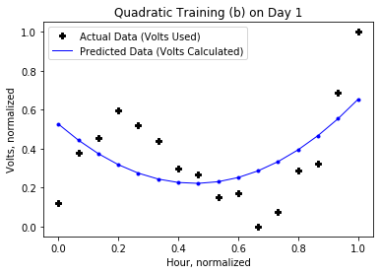**Day One:**

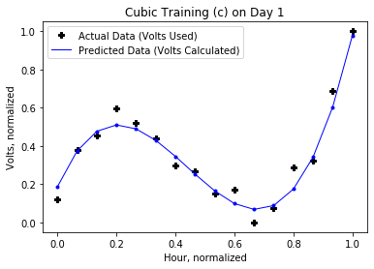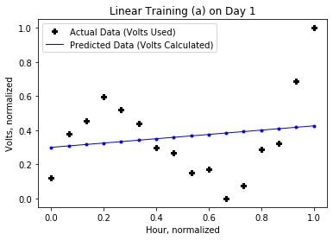

Total Errors:

Linear(a): 0.9431

Quadratic(b): 0.6902

Cubic(c): .0480

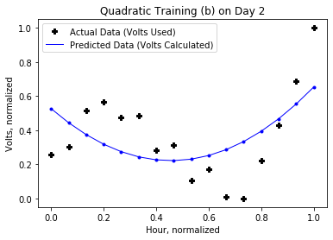**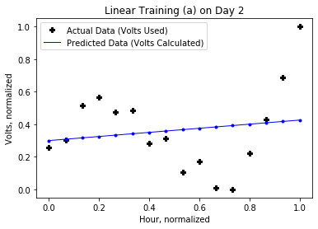Day Two:**

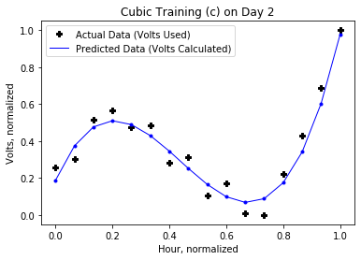

Total Errors:

Linear(a): 0.9825

Quadratic(b): 0.6599

Cubic(c): 0.0628

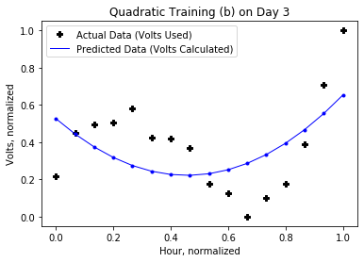**Day Three:**

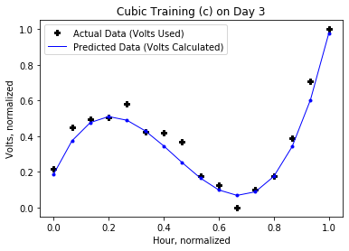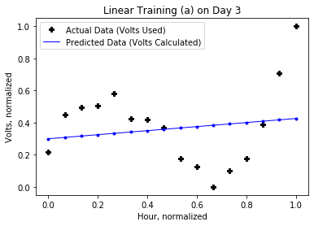

Total Errors:

Linear(a)= 0.9600

Quadratic(b)= 0.6820

Cubic(c)= 0.0540

**Day Four**

Linear(a) Prediction

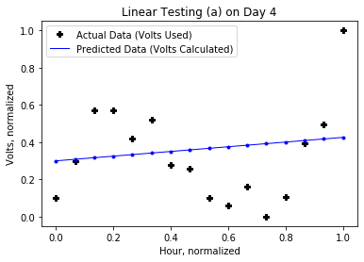

Predicted Values (Normalized):

(0.2997, 0.3081, 0.3165, 0.3249, 0.3333, 0.3417, 0.3501, 0.3585, 0.3669, 0.3753, 0.3837, 0.3921, 0.4005, 0.4089, 0.4173, 0.4257)

Actual Values (Normalized):

(0.0982, 0.2994, 0.5690, 0.5731, 0.4200, 0.5219, 0.2757, 0.2556, 0.1007, 0.0596, 0.1628, 0.0000, 0.1061, 0.3921, 0.4960, 1.0)

Total Error: 1.0181

**Day Four (Cont.)**

Quadratic(b) Prediction

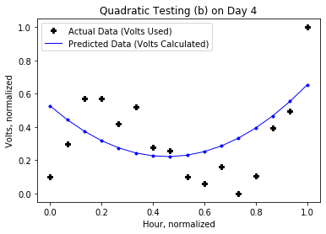

Predicted Values (Normalized):

(0.5255, 0.4433, 0.3742, 0.3179, 0.2746, 0.2443, 0.2269, 0.2224, 0.2309, 0.2523, 0.2867, 0.3339, 0.3942, 0.4674, 0.5535, 0.6525)

Actual Values (Normalized):

(0.0982, 0.2994, 0.5690, 0.5731, 0.4200, 0.5219, 0.2757, 0.2556, 0.1007, 0.0596, 0.1628, 0.0000, 0.1061, 0.3921, 0.4960, 1.0)

Total Error: 0.8016

**Day Four (Cont.)**

Cubic (c) Prediction

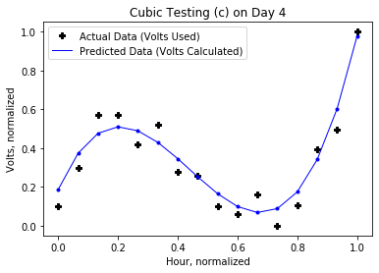

Predicted Values (Normalized):

(0.1873, 0.3739, 0.4765, 0.5100, 0.4893, 0.4296, 0.3457, 0.2526, 0.1654, 0.0990, 0.0684, 0.0885, 0.1745, 0.3411, 0.6035, 0.9767)

Actual Values (Normalized):

(0.0982, 0.2994, 0.5690, 0.5731, 0.4200, 0.5219, 0.2757, 0.2556, 0.1007, 0.0596, 0.1628, 0.0000, 0.1061, 0.3921, 0.4960, 1.0)

Total Error: 0.0862

1. For this project, we used 10,000 iterations in our learning algorithm. While it wasn’t needed for the linear architecture, it proved useful for the cubic architecture. It wasn’t as useful for the quadratic architecture, but still worked.

We normalized the data before training it because when taking the Total Error as

(Desired-Actual)2 for regular data the numbers are too high and hard to work with.

Optimal learning rates were found by trial and error, for linear and quadratic 0.001 was used, while cubic had a learning rate of 0.05. Variations in either direction altered the TE negatively, and so in the end these values were chosen.

For pre-processing the only action taken was normalizing the data. We had thought about taking the data of the 3 days at random, but in the end decided to take it out.