Grumpy maker wanna make an air quality sensor

Grumpy maker:
I Wanna make an air quality sensor from sensor-community. But it’s too haaaard...

Sensor community dude:
No, it’s easy! Come on, you geeky bear, I’ll show you.

Grumpy maker:
But what’s the minimal BOM (bill of materials)? I’m sure lots of components are needed...

Sensor community dude:
Oh, you’re so delectably negative! In fact, All You need is:

A Micro controller
a nodeMCU (esp8266) V3 | 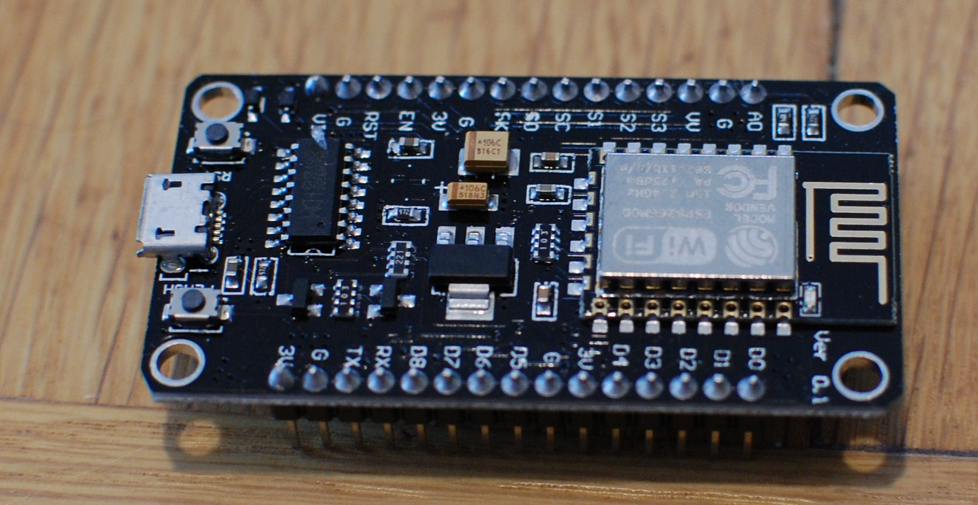
A Temperature/humidity sensor
a BME 280 | 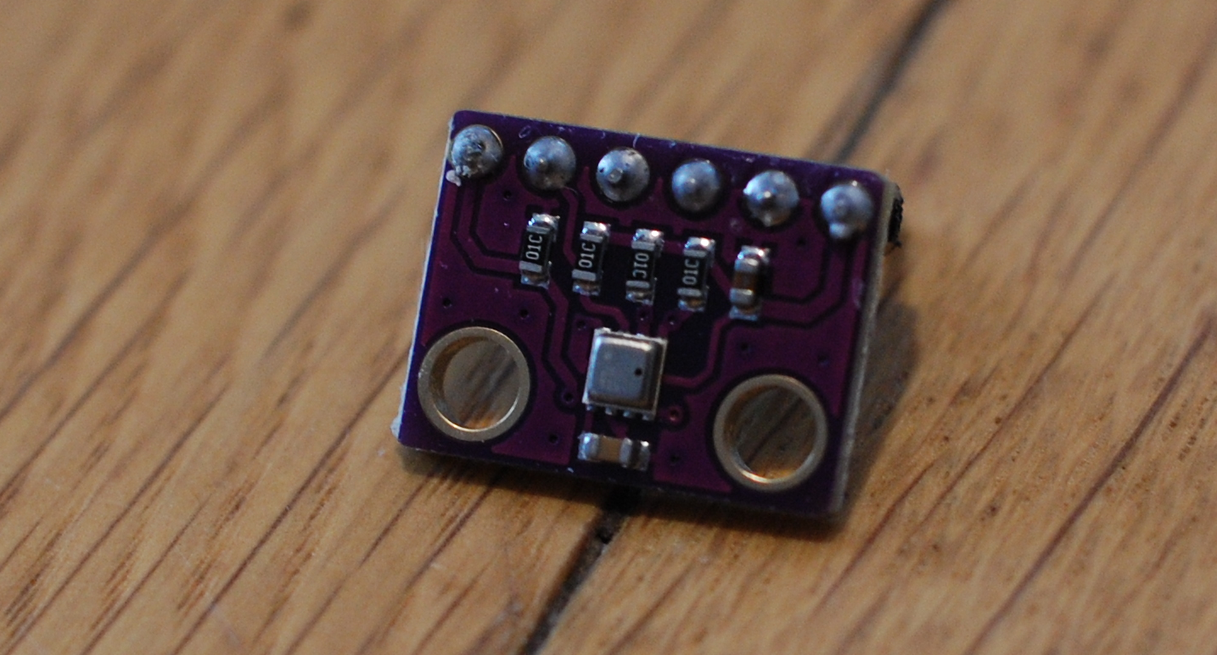
A PM sensor
a NOVA PM SDS011 with a small flexible pipe attached to it | 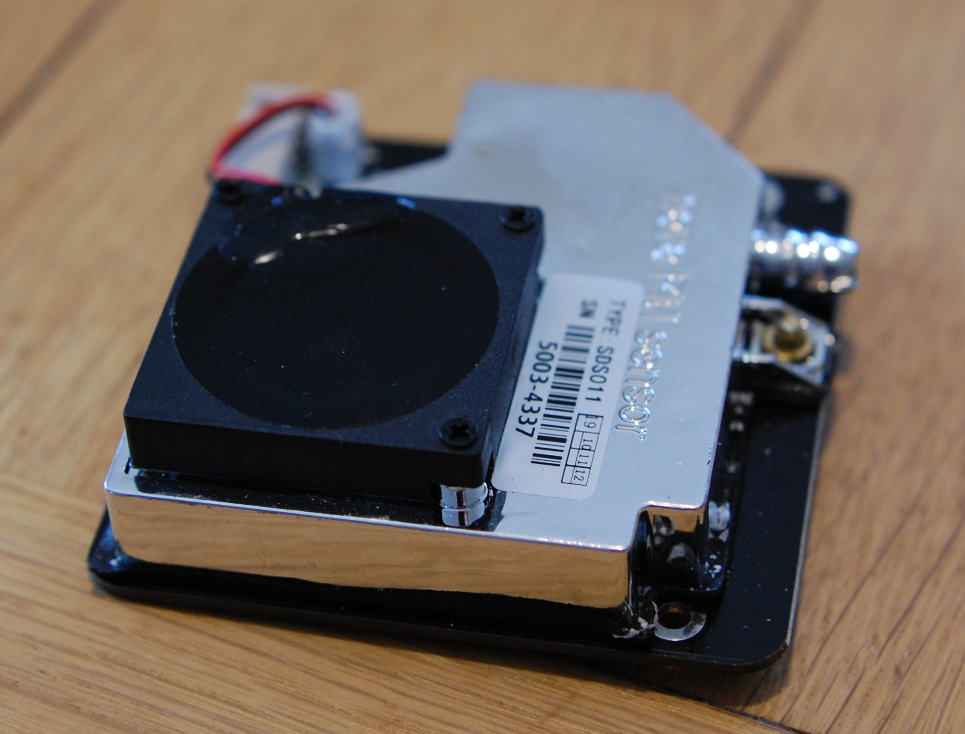
or
a PLANTOWER PMS7003 with its adapter | 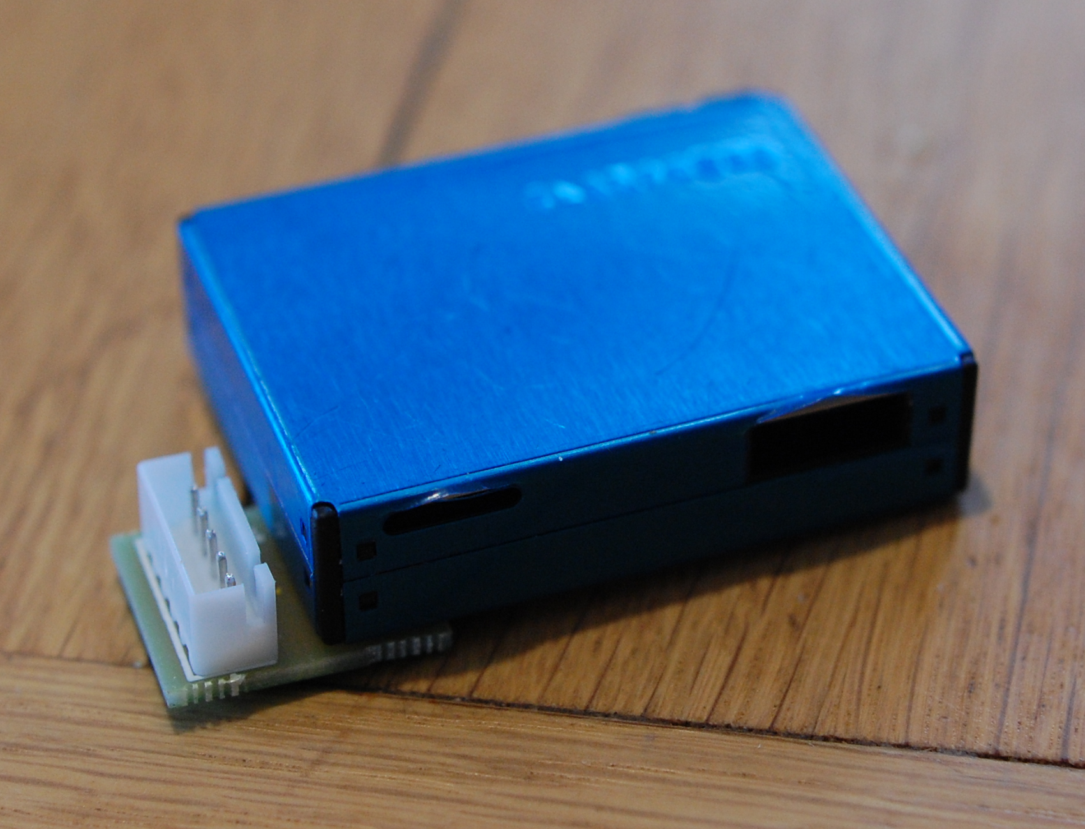
wires
8 female/female DuPont wires | 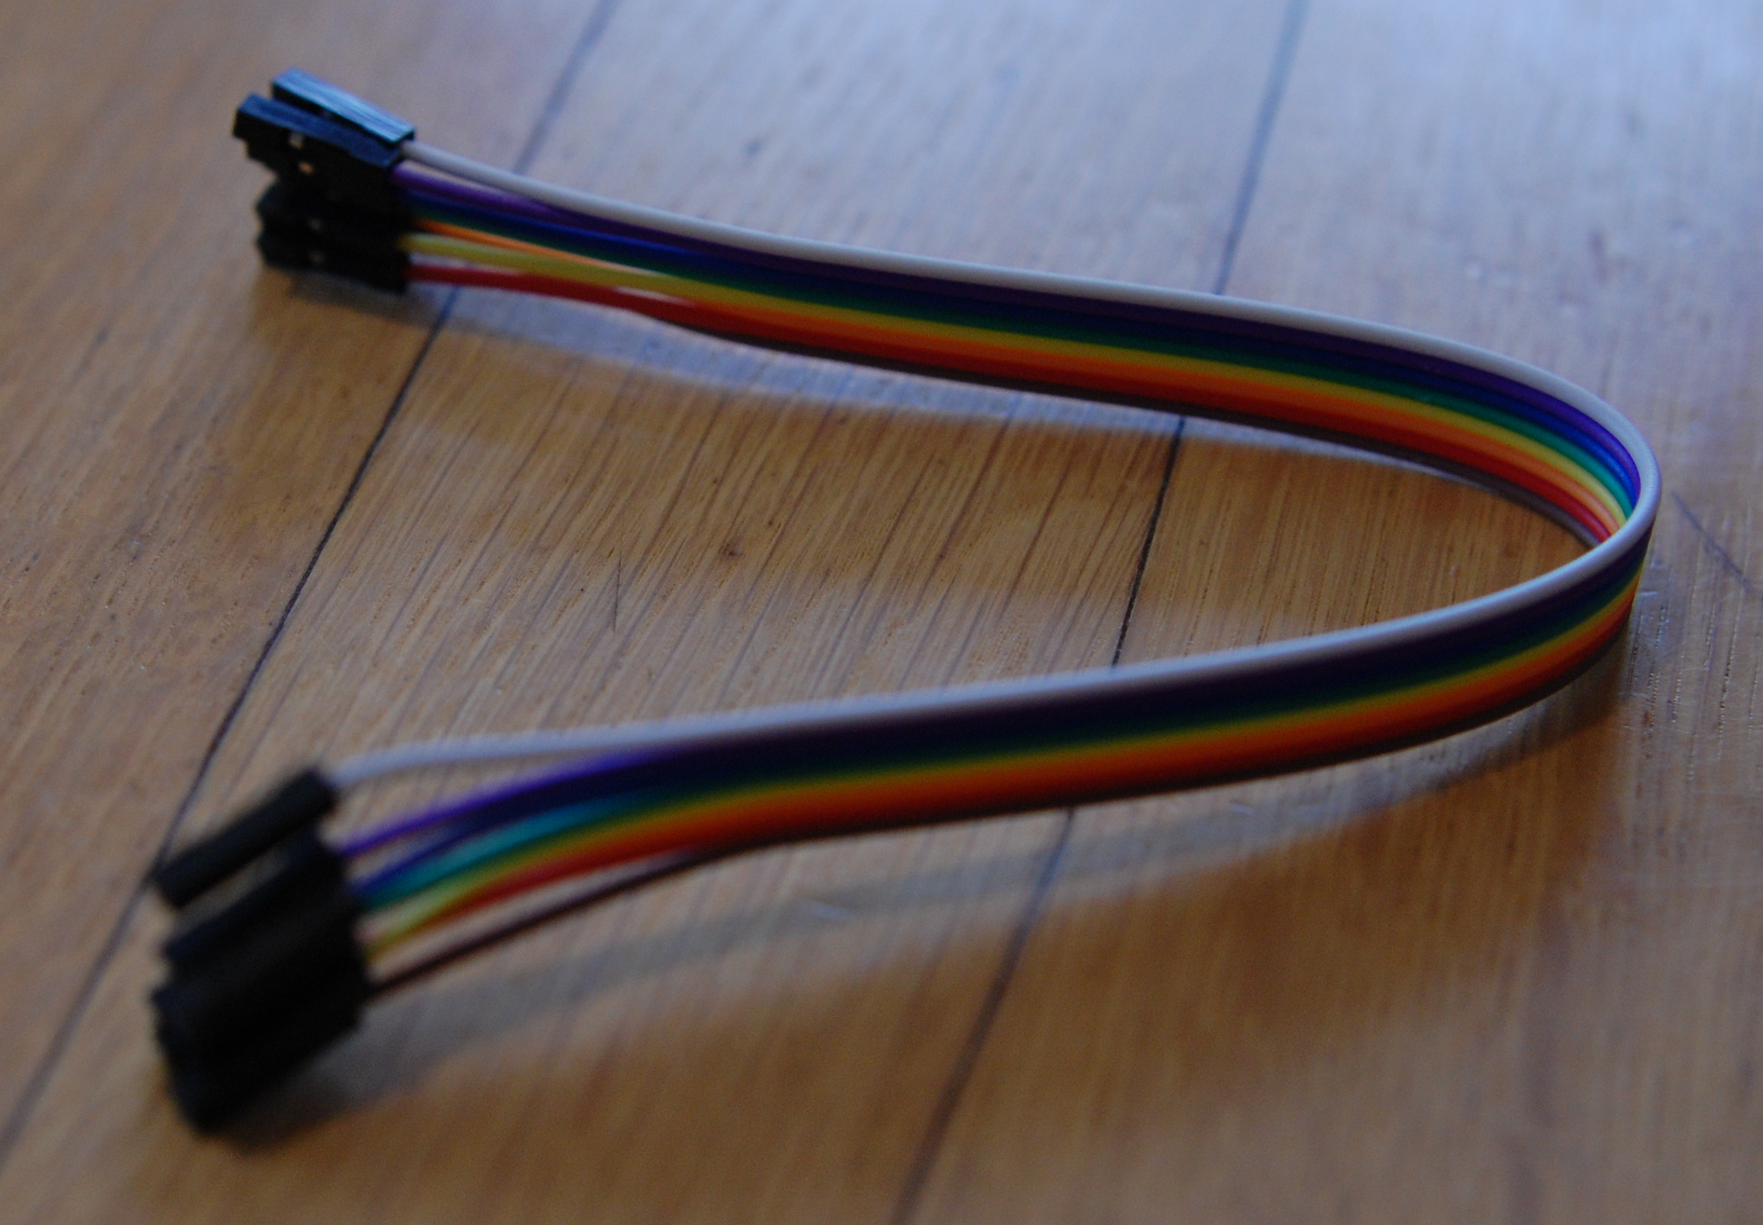

Grumpy maker:
And how do I connect things, with those two left hands of mine?

Sensor community dude:
Oh, isn’t he a cute little pain in the ass… Here is a little schematic:

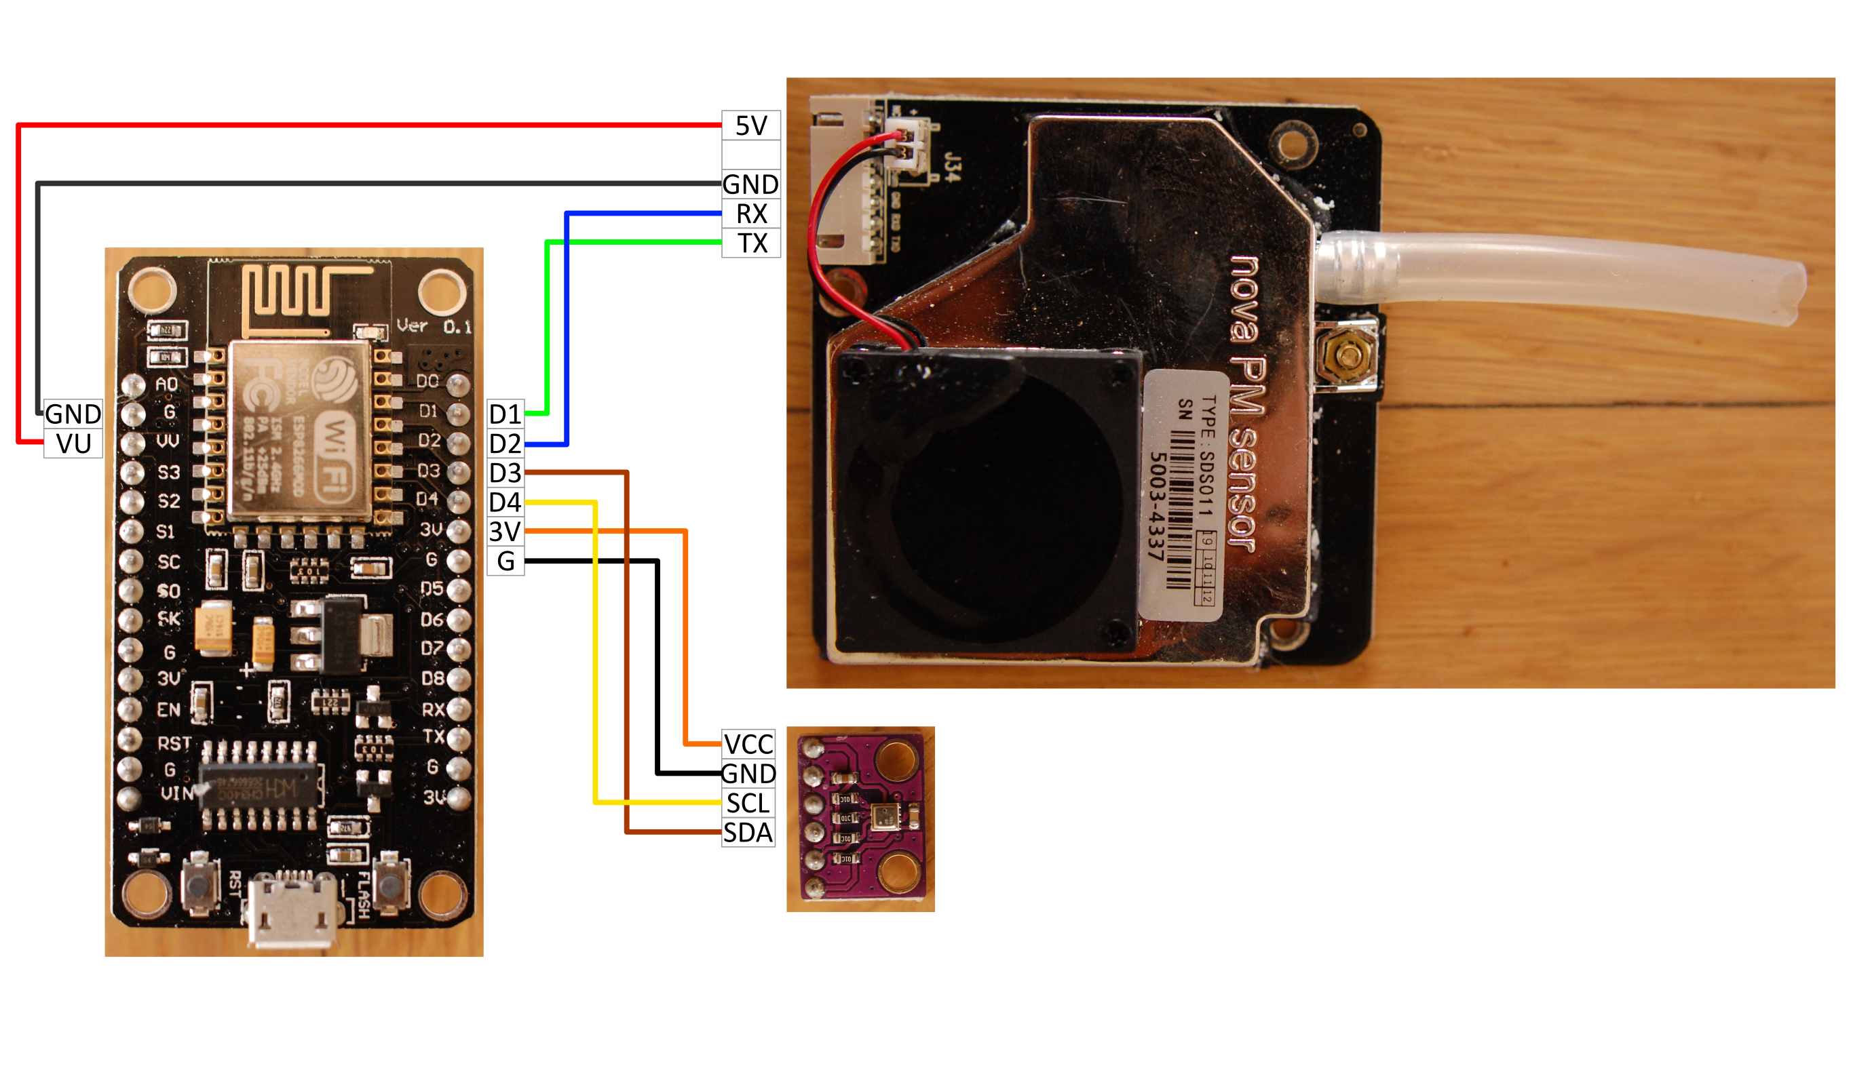
Use the DuPont wires to connect everything according to this plan. Put the flexible tube on the end of the SDS011.
Same connections can be made with the plantower PMS7003.

Grumpy maker:
Is it gonna take time to program?

Sensor community dude:
No!
[Pjg part]

Grumpy maker:
Ok, but I don’t like the wiry look. And want to see data in real time. Guess that’s not possible...

Sensor community dude:
Yes, it is!
1) make a custom PCB to wire everything, like this one:
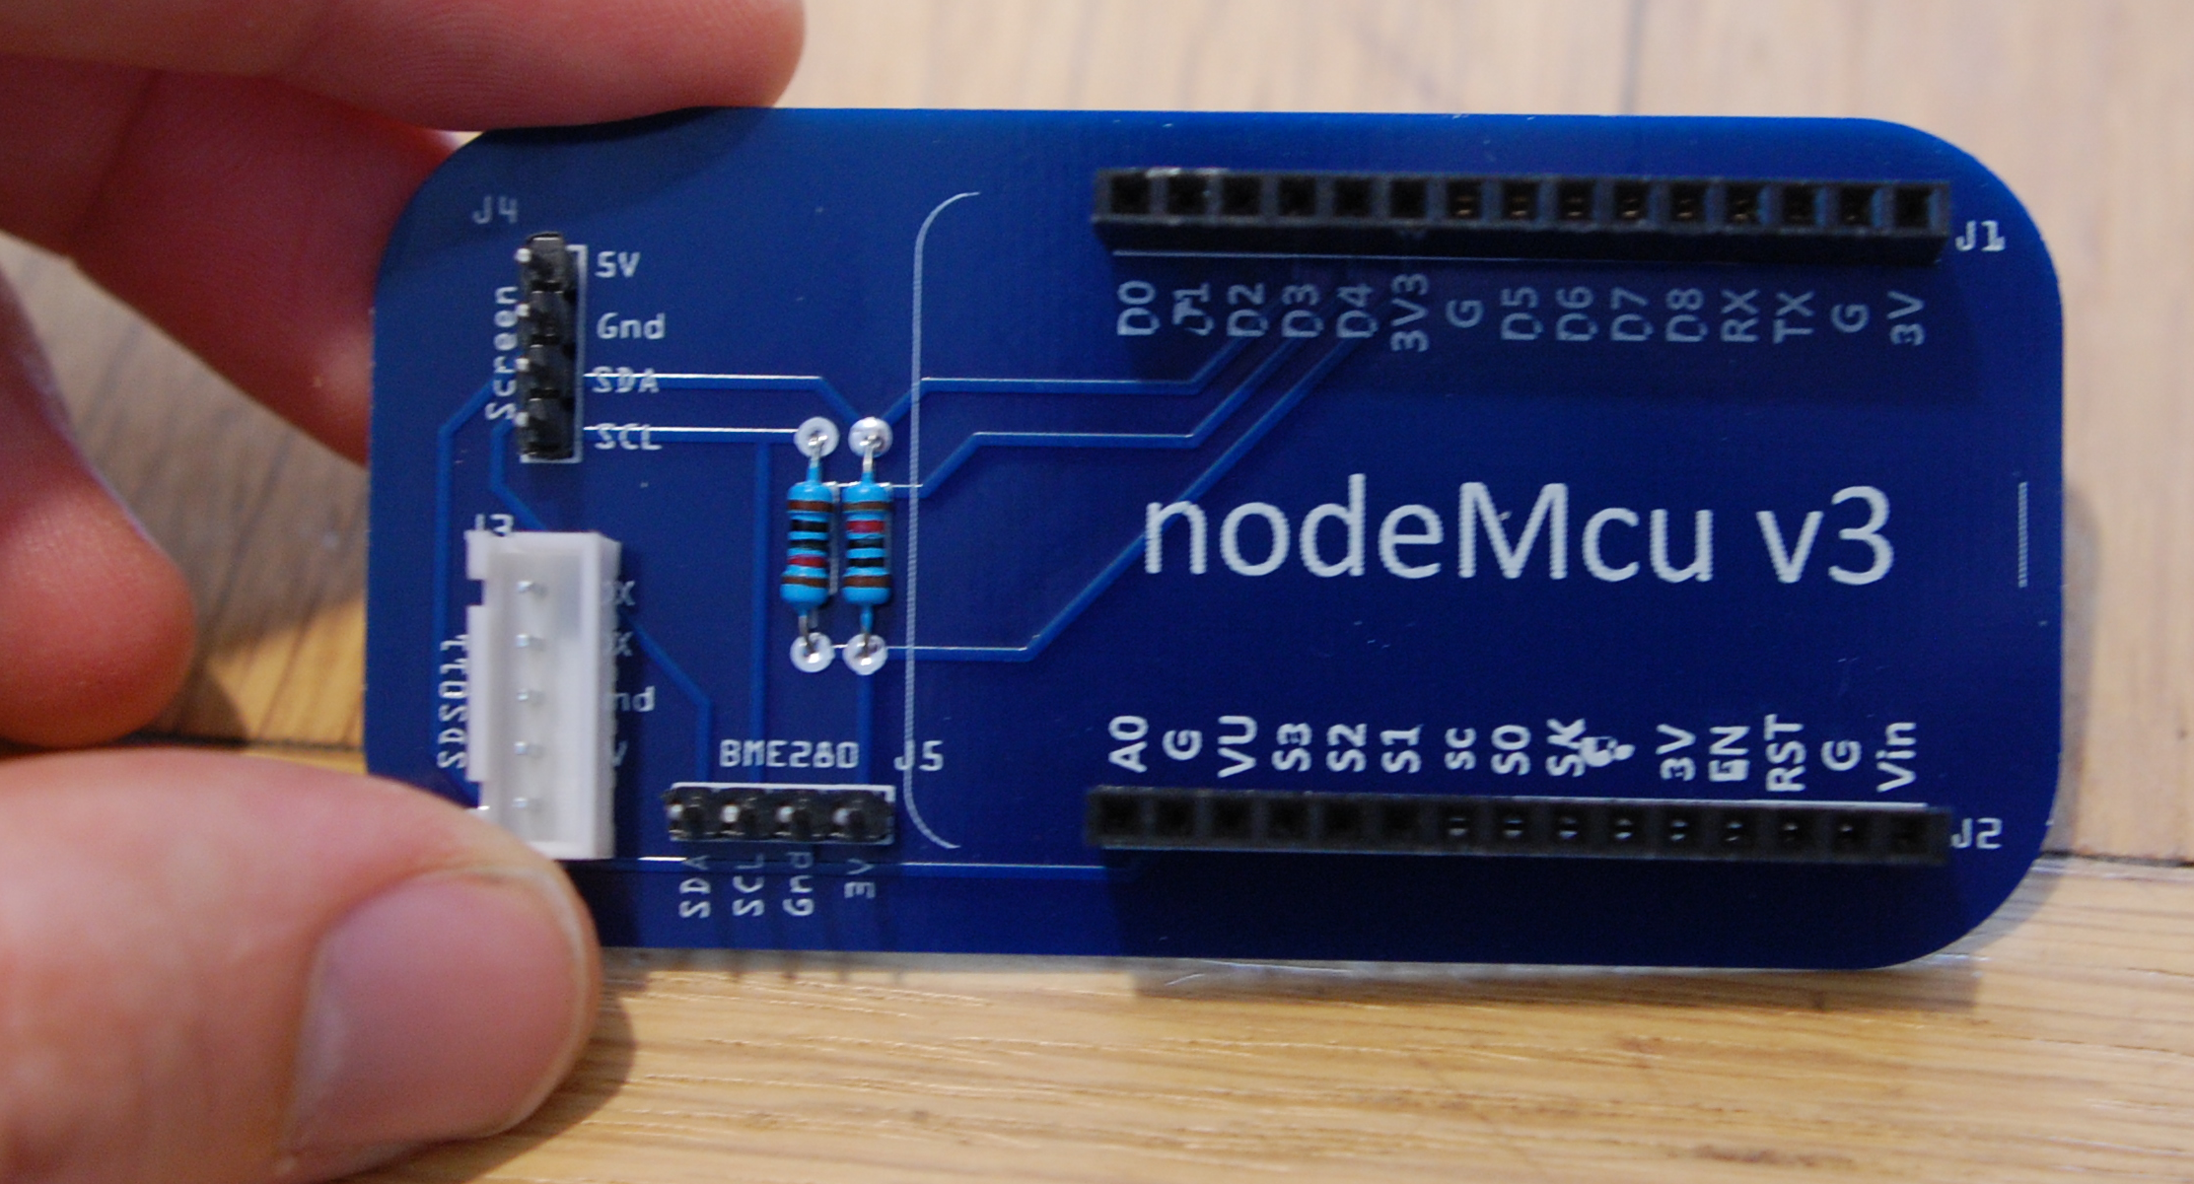
Gerber file and BOM is linked.

2) And add a screen such as:

LCD 1602 with i2c backpack | 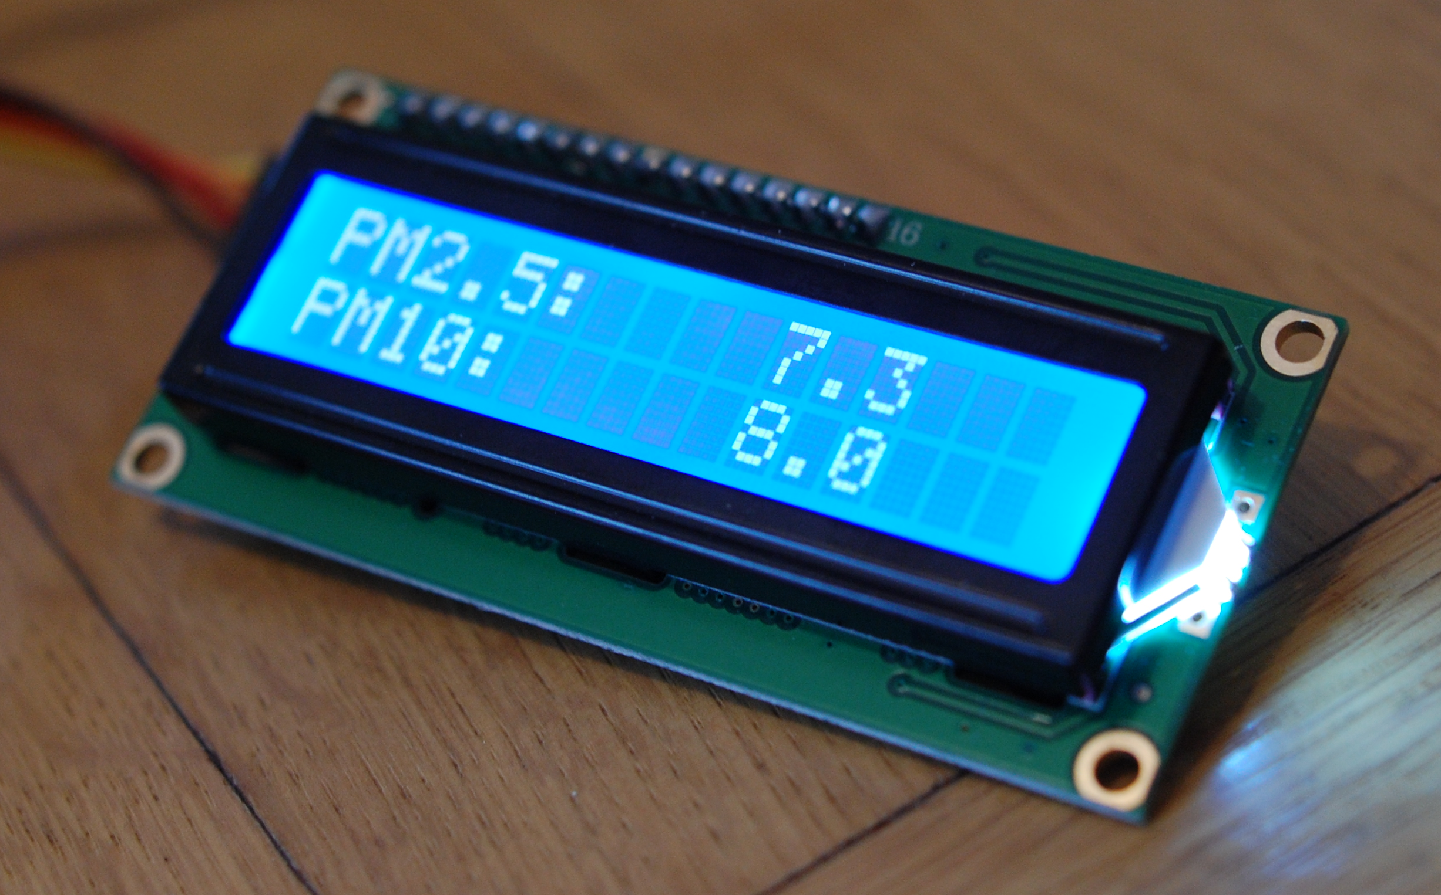
LCD 2004 with i2c backpack | 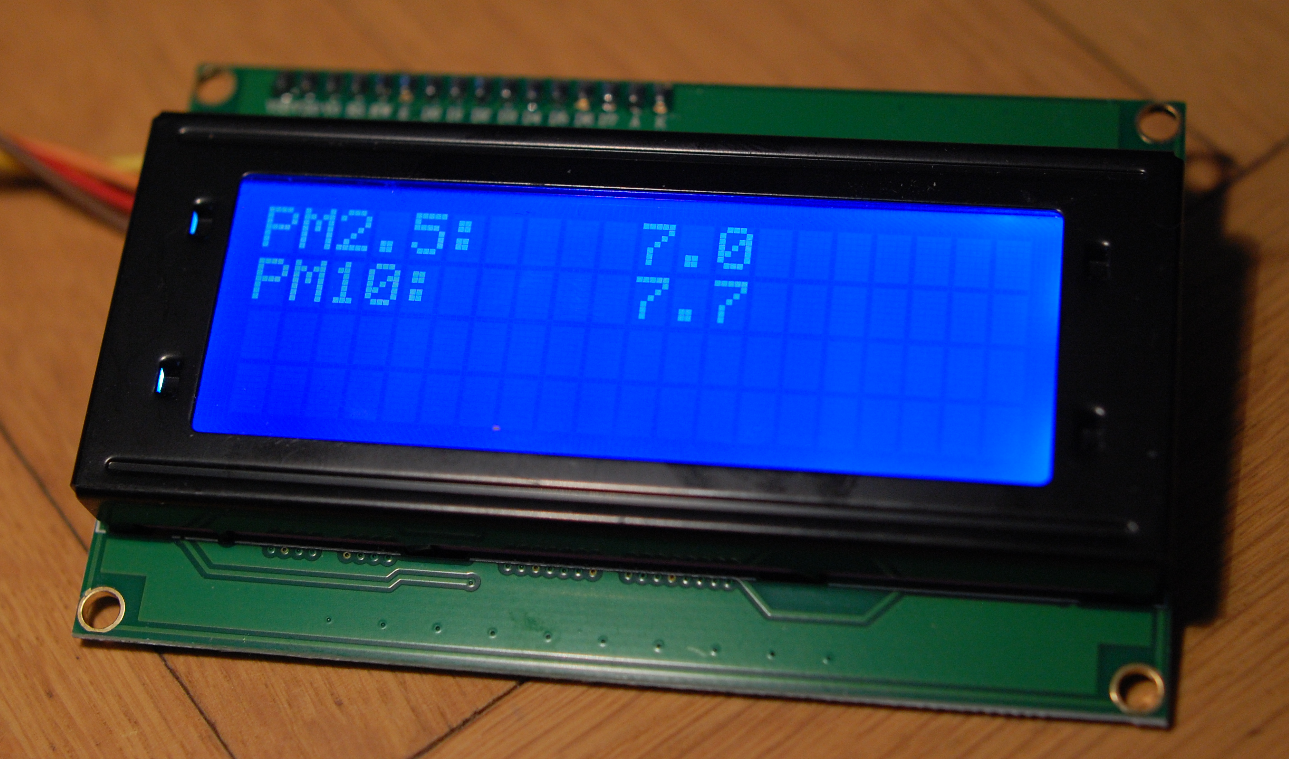
SSD1306 | 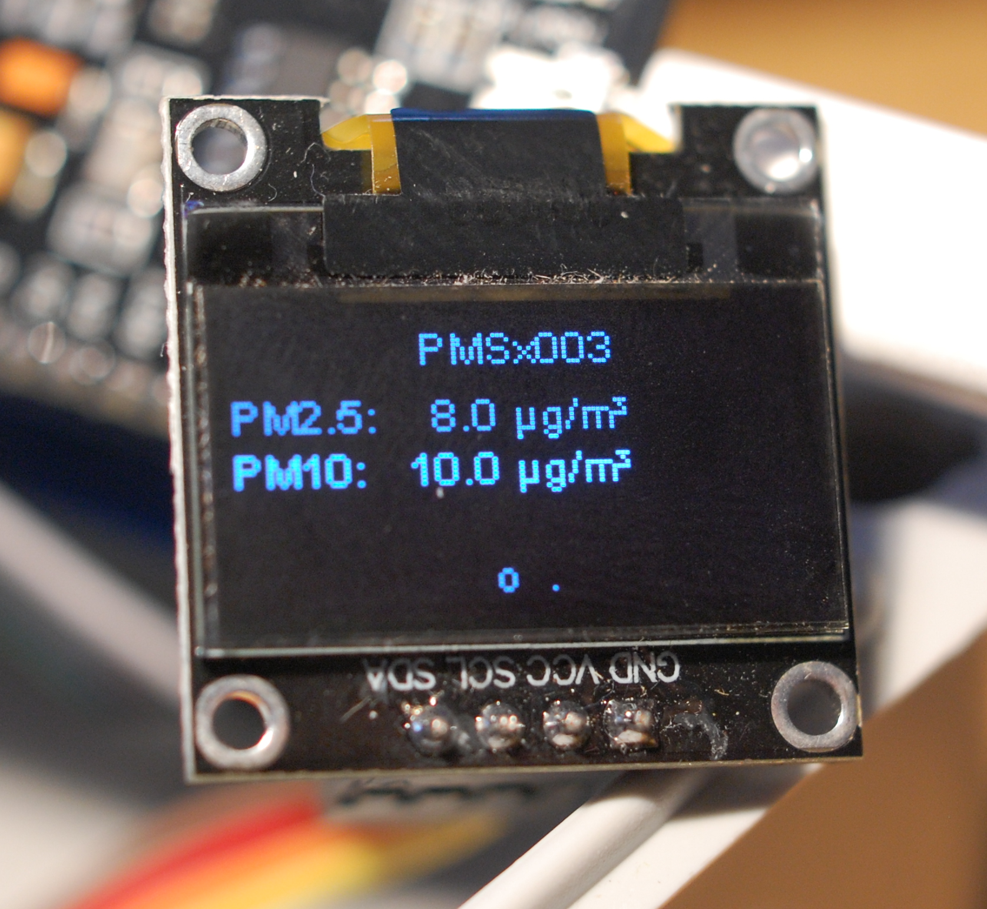

Here is the result, with a PLANTOWER PMS7003:
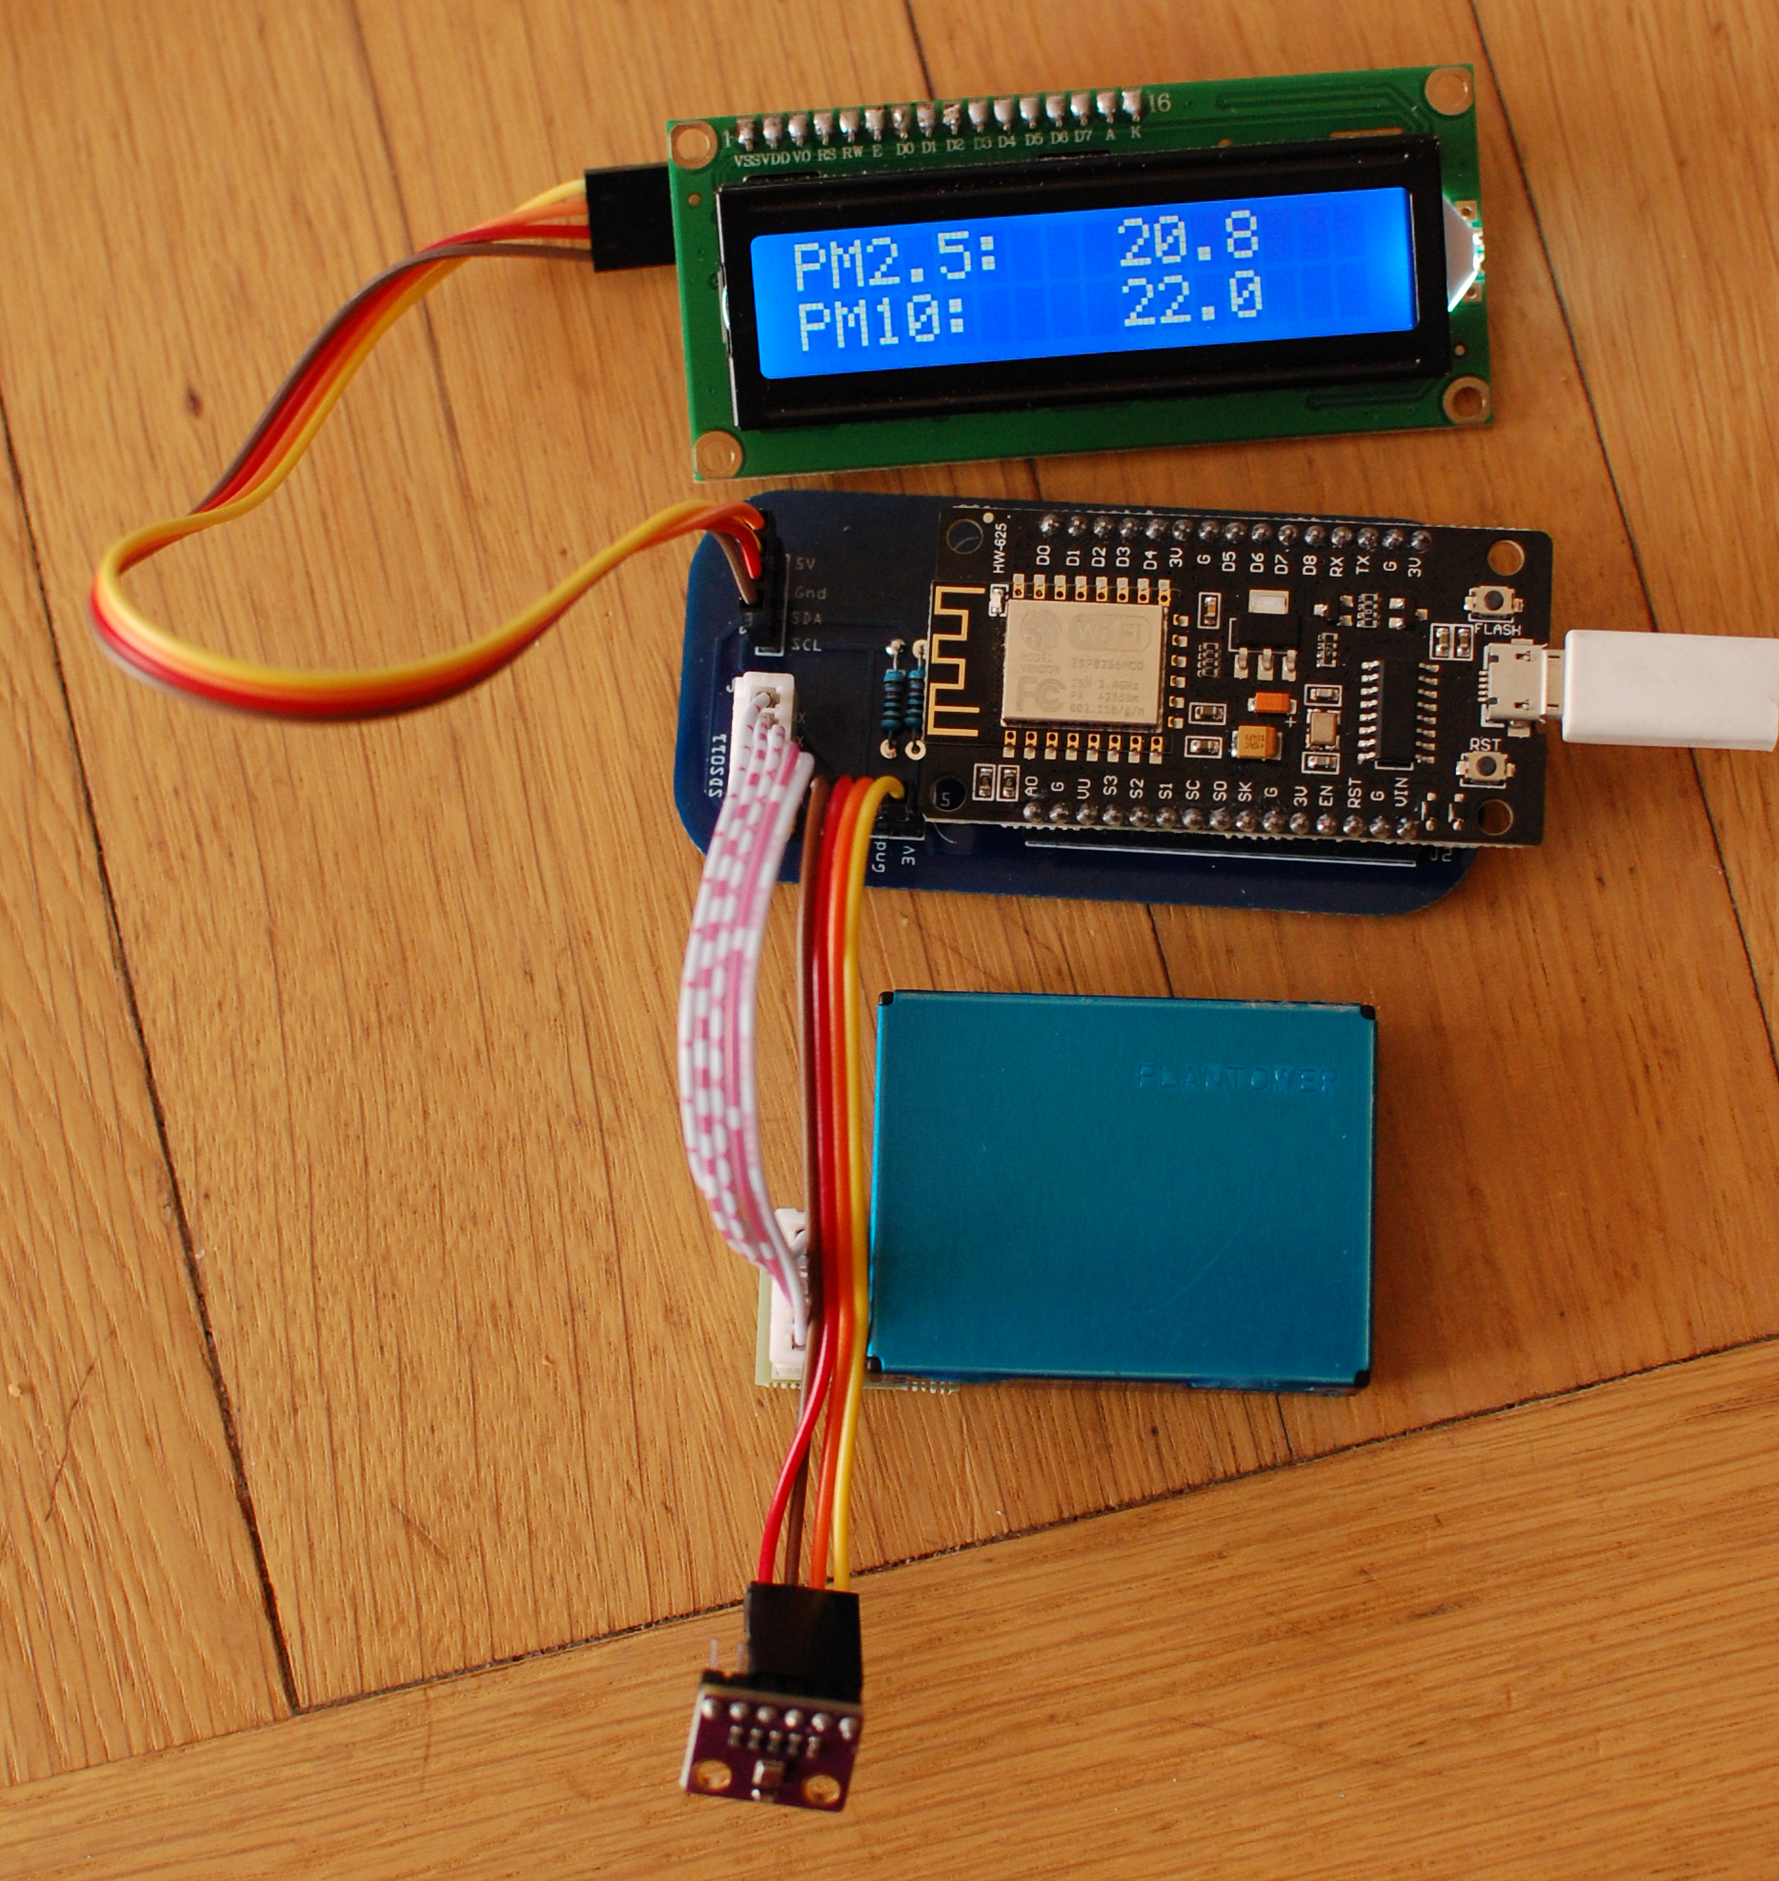

Grumpy maker:
OK, but the thing will not stand a day outside, with rain, sun and all. What can you do about it?

Sensor community dude:
You can put it in a IP65 box to prevent it from weather conditions. Here is an example, in a junction box:

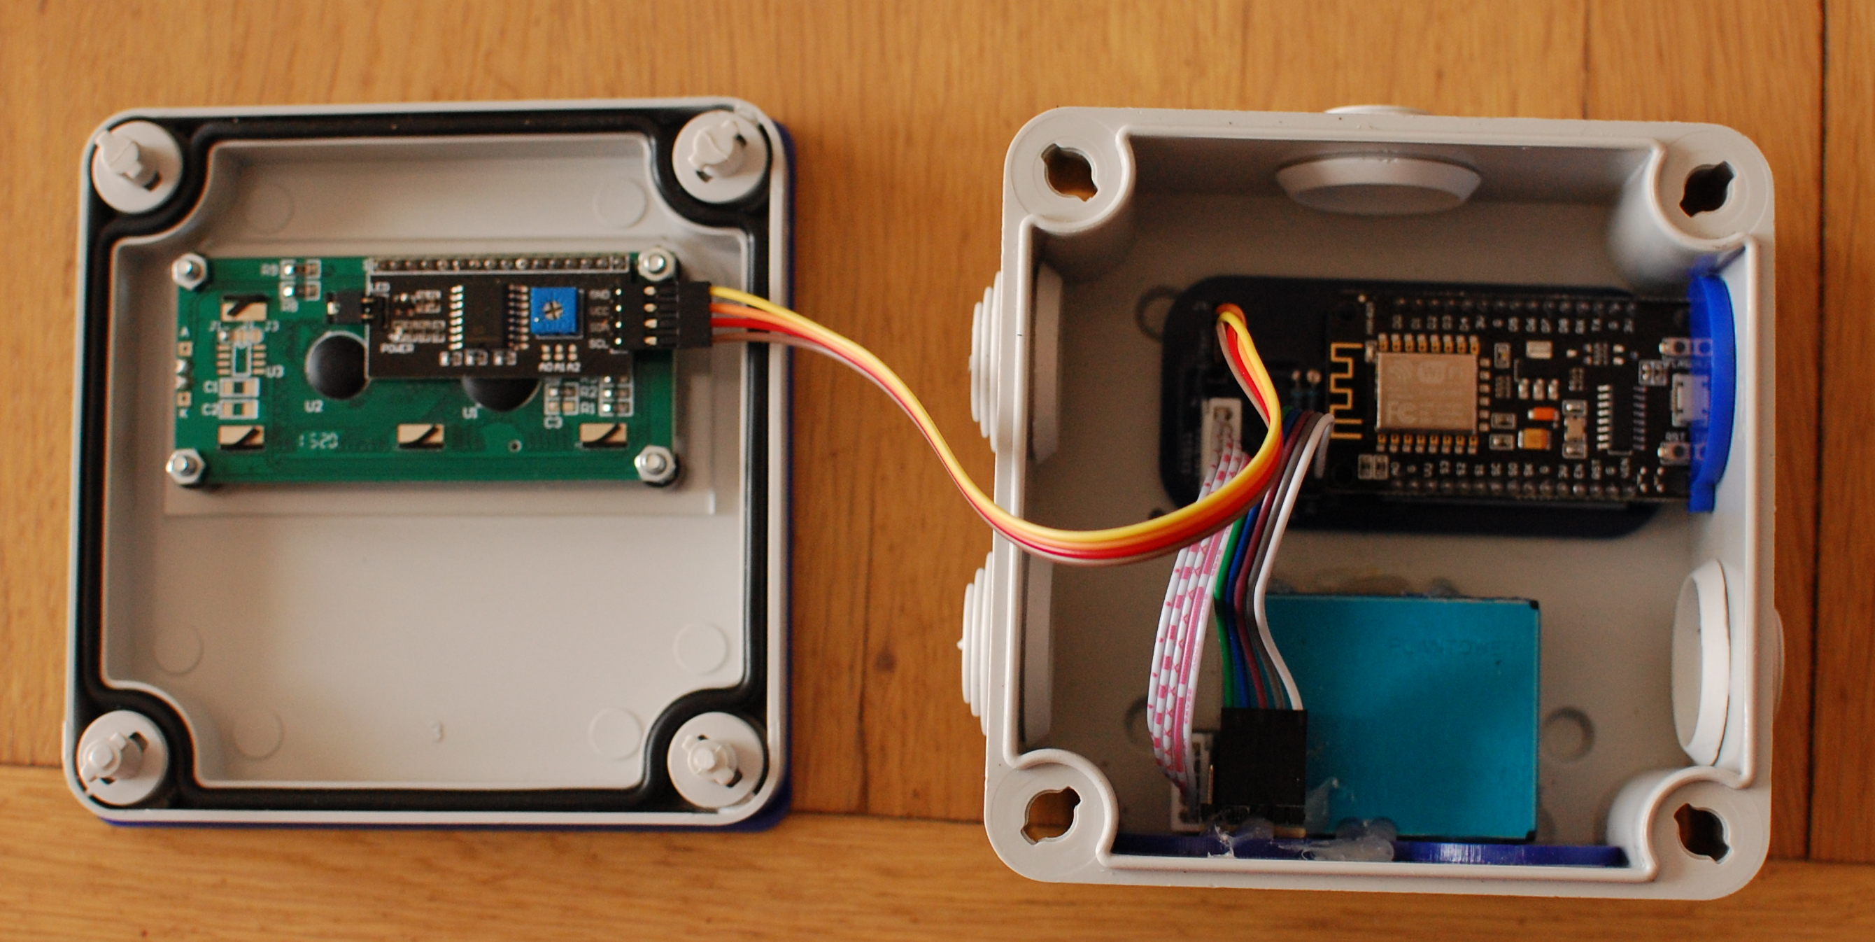
inside the box
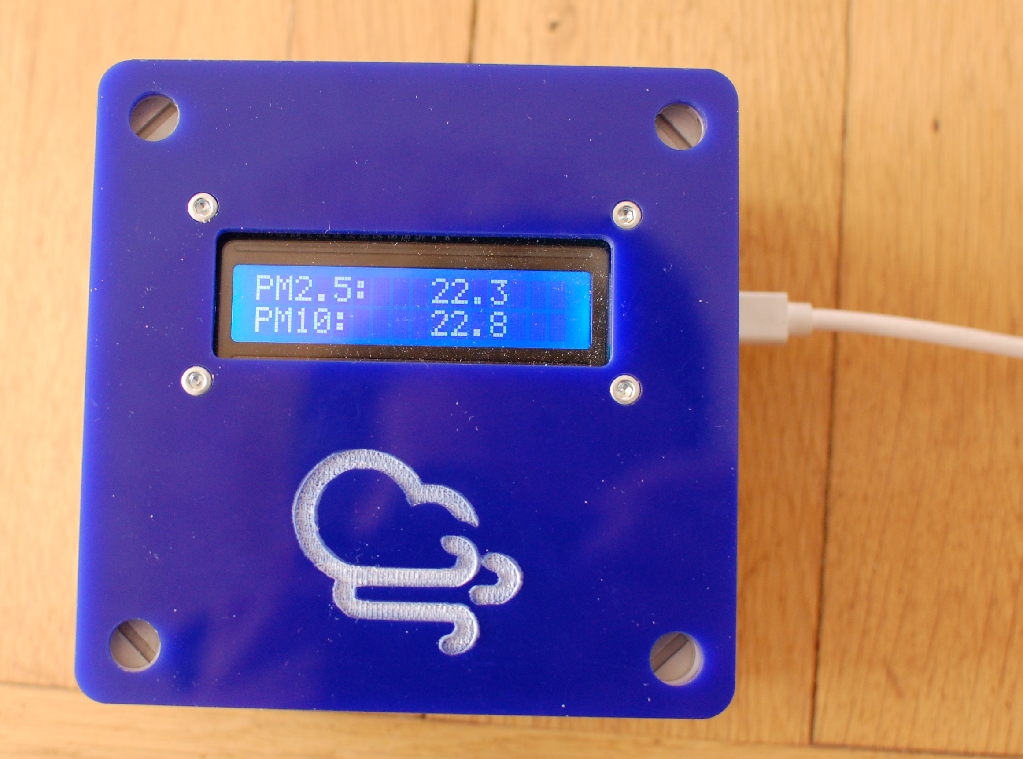
while working
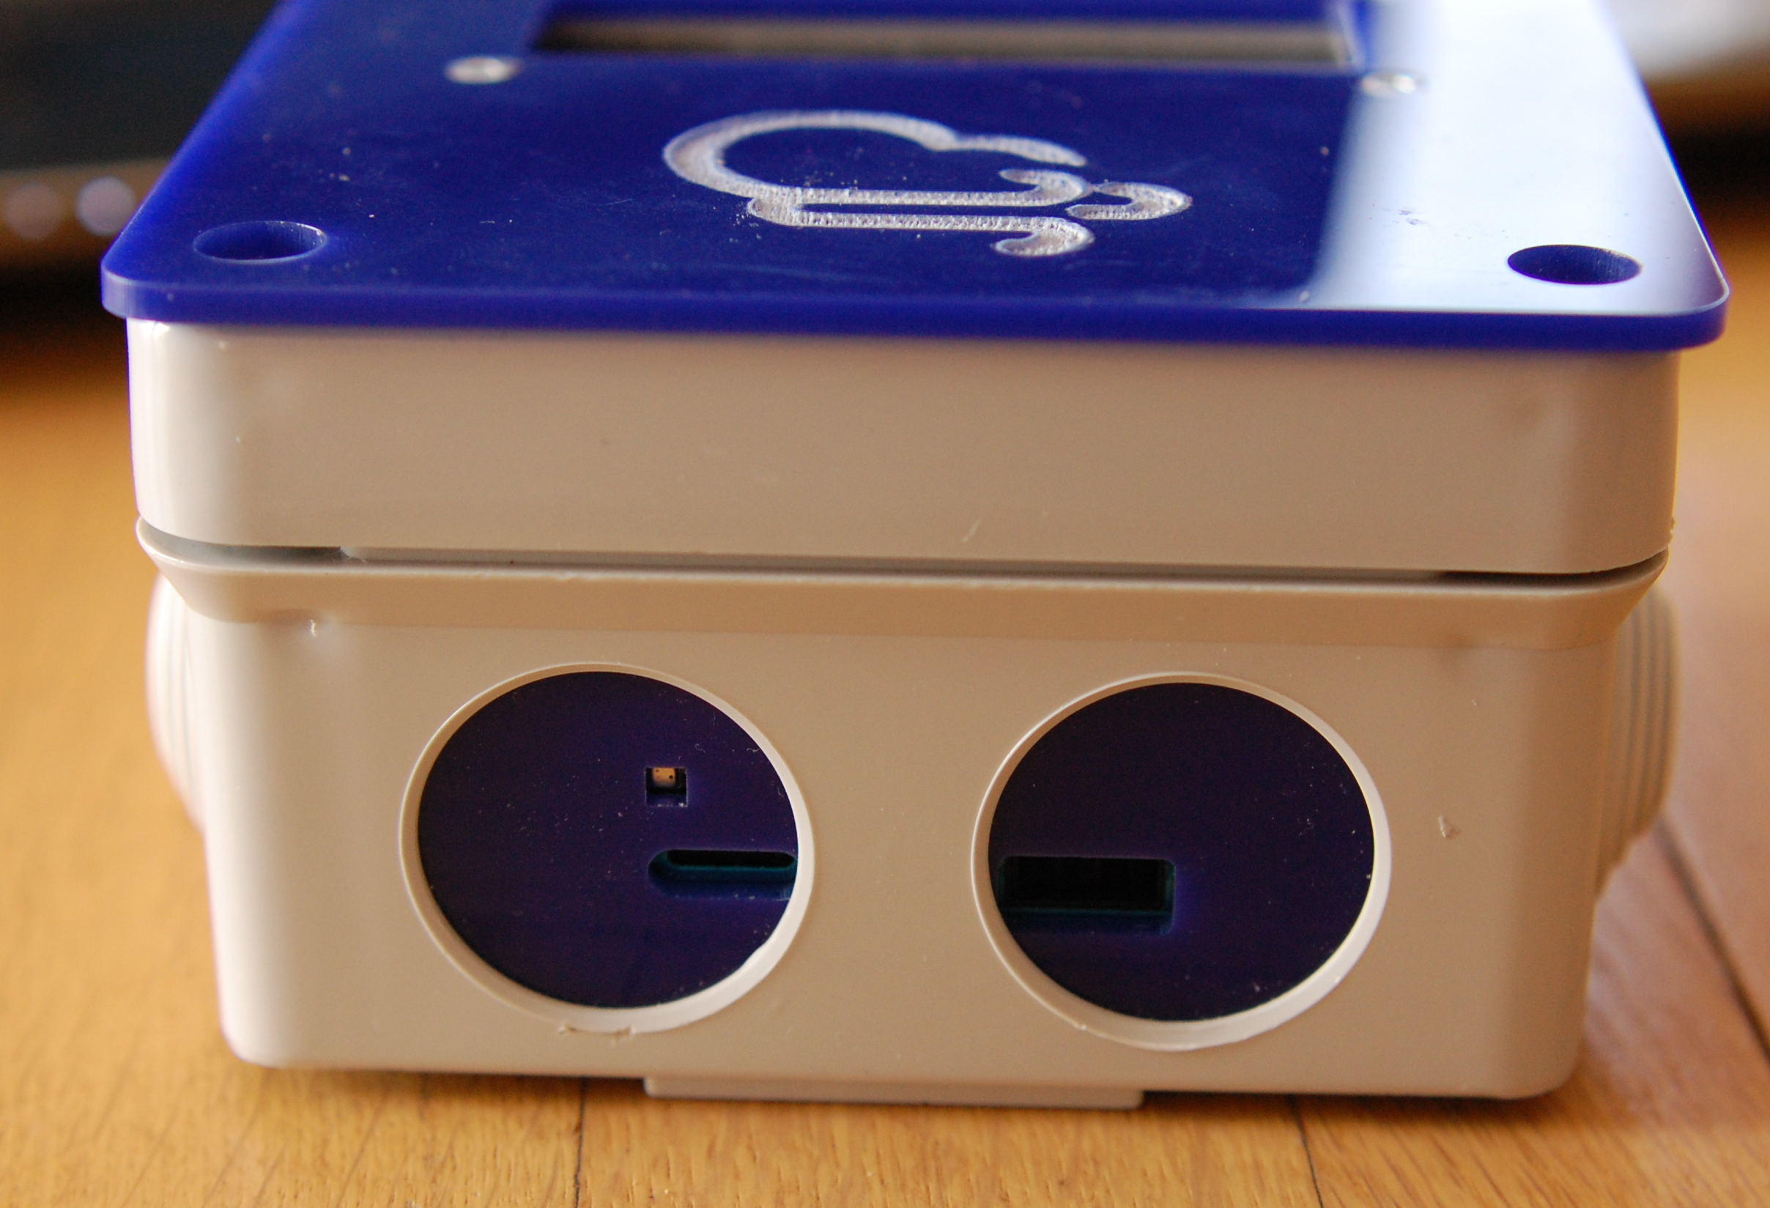
side openings for PMS7003 and BME280

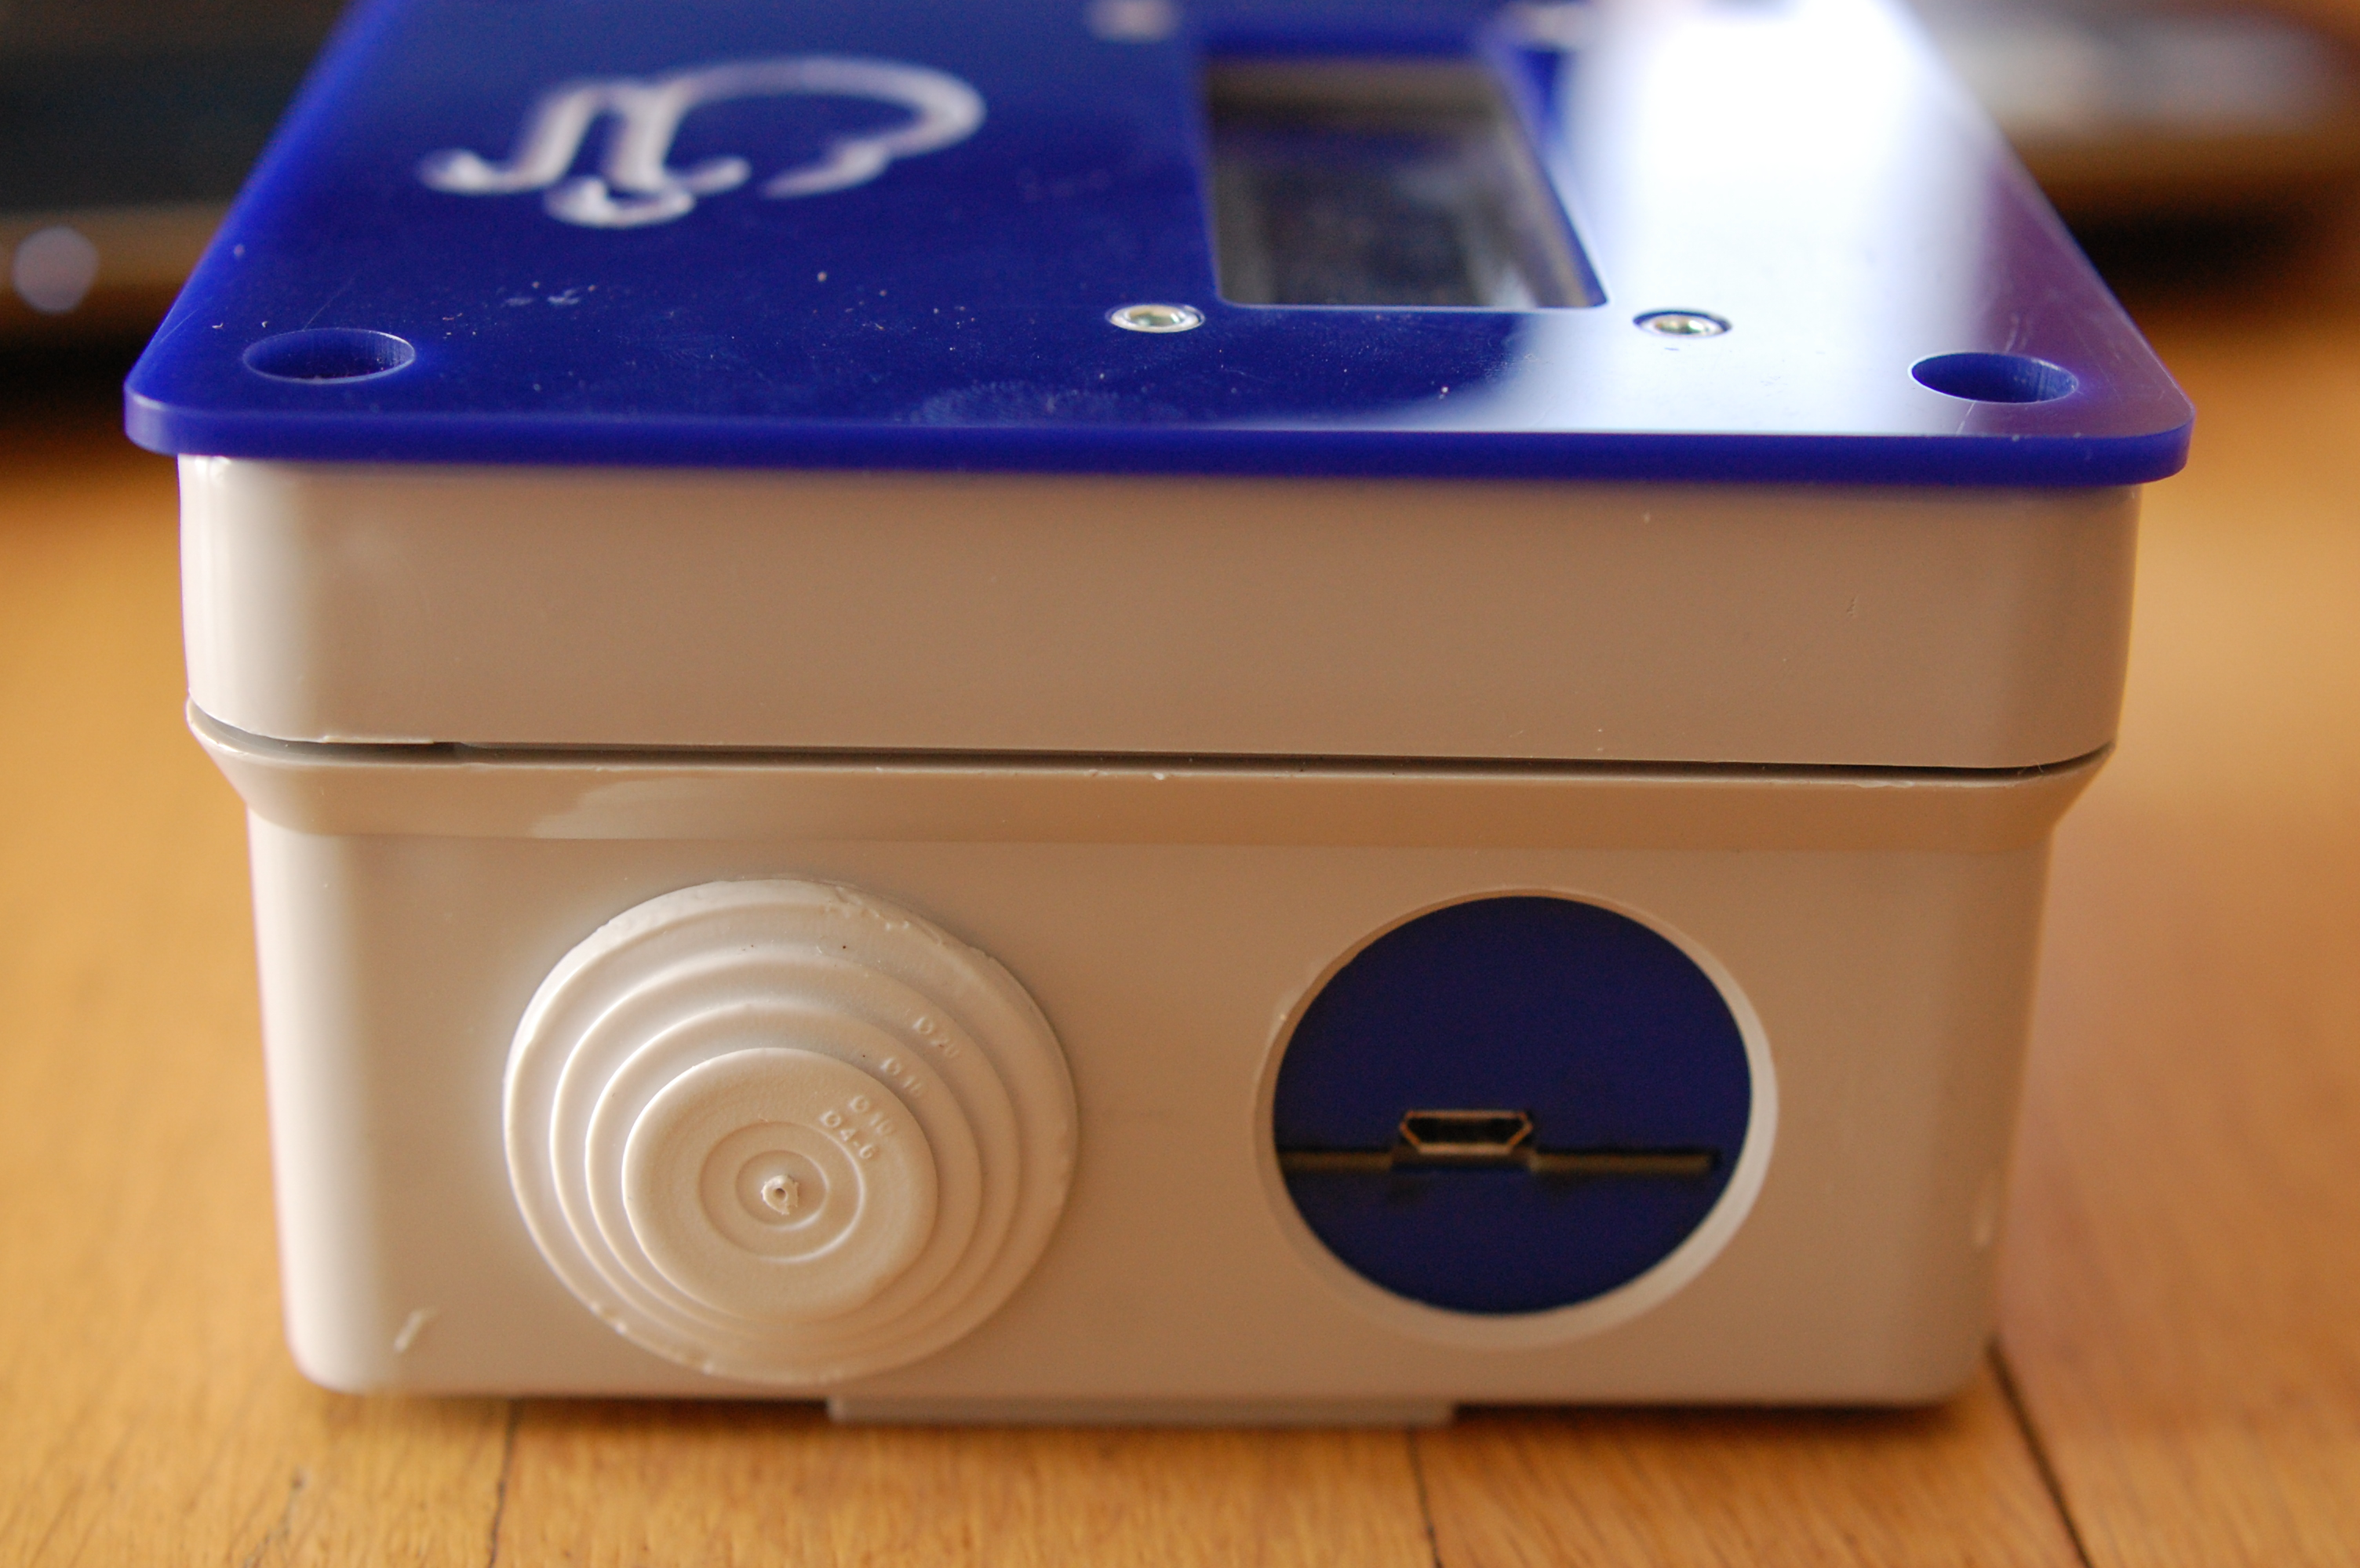
side openings for nodMCU power supply

svg files for laser cutted part are linked. Link for junction box supplier.

(Not so) Grumpy maker:
I don’t feel so grumpy after all. Maybe I’ll even kiss a unicorn, and fart rainbows today. All thanks to you, sensor community dude!

Sensor community dude:
Good booy! You’re welcome…

