Junhao Pan

CS 498 AM1

Homework 1

Part 1:

1A: 0.75817

1B: 0.74575

1D: 0.77386

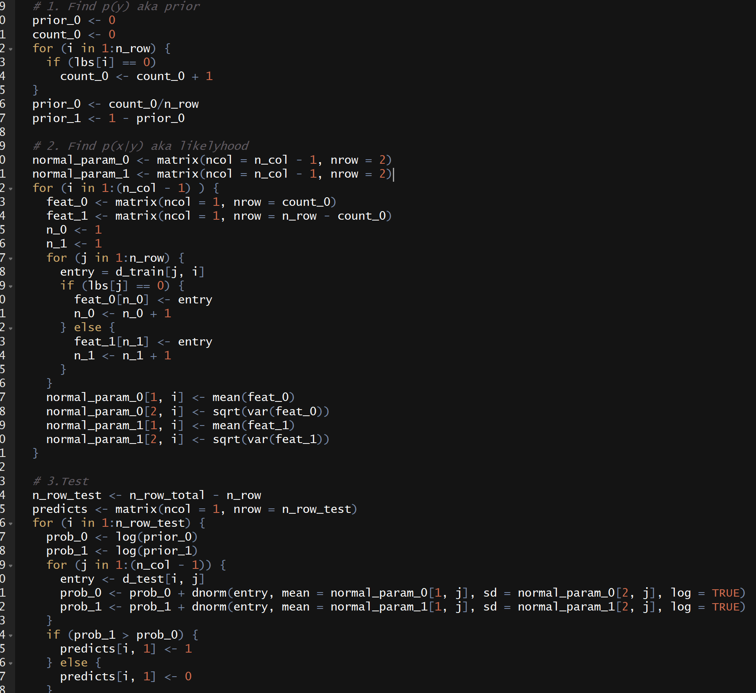

P1A

P1B is roughly the same with substitution of NA

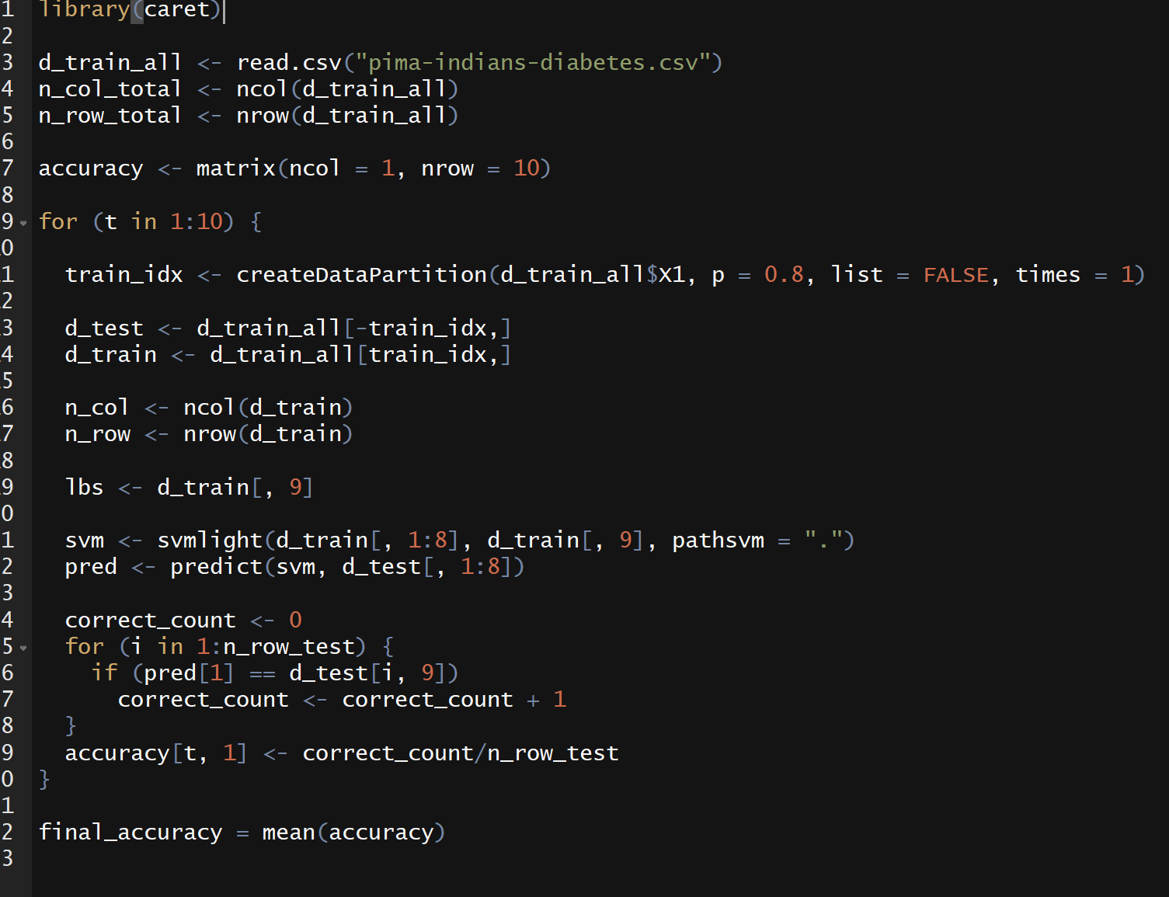

P1D with SVM Light

|  |  |
| --- | --- |
| Gaussian untouched | 0.6746 |
| Gaussian stretched | 0.6576 |
| Bernoulli untouched | 0.6917 |
| Bernoulli stretched | 0.6346 |
| 10 trees 4 depth untouched | 0.7284 |
| 10 trees 4 depth stretched | 0.72515 |
| 10 trees 16 depth untouched | 0.9575 |
| 10 trees 16 depth stretched | 0.96415 |
| 32 trees 4 depth untouched | 0.76645 |
| 32 trees 4 depth stretched | 0.7558 |
| 32 trees 16 depth untouched | 0.97055 |
| 32 trees 16 depth stretched | 0.97455 |

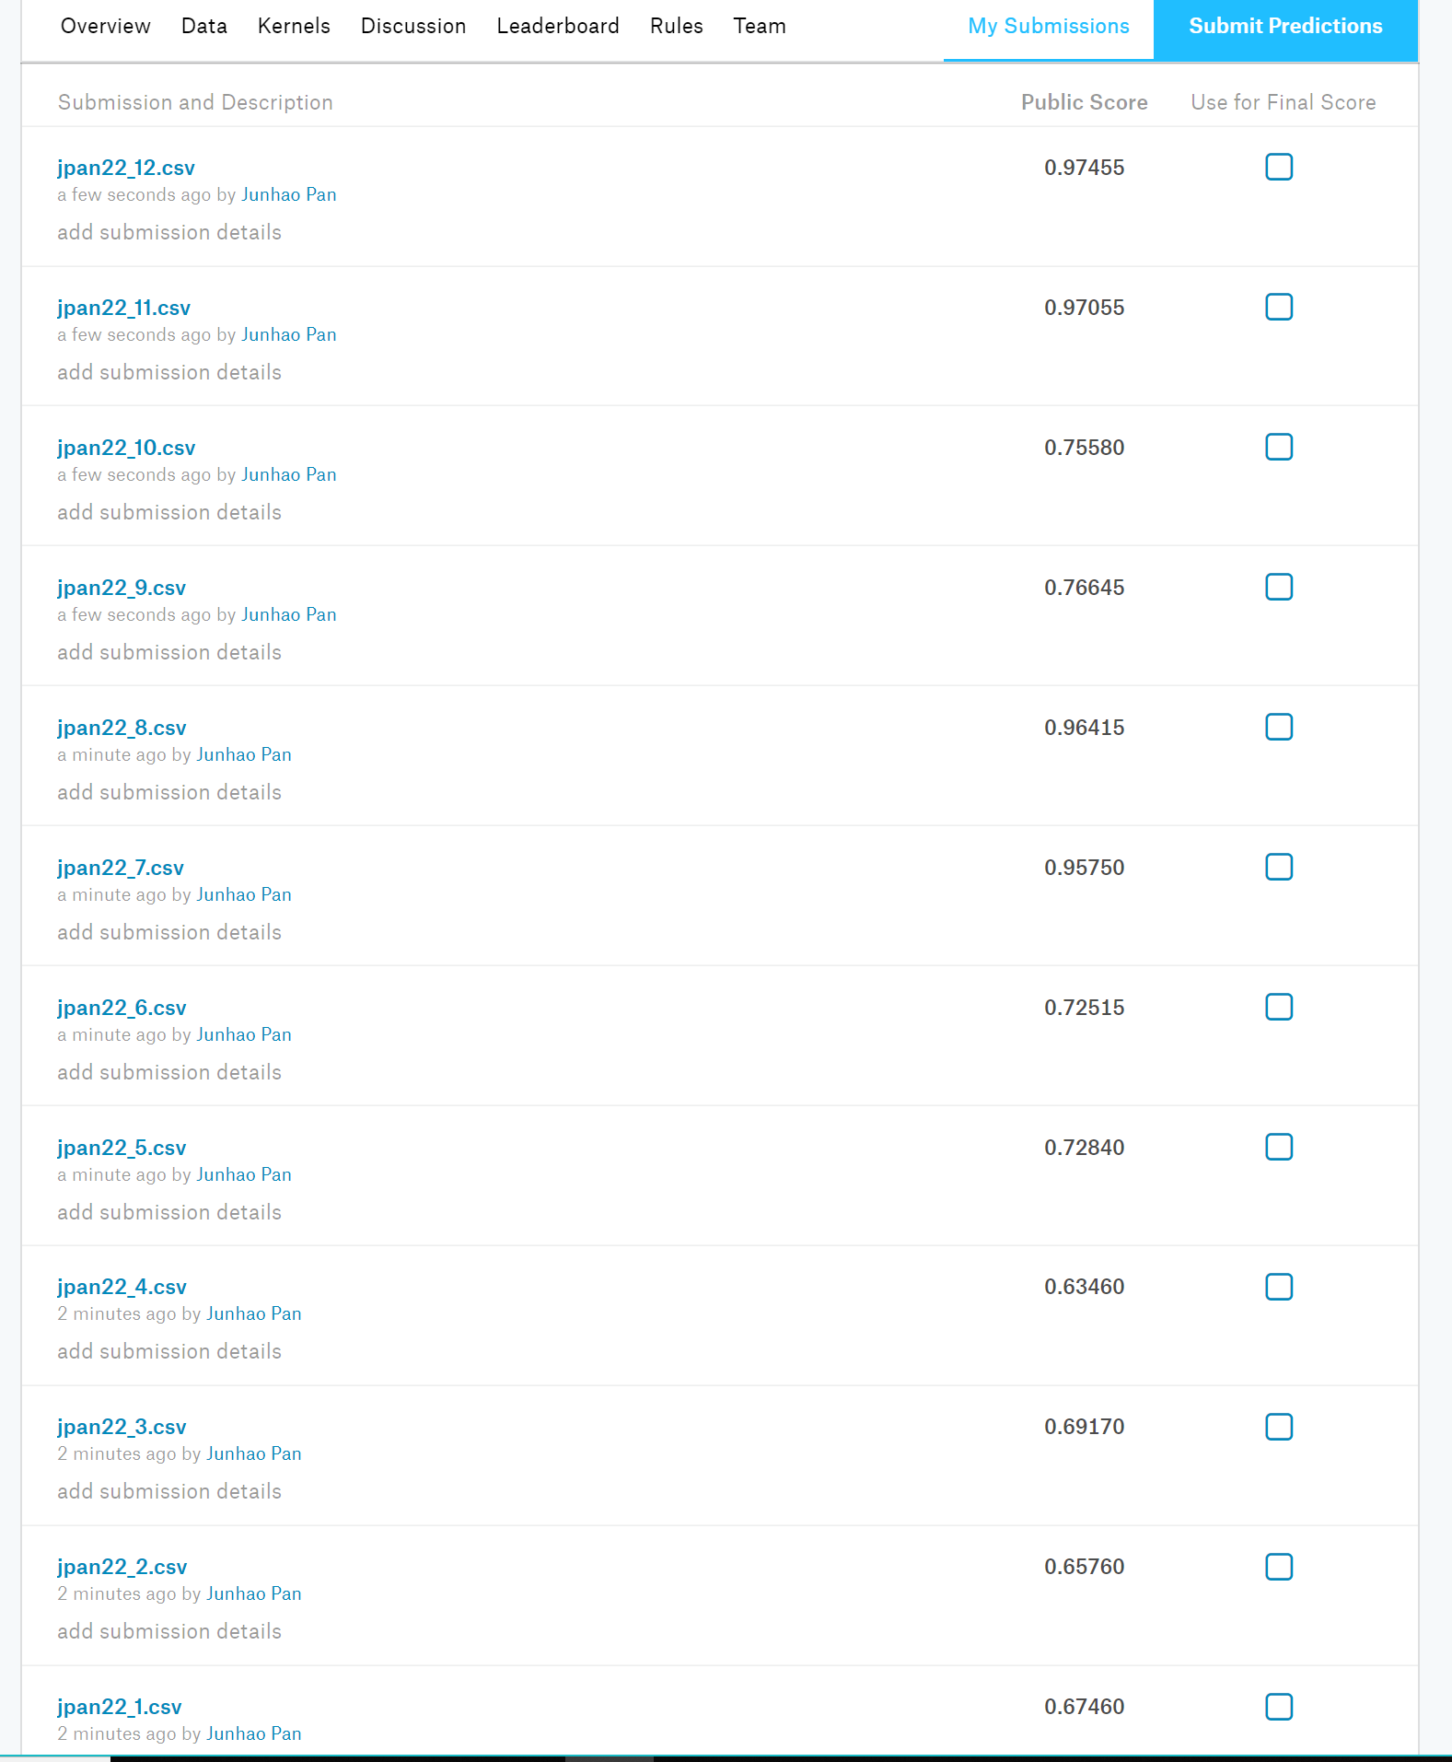

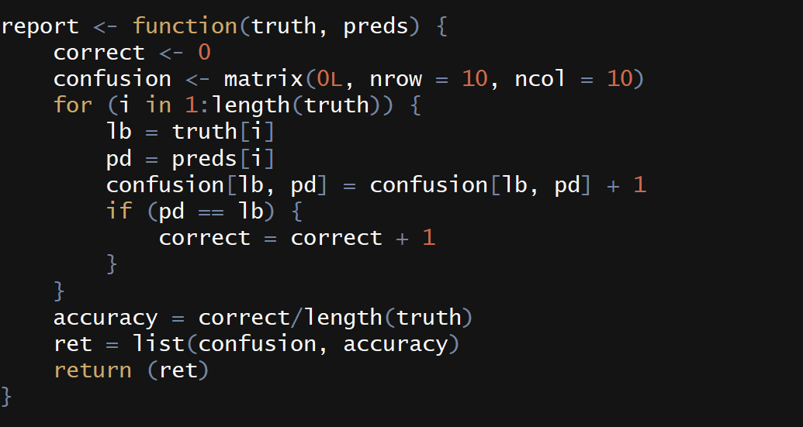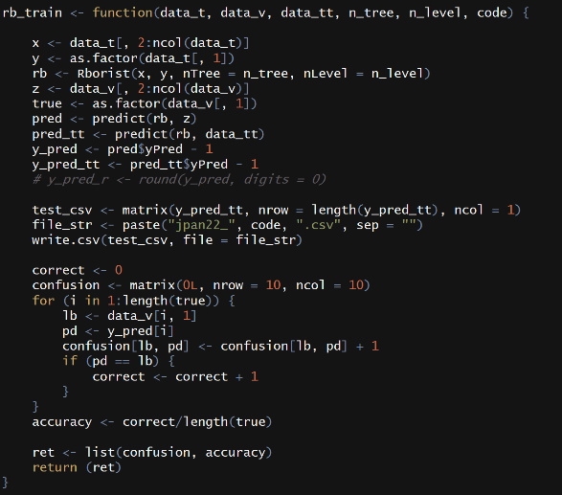

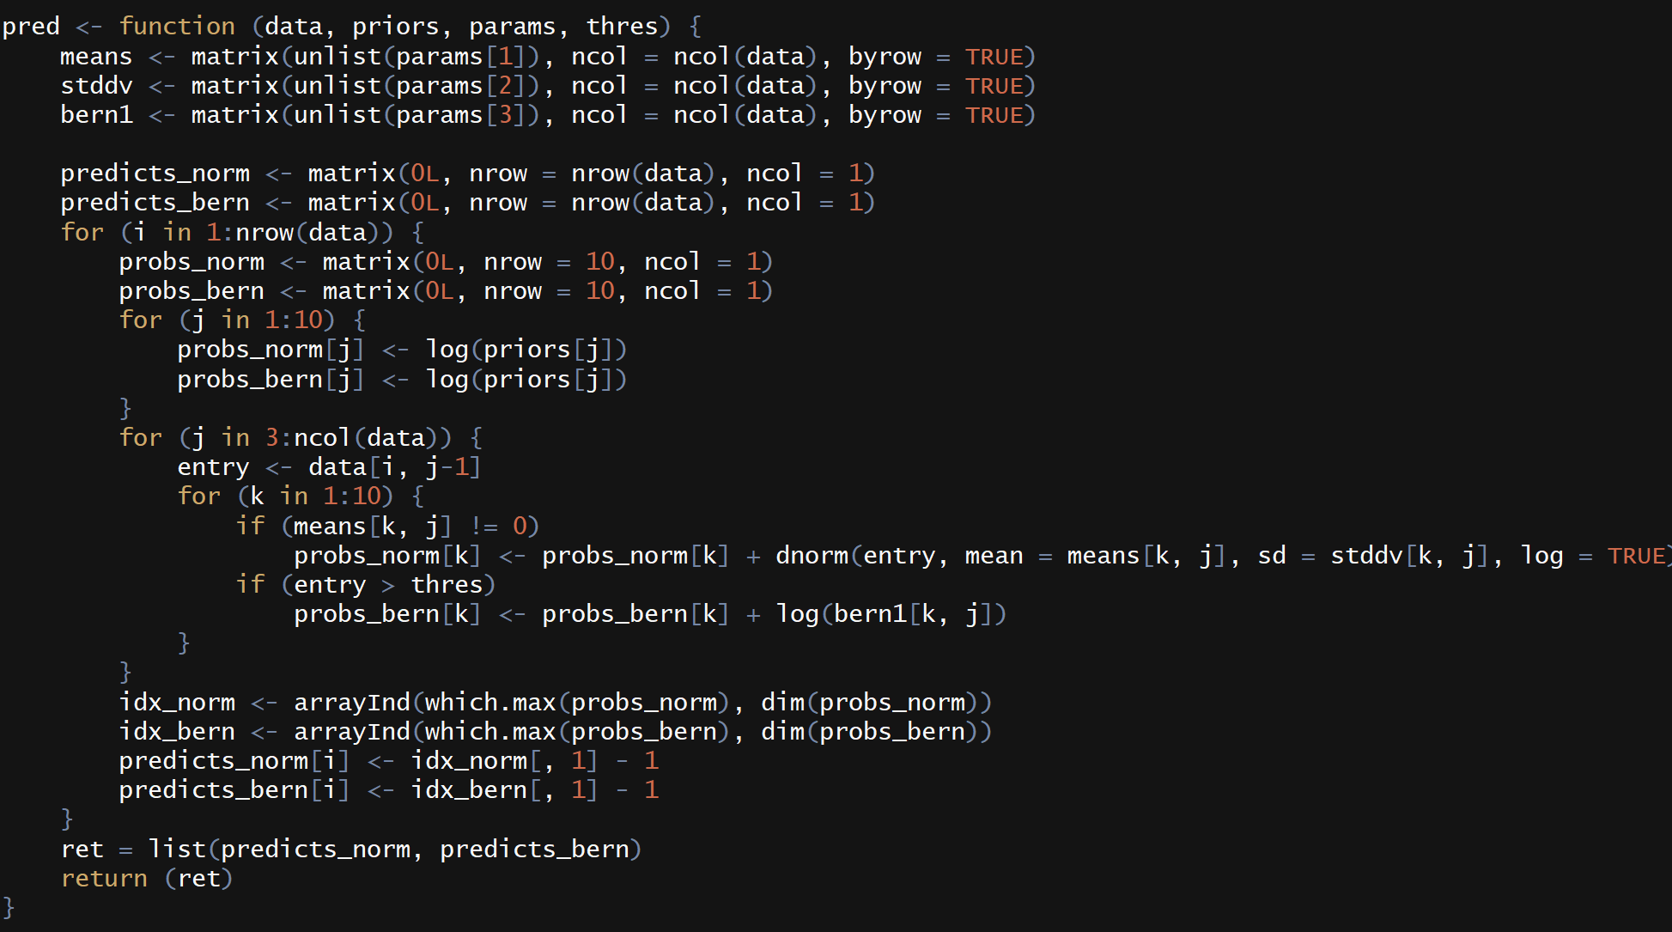

|  |  |  |  |  |  |  |  |  |  |  |
| --- | --- | --- | --- | --- | --- | --- | --- | --- | --- | --- |
|  | 0 | 1 | 2 | 3 | 4 | 5 | 6 | 7 | 8 | 9 |
| Gaussian untouched |  |  |  |  |  |  |  |  |  |  |
| Gaussian stretched |  |  |  |  |  |  |  |  |  |  |
| Bernoulli untouched |  |  |  |  |  |  |  |  |  |  |
| Bernoulli stretched |  |  |  |  |  |  |  |  |  |  |

There must be a way to display in gray scale instead of either white or black. I failed to figure out how to do that…