

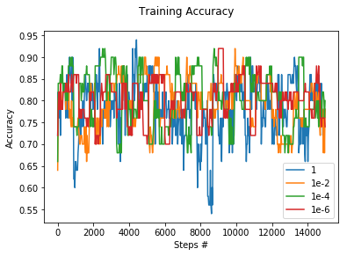

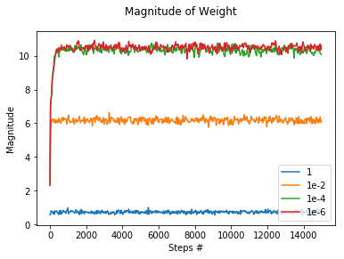

The model is not overly sensitive to the choice of the lambda when it is around 1e-2 or less. In theory, smaller lambda would take longer time to stabilize themselves to establish a consistent accuracy. However, since we run 50 epochs on the dataset, it is enough for small lambda at even 1e-7 to stabilize.

My best accuracy is generated with a lambda of 1e-5. I have experienced with other numbers as well, but accuracy fluctuates only slightly.

In fact, there are other parameters which have more effects on the outcome. For example, the way to calculate the learning rate is quite a major impact on the result. I have changed the constants in the formula to control the update of the weight, but apparently the one documented by professor gave a consistent and good result. It uses the season’s count as a variable to gradually decrease the step length.

