Computational Biology Summary

# Open questions for CB

Lecture 4, 49: How do we get these numbers?

Lecture 6, go over Felsenstein, Fitch and MLE again.

Lecture 8, go over independent contrast again.

Lecture 13, go over questions

# Sequencing methods (excluded from the exam)

# Sequence alignments and BLAST

**What happens when DNA/RNA is copied?**

* Mutation
* Insertion
* Deletion
* Repeats
* Inversions
* Inverted repeats.

**What is the premise of an alignment?**

It’s based on the fact that there is a common ancestor. This assumption is impossible to know for sure.

**What is a homologous sequence?**

It’s a sequence with shared ancestry (= which has the highest probability/score under a certain model).

**What are the types of alignment that can be made?**

Pairwise alignment types:

* P-P
* DNA-DNA
* RNA-DNA
* DNA/RNA-P -> be careful for gaps and frameshifts within codons

It’s also possible to have a multiple sequence alignment (MSA).

**What is the difference between a local and a global alignment?**

Global alignment aligns one sequence to the other from the start to the end.

Local alignment finds the longest subsequences with highest similarity.

**What are the different strategies to find alignments?**

* Qualitative methods: dot-matrix method
* Exact method w dynamic programming: N-W (global) & S-W (local).
* Heuristic and fast methods (e.g. BLAST)

**What is the dot matrix method?**

Simplest way to align sequences.

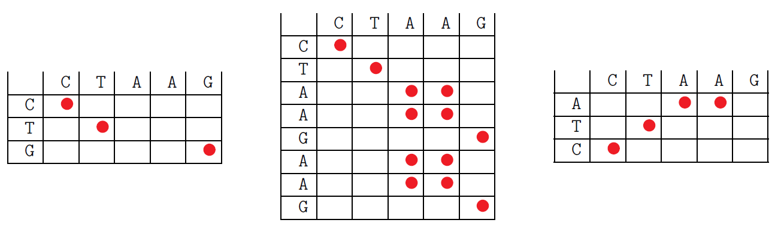

Gap in sequence repeats inversions.

**What are some of the (dis)advantages of the dot matrix method?**

Pro:

* Visually easy method to identify sequence features such as repeats, inversions, and inverted repeats.

Cons:

* Time consuming
* Does not give one optimal alignment.

**What is a big trade-off to make when doing local alignments?**

Do we accept that a position in our alignment has a mutation or do we introduce a gap?

**What strategy can be adopted to tackle this tradeoff?**

Assign costs for different actions in the alignment process.

**How many possible alignments are there between sequence a and b, each of length m and n, respectively?**

If k is the number of gaps that can be introduced, then there is (m+k k) possibilities to place these gaps between the m letters of a.

The total number of possible alignments is:

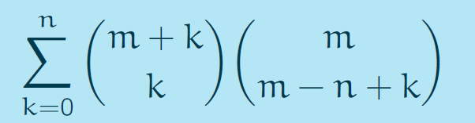

**What are the three steps in the S-W algorithm?**

1. Initialization: 0th row and 0th column set to 0, remaining rows and columns correspond to nucleotides.
2. Iteratively calculate the score H(i,j) of the optimal alignment with ai and bj at the end of the field (i,j) and keep track from where the optimal alignment comes according to:

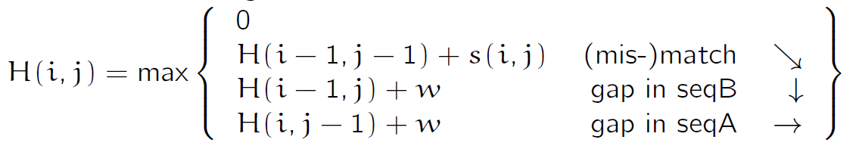

s(i,j)=3 if ai=bi

s(i,j)=-1 if ai≠bi

w=-2 (gap penalty)

1. Start from the highest number, which corresponds to the best local alignment and walk backwards until 0 is reached.

**What are some of the advantages of the S-W algorithm?**

Pros:

* Fast w.r.t. brute force search -> O(mn)
* Finds optimal local alignment or one of the optimal alignments if there is more than one with the same highest score.

Cons:

* S-W works only for local alignment
* Only pairwise alignments are possible
* Too slow for scanning big libraries

**What are the changes to the S-W algorithms to transform it to the N-W algorithm for global alignment?**

1. Initialization: H(0,j)=j x w and H(i,0)=i x w
2. Has to start from the bottom right field (m,n) and follow until the top left field (0,0).

**What is the most widely used heuristic approaches to find alignments?**

BLAST: Basic Local Alignment Search Tool.

**What are the steps in the BLAST algorithm?**

1. Split the query sequence into subsequences of length k.
2. Search these k-letter words in the database sequences. Similar words are allowed but scored, e.g. match +5 and mismatch -3.
3. Keep only the sequenes with the highest scores
4. Expand the k-letter word to the right and left, note the scores
5. Stop if the score drops below a certain threshold.
6. Keep only the pairwise alignments that are above the threshold.
7. Report sequences.

**What are the (dis)advantages of BLAST?**

pros:

* Up to 50-100x faster than direct alignment
* Allows searches for exact matches but also for similarity up to a pre-defined degree

cons:

* Does not guarantee the optimal pairwise alignments of the query and database sequences
* Limitation: can only find a match when the gene/sequence is available in the database

**When do we want to perform MSA?**

* Reconstruct the evolutionary history of individuals in a phylogeny
* Assess the sequence conservation of proteins

**What are the approaches that allow us to perform MSA?**

Heuristic, computationally demanding.

1. Ad hoc approach: pairwise alignment against a reference sequence.s
2. Arrays: perform SW on multiple dimensions (!: extremely slow, k sequences of length m requires mk steps)
3. Other dynamic programming based approaches: ClustalW, Muscle, Malign.

**With which alignment methods do you get an optimal alignment?**

SW/NW

**Do you obtain the same alignments when using different scoring schemes in the S-W and N-W algorithms?**

No, but it’s possible.

# Nucleotide substitution models

**What is the RQ that GWAS addresses?**

Can we identify genetic risk factors for common diseases?

**What is the most widely used strategy?**

* Two large groups of individuals: one healthy control group and one group with a certain disease.
* All individuals are genotyped for the majority of known SNP locations.
* For each SNP, count the number of healthy individuals without this specific mutation and with the mutation as well as the number of diseased individuals without the mutation and with the mutation.
* Calculate the odds ratio of diseased and healthy people w.r.t. the abundance of each SNP. $OR= \frac{odds of having the disease amongst individuals with minor variant on SNP position}{odds of having the disease amongst individuals with the major variant on SNP position}= \frac{{Ds}/{Hs}}{{Dn}/{Hn}}$

**What does this OR tell us?**

This can only inform us about a potential association between an SNP and a genetic disease.

**How can we test for the significance of the OR?**

We perform a contingency table test (Fisher’s exact test or Pearson’s chi^2) to calculate the p-value.

**What is the definition of the p-value?**

Given a random variable X and an observation x. Let us assume a null hypothesis H0, which is a statement on the distribution of X. The p-value is the probability of observing x or a more extreme realization under the assumption the null hypothesis was true. P(X=x or more extreme|H0)

**What is the definition of the significance level?**

The significance level alpha is a value that one defines before performing a statistical test. If the p-value lies below this significance level, the observed result of the r.e. cannot support the null hypothesis.

**How is Fisher’s exact test performed?**

* A contingency table is constructed

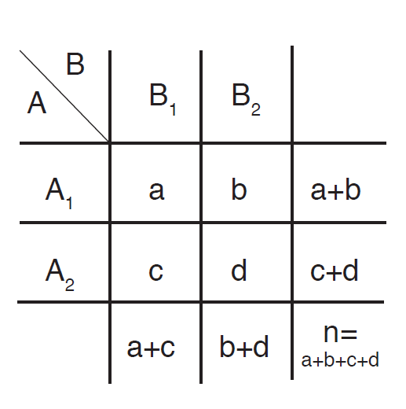

* Our hypothesis is that we want to test whether class A is linked to class B. H0: The random variable expressing A1 and B1 is distributed according to a hypergeometric distribution.

$p-value=\sum_{i=a}^{a+b}{\frac{\left(\begin{matrix}a+b & \\ i & \end{matrix}\right)\left(\begin{matrix}c+d & \\ a+c-i & \end{matrix}\right)}{\left(\begin{matrix}n & \\ a+c & \end{matrix}\right)}}$

**What are the pitfalls for Fisher’s exact test?**

It only works for small numbers, n choose k cannot be computed for larger numbers.

**How does Pearson’s chi^2 test compare to Fisher’s exact test?**

It was invented for bigger numbers. It’s used to calculate the deviance between observed and expected numbers based on a hypergeometric distribution.

**How is the test performed?**

We compared observed vs. expected results:

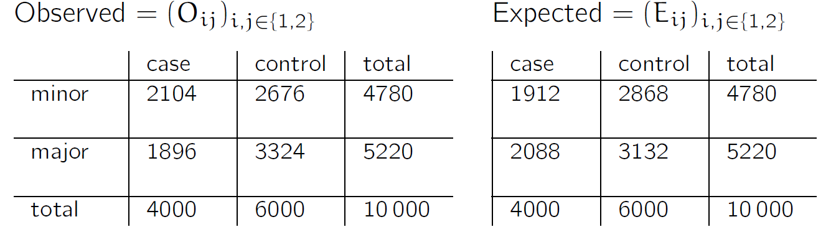

Then we compute the following test statistic:

$$x=\sum_{i,j=1}^{2}{\frac{{\left(O_{ij}-E_{ij}\right)}^{2}}{E_{ij}}}$$

Which should be chi^2-distributed. The p-value is then the probability of a chi^2-distributed random variable being higher or equal to x.

**What are the criticisms that GWAS receive today?**

* Missing QC steps, e.g. test for biases for tested group structure
* Multiple testing correction required
* Correlation only between single SNPs but not between genes tested.
* Methogological problems have been addressed and used to identify over 4,000 SNPs.

**Why do we want to quantify variation between sequences?**

In order to construct the phylogeny between sequences.

**What is the distance between two sequences?**

The number of differing nucleotides substitutions per site.

**What are the requirements for the mathematical model estimating the distance?**

* Stochastic process modelling the substitution through time.
* Substitution rates.

**How can nucleotide substitution be modelled?**

They can be modelled as a Markov chain:

* It’s a stochastic process
* Lives on a state space and jumps to the different states
* Is memoryless: the probability of jumping to a state only depends on the current state.

**When is a Markov chain called time homogenous?**

If the transition probabilities on the state space do not change over time.

**What is the difference between a rate and a probability?**

Rates: measures events per time unit

* Rates are fixed, deterministic quantities.
* Describes averages

Probabilities: measure of chance that a random event occurs

* Stochastic
* Describes an exact event

**How do rates relate to probabilities?**

$$P\left(0<X<τ\right)=1-e^{-αt}$$

**Assume we have the transition matrix Q, how can we infer probabilities from it?**

$$P\left(t\right)=e^{Qt}$$

**What does $P\left(t\right)=e^{Qt}$**  **mean?**

It means that every possible series of states is visited in time t.

**What are Markov chains a great model for nucleotide substitutions?**

1. They are memoryless: a nucleotide substitution happends independently from the substitution history at this site.
2. Substitution rate matrix defines the transition probabilities
3. The transition probabilities take into account every possible substitution path.

**What is the JC69 model?**

All substitution rates are the same, lambda. Probability of staying the same is 1-3lambda

**What is the K80 model?**

* Transitions: pyrimidines-pyrimidine & purine-purine: alpha
* Tranversions: pyrimidines-purine & purine-pyrimidine : beta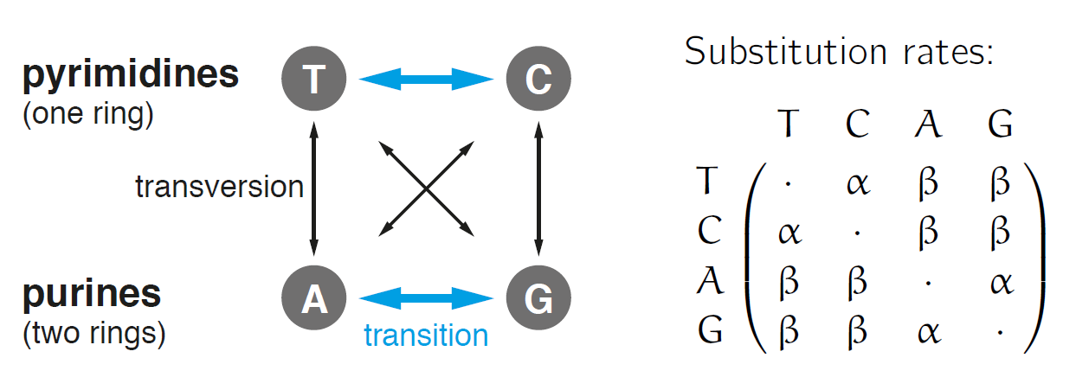

**What is the TN93/HKY model?**

Adds to the K80 model, multiply each rate of K80 by nucleotide equilibrium frequency. Additionally, T-C & A-G happen at different rates. HKY considers alpha1=alpha2.

**What is the GTR model?**

It’s the generalized time-reversible model.

Pros:

* Flexible
* Time-reversible

Cons:

* Not completely general

**What does time-reversibility enable?**

Makes calculations and simulations easier.

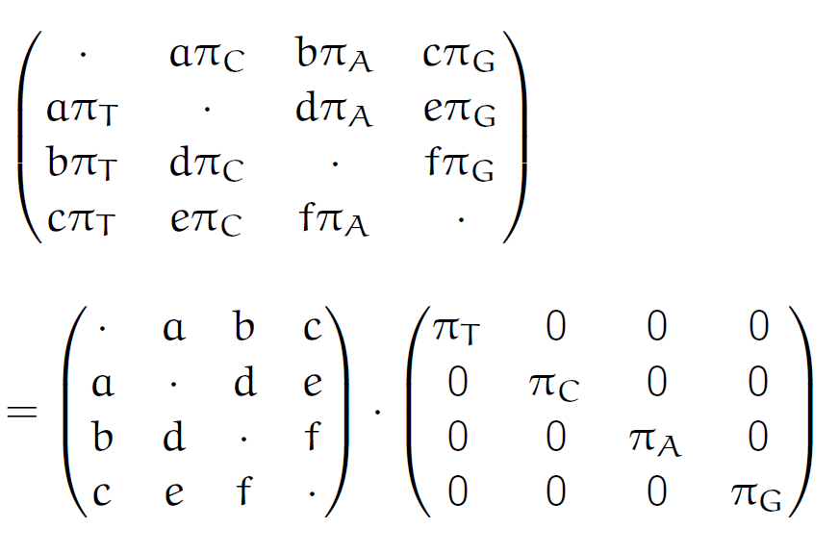

**What is the most general substitution model?**

It’s the unrestricted mode, where each substitution has a different rate, not handy to use & not time-reversible.

**In a GWAS, why can you not reject your null hypothesis if the p-value is <alpha?**

Because of multiple testing, this is called a Bonferroni correction.

**Why is it not advisable to reconstruct a phylogeny based on the Hamming distance?**

Does not include substitution rates or stochasticity.

# Nucleotide, amino acid and codon substitution models

**What is the maximum likelihood estimator?**

It is an estimator of a model parameter that maximises the probability to obtain the observed results.

**How is it obtained?**

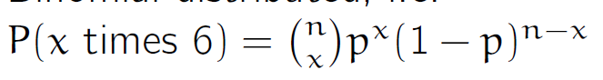

**How can the log likelihood be derived from this example?**



**How can the maximum be found?**

Set first derivative to 0:



**How can the CI of the MLE for the parameters of the distribution of a random variable X be found?**

Under certain conditions, 2(l(theta hat)-l(theta)) is chi^2_k distributed, where k is the length of theta.

1. Determine the value of l(theta hat; x)
2. Substract 0.5chi^2_(k,5%)
3. Determine theta value for which

l(theta;x)=l(theta hat;x)-0,5chi^2_{k,5%}

**What is the MLE for the sequence distance under the JC69 model?**



Log likelihood:



MLE of the JC69 distance:

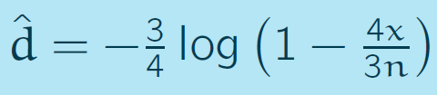

**Why could the JC69 model be supplemented with a gamma distribution?**

To encode for the variability in substitution rates.

**What is the distance function under the JC69+gamma model?**

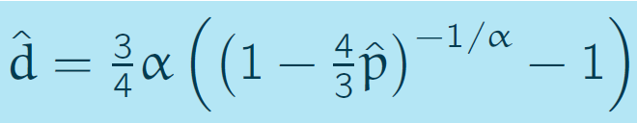

This avoids ignoring site variation, which leads to an underestimation of the sequence distance.

**What differs when trying to model amino acid substitution?**

Q needs to be 20x20 -> increases computational complexity.

**What are the two approaches that can be adopted in AA substitution modelling?**

Empirical

Mechanistic

Desired: time-reversibility.

**How does the JC69 distance look like when doing AA substitution?**

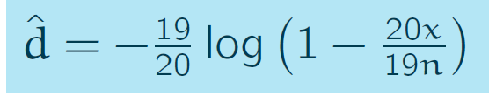

The distance can be estimated with an empirical or mechanistic Q matrix.

**What changes when doing codon substitution models?**

There are multiple codons leading to the same AA, which are empirically more likely to occur. Codon changes leading to the same AA are called synonymous substitutions. Non-synonymous substitutions are when the resulting AA changes.

Transversions and transitions can also be modelled, making some of the codon changes more likely. Also, equilibrium frequencies can be incorporated.

**What are the dimensions of the substitution matrix in the case of codon transitions?**

61x61. No stop codon included. (43-3)

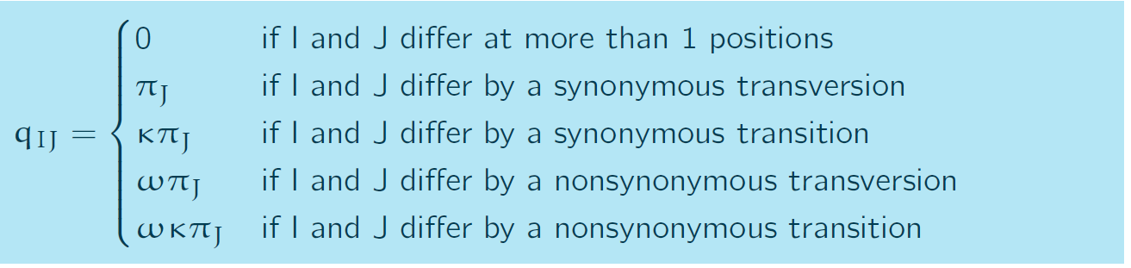

**How can selection be uncovered from these substitutions?**

Comparing the amount of nonsynonymous and synonymous substitutions.

dN: distance at nonsynonymous codon positions

dS: distance at synonymous codon positions

* dN/ dS

Then use dN/ dS counting method:

1. Count the (non-) synonymous differences
   1. Taking into account all possible pathways!

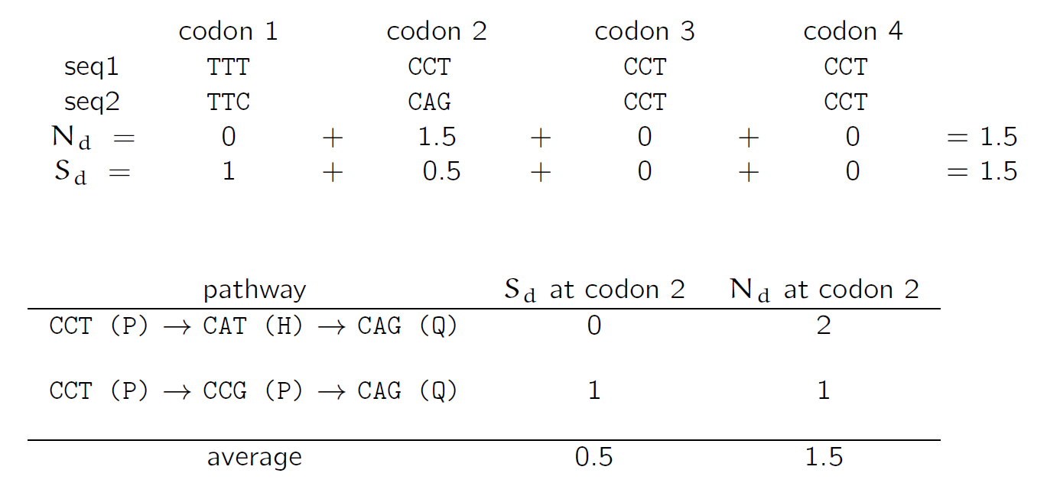

1. Count the (non-) synonymous sites

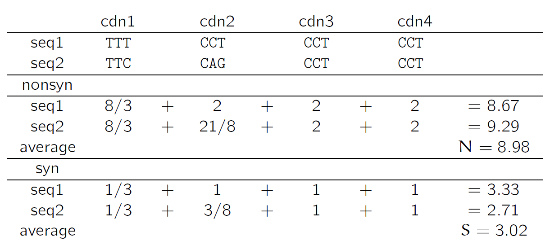

1. Account for evolutionary history

**How can we interpret the** dN/ dS **ratio?**

dN/ dS<1: nonsynonymous mutation occur less frequently than synonymous mutations (purifying selection)

dN/ dS>1: nonsynonymous mutation occur more frequently than synonymous mutations (positive selection)

**What is the difference between the JC69 and the TN93 models?**

TN93 Considers transitions, transversions & equilibrium frequency, compared to JC69 which does not.

**Which of the two models would you choose if you were to perform a phylogenetic analysis based on sequence distances?**

TN93 probably, because more realistic.

**In lecture 3, we tried to naively reconstruct a phylogeny based on three sequences. The pairwise Hamming distances were all the same. Would you expect that any of the presented nucleotide sequence models would result in different trees?**

Yes, will cluster sequences differently.

# Phylogenetics: UPGMA and least squares

**What is a tree?**

It’s a graph of nodes and branches without cycles

**What is an unrooted phylogenetic tree?**

It’s a tree with two types of nodes:

* Tip/leaf: node with 1 branch attached
* Internal node: Node with 3 branches attached.

**What is a rooted phylogenetic tree?**

It’s an unrooted tree in which one branch is devided by a new node (root)

**How can unrooted trees be rooted?**

If one adds an outgroup. It means that the branch ending in B is subdivided by the root node. B is chosen by the user as a very distantly related organism to the remaining organisms in the tree.

**What is one condition concerning branches which is required in trees?**

Branch length needs to be positive.

**What is a pendant branch?**

It’s a branch attached to a tip

**What is a cherry?**

It’s a pair of tips which are only separated by one internal node.

**What is a caterpillar tree?**

It’s a rooted tree which only one cherry.

**What is a monophyletic group/clade?**

All ascendants of an internal node in a rooted tree.

**What is an ultrametric tree?**

It’s a rooted tree where the sum of branch lengths from any tip to the root is the same.

**What is a polytomy?**

The definition of a phylogenetic tree is extended such that internal nodes may have more than three branches attached. Such a node is a polytomy. It can be represented as a classic phylogenetic tree with branch lengths of 0.

**How can a rooted Newick tree be constructed?**

Recursively:

* Choose two tips C and D that form a cherry
* Replace the two tips by the new tip C: tx, D:tD where tx is the length of the branch ancestral to the node X.
* The length of the branch ancestral to the new tip is the branch length ancestral to the cherry.

**How can an unrooted Newick tree be constructed?**

* Choose an internal node arbitrarily
* Proceed as in the rooted tree towards the chose internal node
* Connect the three last tips X, Y, Z to (X:tx, Y:ty, Z:tz)

**What properties does a Newick tree have?**

Each tree does not have a unique Newick representation.

**What needs to be respected when representing trees?**

The distance along the evolutionary time axis needs to be respected.

**How are phylogenies reconstructed?**

Similar individuals are clustered together according to sequencing data. Similarity may be defined in different ways:

* Phenetic:
  + Based on overall similarity
  + Pairwise distance based
  + Methods: UPGMA, least squares
* Cladistic:
  + Based on shared characteristics
  + Character-based
  + Methods: parsimony
* Mechanistic:
  + Based on evolutionary model
  + Character-based
  + Methods: ML/Bayesian inference.

**What is the basic idea behind phenetic approaches?**

1. Define how to measure distance between sequences
2. Calculate distances between all pairs of sequences
3. Find a tree where the distances, i.e. branch lengths between the pairs of tips most closely follow the sequence distance matrix.

**What are the two strategies to reconstruct the three in phenetic approaches?**

* Algorithmic approach (UPGMA): sequences separated by the smallest distance are clustered iteratively in a tree.
* Optimality approach: minimise the difference of the pairwise sequence distances to the pairwise distances between the tips in the tree, calculated by summing the length of branches between two tips.

Note: only distances between pairs of sequences are used but not any higher order correlations between sequences.

**What is the I/O of UPGMA?**

Input: distance matrix.

Output: the ultrametric phylogenetic tree

**What are the assumptions behind the UPGMA algorithm?**

* All sequences must come from the same time point
* The algorithm assumes evolution according to a strict molecular clock: the rate of DNA/RNA/protein sequence evolution is constant over time

**Which algorithm relaxes these assumptions?**

Neighbour-joining algorithm, where the branch length corresponds to the number of mutations. The output tree will be unrooted.

**What are the computational steps of the UPGMA algorithm?**

Initialize the size of each node si as ni=1.

While the distance matrix is not empty, iterate:

1. Choose nodes si and sj such that d(si,sj) is the smallest entry in the distance matrix, in case of several minima, choose one at random.
2. Coalesce si and sj to node sij with size ni,j=ni+nj. The branch length between si , si,j and between sj , si,j is chosen such that all tips descending from si,j have the same distance d(si,sj)/2 so si,j
3. If the distance matrix includes more than 2 nodes, include si,j into the distance matrix with

$$d\left(s_{m},s_{i,j}\right)=\frac{n_{i}d\left(s_{i},s_{m}\right)+n_{j}d\left(s_{j},s_{m}\right)}{n_{i}+n_{j}}$$

Where $s_{m}$ is a node in the distance matrix

1. Delete nodes $s_{i}$ and $s_{j}$ from the distance matrix.

**What is the formula for the optimality objective in the least squares method?**

It’s the squared difference between the sequence distance matrix and the tree distance matrix:

$$S≔\sum_{i=1}^{n}{}\sum_{j=i+1}^{n}{{w_{i,j}\left(D_{i,j}-d_{i,j}\right)}^{2}}$$

Where D is the between sequence distance matrix, d the tree distance matrix for the proposed tree and w weights. It can be a matrix of 1 or inverse proportional to Di,j.

**What is the I/O of the tree?**

Input: distance matrix

Output: tree with smallest S

**What is the algorithm to be used?**

Repeat until all tree topologies were proposed:

1. Propose an unrooted tree topology (without branch lengths)
2. Minimise S by optimizing the branch lengths.

**What is the computational complexity of UPGMA?**

O(n3) for n sequences.

**What is the computational complexity of the least squares method?**

(2n-5)!! + (2n-3)!! -> NP-hard, because each tree architecture needs to be tested.

**What is statistical consistency?**

A phylogenetic reconstruction method is statistically consistent if the true tree is returned for an infinite amount of data, i.e.

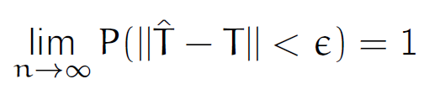

**Are UPGMA and least squares consistent?**

Yes.

For UPGMA, the distance matrix tends towards the tree distances. If the sequence distance matrix equals the tree distance matrix, then the true tree is reconstructed.

For least squares, the squared difference between the calculated distance matrix and the tree distance tend towards 0, thus the tree is a least squares tree. Each tree has a unique distance matrix, thus the true tree is the least squares tree.

**What is the minimal number of cherries in a phylogenetic tree of 99 tips?**

Min: 1.

Max: (n-1)/2

**In how many ways can you write the Newick string for a rooted tree with species A, B, C? In how many ways can you write the Newick string for a rooted tree with n species?**

2, 2^(n-1).

**Consider the least squares method. Why would we use weights wi,j not equal to 1?**

The longer the evolution time, the longer the distance and the higher the variance in distances. A better weight for distances that are short could be a nice alternative. Inverse of distance could be used as weights.

# Phylogenetics: Cladistic tree inferences

**What do cladistic approaches consider?**

They consider the similarity as measured by shared characters in the alignment sequences.

**What method is used to use cladistic approaches?**

The parsimony method: find the tree that needs the minimal number of mutations to get the alignment.

**What are the elements of the parsimony method?**

* Parsimony score of a tree: the minimal number of mutations required to explain the sequences at the tips of the tree.
* Most parsimonious tree: the tree with the minimal parsimony score.

**What is a relationship between unrooted trees and rooted trees in the context of the parsimony method?**

Rooted trees obtained from the same unrooted tree have the same parsimony score.

**What is the I/O of the parsimony tree reconstruction method?**

Input: sequence alignment of n sequences with sequence length m.

Output: Unrooted tree with the lowest parsimony score.

**What is the algorithm for parsimony tree reconstruction?**

* Consider each unrooted tree (2n-5)!!
* Calculate the parsimony score for the unrooted tree, which requires 4n-1m internal sequence alignments. This can be improved by using the Fitch algorithm.

**What is the Fitch algorithm?**

It’s an algorithm to quickly determine the parsimony sore of a tree.

**What is the I/O of the Fitch algorithm?**

Input: Unrooted phylogenetic tree and an alignment of n sequences of length m, corresponding to the n tips of the tree.

Output: Parsimony score k of the tree, i.e. the minimal number of mutations required to explain the sequences at the tips.

**What are the steps in the Fitch algorithm?**

1. Root the tree at an arbitrary edge
2. K=0
3. While the root has no sequence assigned, iterate:
4. Choose a node in the tree where all descending nodes have sequences assigned
5. Assign a sequence to the chosen node. For i=1,…,m:
6. Let Cl and Cr be the sets of nucleotides assigned to the two direct descendants of the chose node for site i.
7. If Cl inter Cr is not empty, assign Cl inter Cr to nucleotide I of the chosen node
8. If C inter Cr is empty, assign Cl union Cr to nucleotide i of the chosen node and set k = k+1

**What is the computational complexity of the Fitch algorithm?**

(n-1)m

**How is the parsimony tree found?**

By calculating the parsimony score on each unrooted subtree = NP-complete.

**Is the parsimony method statistically consistent?**

No, imaging there are two nucleotides (0 and 1) with the same rate of transition 0->1 1->0. The probability of change in the long branch is p and the probability on the short branch is q. Parsimony infers the wrong tree if p,q are in the Felsenstein zone, i.e. p2>q(1-q).

It’s also a phenomenon referred to as “long branch attraction”.

**What is the I/O of the maximum likelihood inference?**

Input: sequence alignment

Output: tree which maximises the probability of the sequences given the tree & the sequence evolution parameters:

* Requires an evolutionary model
* Parameters of the evolutionary model are co-estimated with the tree.

**What is the objective of MLE in the context of phylogenic inference?**

What is the maximum likelihood phylogeny given the sequence data?

**What is the parameter in the context of MLE phylogenetic inference?**

The trees.

**What is L(T, Q; D) := P(D|T,Q)?**

It’s the likelihood function of the parameters T, Q for the given sequence data.

**State the inference problem.**

Determine T, Q which best explains the alignments observed, i.e:

$$\max_{TQ}{L\left(T,Q;D\right)}$$

We determine the best tree by evaluating the likelihood for many different proposed trees.

**What is the likelihood calculation for a single tree?**

For an alignment of length m:

$$P\left(s_{1},…, s_{n} | T,Q\right)=\prod_{j=1}^{m}{P\left(s_{1,j},…, s_{n,j} | T,Q\right)}$$

Where sk,j is the site j of sequence sk. Then, $P\left(s_{1,j},…, s_{n,j} | T,Q\right)$ is defined as:

$$P\left(s_{1,j},…, s_{n,j} | T,Q\right)=\sum_{s_{n+1,j}∈\left\{A,C,G,T\right\}}{…}\sum_{s_{2n-1,j}∈\left\{A,C,G,T\right\}}{P\left(s_{1,j}, s_{2,j},…, s_{2n-1,j} | T,Q\right)}$$

$P\left(s_{1,j}, s_{2,j},…, s_{2n-1,j} | T,Q\right)$ can be evaluated by calculating for each branch l (with starting sequence sl1 and ending sequence sl2 , and branch length tl) the transition probability from the ancestral nucleotide to the descendant nucleotide. The root nucleotides are then weighted by their equilibrium probabilities pi, so that:

$P\left(s_{1,j}, s_{2,j},…, s_{2n-1,j} | T,Q\right)=π\left(s_{2n-1,j}\right)\prod_{l=1}^{2n-2}{Ps_{l1,j,}s_{l2,j}\left(t_{l}\right)}$

**What is the runtime of the MLE?**

O(m4nn)

**What allows us to speed up calculations?**

Felsenstein’s pruning algorithm. Make the summation more efficient, i.e. polynomial in n through dynamic programming. At tip k, $P\left(D_{k} | X\right)=1$ if X is the observed nucleotide, otherwise 0 $∀X∈\left\{A,C,G,T\right\}$. Cherries are pruned recursively towards the root. Let k be a node with the descendants l,m.

$$P\left(D_{k} | X\right)=\left(\sum_{Y∈\{A,C,G,T\}}{P_{X,Y}(t_{l})P(D_{l}|Y)}\right)×\left(\sum_{Z∈\{A,C,G,T\}}{P_{X,Z}(t_{m})P(D_{m}|Z)}\right)$$

**What is the probability of the sequences at site j?**

$$P\left(s_{1,j},…, s_{n,j} | T,Q\right)=\sum_{X∈\{A,C,G,T\}}{P\left(D_{r} | Y\right)π_{X}}$$

**What is the runtime of Felsentein’s pruning algorithm?**

O(mn), only bottleneck is finding the optimal tree structure, which is NP complete.

**Consider the Fitch algorithm. Do you obtain all most parsimonious ancestral sequences when choosing the different nucleotides in the curly brackets?**

No, counter-example possible.

**Does the ML tree reconstruction method return estimates for the internal sequences? Give a reason for your answer.**

No, we only have P(Dk|X), not P(X).

**Does the Fitch algorithm return the parsimony score for any phylogenetic tree and any sequence alignment? Or are there situations when the Fitch algorithm does not return the smallest number of mutations required?**

It possible to always find the smallest number of mutations required.

# Maximum likelihood method & testing

**How can we search the tree space for the maximum likelihood tree?**

Use methods like NNI, SPR, and TBR for branching structure. Propose different branch lengths. Use hill-climbing strategies to find the optimum.

**What is the nearest-neighbour interchange (NNI) algorithm?**

Each internal branch in the tree connects four subtrees or nearest neighbours. Interchanging a subtree on one side of the branch with another on the other side constitutes an NNI. Two rearrangements are possible for each internal branch.

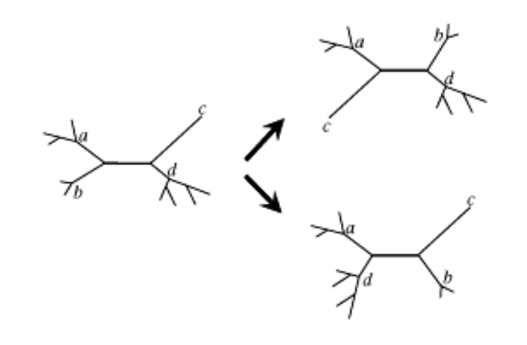

**What is subtree pruning and regrafting (SPR)?**

A subtree is pruned, and then reattached to a different location on the tree.

**What is tree bisection and reconnection (TBR)?**

The tree is broken into two subtrees by cutting an internal branch. Two branches, one from each subtree, are then chosen and rejoined to form a new tree.

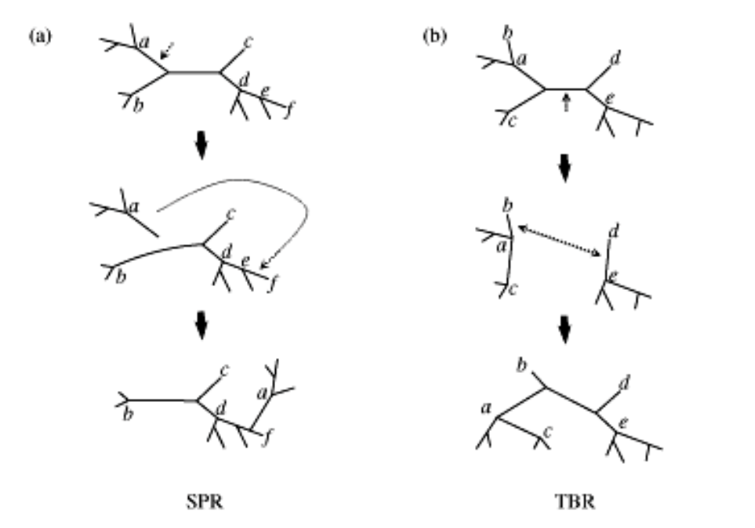

**What question is answered by model testing?**

Which evolutionary models are appropriate for our data?

**What are the ways by which we can answer this question?**

Via likelihood ratio tests & AIC.

**How can we assess our confidence in the phylogeny and substitution rates?**

Via

* Likelihood ratios
* Bootstrapping (only method not requiring ML)

**How can we perform likelihood ratios for models?**

* Assume the ata evolved under a model H0
* Assume model H1 within which H0 is nested
* For the given data, let the ML parameter estimate under the model H0 be θ0hat and under H1 θ1hat.
* Assume large amount of data, then:

$$2\left(\log{L\left({\hat{θ}}_{1} \right)}-\log{L\left({\hat{θ}}_{0} \right)}\right)\sim χ_{df}^{2}$$

Where df is the difference in the number of parameter in the general and in the nested model. If that difference is either infinity or 0, then choose 0.5.

* Note that:

**What is the likelihood ratio test?**

1. Consider two models: H1 general model parameterized in , and H0 general model parameterized in .
2. Derive the likelihood function for both models and the ML estimators and for a given dataset.
3. Calculate
4. Reject H0 if is in the tail of the

**What is the formula for accuracy and power?**

Accuracy = 1 - (TI error)

Power = 1 – (TII error)

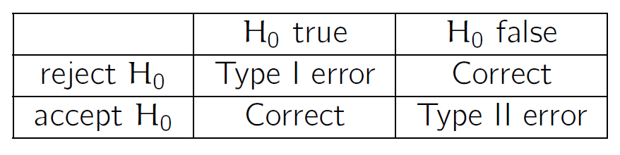

**How can non-nested models be tested?**

Using the AIC:

Where is the number of parameters and is the likelihood function of model i.

This can be integrated in the following workflow:

1. Calculate AIC
2. Choose model with lowest AIC
   1. Rationale: AIC claims to pick the model with the smallest expected Kullback-Leibler distance to the true model.

**How can different values of the AIC be compared to one another?**

* Models having AIC within 1-2 of the minimum: substantial support, should receive consideration in inference
* Models with AIC 4-7 of the minimum: considerably less support
* Models with AIC>0 have essentially no support.

**Given you want to test JC against GTR, can you use a likelihood ratio test?**

* Yes if you perform the test on the same tree with fixed branch lengths.
* No if you perform the test on different trees. Each tree is a different parameter, thus the full models are not nested. AIC needs to be used in that case.

**How can the confidence interval be derived?**

**How can we estimate our confidence in our MLE?**

1. Compute CI. (This is not possible for complex topological structures.)
2. Do more experiments, ignore bottom and top 2.5%. (This is not possible for non repeatable events, like speciation)
3. Mimic more experiments through bootstrapping. Bootstrapping refers to tests relying on random sampling with replacement. If we have enough observations, then bootstrapping results should be the same as rolling the dice again, and we obtain the 95% interval like we would if redoing the experiment.

**How can bootstrapping be achieved in phylogeny?**

Consider alignment sequences of length m:

1. Sample m sites at random with replacement
2. Infer phylogeny on the new data
3. Repeat.

**Is there a way to test how to best root a ML tree?**

If nucleotide substitution model if TR, then there is no way to root it unless there is an outgroup.

For non-TR trees, choose highest likelihood.

**Can you use the bootstrapping ideas for assessing confidence in a UPGMA tree?**

Yes, use procedure described above.

**What is required to infer the direction of transmission from a phylogeny?**

If one cluster is embedded in another cluster, you can infer that the sub cluster likely emerged after the main cluster. Only with 100% coverage can one infer the direction of transmission from a phylogeny.

# Continuous traits and comparative methods

**What are examples of phenotypic traits/characters?**

Discrete:

* Spike numbers of HIV virions
* Number of legs in arthropods
* Fur patterns in rodents

Continuous

* Height
* Surface to weight ratio
* Virulence of influenza
* Shape of dinosaur jaw

**What test needs to be performed to test whether there is a true correlation between hair color and eye color?**

Fisher’s exact test.

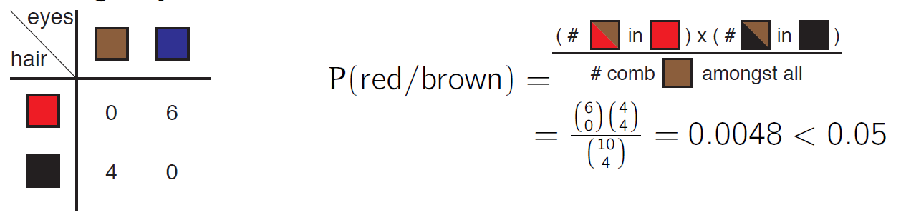

**What factor could bias our analysis?**

Phylogenetic relatedness

**What is the correct way to look at this problem?**

Problem statement: is the change of characters on the branches correlated?

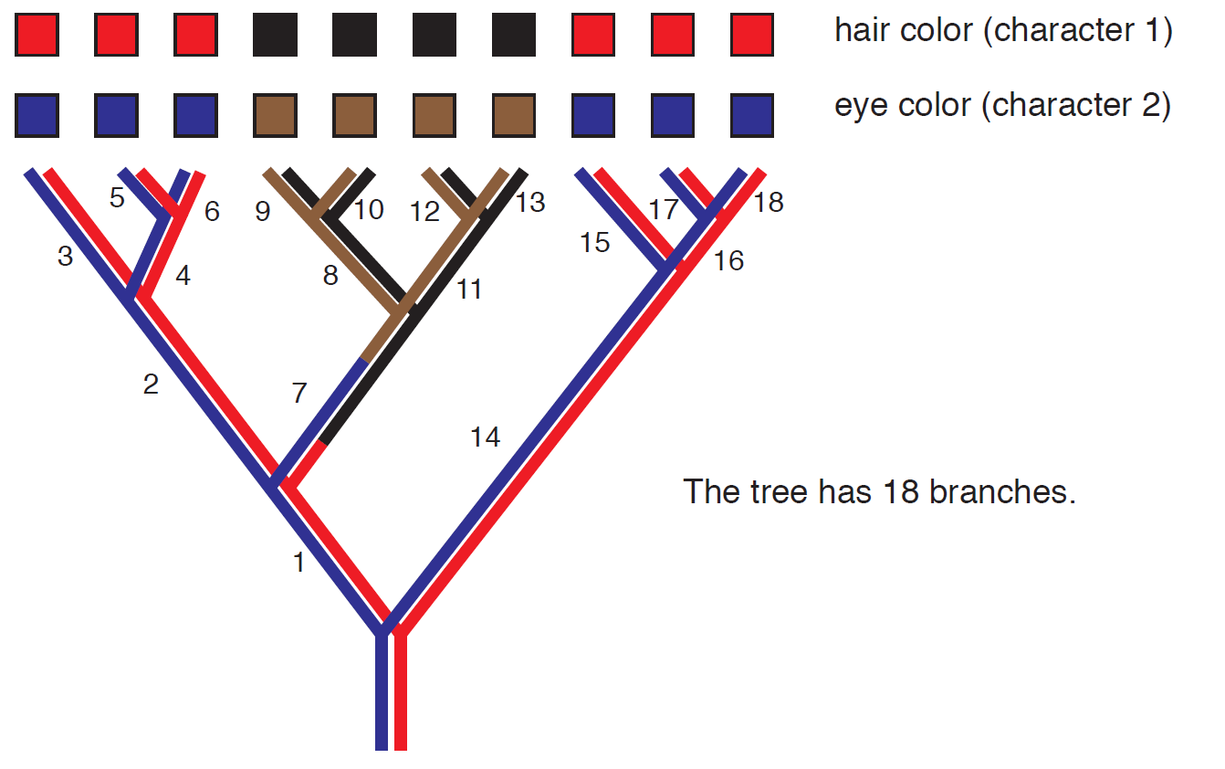

**How can Fisher’s exact test be rephrased in this case?**

H0: the character changes are equally likely on every branch.

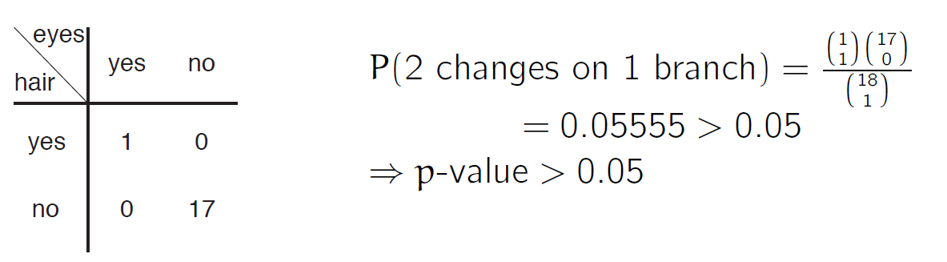

**Why can’t linear regression be used to compare two characters evolved on a phylogeny?**

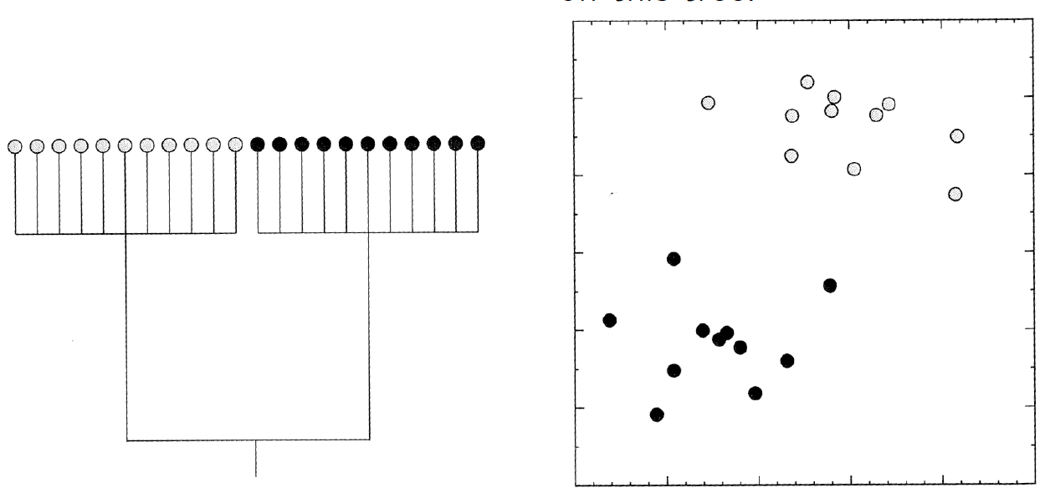

No correlation, only clade effects

**What is Brownian motion?**

It’s a Wiener process which fulfils the following four conditions:

1. is almost surely continuous
2. has independent increments -> memorylessness
3. ,

**How can a Brownian motion be applied to a phylogeny?**

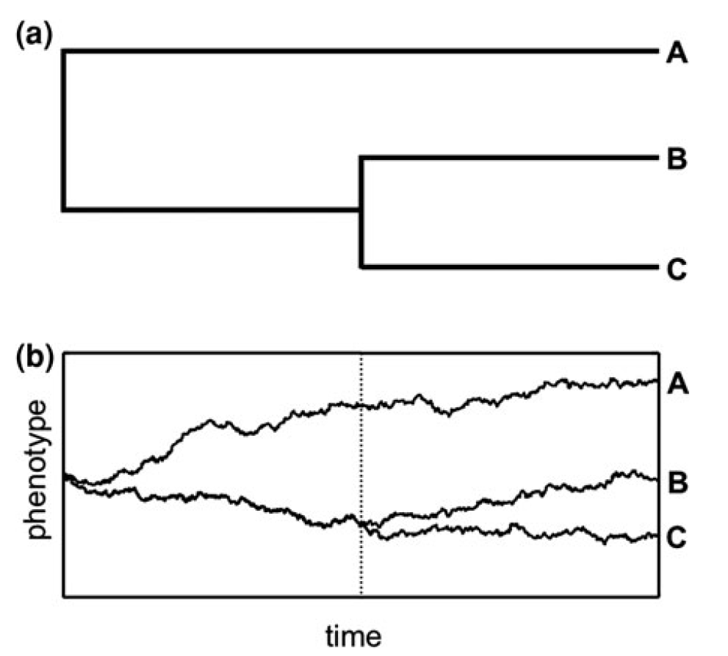

**What is one method to overcome interdependencies of the evolutionary trait?**

Suppose a phylogeny of 4 species.

**In a Fisher’s exact test, how would you calculate which values for one of the cells in the contingency table would lead to a rejection of the null hypothesis, given that row and column sums remain the same?**

Take one value, based on the hypergeometric distribution calculate the probability that It’s above or below a certain threshold value.

**Is the Brownian motion model a good model for all continuous traits? Could you imagine situations where this is not the case and which assumption in this model could be violated?**

Models drift/ Random walk, which is good when traits evolves like this. If there is selective pressure, then not a good idea.

**Do you think it is a good strategy to first determine the species tree and then look at character evolution, or would a co-estimation of characters and the phylogeny make more sense?**

Using characters as alignment to build phylogeny. Then for characters assume models for evolution which themselves assume neutrality. If the phenotype is part of the selection process, then the wrong phylogeny is inferred because the models assume neutrality.

# Phylodynamics

**What is the question addressed by phylodynamics?**

What is the process that generated the phylogenetic tree?

Population dynamics is the speciation ad extinction process

**What are key application of phylodynamics?**

Immunology: individuals = B cells

* Phylogeny displays B cell differentiation through somatic hypermutation
* Population dynamics is the B cell generation and loss process

Cancer: individuals = cells

* Phylogeny displays relationship of different cancer cells and healthy cells.
* Population dynamics is the spread and loss of cell types

Languages:

* Phylogeny displays language evolution
* Population dynamics is the gain and loss of languages

**What are population dynamics?**

They are models of the birth and death of individuals. The birth and death process gives rise to a phylogenetic tree.

**What is phylodynamics?**

Phylodynamics aims to understand and quantify the population dynamics based on a phylogenetic tree. Today we quantify birth and death dynamics given the phylogenetic tree and then also R0.

**How does a linear birth-death process look like?**

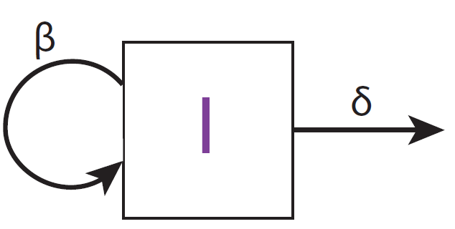

**What are the properties of this model?**

* Rate of birth of new individuals in I is
* Rate of death per individual in I is
* The probability of giving birth to another individual in a very small time step is
* The probability of dying in a very small time step is
* The waiting time to a birth event is exponentially distributed with parameter .
* The waiting time to the first event (birth or death) is exponentially distributed with parameter
* For individuals, that would be

**How does a complete population tree look like?**

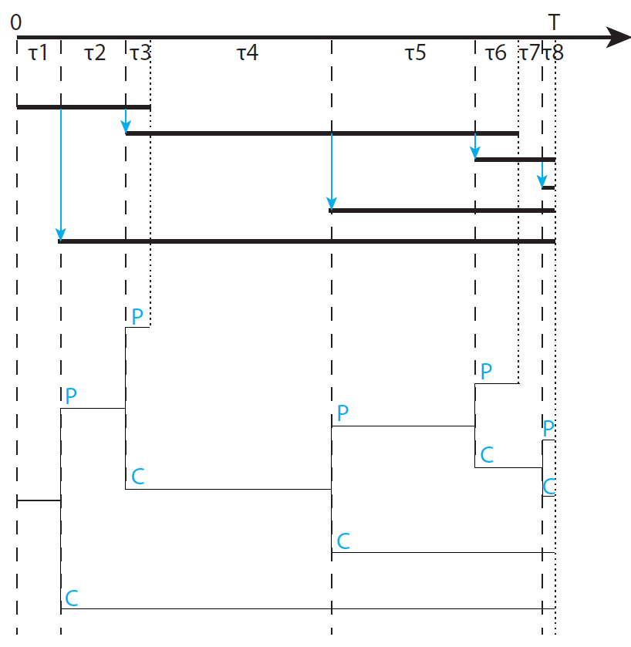

**What parameters are included in the simplest phylodynamic model?**

* Birth rate
* Death rate
* Process duration
* Extant tip sampling probability
* Extinct tip sampling probability

**What is the process of plotting the number of lineages vs time?**

The lineage-through-time (LTT) plot. The number of surviving lineages through time.

**Can we infer the birth and death rates from reconstructed phylogenies?**

Yes, consider the LTTs for a population of age T=50.

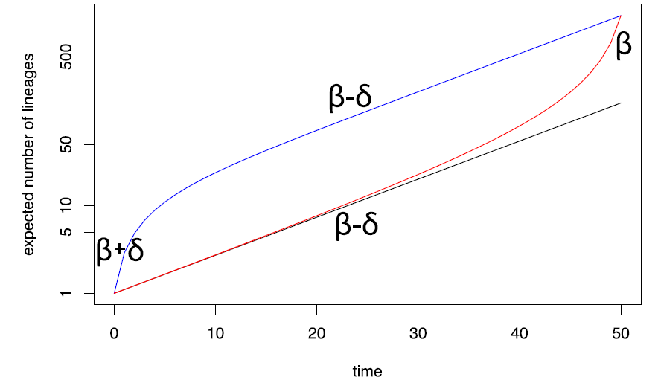

* Red: average number of lineages in the phylogenetic tree
* Blue: average of surviving population trajectories
* Black: exponential growth curve with linear slope on the log scale.
* The early blue part is called push of the past and the late red part is called pull-of-the-present.
* The push-of-the-past comes from individuals with a quick replication early on which produce surviving populations.
* The pull-of-the-present (i.e. an apparent acceleration in diversification towards the present) is observed as the very recent lineages did not yet have time to go extinct.
* Fitting a regression line to the early branching events form an estimate for
* The late branching events can form a slope to estimate .

**What problems does this method have of estimating and ?**

It is not clear how to incorporate the variances into the regression and how to choose the time interval for the two regression lines.

**How does phylogenetic likelihood differ from phylodynamic likelihood?**

In Phylogenetic likelihood, we estimate:

In phylogynamic likelihood, we estimate:

i.e. we aim to determine the maximum likelihood estimate for the parameters given a phylogenetic tree. The age of the process T is assumed to be fixed here (relaxed later).

**How can we derive ?**

This requires to derive the probability of a single individual after time t leaving 0 or 1 offspring. We denote this as and .

**What is the ODE for ?**

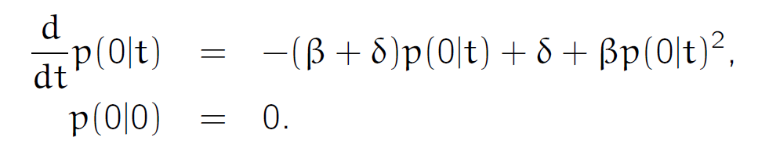

So the solution is

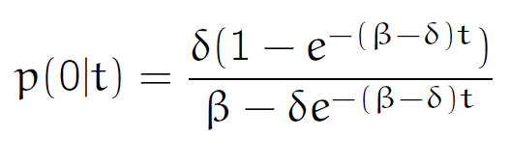

**In general, what is the probability of giving rise to n descendants?**

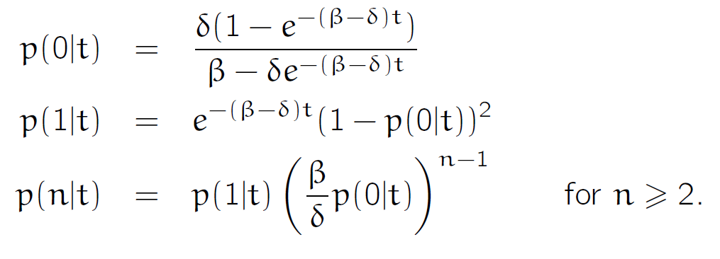

**How can the probability density of a tree be expressed?**

* Time is measured as age relative to the present
* is the probability density for a branch of length extending from an individual at time in the past.
* Then, the probability density of a tree with age is

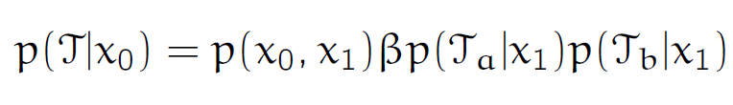 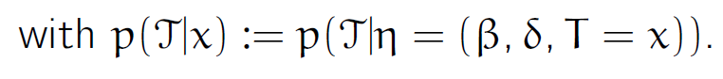

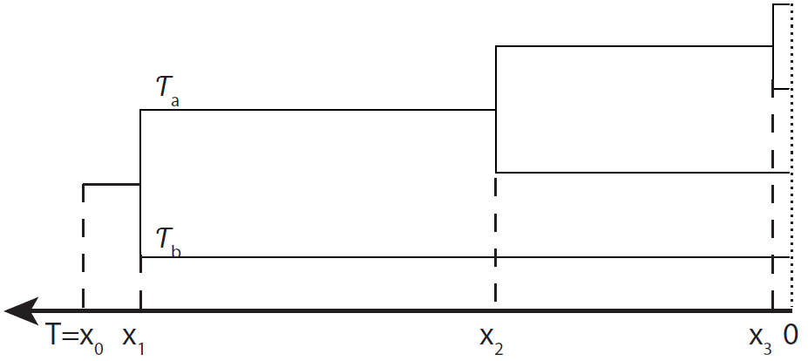

**How can the probability density of the branch between t and x1,**  **be calculated?**

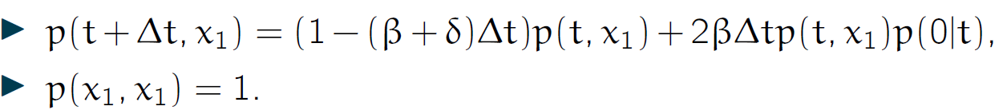

This leads to:

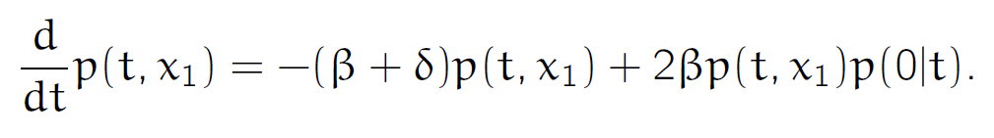

This yields the same differential equation as for As the initial condition is different (), we have:

**How does this translate to a tree with n present day tips?**

Age of the process is and branching times we have the probability density of the tree:

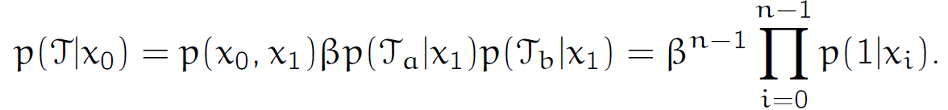

**What are the application of phylodynamics?**

Crucial to know , the number of secondary infections caused by a single infected individual in a susceptible population. The number indicates the amount of public health effort for containing the epidemic.

Likelihood estimates of beta and alpha + CI, Bayesian methods improved estimate.

**How does the approximate number of steps required to calculate the phylodynamic likelihood depend on the number of leaves in a phylogenetic tree? (what’s the time complexity?)**

O(n-1)=O(n)

**What kind of population dynamic process could a decrease in slope in the LTT plot reflect?**

It means that either the death rate increases or that the birth rate decreases.

**Assume a birth-death process where each individual at present is sampled with probability p. How is the derivation of , the probability of sampling no individual at present, different compared to the derivation of** .

# Coalescent theory

**What is a Wright-Frisher process?**

* It is formed by discrete generations.
* Each generation consist of N individuals.
* Each individual in the offspring population chooses its parent uniformly at random from the N parents
  + A given parent has a binomially-distributed number of offspring.
* For phylogenies of a particular gene, ploidy can be taken into account by multiplying N by a factor which accounts for the number of copies of a gene present in each individual.

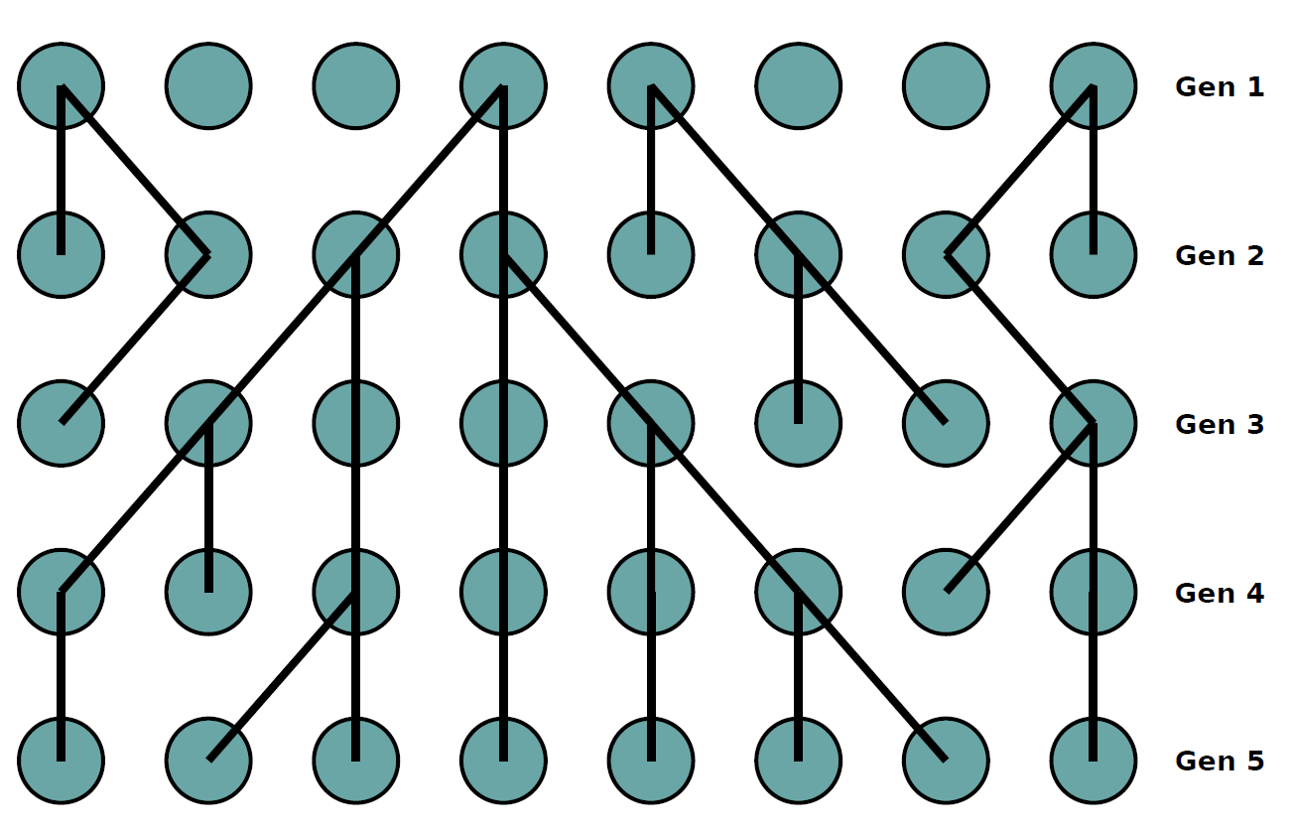

**What is the probability of coalescence in generation i-m of two sampled individuals in generation i?**

At any generation of size N, the probability of coalescing is:

Hence, the probability of coalescing at generation is:

**What is the distribution of this value?**

It can be approximated by an exponential distribution for large :

**How does the coalescent translate to calendar time?**

Assume g be the calendar time of a generation. Then is the calendar time span of m generation. The probability density function for the coalescence time then becomes:

I.e. for large N, the time to coalescence is exponentially distributed with mean gN.

**How can the coalescence probability be generalized for k samples?**

**What is Kingman’s coalescent?**

* It’s a continuous-time Markov process which produces samples time trees.
* The process occurs backwards in time.
* Equivalent to sampled trees produced by a Wright-Fisher model when N is much larger than the number of samples.
* Times between coalescence events are drawn from an exponential distributions with rate parameters , i.e.:

**What is the average time required for n lineages to coalesce into one?**

Therefore, when n is large. This is an upper bound on the expectation, individual coalescent trees can be older.

**What is the probability of a given coalescent tree?**

Given the following tree

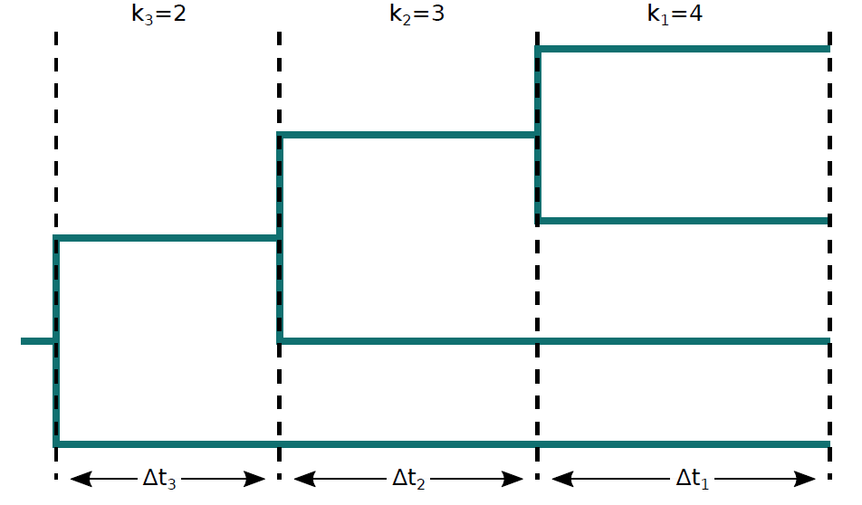

, we have:

**Why would population size inference based on the coalescent distribution be biased?**

Because the real dynamics differ from the WF dynamics, e.g. WF assumes that the population is completely homogeneous, whereas real populations are structured.

**If the WF population shares some statistical similarity with the real population, what is the inferred population size referred to?**

The effective population size .

**What is often derived as a limit of the WF process?**

The coalescent distribution/process.

**Where is this distribution/process also used as a limit?**

In other population processes, such as:

* The Cannings model (generalized WF model)
* The Moran model (overlapping generations, fixed population size)
* Some stochastic logistic models (continuous time, population fluctuations)
* …

**How is the fact that the coalescent distribution persists in the face of many departures from the WF model called?**

The robustness of the coefficient.

**What are general assumptions of the coalescent?**

1. Samples are members of a population that is at demographic equilibrium
   1. Justifies use of fixed/slowly varying population size
2. Number of samples is small compared to the total population size
   1. Justifies neglect of >2 lineages coalescing in the same generation.
3. Population is well mized, samples are drawn uniformly at random.
   1. Justifies the coalescent rate between any pair of samples lineages being equal
   2. Population structure violates this assumption.

**What if the population changes?**

Take into account population changes as below:

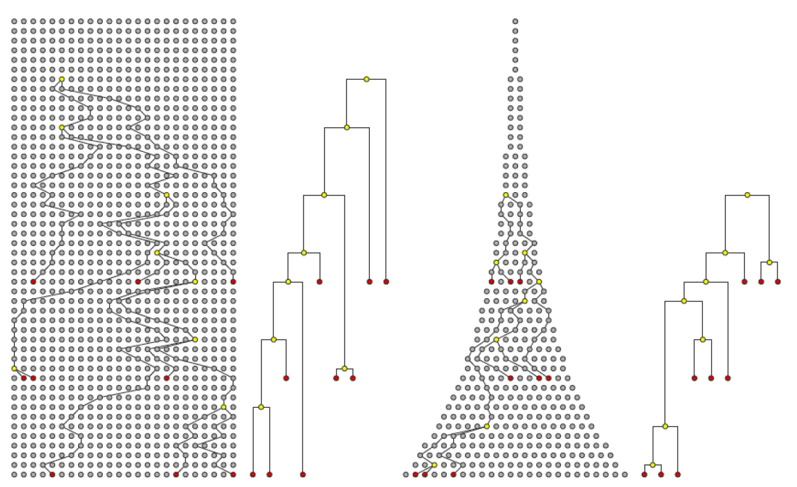

is then calculated via the rate of coalescence where N(t) is the population size as a function of time. Where N(t) is large, the coalescence rate is slower.

**How does the probability of the sampled tree look like?**

Where is the time at the beginning of interval i.

If , then , i.e. the likelihood for the demographic model parameters. Thus we can test and compare different demographic scenarios for a given tree.

**What is a skyline plot?**

It’s the resulting plot showing distinct MLE for population sizes at each interval between coalescent events.

**What is the coalescent approximation of birth death models?**

Assume the ODE for linear birth-death process:

In addition,

* we know that a birth event occur at time t with the overall rate of
* every birth is a potential coalescence between sampled lineages.
* The probability of choosing a sampled lineage pair is

Then, the approximate coalescence rate is:

This can then be used to approximate .

**What determines the quality of the approximation?**

It depends on how well the birth-death population dynamics are approximated by the deterministic ODE solution, which can be very bad at the start of an epidemic.

**What are the key differences between birth-death vs. coalescent models?**

How to choose between the models:

|  |  |
| --- | --- |
| Birth-Death model | Coalescent |
| Parameters: transmission rates, removal rates, sampling rates/proportions | Parameters: effective population size, not actual population size! |
| Models sampling process (sample times/locations are data) | Assumes number of samples lineages are small (k<<N) |

Birth-death models:

|  |  |
| --- | --- |
| Advantages | Disadvantages |
| Accounts for stochastic variability in population dynamics | Sensitive to unmodeled changes in sampling fractions |
| Generally easier interpretation of parameters | Difficult to extend to complex population models |
| Uses information about sampling |  |

Coalescent models:

|  |  |
| --- | --- |
| Advantages | Disadvantages |
| Generally fast likelihood calculations | Sensitive to uncertainty in population dynamics at high sampling |
| Easy to extend to complex population dynamics | Sensitive to hidden population structure and nonrandom sampling. |
| Naturally account for incomplete sampling |  |

**Under the WF mode, how many generations do we have to go back before we find the common ancestor of a pair of genes samples from a haploid population of size N?**

**Suppose you had a tree inferred using present-day samples from a population that experienced a severe bottleneck in its recent past. How and why would this bottleneck likely affect our ability to infer ancestral population dynamics?**

Can’t infer beyond bottleneck.

**Imagine spreading a WF population across islands in an archipelago, so that the movement between the island is restricted but within each island the population is well mixed. Qualitatively, how would you expect this population structure to influence estimates of the effective population size?**

Two extremes: either well mixed or two population

Over time: short term: share common ancestors, estimates are small

Long-term: don’t share common ancestors, estimates are high.

# Bayesian inference

**How can we apply Bayesian inference to phylogenetics?**

* We could assume a model for evolution of sequences and for population dynamics
* We could assume some starting knowledge of the parameters before looking at the data
* We would then obtain and analyse sequencing data leading to a posterior distribution of trees and model parameters
* If we received more data, we could use the knowledge obtained from the first analysis as the starting point for the analysis of the new data.

**How can we use probabilities to infer the distance between sequences?**We want to know an unknown genetic distance d.

The JC transition probabilities for each site are a function of the random variable d:

The number of the number of substitution is S=4 and the total number of sites is L=10, so the likelihood for the pairwise alignment is:

**How can**  **be obtained?**

quantifies knowledge of d in the absence of the observation, while is the distribution over possible numbers of segregating sites given the JC69 model and any independent knowledge of .

Here, we assume that our prior information is only about that so we take:

* i.e. a uniform distribution between 0 and 3.

**State Bayes’ theorem:**

Where are parameters of some model M which D are data assumed to be generated by that same model.

**What is the difficulty when making Bayesian inference?**

Finding

**What are Monte Carlo methods?**

They are algorithms which produce random samples of values in order to characterize a probability distribution. Usually, the algorithms we deal with seek to produce an arbitrary number of independent samples of possible parameter values drawn from the posterior distribution .

* MCMC is an example of such an algorithm which is extremely popular in Bayesian phylogenetics and phylodynamics.

**How does the MCMC algorithm work?**

Let be the current state. Let be a proposed parameter set for the new state. For the proposed parameter set, we compute:

We draw a uniform number u on (0,1). We accept the proposed step if

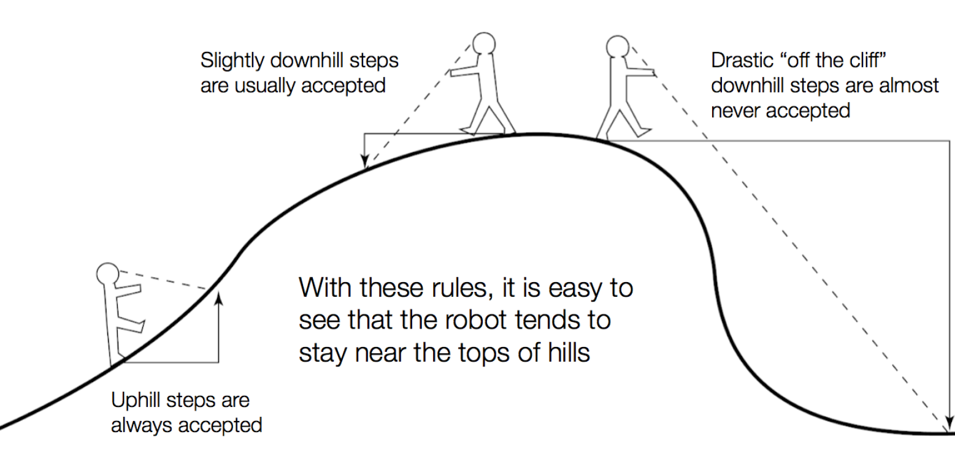

**What is an additional constraint in the MH algorithm?**

It requires that the proposal probability q for a new state given satisfies , which allows for nonsymmetric distributions when computing R:

**What is the phylogenetic likelihood?**

Evaluate:

Where A is a sequence alignment, is a phylogenetic tree and Q is the substitution rate matrix and possibly other substitution model parameters. In this case, we look for

**State the phylogenetic posterior:**

Where is the tree prior or phylodynamic likelihood. are the parameter prior distributions.

**What does Bayesian phylogenetic inference infer?**

Jointly the phylogenetic tree, the substitution model parameters and the phylodynamic model parameters.

**What are some other practical considerations of the Bayesian phylogenetic inference approach?**

* Infers phylogenetic tree, the substitution model parameters and the phylodynamic model parameters
* Correctly accounts of uncertainty both in the phylogenetic tree itself and in the model parameters.
* Additional sources of information are straight-forward to include: e.g. prior information about parameter values, constraints on tree topology
* Posterior distributions include the uncertainty in the inference results.

**Which assumption is made here that allows us to separate the process of tree generation from that of sequence evolution?**

Neutrality.

**What does the MH algorithm propose?**

New states of based on the states and evaluates the numerator of Bayes formula. Accepted states is a samples from .

**How can new trees be proposed?**

MH requires a set of proposal distributions where is a point in the space of rooted time trees.

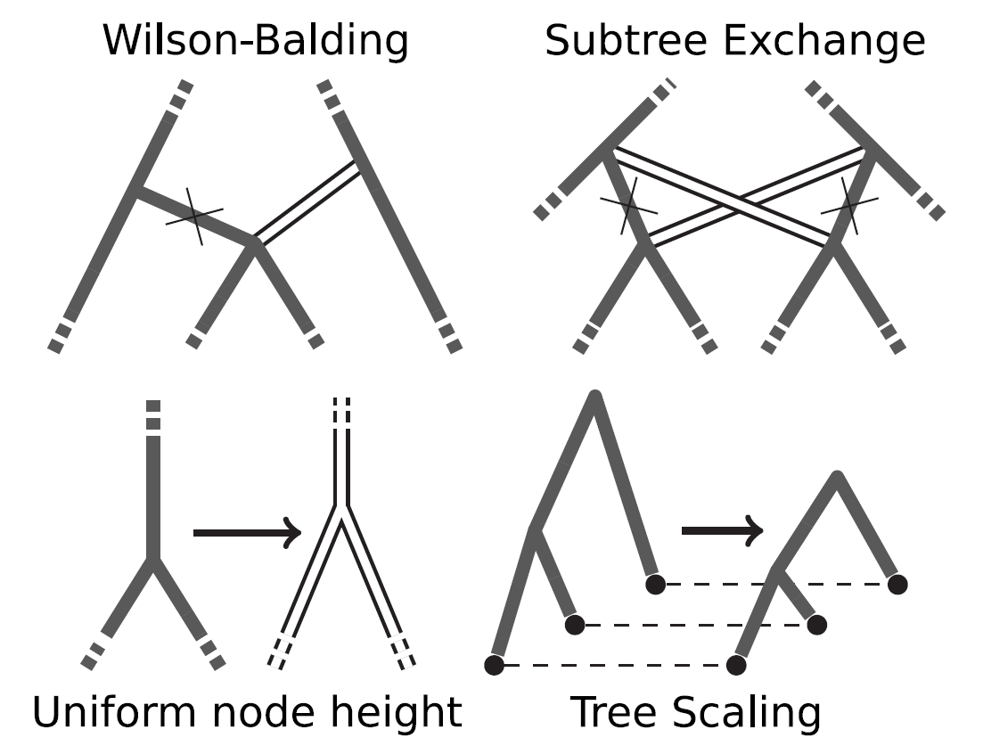

**Does a Bayesian phylogenetic analysis of the kind described here allow one to directly infer ancestral sequences? Why/Why not?**

No, we integrate over all ancestral states.

**How might we test to see whether a Bayesian MCMC analysis has explored the full state space supported by the posterior?**

Run MCMC several times and see if the results quantitatively differ.

**Suppose you have conducted Bayesian phylodynamic analysis and recovered a 95% HPD interval for the birth rate parameter. If you take this result and use it to construct a new prior for this parameter and use this prior to analyse the same data, would the resulting second posterior be valid?**

No, because prior is based on data and by definition one shouldn’t look at the data prior to inferring prior distributions.

# Structured populations

**What is meant by structured population?**

A population is structured if its members possess one or more traits (e.g. location, group membership, pathogen sub-populations ) that affects their phylodynamic parameters (e.g. birth rate, death rate, sampling rate, coalescence rate).

**What is the difference between *de novo* drug resistance vs. transmitted drug resistance?**

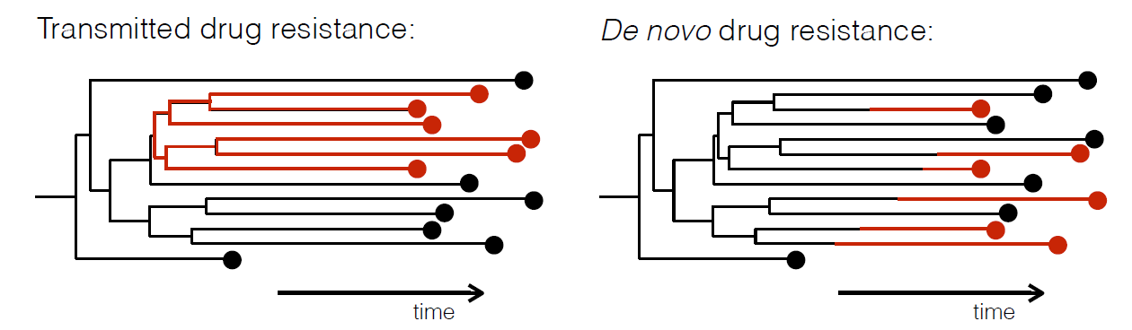

Counting does not allow us to decide whether the resistance was de novo or transmitted.

Inference of structured B-D model is hard:

**What are the different kinds of structured birth death models?**

* Binary state speciation and extinction (BiSSE): allows for 2 states affecting birth and death rates. Assumes complete present day sampling.
* Multi-state speciation and extinction (MuSSE): allows for more than 2 states and incomplete present day sampling
* Multi-type birth death (MTBD): allows for more than 2 states and both incomplete and through-time sampling.

**How does a structured BD model look like?**

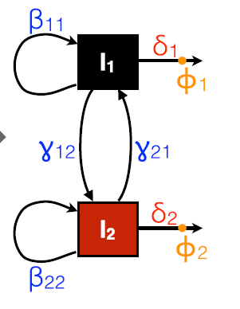

**How is the likelihood of the multi-type birth-death phylodynamic method calculated?**

Let be the probability that an individual of type, alive at time in the past, gives rise to no sampled descendants, then we have:

A similar ODE can be computed to compute the probability that an individual of type alive at time in the past and belonging to the sampled tree edge gives rise to the sampled phylogeny below that edge.

* No known solution, must be computed numerically.

**How can one do Bayesian inference for multi-type birth-death models?**

Where

* is the phylogenetic tree
* are the locations/types associated with the sequences
* are the parameters of the multi-type birth-death model
* is the structured phylodynamic likelihood. – computed using equation from previous question and averages over ancestral states.
* is the sequence alignment
* the substitution rate matrix.

Should MCMC be performed to find the probability of colored tree with ancestral states marked, then MCMC must be performed on the expanded state space of colored trees, which makes the posterior distribution for ancestral types directly available, but it’s more computationally demanding.

**What problem does this multi-type birth-death model not address?**

It does not address the problem of unknown number of leaf types.

**What does a structured coalescent model yield?**

It yields type-specific population sizes.

**How does a structured WF process look like?**

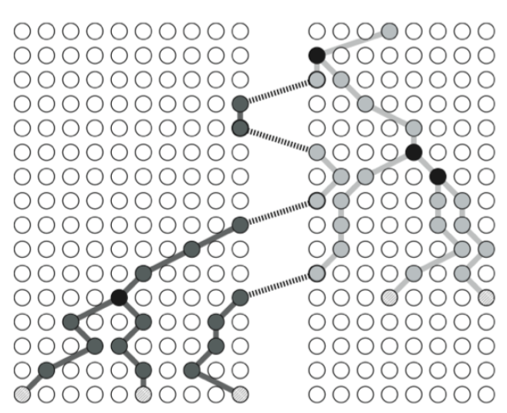

Formally:

* Assumes a single population divided into sub-populations (demes) of size
* Allows for migration between demes at rate .
* As in unstructured case, we can assume a fixed time interval between successive generations.
* Assume that sub-population sizes are unaffected by migration in the long term.

**What are the two phases of a structured WF model?**

Each generation in the structured WF model includes a migration phase and a sampling phase:

* The migration phase is when individuals migrate according to probabilities to form an intermediate generation.
* The sampling phase is when children in the next generation sample parents uniformly from intermediate population. It ensures subpopulation sizes remain fixed, even with asymmetric migration rates between demes.
* Crucial assumption: migration rate is much slower than the time necessary for sub-population to return to equilibrium population size.

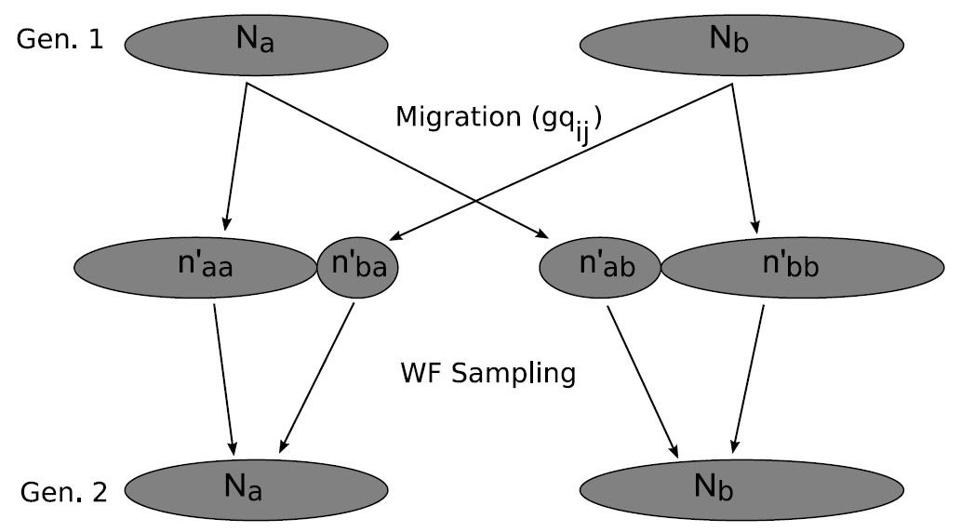

**What is the structured coalescent?**

It’s a backward in time tree generation process corresponding to the coalescent limit of the structured WF model.

It contains a coalescence rate in deme :

A backward migration rate :

The backward-time migration rate is related to the forward time rate from the structured WF model by:

**How can we derive the expected time for two lineage coalescence for a 2 deme model, where**  **and ?**

Let and as the expected coalescence times when lineages are in different/same demes respectively. Given lineages in distinct demes cannot coalesce, we have

Lineages in the same deme wait for average time before either coalescing or migrating:

Solving these two equations yields:

Note: the expected time to coalescence in the same deme is independent of the migration rate.

**What is the formula to calculate the posterior for a structured coalescent model?**

Where:

* is a phylogenetic tree with ancestral locations marked
* are the locations/types associated with the sequences
* are the parameters of the structured coalescent model
* is the structured coalescent likelihood, which is a simple extension of the unstructured coalescent expression.

**What is one crucial difference when computing the likelihood in structured coalescence models vs. multi-type birth-death models?**

It’s difficult to integrate over ancestral states, needs to be done approximately.

**What are ghost demes and how do they affect sub-population size estimates?**

Ghost demes are unsampled types from particular locations for instance. It can lead to overestimates of sub-population size.

**How can coalescence models be further modified to model real-world scenarios?**

It can be amended to incorporate structure changes over time.

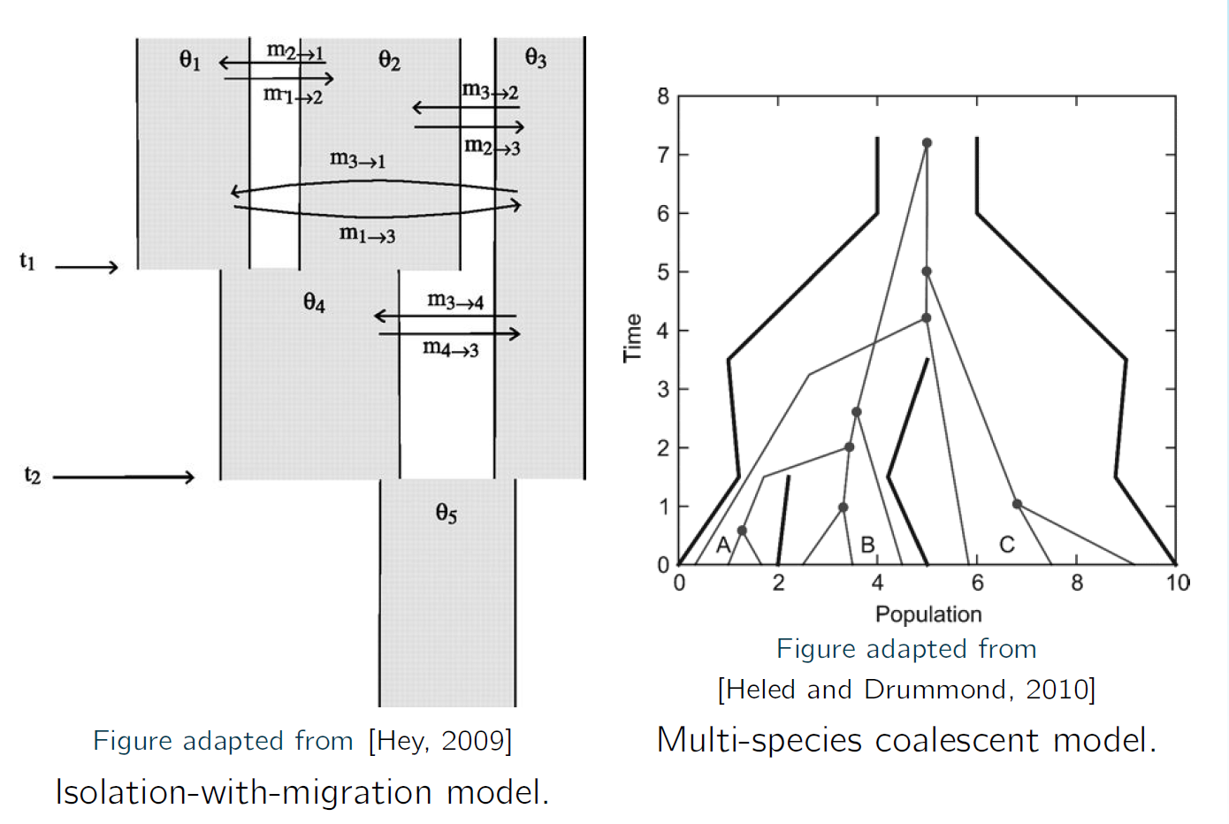

**Under a structured birth-death model, how do the sub-population sizes vary, if at all, through time?**

Depending on the sub-population rates of deaths and births and migrations, the sub-populations exponentially increase or decrease over time.

**Suppose you perform a structured coalescent analysis on sequences collected from a relatively unstructured population. Would you expect the posterior migration rate to be very low or very high? Why?**

High, because no spatial barriers/types. Could be low as well.

**How might the evolution of languages violate the assumptions of a substitution + birth/death phylodynamic model?**

Concept of “borrowing” not modelled.

# Phylogenetic networks

**What is the difference between a tree and a network?**

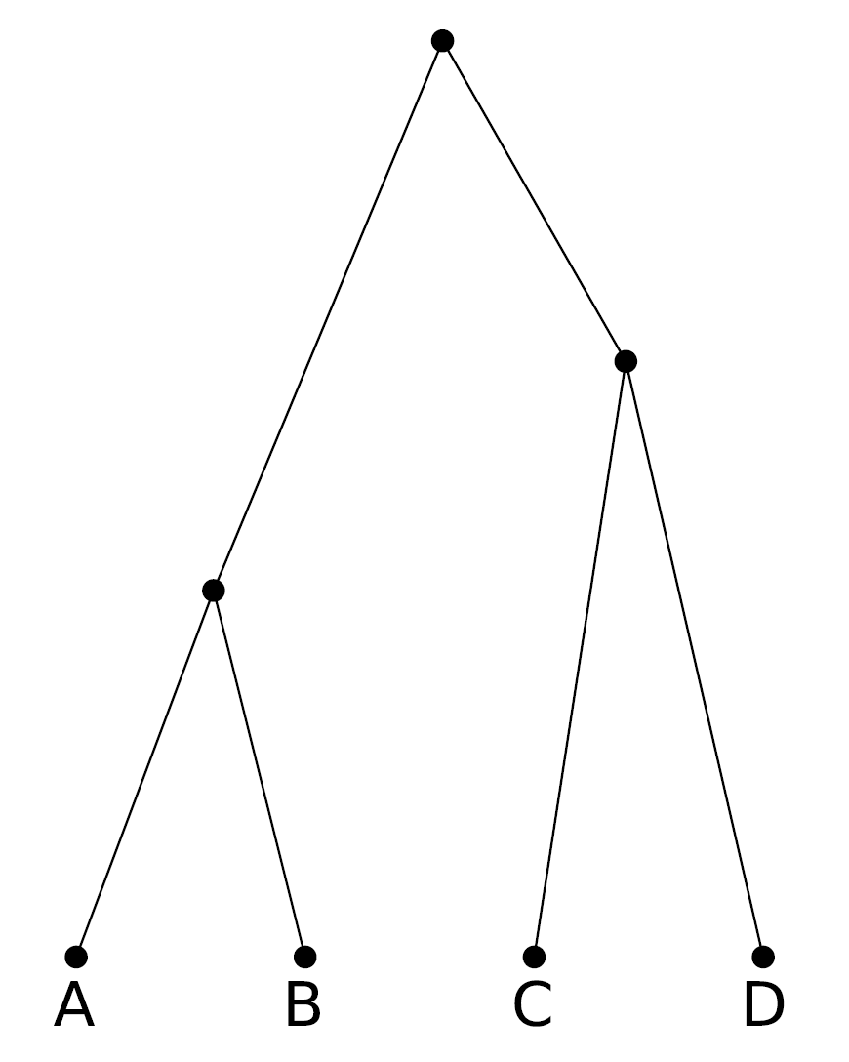 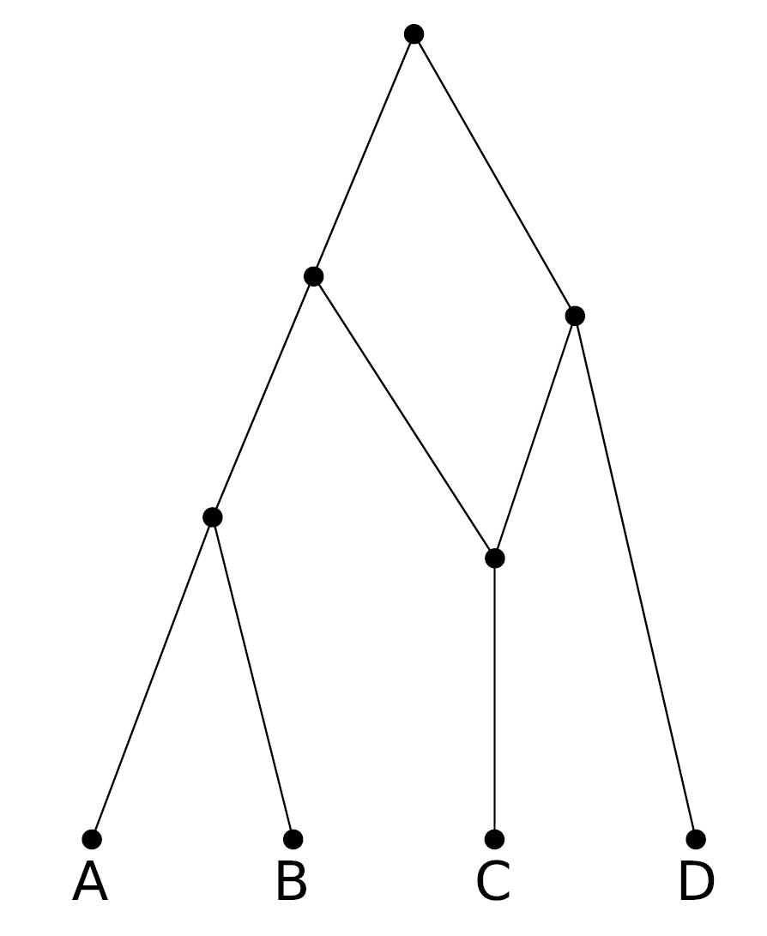

Tree Network

**What can networks represent?**

For species: species ancestry and nodes with multiple parents representing hybridisation or HGT events.

For individuals: Ancestry with mutltiple parents which represents hybridization, HGT or a node in a pedigree of a sexually reproducing organism.

For genes or chromosomes: ancestry of sequence data and nodes with multiple parents which represents recombination events.

**What is the state space of phylogenetic networks?**

Infinite.

**What is a crucial assumption for GWAS studies?**

That SNPs are assumed to be completely unlinked.

**How does a WF process with recombination work?**

* Consider a WF population with male and female individuals.
* Each child selects 1 male and 1 female parent randomly from the previous generation
* is then the probability, which depends on the segment length, of homologous recombination from one of the parents.

**Since the specific pairing of chromosomes only matters over a single generation, what approximation can be made over the long term? What does it enable?**

Haploid approximation. It simplifies calculations:

* Each child i+1 selects a parent at random from generation i.
* With probability r an additional parent is selected
  + In this case, a break-point is chosen randomly on the chromosome, and everything to the right is replace by the homologous section of the second parent’s chromosome.

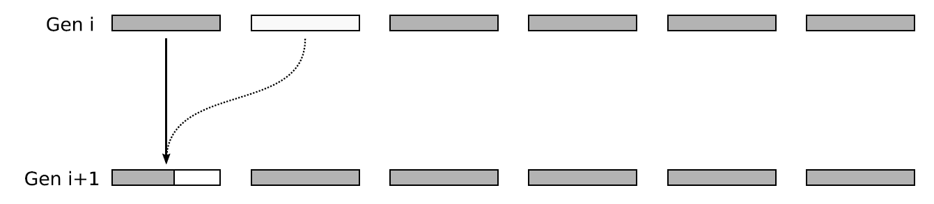

**How can this model be incorporated in the coalescent?**

It can be incorporated in the coalescent with recombination model.

For fixed recombination rats in the limit and and , the genealogical process is the coalescent with recombination with the following properties:

* A coalescent rate
* A recombination rate
* Recombination breakpoints chosen randomly along the sequence: one parent contributes everything to the left, the other everything to the right.
* Each site possesses a local tree
* Local trees may find most recent common ancestors (MRCA) (grey sites) before they find the grand MRCA of the process.

**What is the result of the coalescent with recombination?**

An ancestral recombination graph:

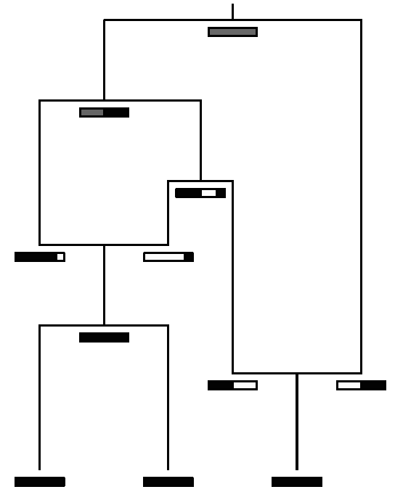

**What is the formula to find the Bayesian posterior for a phylogenetic network given a sequence alignment?**

Where:

* is the recombination graph/network
* is the substitution rate matrix
* is the recombination rate
* is the effective population size

**What makes this posterior approximation difficult?**

* Some features of do not contribute to the likelihood (= “unidentifiable”)
* The likelihood surface contains many distinct peaks
* The volume of space of phylogenetic networks with significant posterior probability is usually extremely large
* Still, good approximating algorithms exist.

**How can sequence alignments lead to estimates of the population size?**

Each local tree contributes additional information to the inference of the population size. The longer the sequence, assuming the local trees can be accurately inferred, the more powerful the population dynamics inference.

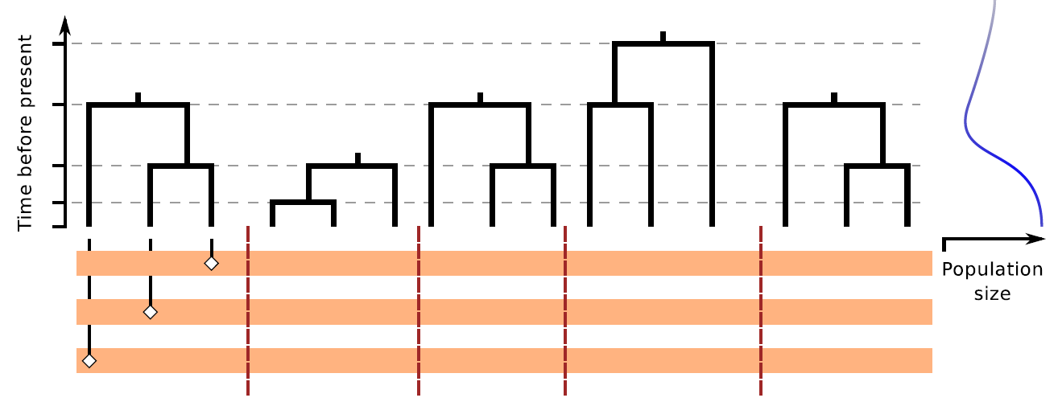

**How does the sequentially markovian coalescent modify the coalescent with recombination to model to estimate demographic history from genomic data?**

It reformulates CwR as a spatial process along sequences to produce a process for local trees which is Markovian along sequences.

Sites between breakpoints are exponentially distributed with rate where is the total length of the current local tree.

It neglects some possible recombinations, which do not affect the data.

**How can this further be modified to infer heights and population sizes jointly?**

Use SMC-based HMM on pairs of alignments, where the hidden states of the HMM are local tree heights at each site.

**What is the relationship between a gene tree and a species tree?**

The gene tree is embedded within the species tree.

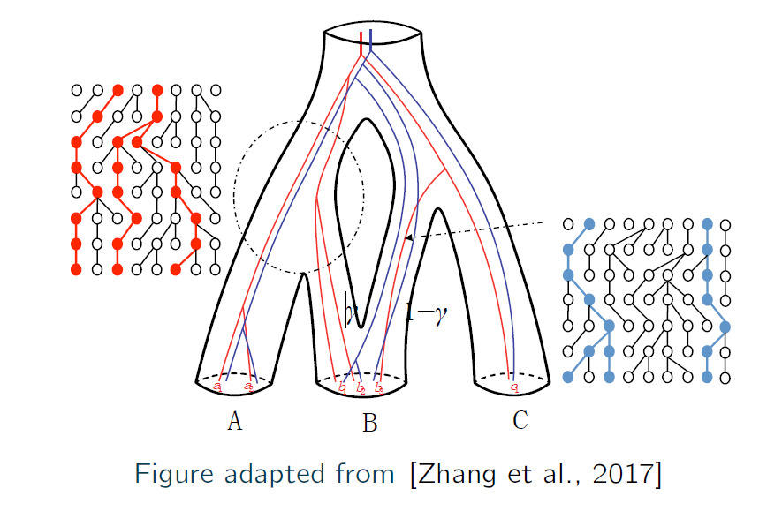

**What is incomplete lineage sorting?**

It’s the failure of two homologous genes within the same species to coalesce during the lifetime of the species.

It leads to non-overlapping topologies of the species tree and the gene tree do not overlap.

**What is a hybrid node in a species network?**

It’s a node which has two ancestors and one descendant lineage.

**What is the maximum number of local trees that can correspond to a sequence alignment?**

Suppose the alignment has n sites, then there are n(2n-5)!! possible local trees.

**Draw the local topologies implied by the following ARG:**

**We saw how recombination can improve our ability to infer ancestral population dynamics. Would you expect higher recombination rates to improve this?**