How to Use this Web Site

This web application requires Silverlight 4 plug-in installed on your machine. If the browser on your computer, e.g. Apple IPad, does not support Silverlight plug-in, you are not able to use this web application.

- How to use Taskbar

- Hold a <Cltr> key and click on the Taskbar to open a context menu with three radio buttons – Enable Float, Dock to Top, and Dock to Bottom. The default selection is Dock to Top (see picture above.)
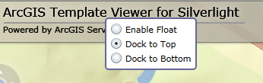

If you choose Dock to Bottom the taskbar will dock to the bottom of the page, look likes (see picture below)

If you choose to use Floating Taskbar, the taskbar becomes floating and widgets are listed in a DropDown menu (see picture below.)
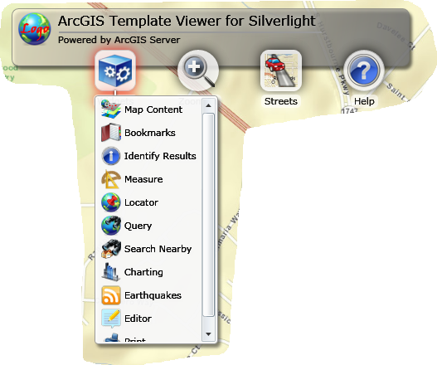

Tip: the availability of the three taskbar status options is based on the skin (theme) that is chosen for the application.

- Click on a Widget button to open a widget. For example, the Map Content widget is open below, click the Close button to close the widget and click the Minimize button to minimize the widget. Most widgets have multiple tabs, e.g., the Locator widget. Click the tab buttons on the top of a widget to switch the tab content in the widget. If the widget creates a graphic layer on the map, click the Clear Graphics to clear the graphics from the graphic layer.

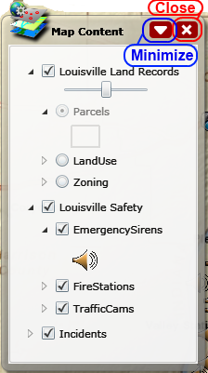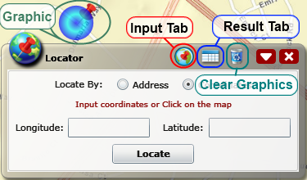

- Click (hover over after the first-time click) the Map-Tool button to switch the Map-Tool mode. The default Map-Tool mode is
Pan – drag map by holding-down the left mouse button to change the map extent.
Other Map-Tool modes are:
Zoom-In – draw a box on the map to force the map zoom in to that area,
Zoom-Out – draw a box on the map to force the map zoom out based on the size of the box, the smaller the box, the further the map zoom out,
Identify – click on the map to identify a feature (which feature layer is identifiable is based on the configuration of the Identify widget). The Identify widget will open when an identification action is complete. Tip: actually, it is not needed to switch to the Identify tool mode to do an identification action. Opening the Identify widget also activates the Identify tool mode.
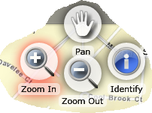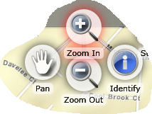

- Click (hover over after the first-time click) the Base-Map switch button to change the base map layer. Commonly available base map layers include Streets, Imagery (Satellite), Topology, and Hybrid (Imagery + Labels)
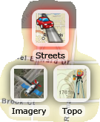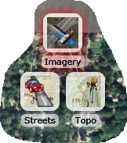

- Click the Help DropDown menu button to show link menus and help page (this page) menu
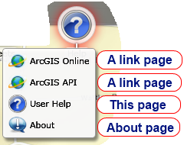

- How to use Map Navigator

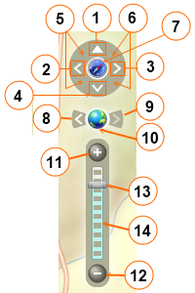 | - Click to pan the map to north  - Click to pan the map to west  - Click to pan the map to east  - Click to pan the map to south  - Hold mouse down and drag to rotate the map  - Hold mouse down and drag to rotate the map  - Click to reset the map rotation angle to 0  - Zoom the map back to the previous extent  - Zoom the map the next extent  - Zoom the map to the full extent  - Click to zoom in the map  - Click to zoom out the map  - Hold and drag the button to change the map zoom level  - Click the slider to change the map zoom level

- Use Hot Keys
- At any time and any where you may press a Shift key and draw a box on the map to zoom in the map
- At any time and any where you may press Space key and draw a box on the map to zoom out the map

