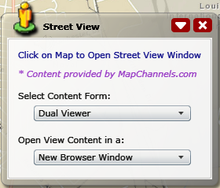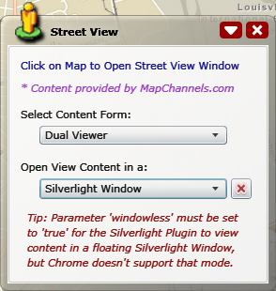
By default, the Street View content is open in a new Browser window. If you choose to open the Street View content in a floating Silverlight window, you have to set the value of the windowless parameter of the Silverlight plug-in to ‘true’ in default.aspx, default.htm, or default.jsp.
However, Google Chrome does not work well with a Windowless Silverlight application (it is a Silverlight bug or Chrome’s problem). You may keep windowless="false" if you want the application to support Chrome. Users can close the Street View content window by clicking the button on the widget, but not as convenient as using a floating Silverlight window.
<param name="windowless" value="true" />

The final definition of the Silverlight plugin application must like this:

<object id="MapViewer" data="data:application/x-silverlight-2," type="application/x-silverlight-2" width="100%" height="100%">
<param name="source" value="ClientBin/ESRI.SilverlightViewer.xap" />
<param name="windowless" value="true" />
<param name="onLoad" value="onPluginLoaded" />
<param name="onError" value="onSilverlightError" />
<param name="initParams" value="<%#InitParameters%>" />
<param name="background" value="white" />
<param name="minRuntimeVersion" value="4.0.50826.0" />
<param name="autoUpgrade" value="true" />
<a href="http://go.microsoft.com/fwlink/?LinkID=149156&v=4.0.50826.0" style="text-decoration: none">
<img src="http://go.microsoft.com/fwlink/?LinkId=161376" alt="Get Microsoft Silverlight" style="border-style: none" />
</a>
</object>

