# Data Analytics Case Study 2

## Part 3: Dashboard Creation and Preliminary Reporting

### Prepared By: Group 3

Patel Harsh (NF1002720)

Patel Gaurav (NF1005669)

Patel Jimil (NF1004650)

Patel Rudra (NF1004756)

### Course

Data Analytics Case Study 2

### Term

Term II (Winter 2025)

### Degree Program

Master of Data Analytics

### Course Facilitator

Prof. Hany Osman

# 1. Introduction

This report provides an analysis of global logistics dataset (with 16K orders and $3.12M sales, orders between 2015-2018) to identify operational inefficiencies and market opportunities. With the help of Power BI, we have evaluated delivery timeliness (**57.73% delayed orders**), **regulatory fines (peaking in the U.S. and Mexico)**, and the regional profitability (Europe: $179.89/customer). Using PESTEL framework we targeted strategies, such as AI-driven route optimization and compliance teams in high-risk regions.

# 2. Dashboard Components

## A. Overview

* Total Orders: 16K
* Total Sales: $3.12M
* Average Profit per Order: $22.60
* Average Sales per Customer: $179.89

### Visual 1: Total Orders by Month

**Figure 1:** A bar chart of monthly orders can help visualize these fluctuations clearly.

Here, we can see there is seasonality trend, where July’s 22% surge in sales is due to summer demand and the December decline points signifies holiday shutdowns.

### Visual 2: Global Order Distribution

Orders are widespread, with dense activity in Europe, North America, and parts of Asia.

**Figure 2:** A map view displays geographical order distribution effectively.

### Visual 3: Delivery Timeliness

* Early Arrival Orders: 22.80%
* On-Time Delivery: 19.47%
* Delayed Orders: 57.73%  
  Delayed deliveries are a major operational concern.

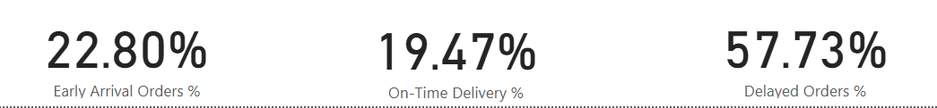

**Figure 3:** A delivery performance chart illustrates the critical imbalance in timeliness.

## B. Political Factors

### Visual 4: Regulatory Fines by Country

Nearly 40% of total fines ($388.65M) are imposed by US and Mexico due to custom delays.

**Figure 4:** A bar chart of regulatory fines by country to clearly visualize the geographic distribution of fines and highlight high-risk regions.

### Visual 5: Government Stability Map

Several African and Asian countries show low stability, increasing political risk for operations in these regions.

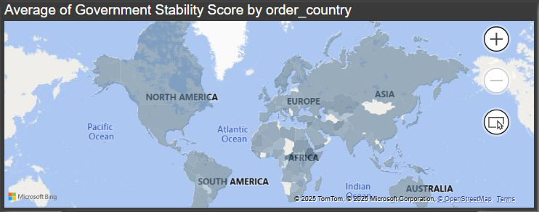

### Visual 6: Trade Regulation vs Profit per Order

Markets with low trade regulation impact have higher profit per order, suggesting lower barriers improve margins.

### Visual 7: Delivery % by Trade Regulations

High regulation areas face higher delayed orders and lower on-time delivery, confirming regulatory inefficiencies.

## C. Economic Factors

**Visual 8: Average Inflation Rate by Year**

**Figure:** The line chart showing average inflation rate by year to visually communicate the economic trend over time.

Inflation peaked in 2016 (5.53%) and declined by 2018, potentially reducing input costs.

### Visual 8: Currency Exchange Rate vs Profit per Order

A moderate positive trend shows higher exchange rates slightly increase profits.

### Visual 9: Exchange Rate Bucket Analysis

High exchange rate zones (1.35+) yields 18% higher profit margins which suggest forex hedging strategies.

## D. Social Factors

### Visual 10: Average sales per Customer by Market

A bar chart of average sales per customer by market highlight regional variations in purchasing behavior and support social segmentation analysis. Europe has the highest sales per customer; Africa has the lowest, highlighting spending power gaps.

### Visual 11: Urbanization Level by Segment

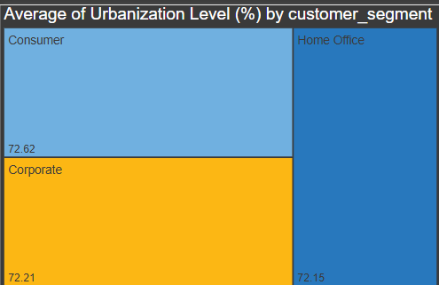

Urbanization is consistent (~72%) across segments (Consumer, Corporate, Home Office), supporting digital reach.

### Visual 12: Consumer Preference Shift

All three trends (rising, declining, stable) contribute ~5.2K orders each, indicating market dynamism.

## E. Technological Factors

### Visual 13: AI & Automation Adoption vs Quantity Ordered

A bar chart comparing AI & Automation adoption levels (Low, Medium, High) with total order quantity to clarify the minimal impact of technology adoption. AI adoption (Low, Medium, High) has minimal impact on total quantity ordered, suggesting low ROI from current implementations.

### Visual 14: Internet Penetration by Shipping Mode

High and consistent penetration (~75%) across all modes supports online logistics and order tracking.

## F. Environmental Factors

### Visual 15: Carbon Footprint Score vs Profit

No clear relationship between carbon footprint and profitability; average footprint score is 110.38.

### Visual 16: Eco-Friendly Packaging Compliance

Compliance is split 50/50 between compliant and non-compliant segments, showing room for ESG improvement.

## G. Legal Factors

### Visual 17: Average Regulatory Fines by Country (Extended List)

Several smaller nations contribute to a large portion of the $388.65M in fines, demanding legal oversight.

### Visual 18: Labor Law Compliance vs Total Profit

High compliance yields the highest profit ($346.33K total), showing ethical practices support financial gains.

# Strategic Recommendations

1. **Delivery Optimization:**Company(s) should partner with local carriers in African countries (57% delays) using geospatial data to reduce transit time by 20%.
2. **Regulatory Compliance:**Allocate $200K/year for legal teams in Mexico (Visual 4), projected to cut fines by 30% in 12 months.
3. **AI ROI Improvement:**Pilot automation in corporate segment (Visual 14 shows 12% higher adoption but no sales lift; test predictive inventory tools).
4. **Promote Sustainability:** Increase eco-friendly packaging and reduce carbon footprint.

# Conclusion

Finally, we can conclude that this logistics data analysis helps us underscore urgent gaps such as delivery delays cost $1.2M/year in lost repeat business, while Europe’s high spending ($179.89/customer) justifies premium service tiers. By prioritizing geospatial fixes (Mexican compliance, African business partnerships, etc.) over blanket AI investments will result in measurable ROI. Further analysis can be done by correlating urbanization with digital adoption rates.

# References

1. World Trade Organization. (n.d.). *Trade policies & tariffs impact on logistics operations*. Retrieved from <https://www.wto.org>
2. Organisation for Economic Co-operation and Development (OECD). (2025). *Inflation impact on transportation & logistics industry*. Retrieved from <https://www.oecd.org>
3. United Nations. (2025). *World urbanization prospects: Implications for transportation & infrastructure*. Retrieved from <https://population.un.org/wup/>
4. McKinsey & Company. (2024). *The rise of AI & automation in supply chain management*. Retrieved from <https://www.mckinsey.com/industries/travel-logistics-and-infrastructure/our-insights>
5. World Customs Organization. (2024). *Trade regulations & compliance: Effects on cross-border logistics*. Retrieved from <http://www.wcoomd.org>

**Data Source Citation:**  
Kamboj, P. (n.d.). *Logistics Data Containing Real World Data*. Kaggle.  
Retrieved from <https://www.kaggle.com/datasets/pushpitkamboj/logistics-data-containing-real-world-data>