Criteria followed for Stock Selection:-
- Bottom-up approach
- Value investing
- PE ratio less than Industry PE to identify undervalued stocks. This cannot be the only measure as the stock might actually be financially poor performing. Thus, we also have to consider Piotroski score along with PE ratio less than Industry PE.
- Piotroski F-score as a measure of financial health of the company. We will use Piotroski score > 7.
- Market Capitalisation as a measure of the size of the firm. We will use market capitalization between 45000 and 100000.

Using Screener with the following query:-

Price to Earning < Industry PE AND
Piotroski score > 7 AND
Market Capitalization > 45000 AND
Market Capitalization < 100000

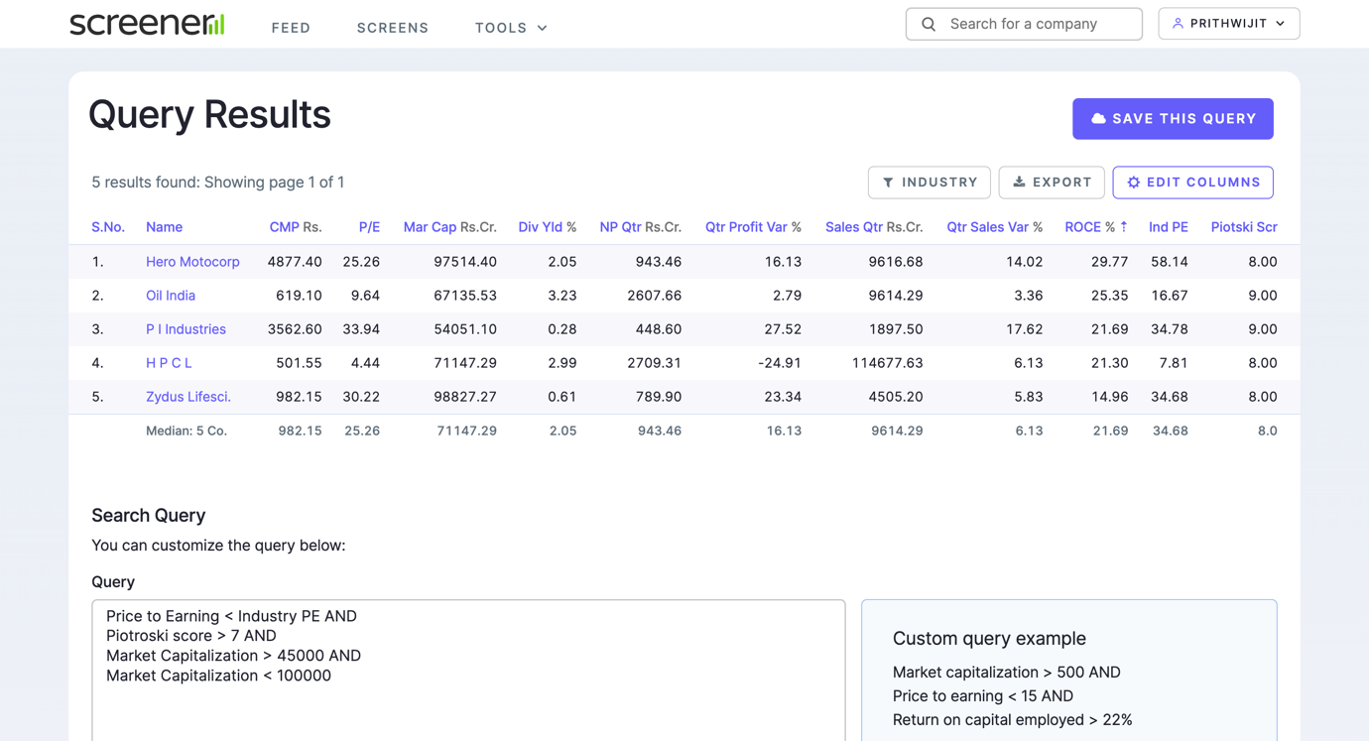

stocks = ['HEROMOTOCO.NS', 'OIL.NS', 'PIIND.NS', 'HINDPETRO.NS', 'ZYDUSLIFE.NS']
Used these five stocks obtained for portfolio construction using Python.

- Importing the required libraries.
- Defining the start and end date as 1/1/2022 to 31/12/2023 and taking the ticker symbols of the above five stocks from the Screener query. Creating 25000 number of randomly weighted portfolios from which the best portfolio needs to be chosen. Also defining the risk-free rate as 0.071.
- Created a looping function that :-
i. Downloads the stock price data for all the ticker symbols defined above
ii. Computes the percentage change (returns)
- Drop the missing values using dropna() function.
- Create 4 variables portfolio_returns, portfolio_risks, portfolio_sharpe and portfolio_weights to compute and store the data.
- Compute the weights, returns, risks and sharpe for number of portfolios (2500) defined.
i. Generated 5 random numbers and convert the random numbers into weights.
ii. Add the weights to the array portfolio_weights.
iii. Compute the annualised portfolio return as weighted average.
iv. Add the return to the array portfolio_returns.
v. Create the covariance matrix.
vi. Compute the portfolio standard deviation using mmult.
vii. Add the standard deviation to the array portfolio_risks.
viii. Compute the sharpe ratio.
ix. Add the sharpe to the array portfolio_sharpe.
- Identify the max sharpe ratio portfolio.
- The maximum sharpe ratio obtained is 1.471835 with the portfolio-weight combination of
['HEROMOTOCO.NS'(0.455), 'OIL.NS'(0.361), 'PIIND.NS'(0.005), 'HINDPETRO.NS'(0.034), 'ZYDUSLIFE.NS'(0.144)]
- Plot the visualisation for efficient frontier.
i. The Minimum Variance Portfolio (MVP) is at the peak of the curve (0.165 Volatility, 0.27 Return).
ii. Efficient frontier are the portfolios on the top of the curve (above the MVP).
iii. All the portfolios below the MVP are inefficient portfolios.
- Additionally, the min risk and max return portfolios also are computed and printed.

