Exercise: Understanding Simplified View of Transactions

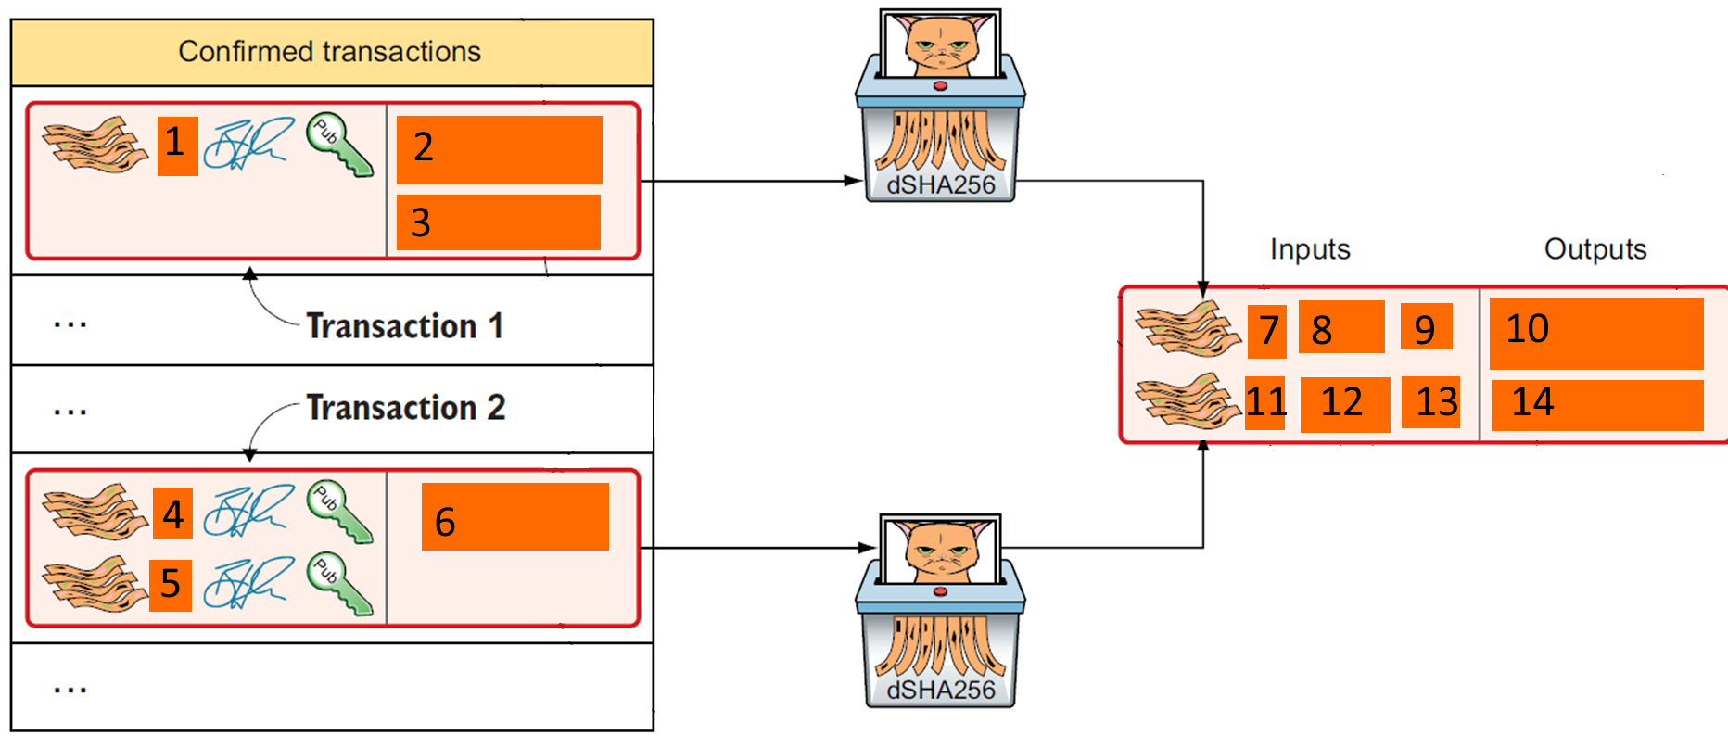

The above is a diagram of how a transaction is created from UXTO set. Suppose PKH1, PKH2 and PKH3 belongs to John. And John is going make a transaction to PKHX amounting to 25 coins. John has two UXTO that amounts to 15 and 18 coins [FIXED].

Fill in the above diagram that is labelled 1-14 with the correct information.

|  |  |
| --- | --- |
| No |  |
| 1 |  |
| 2 |  |
| 3 |  |
| 4 |  |
| 5 |  |
| 6 |  |
| 7 |  |
| 8 |  |
| 9 |  |
| 10 |  |
| 11 |  |
| 12 |  |
| 13 |  |
| 14 |  |