Exercise 1 – MNIST

Jirayu Petchhan, D10907801

Import package and data pre-processing

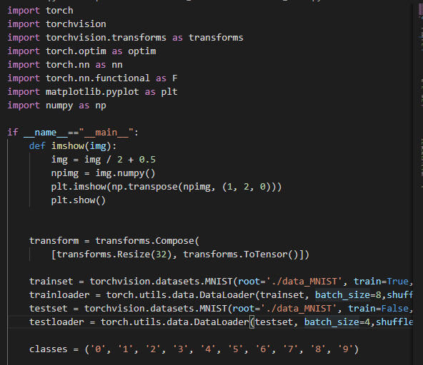

There are 10 classes. [0, 9]

Model usage = LeNet-5

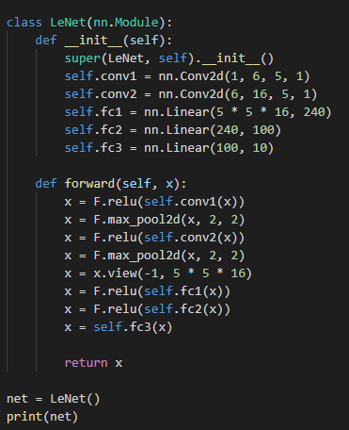

Optimizer, loss and training setup (1 epoch, 6000 steps/epoch)

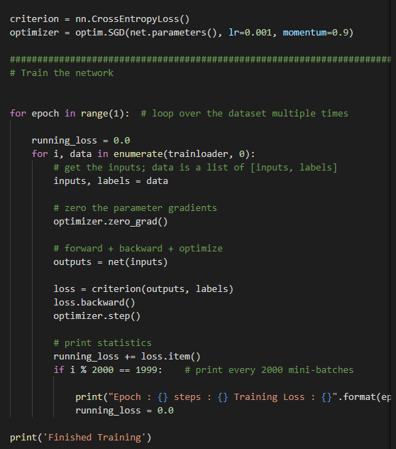

Print >> network

And training phase

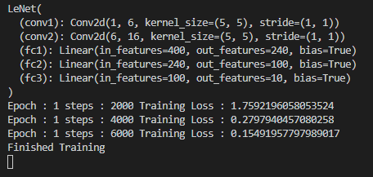

Testing and prediction setup

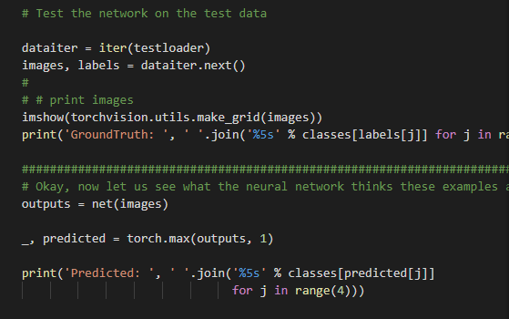

Monitoring accuracy of model (while no gradient process)

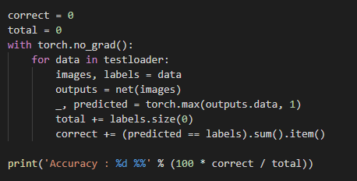

Testing set (pick it up)

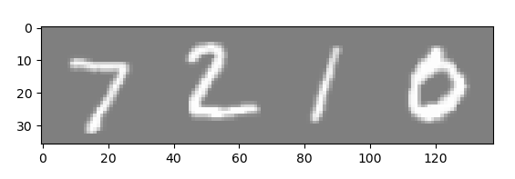

Result

Comparison the accuracy of the prediction and ground-truth (Accuracy of the model = 96%)

