**Exercise 5-2 Pix2Pix**

Jirayu Petchhan, D10907801

Training and testing to generate new synthetic images from Pix2Pix Generative Network with **the same hyper-parameter setting (105 epochs [first 100 epochs for active and the last 5 epochs for delay], lr=2e-4, batch_size =1)** via Façade Dataset

From 3 model type i.e., Vanilla GANs, LSGAN, and WGAN-GP

* Every training has been started at the first step (non-continuing training) and number of training images are 400.)

Vanilla GAN



The result from training

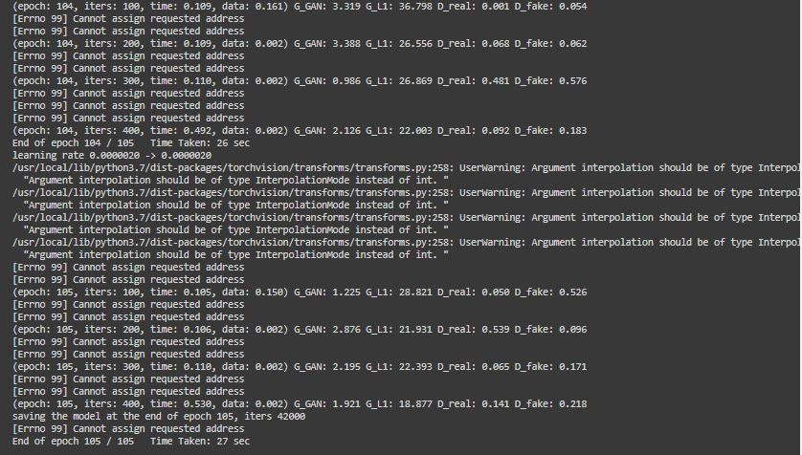

LSGAN



The result from training

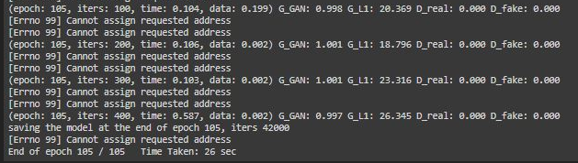

WGAN-GP



The result from training

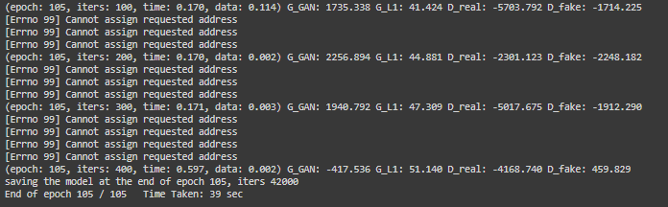

Table I. The result of synthetic image comparison generated by each generative network (CycleGAN is the learning B to A and A to B as cycling)

|  |  |  |  |
| --- | --- | --- | --- |
| Title | Vanilla GAN | LSGAN | WGAN-GP |
| Image_4 | | | |
| Domain B real image  (Ground Truth) |  | | |
| Domain A real image  (Input) |  | | |
| Fake image |  |  |  |

|  |  |  |  |
| --- | --- | --- | --- |
| Title | Vanilla GAN | LSGAN | WGAN-GP |
| Image_25 | | | |
| Domain B real image  (Ground Truth) |  | | |
| Domain A real image  (Input) |  | | |
| Fake image |  |  |  |

|  |  |  |  |
| --- | --- | --- | --- |
| Title | Vanilla GAN | LSGAN | WGAN-GP |
| Image_106 | | | |
| Domain B real image  (Ground Truth) |  | | |
| Domain A real image  (Input) |  | | |
| Fake image |  |  |  |

**Conclusion**

As we tested to generate fake image from three model (i.e., Vanilla, LSGAN and WGAN-GP) at the first step training, WGAN-GP model can model the L1 loss of generative network at the most probably owing to the benefit of the gradient penalty in objective function. By the way, our testing has been set to stop too early (approx. 105th epoch time). This reason got the result of synthetic images from three model look similar the same its don't seem that different.