2-3 Feature Map Visualization

Jirayu Petchhan, D10907801

My pic

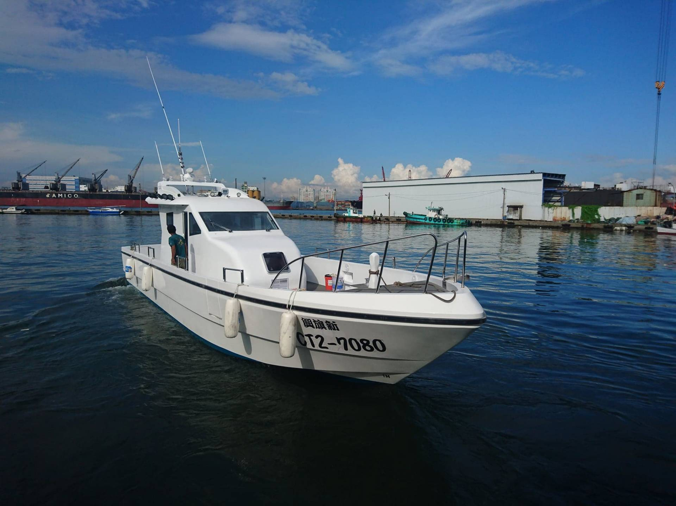

Code from extract layer 5

if __name__=='__main__':

# get class

c = {}

with open("imagenet1000_clsidx_to_labels.txt") as f:

for line in f:

(key, val) = line.split(":")

c[int(key)] = val.split(",")[0]

# Define image path and select the layer

myClass=FeatureVisualization('./PLB48-1.jpg',5)

print(myClass.pretrained_model2)

myClass.save_feature_to_img()

myClass.predict()

Code displaying

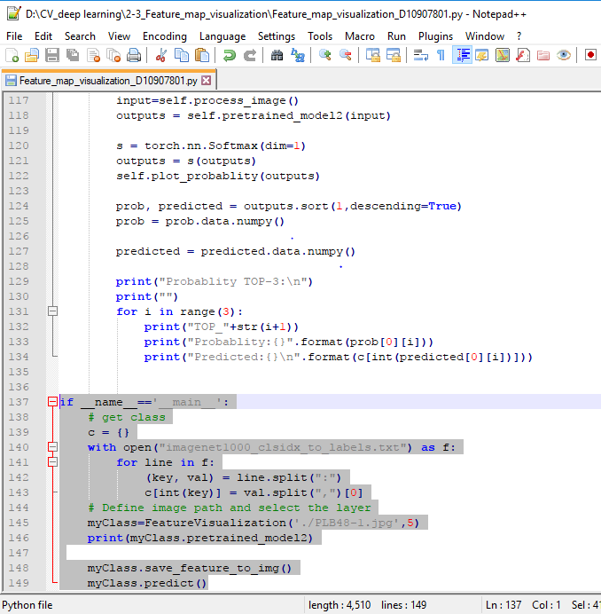

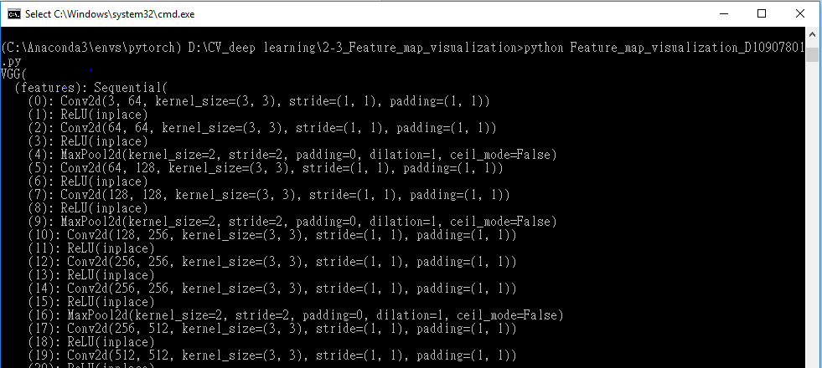Changing extract from layer 2 (default) to layer 5

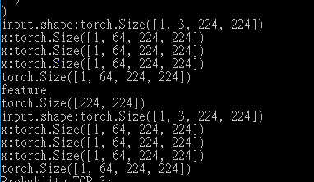

224 x 224 pixel , features = 64

Result

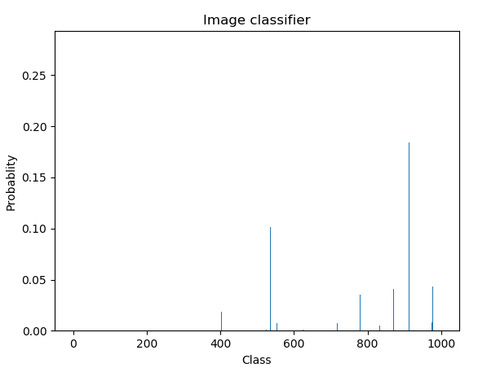

Predicted result in top 3 list

