Exercise 5.1 Non-Maximum Suppression (NMS)

Jirayu Petchhan, D10907801

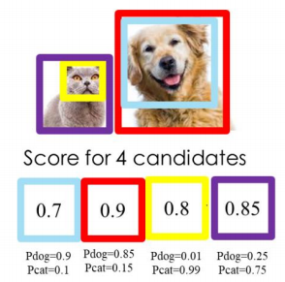

Candidate 1 is red box. (Score = 0.9)

IoU calculation

Red ---------------------------------------------------------------------------------------

| | |

V V V

0.7 (Blue) 0.8 (Yellow) 0.85 (Purple)

IoU 0.6 0 0

Note threshold = [0.5, 0.6] if IoU > 0.5 then set this score = 0.

Score 0 0.8 0.85

Ans.

Selected Objects 0.9 (red box)

Candidate 2 is purple box. (Score = 0.85)

IoU calculation

(Cut pairing of red and blue box remaining purple and yellow)

Purple -----------------

l

V

0.85 (Yellow)

IoU 0.6

Note threshold = [0.5, 0.6] if IoU > 0.5 then set this score = 0.

Score 0

Ans.

Selected Objects 0.85 (purple box)