Exercise 5-2 K-Means

Jirayu Petchhan, D10907801

**Example**

Default setting value (3 clusters, 20 data = seed_num, dot_num)

Result

Orange = the past element position in each cluster

Green = the latest element position in each cluster which moved

Blue = All data (dot_num)

|  |  |
| --- | --- |
| Time | Moving |
| 1st |  |
| 2nd |  |
| 3rd |  |
| 4th |  |

Changing setting to 5 clusters and 30 data

Coding

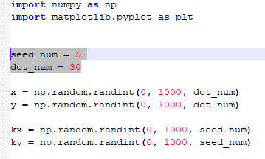

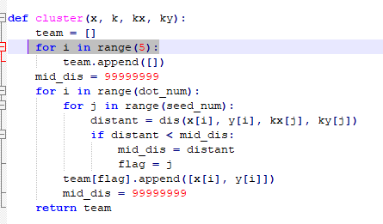

|  |  |
| --- | --- |
| Time | Moving |
| 1st |  |
| 2nd |  |
| 3rd |  |
| 4th |  |