**6-1 Face detection**

Jirayu Petchhan, D10907801

**Sample images**

|  |  |
| --- | --- |
| Type | Image |
| Single | C:\Users\e_user\AppData\Local\Microsoft\Windows\INetCache\Content.Word\down_face.jpg |
| Half | C:\Users\e_user\AppData\Local\Microsoft\Windows\INetCache\Content.Word\half_face.jpg |
| Side | C:\Users\e_user\AppData\Local\Microsoft\Windows\INetCache\Content.Word\R_face.jpg |
| Multiple |  |

**OpenCV**

Example coding (e.g. single)

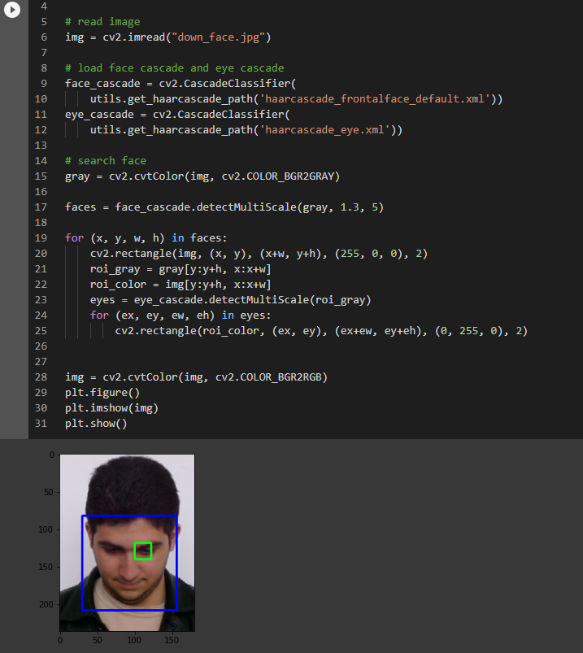

|  |  |
| --- | --- |
| Type | Image |
| Single |  |
| Half |  |
| Side |  |
| Multiple |  |

**MTCNN**

Coding example (i.e. single image e.g. bbox coordinates, keypoints)

Note others from single image will configure the procedure like this one.

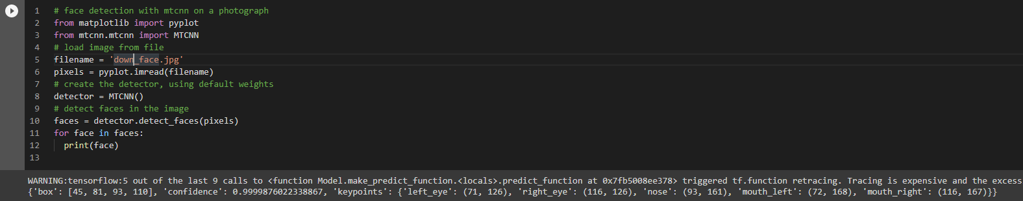Detect faces

Bounding box

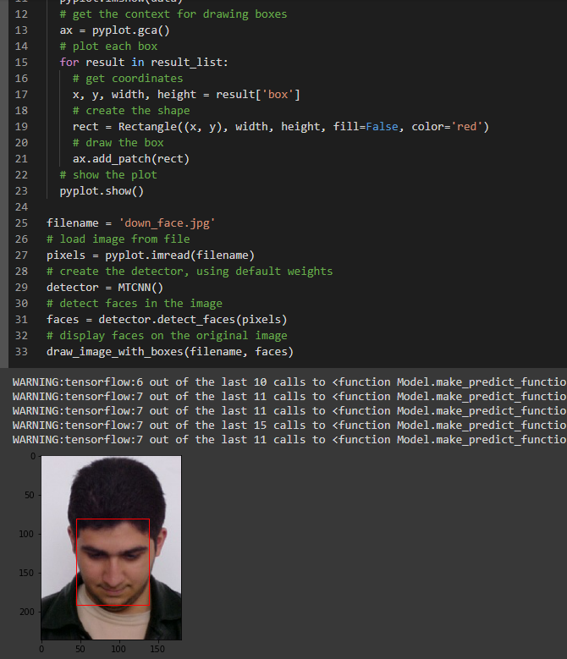

Keypoints predicted

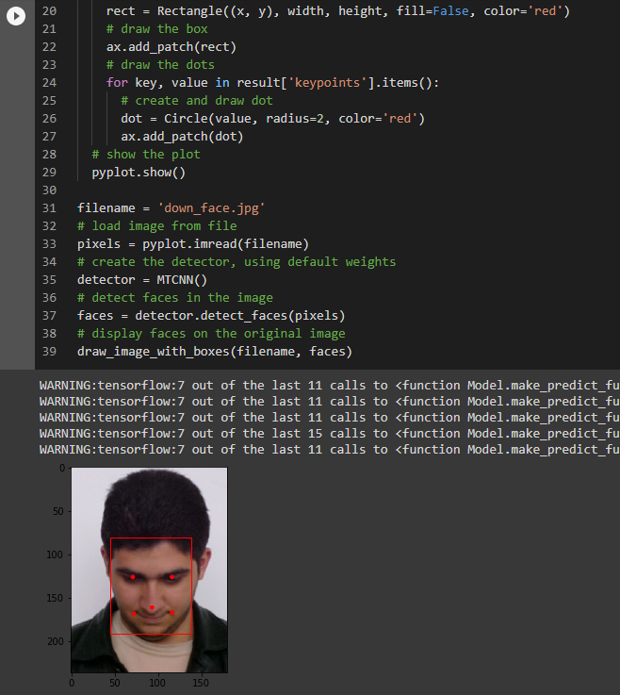

Face detection

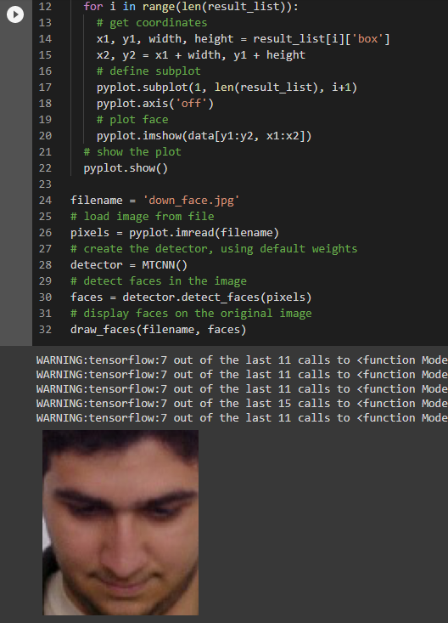

Testing image in MTCNN

|  |  |  |  |
| --- | --- | --- | --- |
| Type | Bounding box | Keypoints predicted | Face detection |
| Single | C:\Users\e_user\AppData\Local\Microsoft\Windows\INetCache\Content.Word\down_bb.png | C:\Users\e_user\AppData\Local\Microsoft\Windows\INetCache\Content.Word\down_dot.png | C:\Users\e_user\AppData\Local\Microsoft\Windows\INetCache\Content.Word\down_facedt.png |
| Half |  |  |  |
| Side |  |  |  |

|  |  |
| --- | --- |
| Type | image |
| Multiple (Bbox) | C:\Users\e_user\AppData\Local\Microsoft\Windows\INetCache\Content.Word\group_bb.png |
| Multiple (Keypoints) | C:\Users\e_user\AppData\Local\Microsoft\Windows\INetCache\Content.Word\group_dot.png |
| Multiple (Face detection) |  |

**Result**

MTCNN is able to detect a lot of detail more than CV method.