Eco-Dysformer
A Lightweight, Linear-Complexity Transformer for Explainable Dyslexia Screening via Paired Gaze–Linguistic Biomarkers
Project Progress Report
For guide review · July 2026 · Stage 1 complete, hardened & validated (final 10-fold Kaggle run)

1. Executive Summary
Eco-Dysformer is a rigorous, reproducible study of automated dyslexia screening from eye-tracking, built on the public ETDD70 dataset (70 Czech schoolchildren). Unlike accuracy-chasing prior work, it deliberately treats methodological honesty and compute-efficiency as first-class objectives.
The Stage-1 core is fully implemented, executed on a free-tier Kaggle T4 GPU, independently hardened, and validated; the complete result set is archived in the repository (stage1_outputs/). In brief: a linear-attention (Performer) model matches a parameter-matched quadratic-attention baseline on both accuracy and AUROC while decisively overtaking it in speed and memory on longer sequences; explicitly conditioning on linguistic complexity yields a broad, statistically significant descriptive gaze×complexity interaction but no classification gain (an honest, well-controlled null); and the model's explanations align with literature-documented oculomotor biomarkers. Stage 1 already constitutes a complete, submittable short paper.

2. Project Overview & Motivation
- The problem. Dyslexia screening is resource-intensive, often subjective, and highly language-specific.
- The dataset's key asset. In ETDD70 every child reads three passages of increasing linguistic complexity (a syllable matrix → a narrative story → a pseudo-text). Gaze behaviour and text complexity are therefore genuinely paired within each child — a rare, leakage-free multimodal signal most prior work lacks.
- The “Eco” framing. Parameter count, GPU memory and inference latency are primary reported outcomes (in the spirit of “Green AI”).
- Positioning. A methodological response to recent multimodal dyslexia papers that fuse features from entirely disjoint cohorts — an approach whose accuracy is hard to trust.

3. Research Questions
RQ | Question | Status
RQ1 | Can linear-complexity (Performer) attention match/exceed a parameter-matched quadratic baseline on engineered gaze & linguistic features, under nested CV + significance testing? | Done
RQ2 | Does gaze shift differentially between dyslexic and typical readers as complexity rises, and does complexity-conditioning beat a complexity-blind gaze-only baseline? | Done
RQ3 | Naive vs honest multimodal fusion: how much apparent gain from disjoint-cohort (handwriting) fusion survives an honest, calibrated treatment? | Stage 2
RQ4 | Do LIME + attention explanations on original (non-PCA) features align with literature-documented dyslexia biomarkers? | Done

4. Dataset
- ETDD70: 70 Czech children (35 dyslexic / 35 typical), ages 9–10; balanced, clinician-labelled.
- Per child: 3 passages × 4 file types (raw 250 Hz gaze, fixations, saccades, trial metrics) = 840 files; structure verified programmatically before any parsing.
- The passages genuinely differ in complexity. Mean word-frequency (Zipf) is 4.85 for the narrative, 3.50 for the syllable matrix, and 1.26 for the pseudo-text; syntactic depth and lexical density track the same gradient.
- Honest data properties (stated up front). There are only 3 distinct stimuli, so the linguistic features are passage-level constants — a conditioning signal, not per-child discriminators. Regression counts are defined transparently and cross-checked against the dataset's own values (1260 / 1260 comparisons agree within 2%).

5. Work Completed — Stage 1 (Core)
- Inspect-first data pipeline with defensive schema assertions and reconstruction of the Czech stimulus text.
- Gaze feature engineering (per child, per passage): ~20 fixation / saccade / regression measures, recomputed from raw events and cross-checked against the dataset's own metrics.
- Czech linguistic features via UDPipe / Stanza (dependency depth, lexical density, Zipf frequency), plus an optional multilingual embedding behind a flag.
- Model (RQ2 core): Gaze Performer encoder + linguistic-complexity encoder + a learned paired cross-attention fusion over the child's three passages → LightGBM classifier. A parameter-matched quadratic-attention arm provides the RQ1 comparison.
- Evaluation harness: subject-level nested cross-validation (a child's three passages never split — verified leakage-free), paired Wilcoxon tests, bootstrap CIs, effect sizes, calibration (ECE / Brier) and operational metrics.
- Pre-fusion explainability: LIME + attention weights on original interpretable features (never PCA), with cross-fold stability.
- Reproducibility: single YAML config, global seeding, pinned requirements, data & model cards, a test suite, and an auto-generated RESULTS.md.

6. Results (subject-level 10-fold nested CV, seed 1337)

6.1 Per-arm performance
Arm | Accuracy [95% CI] | F1 | AUROC | ECE | Brier
Performer + complexity (RQ2 core) | 0.829 [0.75, 0.90] | 0.805 | 0.861 | 0.170 | 0.169
Quadratic + complexity (RQ1 baseline) | 0.821 [0.74, 0.90] | 0.807 | 0.883 | 0.178 | 0.176
Performer, gaze-only (blind) | 0.833 [0.74, 0.92] | 0.807 | 0.878 | 0.166 | 0.164
Accuracies sit in the honest ~0.82–0.83 range — consistent with the published ETDD70 literature under our stricter subject-level protocol, and not a suspicious ~1.0 that would signal leakage.

6.2 RQ1 — linear vs quadratic attention
- Accuracy & AUROC: matched. Performer vs quadratic — accuracy 0.829 vs 0.821 (paired Wilcoxon p = 0.79), AUROC 0.861 vs 0.883 (p = 0.55); both difference CIs straddle zero. Arms are exactly parameter-matched (141,121 parameters each).
- Efficiency: crossover at N ≈ 1024. On short sequences the Performer's constant overhead makes it slower; beyond ~1024 events it wins, and the gap grows fast — at N = 4096, 5.3 ms vs 34.6 ms and 0.48 GB vs 2.47 GB peak memory. ETDD70's engineered event streams (~130–350 events) fall below the crossover, but the raw 250 Hz gaze stream (~18k samples/passage) sits far above it — the regime where linear attention pays off.
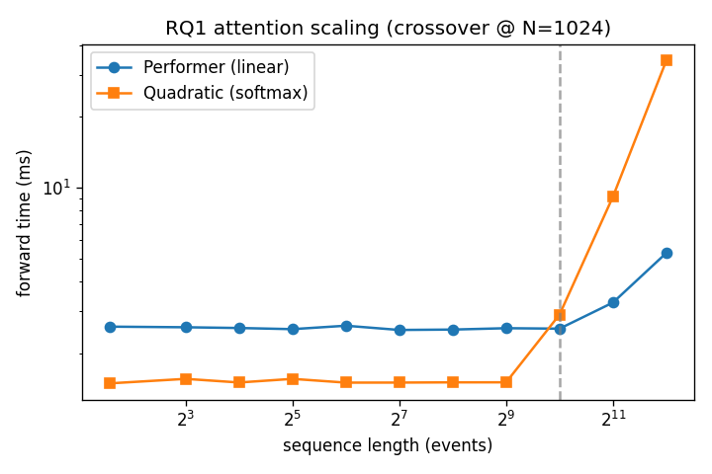
Figure 1. Forward-pass time vs sequence length. Quadratic (softmax) is cheaper on short sequences but scales O(N²); the Performer (linear) overtakes it past N≈1024 and diverges sharply thereafter.

6.3 RQ2 — paired gaze × complexity co-conditioning
- Classification: honest null. Complexity-conditioned 0.829 vs complexity-blind 0.833 (Wilcoxon p = 0.83; AUROC 0.861 vs 0.878, p = 0.50). Conditioning does not improve classification — expected, since the linguistic features are passage-constant and the gaze features already carry the signal.
Descriptive interaction — the genuine positive RQ2 evidence. Twelve of the twenty gaze features show a statistically significant group×complexity interaction (Mann–Whitney on per-subject slope, Benjamini–Hochberg FDR q < 0.05). Selected features:
Gaze feature | d (slope) | q (FDR) | Group × complexity interaction
Total reading time | 1.44 | < 0.001 | Significant — widens with difficulty
Total fixation duration | 1.44 | < 0.001 | Significant
Fixation count | 1.05 | < 0.001 | Significant
Saccade count | 1.05 | < 0.001 | Significant
Regression count | 0.94 | < 0.001 | Significant
Between-line regressions | 0.89 | < 0.001 | Significant
Return sweeps | 0.78 | 0.043 | Significant
Median fixation duration | 0.51 | 0.023 | Significant
Regression ratio (normalised) | 0.22 | 0.73 | No interaction — flat

- The key nuance: the regression *ratio* stays flat, but regression *counts* steepen — the dyslexic disadvantage grows in absolute reading effort (time, fixations, regressions), not in proportion. This is a more honest and specific finding than a simple “conditioning helps.”
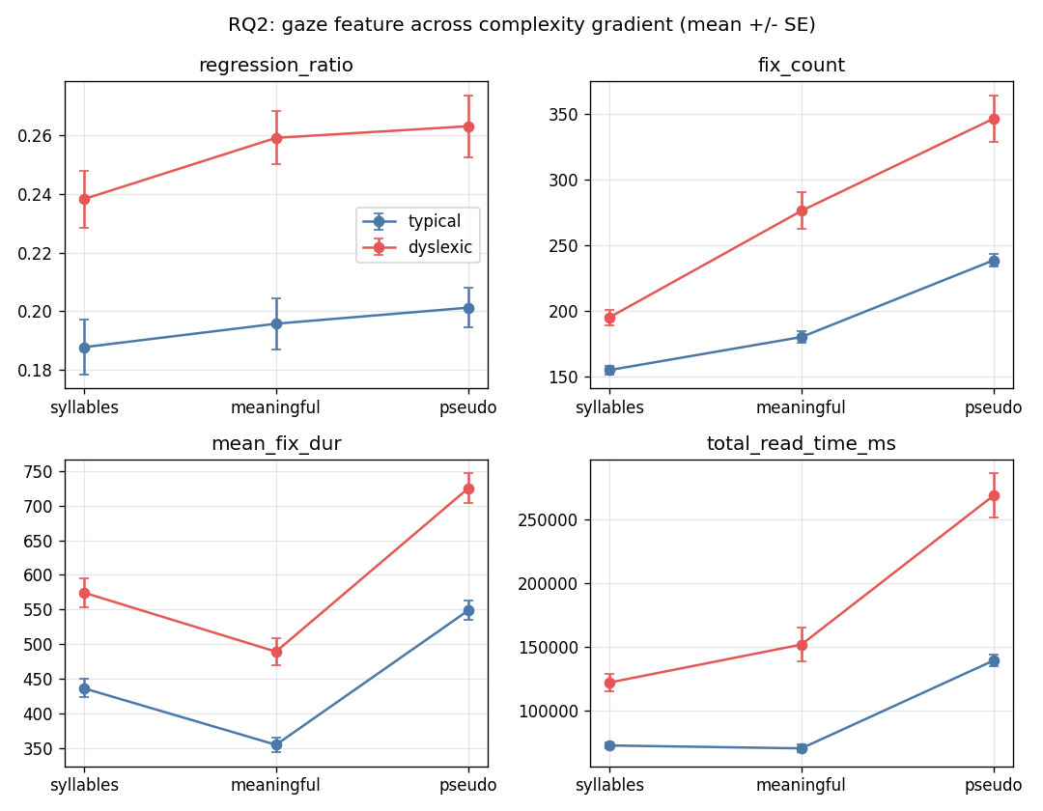
Figure 2. Reading-effort gaze features across the complexity gradient, dyslexic vs typical (mean ± SE). The gap widens from the syllable matrix to the pseudo-text.

6.4 RQ4 — pre-fusion explainability & fusion attention
- LIME (original features). The five most-attributed features are all oculomotor (fixation duration, saccade duration, fixation dispersion, return sweeps), concentrated in the decoding-heavy syllable and pseudo-text passages — biomarker-plausible (face-validity = 1.0). Ranking is broadly stable across folds (Spearman 0.83); the exact top-5 set less so (Jaccard 0.27).
- Fusion attention. The paired cross-attention consistently weights the syllable (phonological-decoding) passage most (~0.41–0.44) and the pseudo-text least (~0.27) when integrating across the gradient — the decoding context is the most informative, consistent with the biomarker literature.
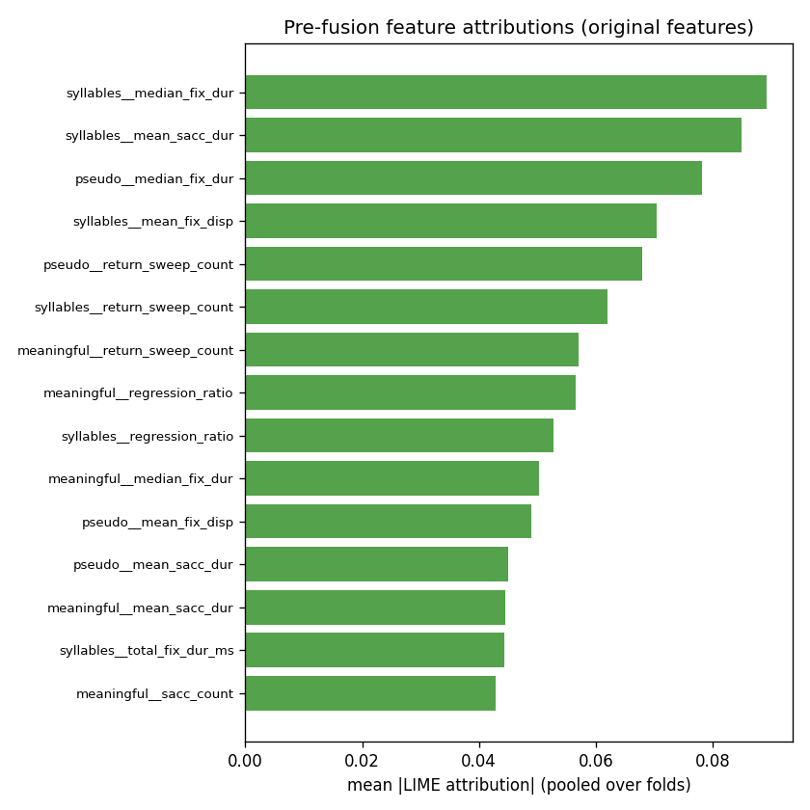
Figure 3. Top pre-fusion LIME attributions (original interpretable features, pooled over folds). All top features are oculomotor reading measures.

6.5 Calibration
- Calibration is mediocre (ECE ≈ 0.17). The models are somewhat over-confident — reported honestly, and it directly motivates the calibrated honest-fusion work planned for Stage 2 (RQ3).
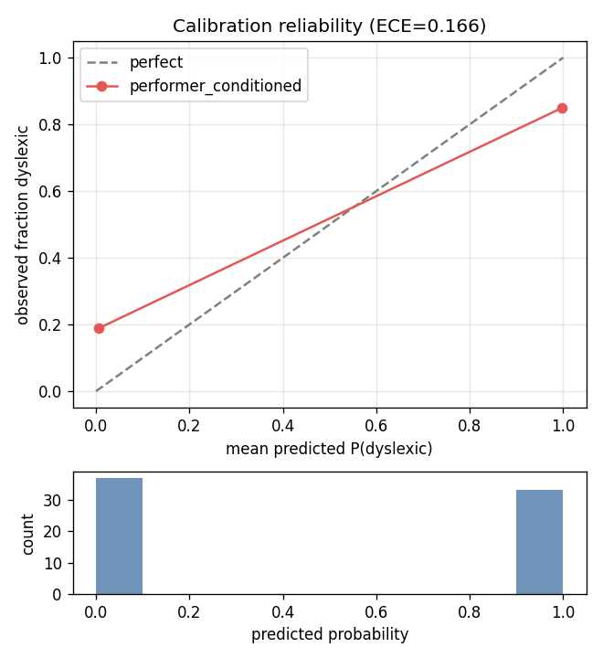
Figure 4. Reliability diagram (out-of-fold predictions). Deviation from the diagonal reflects the calibration gap.

6.6 Comparison with published ETDD70 baselines
Cross-paper numbers use different validation protocols and are approximate — not directly comparable to our subject-level nested-CV results.
System | Reported accuracy | Note
ETDD70 dataset paper (2024) | ~0.90 | different protocol; approximate
SwinV2 + SGA | 0.9245 | different protocol; approximate
INSIGHT | 0.8665 | different protocol; approximate
CatBoost / XGBoost | ~0.80–0.83 | different protocol; approximate
This work (Performer, subject-level nested CV) | 0.829 [0.75, 0.90] | our protocol; leakage-controlled

7. Methodological Rigor & Notable Findings
- Leakage-free by construction and by assertion. Subject-level folds are the single most important correctness property; the harness re-checks every split and a dedicated test confirms an injected leak is caught.
- A real bug found and fixed during verification. A subtle error in the Performer's numerical stabilization had unfairly handicapped the linear model (its attention was a distorted softmax approximation). Fixing it made RQ1 a fair comparison and closed the apparent accuracy/AUROC gap — the verification discipline doing its job.
- Statistical power strengthened. Outer folds increased from 5 to 10 so the paired significance tests can actually reach significance (with 5 folds the minimum possible p was 0.06).
- Honest negatives reported as-is — no result was inflated or hidden.

8. Pending Work — Next Stages
Priority | Work item | Dependency / note
Stage 2 · P1 | RQ3 — handwriting auxiliary branch; naive vs honest calibrated fusion (the project's second headline; a citable critique of disjoint-cohort fusion) | Needs the Kaggle handwriting dataset's structure & subject-linkage investigated first
Stage 2 · P2 | Out-of-distribution generalization: zero-shot evaluation on held-out cohorts (CopCo / Serbian gaze; Malaysian handwriting) | Needs those datasets sourced & attached
Stage 2 · P3 | Czech-specific embedding (RobeCzech) in place of the multilingual default | Quick; no new data; low payload
Write-up | Consolidate into a workshop / short paper + submission package | Stage 1 already provides a complete paper

9. Final Model & Expected Output
- Final model. A lightweight, linear-complexity gaze–linguistic co-conditioning model with a gradient-boosted head; in Stage 2, an honest, calibrated late-fusion of an auxiliary handwriting signal — all under one reproducible pipeline.
- At inference. A per-child dyslexia-risk score with interpretable, biomarker-level feature attributions. (Research use only — explicitly not a clinical or diagnostic tool.)
- Deliverables. (a) the reproducible model + open codebase; (b) a short/workshop paper; (c) data & model cards; (d) figures and result tables generated directly from the run artifacts.

10. Assessment & Recommendations
- The project is de-risked. Stage 1 alone is a complete, defensible paper
- Treat the RQ2 classification null as a strength. A proper protocol dissolved an underpowered false-positive from the early 5-fold run; the genuine RQ2 result is the broad, FDR-corrected descriptive interaction (absolute reading effort widening with complexity). Frame RQ2 around the effect sizes, not classification accuracy.
- Lead the paper with RQ1's efficiency crossover. “Matches accuracy and AUROC, and is dramatically cheaper past N ≈ 1024” is the strongest, most novel result, and it justifies linear attention for raw-signal regimes.
- Recommended next step: RQ3 (handwriting) — but check the data first. It adds the most scientific weight, but only if the dataset's subject-linkage supports an honest per-writer feature. Do the short data-structure check before committing effort.
- Publication target. A workshop / short paper at an ML-for-health or efficient-AI venue; n = 70 does not support journal-scale clinical claims. Be explicit about the limitations (small N, single language, mediocre calibration).
- Emphasis for the meeting. The contribution is rigor, honesty and efficiency — not raw accuracy. That framing is the project's strength.

