**Project 3 – Chibi Fit**

**PJ Khamvongsa**

**Eric Vang**

**Israel Solomon**

**INFO 2040**

**Dalibor Dvorski**

**April 17, 2018**

**Table of Contents**

**Introduction…………………………………………………………………………………3**

**Module A…………………………………………………………………………………..4-8**

**Description…………………………………………………………………………………..4**

**Research ………………………………………………………………………………….5-7**

**Technical Issues……………………………………………………………………………8**

**Module B…………………………………………………………………………………9-28**

**Use Cases………………………………………………………………………………9-15**

**Personas………………………………………………………………………………16-18**

**Entities…………………………………………………………………………………19-20**

**Content Plans…………………………………………………………………………21-22**

**Prototype……………………………………………………………………………….23-28**

**Conclusion…………………………………………………………………………………29**

**Introduction**

In this report you will find the research and design of the application Chibi Fit. This report will take you through what each step from the research to the prototypes. First, Module A will be an explanation of what the application is and what it will do. Then will be the research for how the application will work and some design ques. After, we will list some of the potential hardware features need for the application to function.

Module B will then showcase the use cases that the application may be part of. Also, it will include some personas developed to theoretically test the application. Entities for the application will be included in this report as well as the content plans.

Finally, the prototypes will be showcased. This will include both the mobile and the web versions of the prototypes.

**Module A**

**Description**

Chibi Fit is a free fitness app that features a digital version of yourself that uses information that you input to reflect yourself. For example, if you input your weight, your digital self will reflect what you input and if you gain weight, then your digital self will gain weight. Your character will try to motivate you if you haven’t been active in a while. The app will also suggest exercises and your digital self will demonstrate how to do the exercise.

Also, the app will feature graphs and charts to track your progress. The paid version will feature more ways to customize your character, more exercises and more ways to track yourself in addition to the free versions features.

Future goals for the application may include, other app integration, and a wearable version of the application.

**Research**

Similar apps to our application include:

Tomagotchi: We are referencing this application due to its similar nature to our application. Chibi Fit takes ques from this application by its similar cute characters as you can see in figure 1. We also chose to do something similar so expand our target demographic.

**Figure 1: Tomagotchi web application (**[**http://ca.tamagotchifriends.com/**](http://ca.tamagotchifriends.com/)**)**

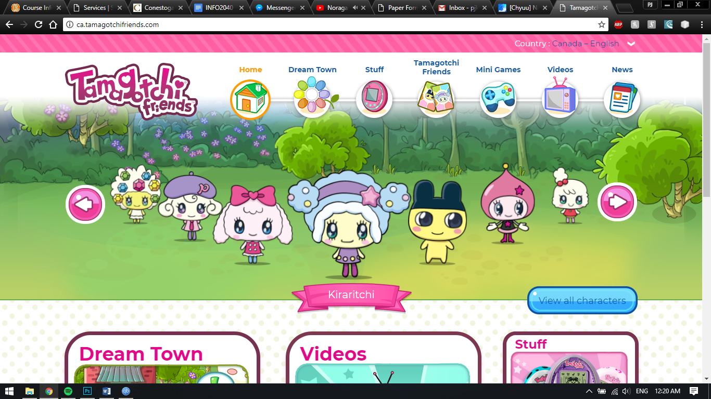

Fitbit: We are referencing this application for its industry leading tracking capabilities. As you can see in figure 2, the tracking system is pretty in depth and we want our application to have as much data as possible to be able to accurate track and give suggestions.

**Figure 2: Fitbit (https://www.fitbit.com/en-ca/app)**

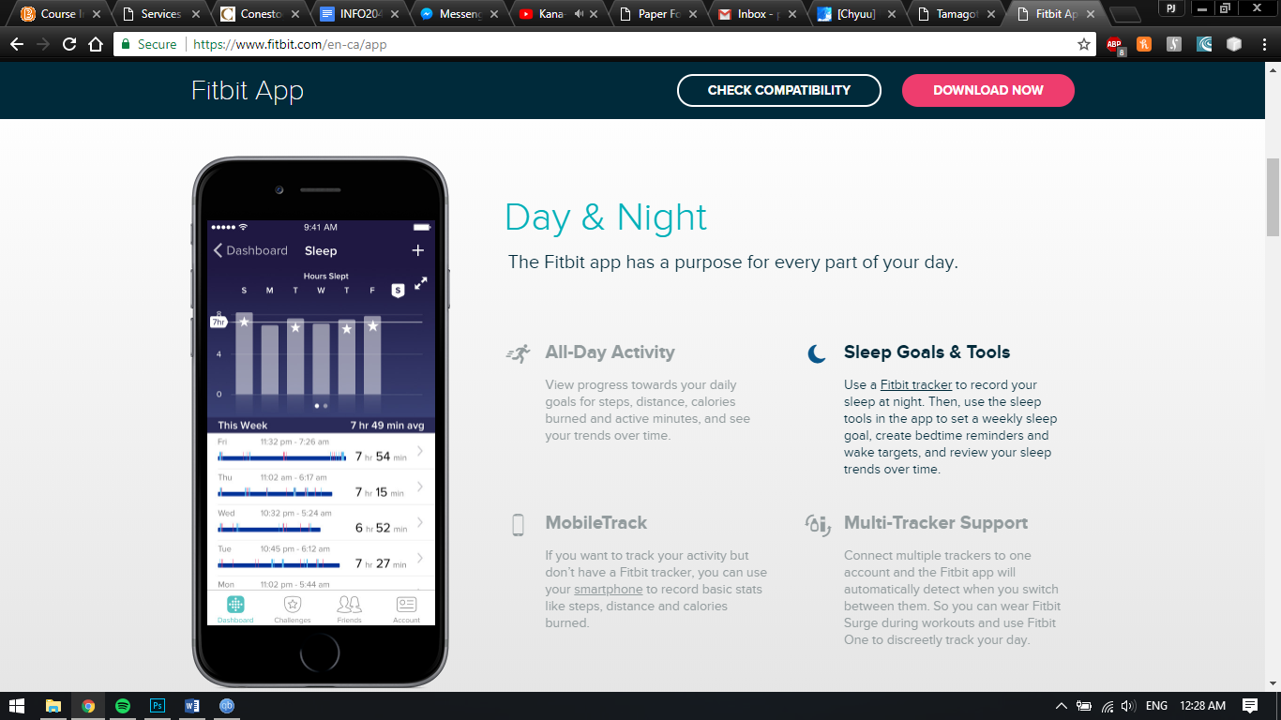

My fitness pal is another well established fitness tracking application. As you can see in figure 3, they have an extensive ecosystem ranging from tracking macros to tracking distance run using GPS.

**Figure 3: myfitnesspal (**[**https://www.myfitnesspal.com/apps**](https://www.myfitnesspal.com/apps)**)**

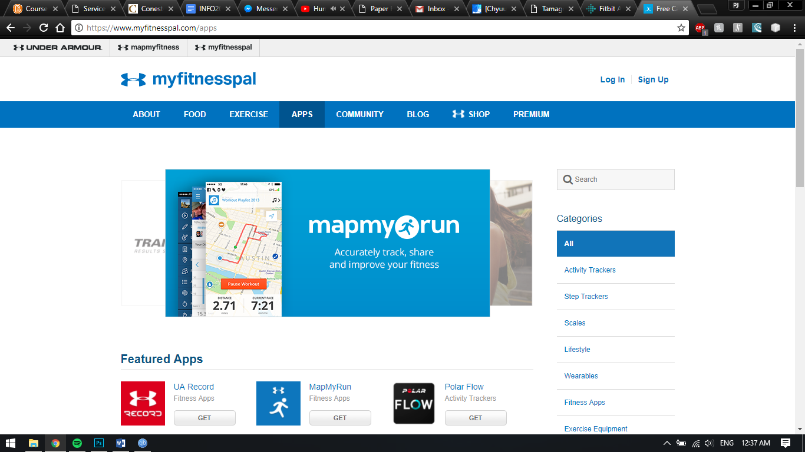

Technical Issues

Some hardware features that the application would require to run are a pedometer, GPS, camera and a network connection. We would use the pedometer to track the total steps the user would take and determine if the application will notify the user to take more steps to meet the goal. We use the GPS to track the user’s location and calculate the distance traveled. We would use the camera as a means for a profile picture so the user can use the network connection to communicate with other users and so that they can compare and compete with each other.

Advantages to using this application are that the application is goal driven, meaning that the more the user uses the application the better the results. Also, the user can set the goals that they want to achieve. In addition, that makes this application motivational. Users can see their character as well as other users achieve their goals.

Disadvantage to using this application is that the application is completely dependent on the user inputting accurate data. The application needs the data to accurately provide the most optimal exercises and nutritional facts.

**Module B**

Use Cases

Login:

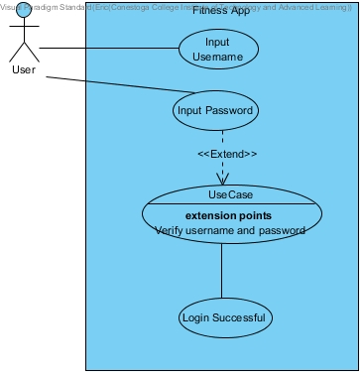

Create Account:

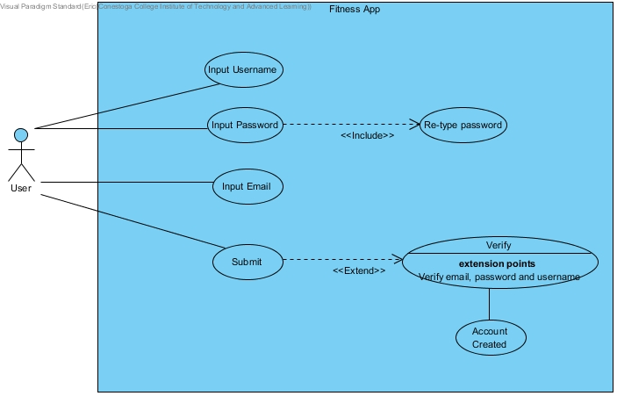

Personal Trainer Help:

User will select an exercise and select option for help. The online personal trainer will either use live chat or messenger to provide help as well as show videos and tutorials on the exercises.

1. User << Selects Desired Exercise >>
2. User << Selects Help >>
3. User << Ask Questions about Exercise>>
4. Personal Trainer << Provides videos and tips to help the user >>
5. User << Executes Exercises >>

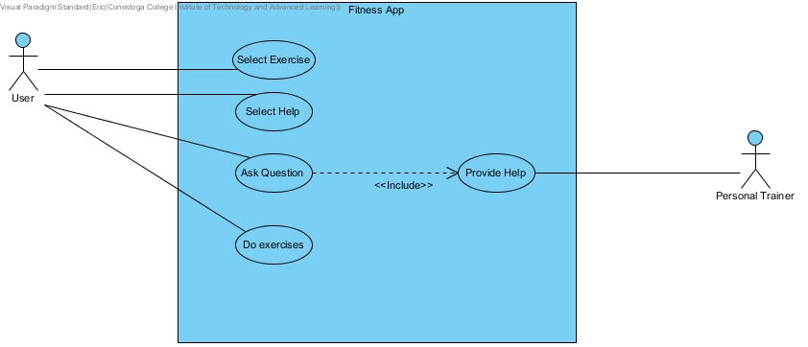

Personal Settings:

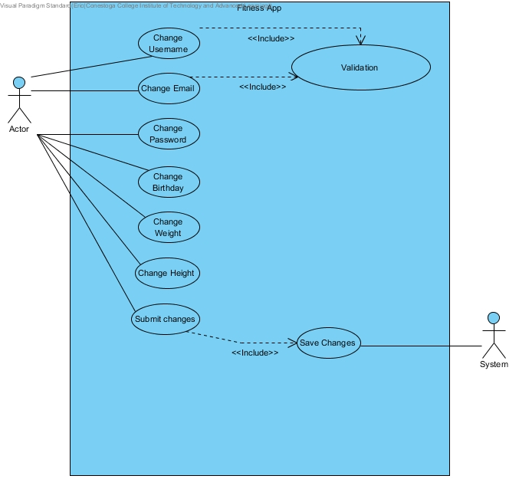

Customize Digital Character:

User can customize digital characters clothing, personal features such as eye colour, hair colour, hair style and facial hair. Also the user will be able to change the weight and the height of their digital character (it will also change the weight and the height of the users personal settings).

1. User << Selects Clothes >>
2. User << Selects Available clothes >>
3. User << Selects Change Appearance>>
4. User << Changes Eye Colour >>
5. User << Changes Hair Colour>>
6. User << Changes Hair Style>>
7. User << Changes Facial Hair >>
8. User << Changes Weight>>
9. User << Changes Height>>
10. User << Submits Changes>>
11. System << Saves Changes>>

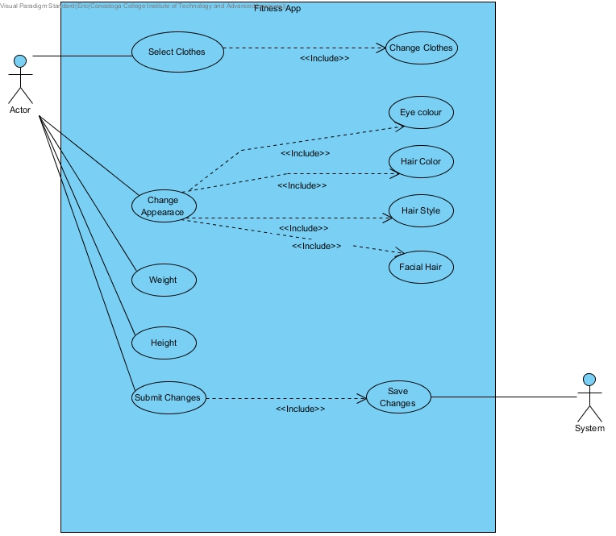

**Choose Exercise:**

The user will be able to select a set of exercises. They will choose the level either beginner, intermediate or advanced. Lastly it will execute and the system will start the timer right away.

1. User << Selects Exercise >>
2. System << Displays Tutorial Videos on Exercise >>
3. User << Selects Level >>
4. User << Starts Exercise >>
5. System << Starts Exercise Timer >>

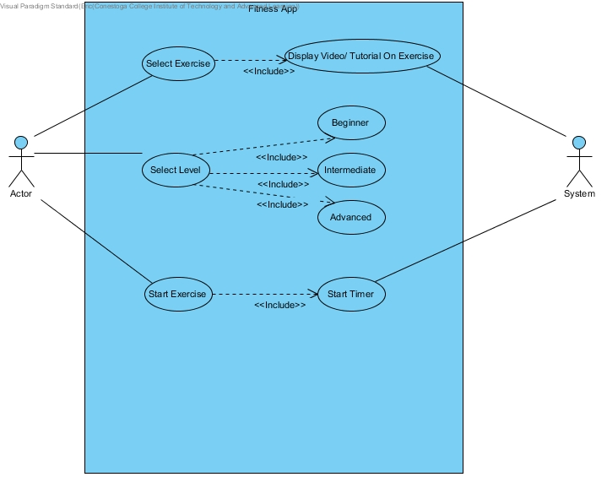

**Show Progress:**

The user will select the display progress and the system will show graphs and charts based on the user's weight loss, muscle gain, fat %, and average weight to height ratio.

1. User << Selects Progress Report>>
2. System << Displays Weight Loss >>
3. System << Displays Muscle Gain>>
4. System << Displays Fat Percentage >>
5. System << Displays Average Weight to Height >>

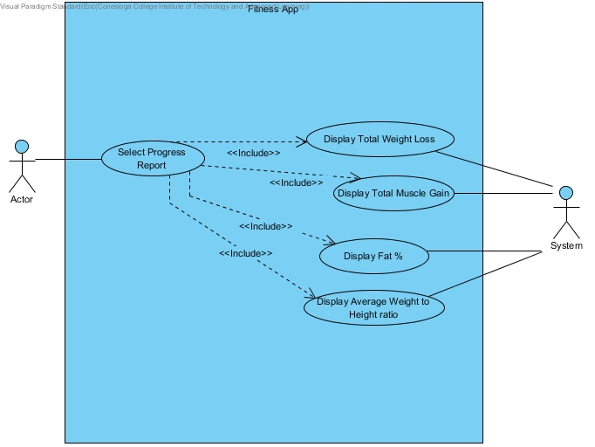

Personas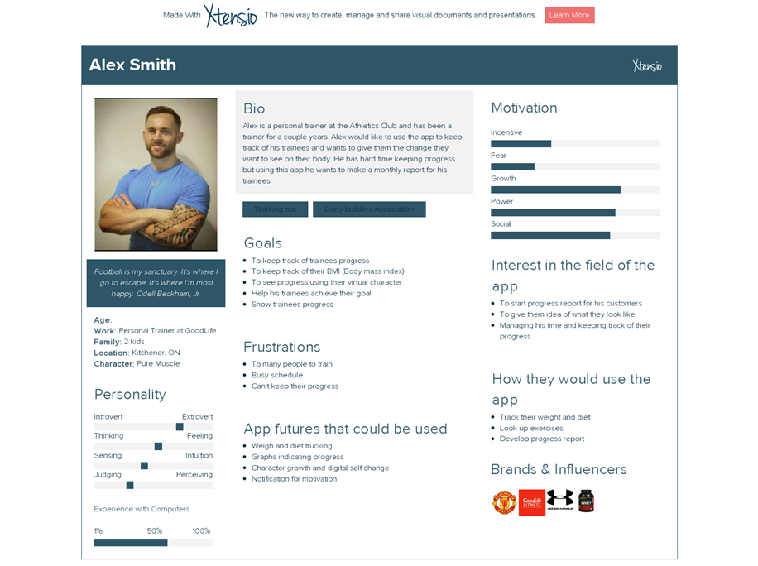

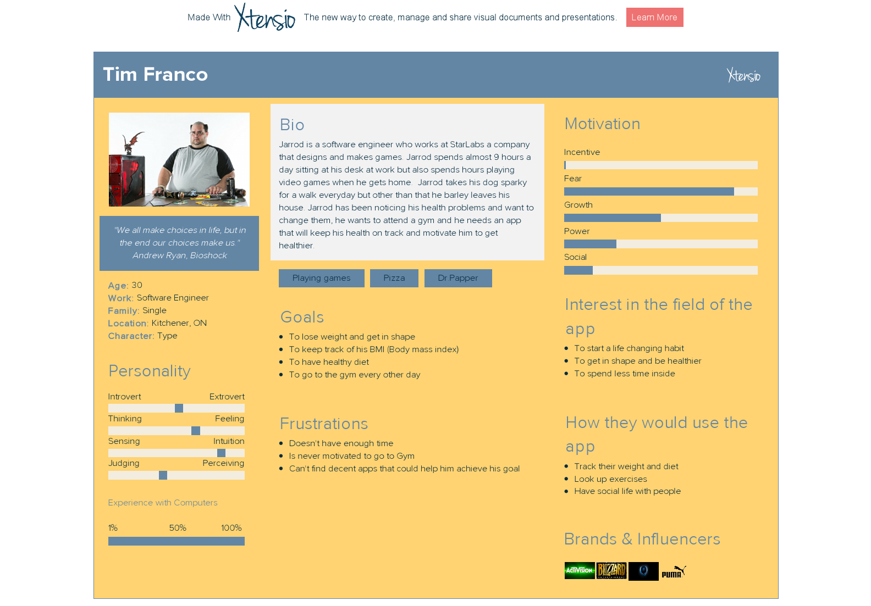

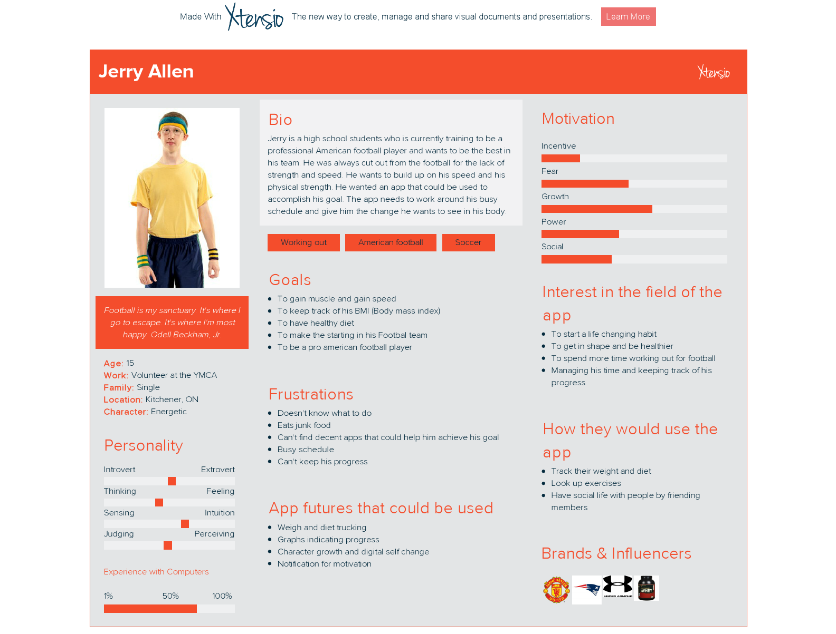

Entities

|  |  |
| --- | --- |
| Entity | Fields |
| User | * Name * Email Address * Weight * Gender * Height * Birthday |
| Digital Character | * Name * Height * Weight * Wearables/Clothes * Personal Features |
| GPS | * X-Coordinates * Y-Coordinates * Z-Coordinates * Longitude * Latitude |
| Personal Trainer | * Subject * Date/Time * Exercise * Tutorial Videos |
| Progress | * Date/Time * Weight * Height |

Content Plans

**Login Page:**

This page will have two options, to log into a existing account or to create a new account. The user will need to provide an email and password to login.

**Create Account Page:**

This page will have options such as Name, the username they wish to use, password and email address. After verification the account will be created.

**Personal Trainer Help Page:**

This page will hold as a live chat/chat for users to ask questions and get videos and quick help on exercises. This will give the user tips and tricks to staying healthy and safe while doing these exercises.

**Personal Settings Page:**

This page will hold the personal settings for the user, it will hold information such as Name, Birthday, Weight, Height, email address and password settings. The user can change anything they wish at anytime.

**Customize Digital Character Page:**

This page will hold information and settings for the users digital character. They can change the digital characters clothing and accessories, as well as the height and weight will change when the personal settings is changed.

**Choose Exercise Page:**

This page will hold all the exercises and tips for the users. It will show instructional videos and as well as rep count and timer for them.

**Show Progress Page:**

This page will hold graphs and charts to show the user how they are doing. It will display their progress since they joined and will help motivate the user to keep going.

Prototype

Progress Prototype: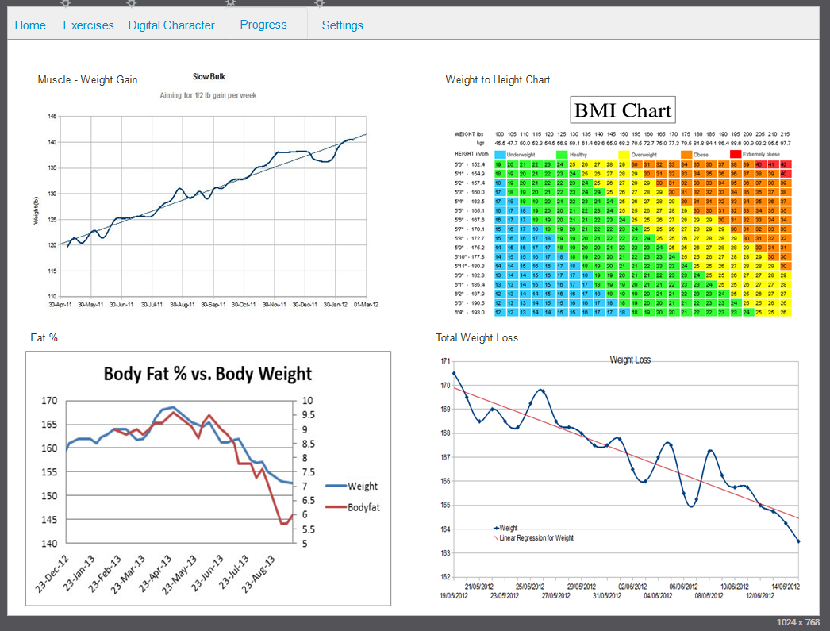

Customize Character Prototype: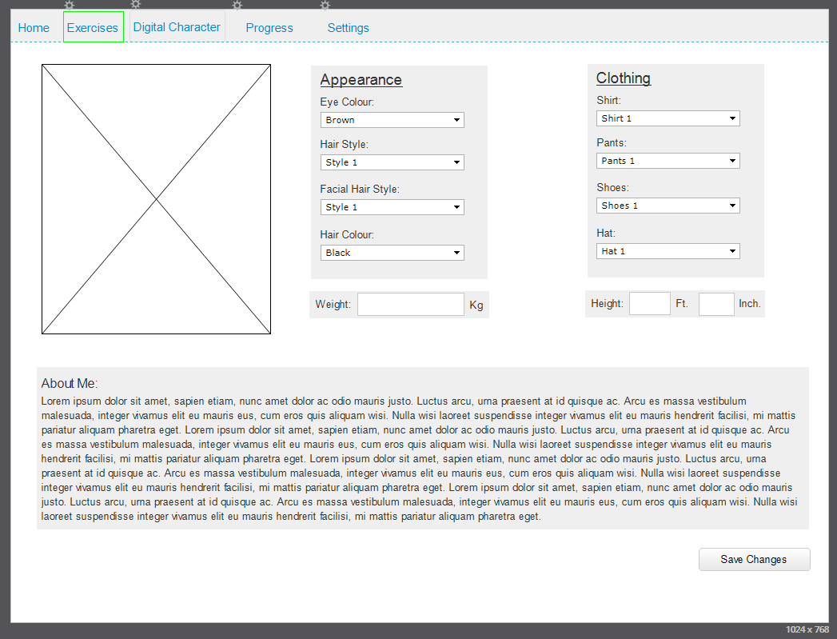

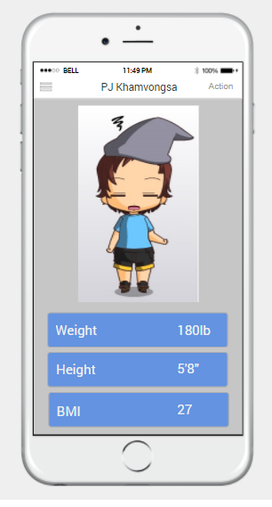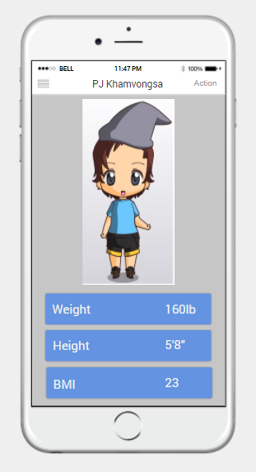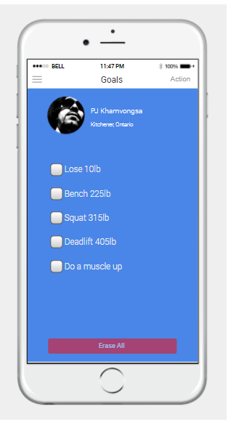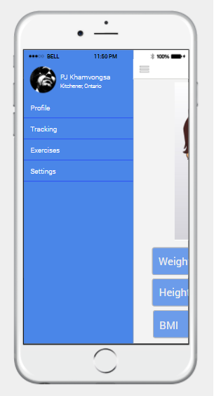

**Conclusion**

In conclusion, as you can see from the prototypes, we applied all the research and design ques mentioned from the modules. We think that this application is simple yet in depth enough for the most hardcore user as described in our persona section. Though there is always room for improvement, in the future we would like to design a wearable version of the application. As technology evolves and improves, so will this application with more accurate data to use. Until then, this is the freemium application Chibi Fit.