Having felt an earnest call to ministry since college, I have been preparing for both foreign missions and domestic church ministry through internship opportunities, academic study, voracious reading, intense dialog, and a foray into electronic publishing. While my primary focus has been church health, including church planting and church strengthening, I have been gifted in personal counseling and have experience in adoption ministry. I hope to transition into ministry prior to or upon graduation.

I affirm the [Abstract of Principles](http://www.founders.org/abstract.html), the [Baptist Faith and Message 2000](http://www.sbc.net/bfm/bfm2000.asp), the [Chicago Statement on Biblical Inerrancy](http://library.dts.edu/Pages/TL/Special/ICBI_1.pdf), and the [Danvers Statement on Biblical Manhood and Womanhood](http://cbmw.org/uncategorized/the-danvers-statement/).

# Personal Background

##### Spouse

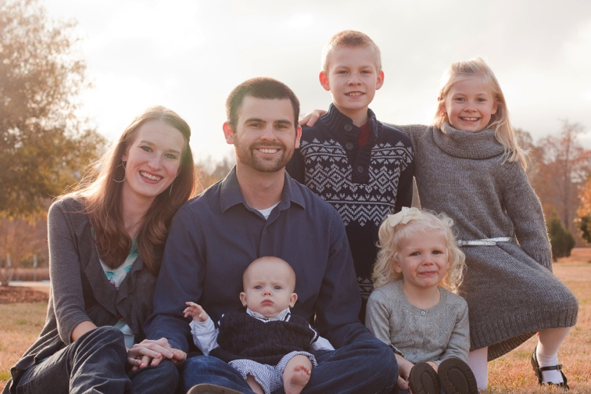Kathryn Rose, married December 22, 2007

##### Children

Vernon Ray, IV (11), Brooklyn Leigh (8),   
Emma Grace (4), Seth Christopher (1)

Our three eldest came into the family in 2011.

##### Contact

81 McDowell Dr.  
Wake Forest, North Carolina 27587  
[vernon.king@outlook.com](mailto:vernon.king@outlook.com) | (817) 458–8174  
Website: <http://www.vernonking.org>   
Family blog: <http://www.adoptedbytheking.com>

# Education

##### Southeastern Baptist Theological Seminary | Wake Forest, North Carolina

Currently pursuing *Master of Divinity in Christian Ministry* Anticipated graduation: December 2014  
GPA: 4.0

##### Southwestern Baptist Theological Seminary | Fort Worth, Texas

Coursework toward *Master of Divinity in Missions* 2009 – 2011  
GPA: 4.0+

##### Texas A&M University | College Station, Texas

*Bachelor of Science in Computer Engineering* May 2007  
GPA: 4.0, *summa cum laude*

# Relevant Experience

##### New Song Church | Windhoek, Namibia

*Missionary Intern* May 2007 – August 2007

Residential intern with an IMB missionary church and youth ministry:

* Assisted in the leadership and administration of a 150+ youth outreach program
* Helped host two American youth mission teams for two weeks each
* Provided technical support for church, youth ministries, and camp

##### Pillar on the Rock | Ecclesiological Online Magazine

*Co-founder and Editor*, [www.pillarontherock.com](http://www.pillarontherock.com) 2009 – 2011

Wrote and edited articles promoting healthy local churches:

* Article reprinted in B&H book, [*Preach: Theology Meets Practice*](http://www.amazon.com/dp/1433673177/?tag=vernonking-20), by Mark Dever and Greg Gilbert
* Edited 100+ articles; Authored 50+ articles ([www.pillarontherock.com/search/label/PJ King](http://www.pillarontherock.com/search/label/PJ%20King))
* Wrote major series on divorce and remarriage, race, membership, and church discipline
* Grew the writing team to include six authors

# Church Background

##### First Baptist Church | Durham, North Carolina

*Member* 2013 – Present

Although a new member, I am scheduled to serve in the following ways:

* Rotating Children’s Sunday School and home group teacher
* Pastoral internship through Southeastern in Spring 2014

##### Church of Christ the King (SBC) | Fort Worth, Texas

*Member* 2010 – 2012

Considered faithful to the community and participated in *ad hoc* duties:

* Deacon candidate (moved out of town soon after nomination)
* Organized greeter and security rotations
* Administered web technologies

##### Portland Avenue Baptist Church | Oklahoma City, Oklahoma

*Member* 2008 – 2009

Sacrificially served while discerning future ministry goals:

* Interim Sunday School teacher for College and Career class
* Break-out teacher for youth ministry
* Assumed temporary guardianship for twin teenage girls from the youth group

##### Trinity Baptist Church | Norman, Oklahoma

*Attended* 2007 – 2008

Actively participated before planned move out of town.

##### First Baptist Church | Bryan, Texas

*Member* 2003 – 2007

Engaged in ministry during full tenure of college:

* Served as a youth leader
* Participated in college discipleship programs

##### First Baptist Church | Woodway, Texas

*Member* 1992 – 2003

Raised by my parents to be a faithful member:

* Baptized by Michael Toby, 1992
* Served on student leadership team during high school
* Counseled as a college leader for youth camps and mission trips

# Professional History

##### Southeastern Baptist Theological Seminary | Wake Forest, North Carolina

*Software Developer* May 2013 – Present

##### FTS International | Fort Worth, Texas

*Lead Software Developer* May 2011 – January 2013

Led a team of five engineers and served as a point of contact with management

##### Deloitte Consulting | Dallas, Texas

*Software Consultant*, Homeland SecurityJanuary 2011 – May 2011

##### FIS | Oklahoma City, Oklahoma

*Senior Programmer Analyst* October 2009 – November 2010 *Programmer Analyst II* September 2007 – October 2009

##### Hewlett-Packard | College Station, Texas

*ASIC Intern* May 2006 ­– May 2007

##### Texas A&M University | College Station, Texas

*Peer Teacher*, Department of Computer ScienceSeptember 2004 – May 2006

# References

##### Nathan Finn

***Elder*, First Baptist Church, Durham *Associate Professor, Historical Theology and Baptist Studies***, Southeastern Baptist Theological Seminary(919) 280-4309  
[nfinn@sebts.edu](mailto:nfinn@sebts.edu)

##### Ryan Hutchinson

*Elder*, First Baptist Church, Durham  
*Executive Vice President for Operations*, Southeastern Baptist Theological Seminary([919) 761-2200](tel:919.761.2200)  
[hutchinson@sebts.edu](mailto:hutchinson@sebts.edu)

##### Benjamin H. Arbour

*Mentor and Friend*(979) 574-1300  
[benarbour03@yahoo.com](mailto:benarbour03@yahoo.com)

##### David Jacks

*Elder*, Church of Christ the King  
(817) 395-2180  
[davidjacks1967@gmail.com](mailto:davidjacks1967@gmail.com)

##### Jonathan Dent

*Elder*, Church of Christ the King  
(404) 667-7765[jdent_gt@yahoo.com](mailto:jdent_gt@yahoo.com)