Supplement for “Chemical Substructures that Enrich for Biological Activity”

Fragmentation Strategies.
- Break all single bonds connecting ring and non-ring atoms; hydrogen atoms in the generated fragments are implicit and were not included in substructure searches.
- Break all single bonds connecting ring and non-ring atoms; hydrogen atoms in the generated fragments are explicit and generic non-hydrogen atoms are attached at bond cleavage sites, with both atom types participating in substructure searches.
- Break all single bonds connecting a ring atom and non-ring atom present in a chain of at least three non-hydrogen atoms; hydrogen atoms in the generated fragments are implicit and were not included in substructure searches.
- Break all single bonds connecting a ring atom and non-ring atom present in a chain of at least three non-hydrogen atoms; hydrogen atoms in the generated fragments are explicit and generic non-hydrogen atoms are attached at bond cleavage sites, with both atom types participating in substructure searches.
- Cleave bonds using RECAP, a set of rules for retro-synthetic analysis. In this order, the following bond types are cleaved: amide, ester, amine, urea, ether, olefin, quaternary nitrogen, aromatic nitrogen-carbon, lactam nitrogen-carbon, aromatic carbon-aromatic carbon, and sulphonamide. Hydrogen atoms in the generated fragments are implicit and were not included in substructure searches.
- Cleave bonds using RECAP, a set of rules for retro-synthetic analysis. In this order, the following bond types are cleaved: amide, ester, amine, urea, ether, olefin, quaternary nitrogen, aromatic nitrogen-carbon, lactam nitrogen-carbon, aromatic carbon-aromatic carbon, and sulphonamide. Hydrogen atoms in the fragments are explicit and generic non-hydrogen atoms are attached at bond cleavage sites, with both atom types participating in substructure searches.

SMIRKS Strings used in each Fragmentation Strategy:

Break all single bonds to rings:
Implicit H: [R:1]-[!R;!#1:2].[H:3][H:4]>>[R:1][H:3].[!R:2][H:4]
Explicit: [R:1]-[!R;!#1:2].[*:3][*:4]>>[R:1][*:3].[!R:2][*:4]

Break all chained single bonds to rings:
Implicit H: [R:1]-[!R:2]-[!D1:5][!#1:6].[H:3][H:4]>>[R:1][H:3].[!R:2]([H:4])-[*:5][*:6]
Explicit: [R:1]-[!R:2]-[!D1:5][!#1:6].[*:3][*:4]>>[R:1][*:3].[!R:2]([*:4])-[*:5][*:6]

RECAP:

1 AMIDE:
Implicit H: [H][H].[O:3]=[C!$(C([#7])(=O)[!#1!#6]):2]-[#7!$([#7][!#1!#6]):1]>>[O:3]=[C:2][H].[#7:1][H]
Explicit: [*][*].[O:3]=[C!$(C([#7])(=O)[!#1!#6]):2]-[#7!$([#7][!#1!#6]):1]>>[O:3]=[C:2][*].[#7:1][*]

2 ESTER:
Implicit H: [H][H].[#6!$([#6](O)~[!#1!#6]):3][O:2][C:1]=[O:4]>>[C:1]([H])=[O:4].[#6:3][O:2][H]
Explicit: [*][*].[#6!$([#6](O)~[!#1!#6]):3][O:2][C:1]=[O:4]>>[C:1]([*])=[O:4].[#6:3][O:2][*]

3 AMINE:
Implicit H: [H][H].[#6:2]-[N!$(N[#6]=[!#6])!$(N~[!#1!#6])!X4:1]>>[N:1][H].[#6:2][H]
Explicit: [*][*].[#6:2]-[N!$(N[#6]=[!#6])!$(N~[!#1!#6])!X4:1]>>[N:1][*].[#6:2][*]

4 UREA:
Implicit H: [H][H].[N:4][C:1]([N:2])=[O:3]>>[N:4][C:1]([H])=[O:3].[N:2][H]
Explicit: [*][*].[N:4][C:1]([N:2])=[O:3]>>[N:4][C:1]([*])=[O:3].[N:2][*]

5 ETHER:
Implicit H: [H][H].[#6:3]-[O!$(O[#6]~[!#1!#6]):1]-[#6:2]>>[#6:2][H].[O:1]([H])-[#6:3]
Explicit: [*][*].[#6:3]-[O!$(O[#6]~[!#1!#6]):1]-[#6:2]>>[#6:2][*].[O:1]([*])-[#6:3]

6 OLEFIN:
Implicit H: [H][H].[H][H].[C:1]=[C:2]>>[C:1]([H])[H].[C:2]([H])[H]
Explicit: [*][*].[*][*].[C:1]=[C:2]>>[C:1]([*])[*].[C:2]([*])[*]

7 QUATN:
Implicit H: [H][H].[#6:1]-[N$(N([#6])([#6])([#6])[#6])!$(NC=[!#6]):2]>>[#6:1][H].[N:2][H]
Explicit: [*][*].[#6:1]-[N$(N([#6])([#6])([#6])[#6])!$(NC=[!#6]):2]>>[#6:1][*].[N:2][*]

8 AROMN-CARBON:
Implicit H: [H][H].[n:1]-[#6!$([#6]=[!#6]):2]>>[n:1][H].[#6:2][H]
Explicit: [*][*].[n:1]-[#6!$([#6]=[!#6]):2]>>[n:1][*].[#6:2][*]

9 LACTAMN-CARBON:
Implicit H: [H][H].[C;R:3](=[O:4])[N;R:1][#6;!R;!$([#6]=[!#6]):2]>>[C:3](=[O:4])[N:1][H].[#6:2][H]
Explicit: [*][*].[C;R:3](=[O:4])[N;R:1][#6;!R;!$([#6]=[!#6]):2]>>[C:3](=[O:4])[N:1][*].[#6:2][*]

10 AROMCARBON-AROMCARBON:
Implicit H: [H][H].[c:1]-[c:2]>>[c:1][H].[c:2][H]
Explicit: [*][*].[c:1]-[c:2]>>[c:1][*].[c:2][*]

11 SULPHONAMIDE:
Implicit H: [H][H].[#7:1][S:2](=[O:3])=[O:4]>>[#7:1][H].[S:2]([H])(=[O:3])=[O:4]
Explicit: [*][*].[#7:1][S:2](=[O:3])=[O:4]>>[#7:1][*].[S:2]([*])(=[O:3])=[O:4]

LEGEND: These are the SMIRKS strings used to perform the various fragmentation strategies. Notice that the implicit H version of each SMIRKS “reacts” with hydrogen, which becomes implicit once each fragment is canonicalized. By comparison, the explicit versions of each SMIRKS include wildcard atoms [*]; these wildcard atoms are later replaced by [!#1] indicating any non-hydrogen atom and the hydrogen atoms are made explicit using other functions.

The Bayesian Information Criterion Score Explained.

The Bayesian Information Criterion (BIC) score is used to select amongst alternative splitting variables within the tree, or to terminate splitting and declare the node a leaf if no variable improves the BIC score. The score attempts to balance the benefits of a model under which the training data is more likely against the danger of overfitting that comes with increased model complexity. If the presence or absence of a substructure divides a group of compounds into two subgroups that are uniformly (100%) active and uniformly (100%) inactive, then the probability of each compound’s observed activity or inactivity is 100%, thus maximizing the data likelihood (mutual information is proportional to the log of data likelihood). In practice, the subgroups are rarely 100% uniform and there are various ways that compounds can be segregated, therefore, the optimal subgroups and the substructures to discriminate them are less obvious. Furthermore, compounds can be over-partitioned to the point that each group has only one compound, so those increases in data likelihood are weighed against a penalty term measuring the complexity of the decision tree model, with larger trees being disfavored. This composite score combining data likelihood and the penalty term is known as the BIC score. The BIC score approximates log(P(G|D)), the likelihood that the decision tree accurately describes the activity observed in the compounds, where G is the proposed decision tree, D is the compound activity data, and θ are the selected subgroup activity parameters:
log(P(G|D)) ~ log(P(D|G)) + log(P(G)) ~ BIC(G, θ |D)
The BIC score is then calculated:
BIC(G, θ |D) = log(P(D|G,θ)) – ½ dim(G) log N
where N is the number of samples
and dim(G) is the number of parameters (equal to the number of subgroups or leafs in this case)
and Likelihood = log(P(D|G,θ)) = Σ N _{k |S}* log θ _{k |S}
where N _{k |S} (θ _{k |S} ) is the number (fraction) of compounds
having S substructures with k (1 or 0) activity
Using the BIC score, the decision tree is built with the following algorithm:
- For each compound subgroup (i.e., each node in the tree for which a split is being considered), select the substructure that best discriminates active and inactive compounds, as measured by the greatest increase in the BIC score.
- If no substructure increases the BIC score, then declare that subgroup a leaf. Otherwise divide the subgroup into two new subgroups having or lacking the substructure and update the BIC score, and go to step 1.
If no more subgroup divisions increase the BIC score, then the decision tree is complete. Record the compound composition of each subgroup (leaf) and the percentage of active compounds in each subgroup (leaf).
Prior attempts to produce decision trees based on compounds with randomly-permuted active/inactive labels produced an empty tree, confirming the significance of the original decision tree constructed using the BIC score.

Cumulative Hypergeometric Test of Association.

For c tested compounds containing a substructure including h compounds that are hits given a library with N tested compounds and H total hits in assay a, the probability of getting h or more of these compounds being hits is:
P_{a}⁺(c, h, N, H) = Σ _{i=h…min(c,H)} C(H, i) * C(N-H, c-i) / C(N, c)
Similarly, the substructures were also scored for the measured absence of chemical activity. The probability of getting the observed number of hits or fewer within a particular assay and threshold was calculated for each class using:
P_{a}⁻(c, h, N, H) = Σ _{i=max(0,c-(N-H))…h} C(H, i) * C(N-H, c-i) / C(N, c)

T-tests Comparing Enrichment of Substructures in Individual Assays.
We categorized each substructure according to 1) the presence or absence of a ring, 2) the exclusive presence of aromatic carbons, 3) the exclusive presence of sp³-hybridized carbons, 4) the number of explicit non-hydrogen substituents (X’s), and 5) the presence or absence of heteroatoms (Fig. S2). We then calculated the net difference between the number of enriched assays and the number of depleted assays (from Table S1) for each substructure. Using t-tests, we determined that substructures containing rings had a greater (net) enrichment in assay activity (6.8 net) than substructures lacking rings (-2.1 net), p=0.0036. Further, we determined that substructures containing only aromatic carbons had a greater enrichment in assay activity (11 net) than substructures only containing sp³-hybridized atoms (-14 net), p=0.0006. Next, we determined that substructures containing rings with two or more explicit non-hydrogen substituents (X’s) had a greater enrichment in assay activity (10.4 net) than substructures with rings having fewer than two explicit non-hydrogen substituents (5.1 net), p=0.0242. Lastly, we compared substructures containing heteroatoms to those that lacking heteroatoms and found no significant difference, p=0.2770.

Figure S1.
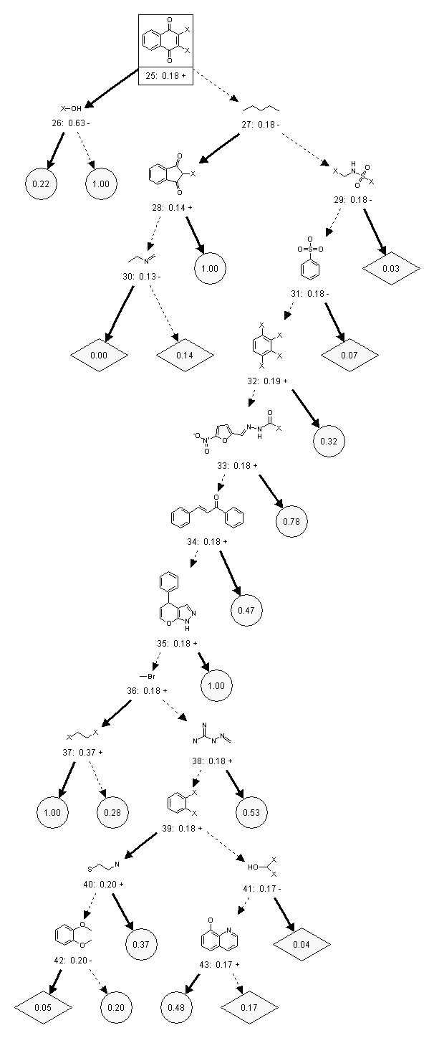
Legend: Discriminating Substructures Identified by the Decision Tree (bottom half of tree). The above substructures were selected by the decision tree to discriminate active and inactive compounds in the Chembridge library. Notice that some substructures have wildcard atoms “X” which indicate any atom that is not hydrogen; the hydrogen atoms in these substructures are explicitly matched. All other substructures only match non-hydrogen atoms. The symbols “+” and “-” indicated whether or not the particular substructure is associated with an increase or decrease in compound activity relative to its parent node in the tree. Bold arrows pointing away from a substructure indicate its presence and dotted arrows indicate its absence. The substructure composition of each leaf (blue circle or red diamond) is then constrained by the intersection of statements about the presence or absence of substructures traced from the tree root (node 1) to each leaf. The selected substructures are also numbered and the fraction of active compounds is listed in each node and leaf. Leaves shown as blue circles are enriched in activity and leaves shown as red diamonds are deficient in activity relative to the entire library (18.4% of the library is active as indicated by the tree root, node 1). For space considerations, the tree is divided into two halves connected by substructure 25, which is enclosed by a box.
Figure S2.
Node# | Enriched | Depleted | DELTA | CONTENT | X's | HETEROATOM
10 | 4 | 14 | -10 | NO RING - SP3 C | 0 | 0
24 | 3 | 15 | -12 | NO RING - SP3 C | 0 | 0
27 | 3 | 20 | -17 | NO RING - SP3 C | 0 | 0
3 | 1 | 24 | -23 | NO RING | 1 | 1
5 | 2 | 17 | -15 | NO RING | 0 | 1
8 | 14 | 7 | 7 | NO RING | 0 | 1
17 | 13 | 0 | 13 | NO RING | 0 | 1
19 | 1 | 14 | -13 | NO RING | 0 | 1
26 | 14 | 9 | 5 | NO RING | 1 | 1
30 | 4 | 6 | -2 | NO RING | 0 | 1
36 | 7 | 0 | 7 | NO RING | 0 | 1
38 | 5 | 0 | 5 | NO RING | 0 | 1
40 | 4 | 5 | -1 | NO RING | 0 | 1
37 | 3 | 20 | -17 | NO RING - SP3 C | 2 | 0
9 | 2 | 0 | 2 | NO RING | 2 | 1
15 | 19 | 2 | 17 | NO RING | 2 | 1
22 | 17 | 1 | 16 | NO RING | 2 | 0
29 | 0 | 3 | -3 | NO RING | 2 | 1
41 | 7 | 6 | 1 | NO RING | 2 | 1
1 | 17 | 1 | 16 | RING | 0 | 1
2 | 5 | 0 | 5 | RING | 0 | 1
6 | 4 | 10 | -6 | RING | 0 | 1
11 | 19 | 0 | 19 | RING | 0 | 1
12 | 8 | 3 | 5 | RING | 0 | 1
14 | 2 | 4 | -2 | RING | 1 | 1
18 | 0 | 4 | -4 | RING | 0 | 1
21 | 6 | 0 | 6 | RING | 0 | 1
28 | 4 | 0 | 4 | RING | 1 | 1
31 | 5 | 3 | 2 | RING | 0 | 1
33 | 8 | 0 | 8 | RING | 1 | 1
34 | 9 | 0 | 9 | RING | 0 | 1
35 | 2 | 0 | 2 | RING | 0 | 1
42 | 3 | 11 | -8 | RING | 0 | 1
43 | 10 | 0 | 10 | RING | 0 | 1
13 | 16 | 0 | 16 | RING - AROMATIC C | 0 | 0
7 | 10 | 0 | 10 | RING | 3 | 1
16 | 18 | 1 | 17 | RING | 4 | 1
20 | 10 | 0 | 10 | RING | 3 | 1
23 | 10 | 2 | 8 | RING | 4 | 1
25 | 10 | 0 | 10 | RING | 2 | 1
4 | 3 | 1 | 2 | RING - AROMATIC C | 4 | 0
32 | 12 | 0 | 12 | RING - AROMATIC C | 4 | 0
39 | 15 | 1 | 14 | RING - AROMATIC C | 2 | 0
Figure S3.
Parent Node | Leaf | Example Structure
2 | right | 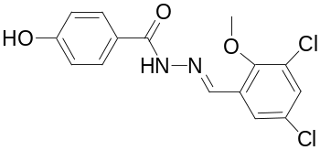
3 | right | 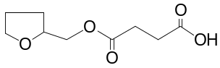
4 | right | 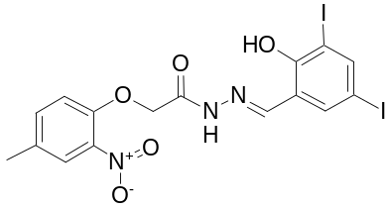
6 | left | 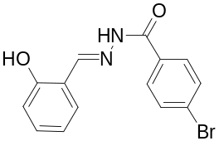
6 | right | 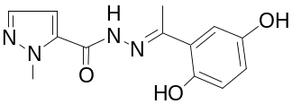
7 | right | 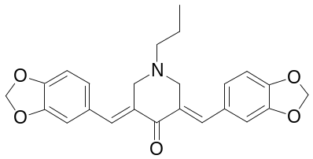
9 | right | 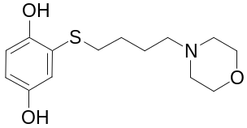
12 | right | 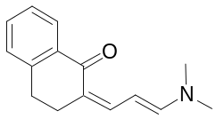
13 | left | 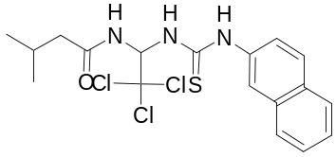
13 | right | 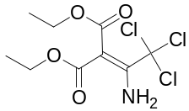
14 | left | 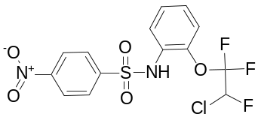
14 | right | 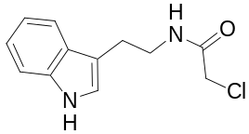
15 | right | 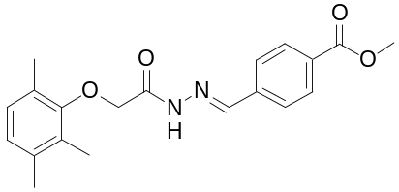
17 | right | 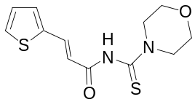
18 | right | 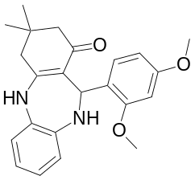
19 | left | 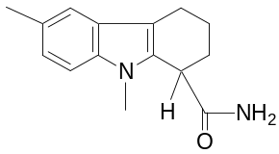
19 | right | 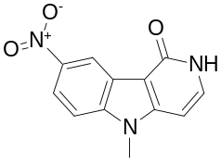
20 | right | 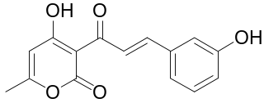
21 | right | 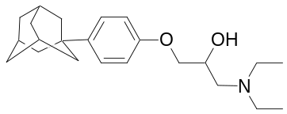
22 | left | 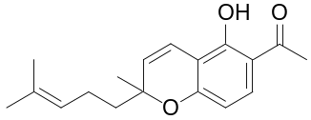
22 | right | 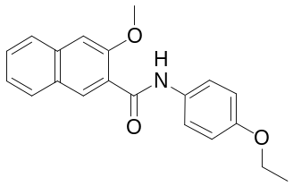
23 | right | 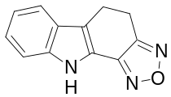
24 | left | 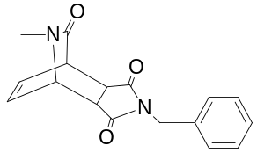
24 | right | 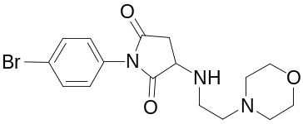
26 | left | 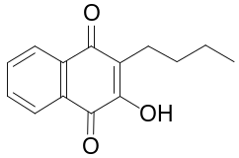
26 | right | 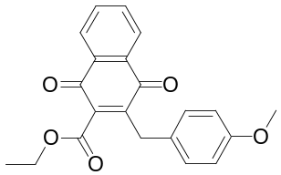
28 | right | 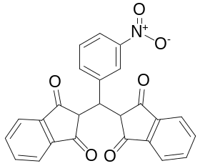
29 | right | 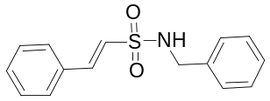
30 | left | 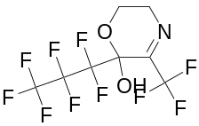
30 | right | 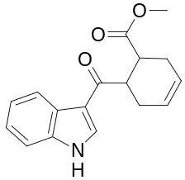
31 | right | 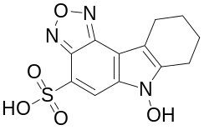
32 | right | 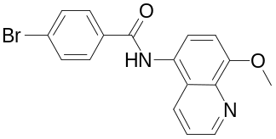
33 | right | 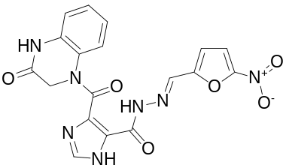
34 | right | 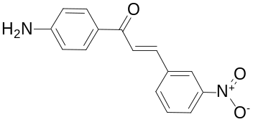
35 | right | 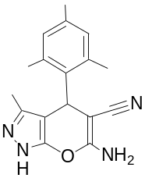
37 | left | 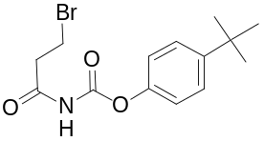
37 | right | 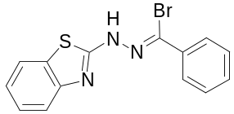
38 | right | 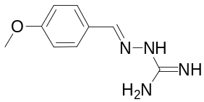
40 | right | 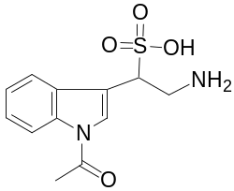
41 | right | 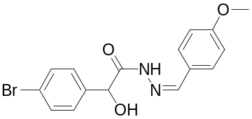
42 | left | 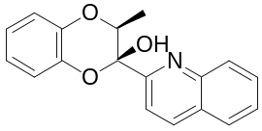
42 | right | 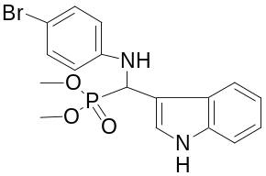
43 | left | 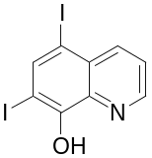
43 | right | 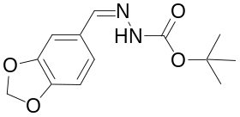

Legend: Example Structures Selected from the Tree. Structures were randomly selected from the leaves of the decision tree described in Figures 2 and S1. Leaves are identified by their parent node as labeled in the decision tree and their orientation as the right or left leaf of that parent node. The structures in each leaf are subject to the constraints of the tree requiring the presence or absence of the preceding substructures in the tree and their composite substructures may be components of larger ring systems in some cases. It is should be noted that aliphatic carbons in the tree’s selected substructures do not match aromatic carbons in the whole compounds and vice versa. The exemplary substructures can be traced to the internal nodes of the decision tree as well.

Figure S4.
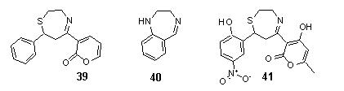
Legend: Tricyclic Ring System Selected as “Privileged”. A tricyclic ring system (39) containing a seven-membered ring similar to that of benzodiazepine (40) was selected by the decision tree derived using a uniform factor of three increase or decrease in assay signal to indicate activity. An exemplary compound (41) from the Chembridge Diverse Set E library which contains the substructure (39) is also shown.

Figure S5.
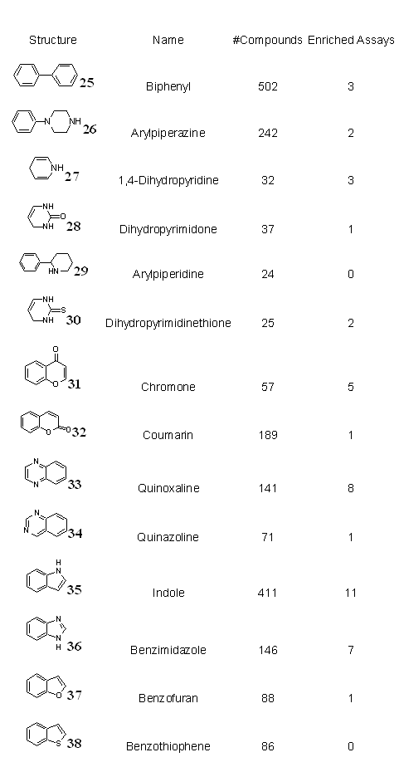
Legend: Enrichment of reportedly privileged substructures in assay activity. The number of assays for which each reported privileged substructure was enriched or depleted out of 59 total assays tested is shown. The number of compounds containing each substructure is also shown. 2 or fewer enrichments or depletions for any given substructure were expected by chance alone (α<0.05). Many substructures reported as privileged are enriched in multiple assay activities.
Figure S6.

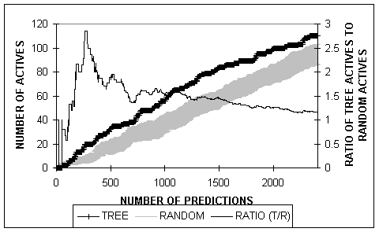

Legend: Recovery of Methyltransferase Inhibitors In the Chembridge Diverse Set E Library. A decision tree trained on 24 assays was used to rank the Chembridge Diverse Set E compounds according to their expected rate of activity in an assay for inhibition of protein arginine methyltransferase (not used in training). The number of actives retrieved by the decision tree rankings (wide black line) is 1.5-3 times greater than that retrieved by random selection indicated by the gray shaded area showing the mean +/- one standard deviation.
Figure S7.

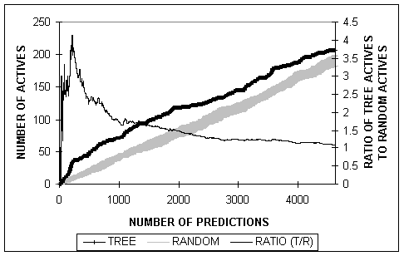

Legend: Recovery of Compounds that Selectively Kill Neu-Overexpressing Cells In the Chembridge Diverse Set E Library. A decision tree trained on 24 assays was used to rank the Chembridge Diverse Set E compounds according to their expected rate of activity in an assay for selective killing of Neu overexpressing cells (not used in training). The number of actives retrieved by the decision tree rankings (wide black line) is 1.5-4 times greater than that retrieved by random selection indicated by the gray shaded area showing the mean +/- one standard deviation.
Figure S8.

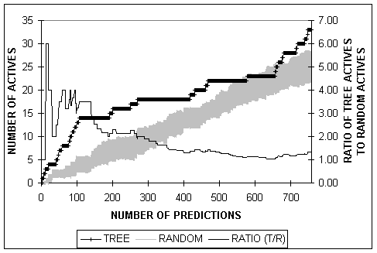

Legend: Recovery of Compounds that Inhibit Histone Acetylation In the Chembridge Microformat Library. The original decision tree was used to rank the Chembridge Microformat compounds according to their expected rate of activity in an assay for inhibition of histone acetylation. For the first 500 compounds, the number of actives retrieved by the decision tree rankings (wide black line) is 1.5-4 times greater than that retrieved by random selection indicated by the gray shaded area showing the mean +/- one standard deviation.

Figure S9.

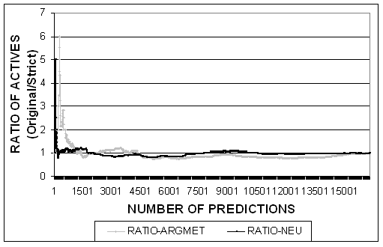

Legend: Ratio of Active Compounds Predicted by Original Tree to Active Compounds Predicted by Tree With Stricter Definition of Activity. The ratio of active compounds correctly predicted by two decision trees in two independent assays of arginine methyltransferase inhibition (ARGMET) and selective killing of Neu-overexpressing cells (NEU) is shown. The original tree was trained defining active compounds as those scoring in one or more assays, and the other tree was trained defining active compounds as those scoring in two or more assays, excluding from training those compounds scoring in exactly one assay. The ratio of correctly predicted actives fluctuates around one, so that no clear advantages in the ability to predict active compounds were observed between the two trees.
Table S1 | Enrichment of discriminating substructures in individual assays.
Node# | Activity | Context | Compounds | Enriched | Depleted
1 | UP | Alone | 288 | 17 | 1
3 | DOWN | Alone | 1642 | 1 | 24
5 | DOWN | Alone | 2479 | 2 | 17
8 | UP | Alone | 695 | 14 | 7
11 | UP | Alone | 1436 | 19 | 0
16 | UP | Alone | 128 | 18 | 1
20 | UP | Alone | 67 | 10 | 0
23 | UP | Alone | 172 | 10 | 2
25 | UP | Alone | 21 | 10 | 0
27 | DOWN | Alone | 2483 | 3 | 20
29 | DOWN | Alone | 115 | 0 | 3
31 | DOWN | Alone | 165 | 5 | 3
32 | UP | Alone | 472 | 12 | 0
33 | UP | Alone | 10 | 8 | 0
34 | UP | Alone | 53 | 9 | 0
35 | UP | Alone | 5 | 2 | 0
36 | UP | Alone | 82 | 7 | 0
38 | UP | Alone | 21 | 5 | 0
39 | UP | Alone | 4918 | 15 | 1
41 | DOWN | Alone | 388 | 7 | 6
43 | UP | Alone | 50 | 10 | 0
2 | DOWN | Combo | 63 | 5 | 0
4 | DOWN | Combo | 533 | 3 | 1
6 | UP | Combo | 4180 | 4 | 10
7 | UP | Combo | 6 | 10 | 0
9 | UP | Combo | 14 | 2 | 0
10 | DOWN | Combo | 6687 | 4 | 14
12 | UP | Combo | 262 | 8 | 3
13 | UP | Combo | 1048 | 16 | 0
14 | UP | Combo | 835 | 2 | 4
15 | UP | Combo | 1313 | 19 | 2
17 | UP | Combo | 1357 | 13 | 0
18 | DOWN | Combo | 380 | 0 | 4
19 | DOWN | Combo | 6646 | 1 | 14
21 | UP | Combo | 51 | 6 | 0
22 | UP | Combo | 896 | 17 | 1
24 | DOWN | Combo | 1601 | 3 | 15
26 | DOWN | Combo | 4692 | 14 | 9
28 | UP | Combo | 33 | 4 | 0
30 | DOWN | Combo | 262 | 4 | 6
37 | UP | Combo | 4922 | 3 | 20
40 | UP | Combo | 537 | 4 | 5
42 | DOWN | Combo | 430 | 3 | 11

The number of assays for which each selected decision tree substructure was statistically enriched or depleted in activity out of the 59 assays tested is shown. The relative enrichment of each substructure to its parent node in the original tree is indicated by “UP” or “DOWN”; each substructure’s presence with other substructures is marked by “Combo” and its absence is marked by “Alone.” The number of compounds containing each substructure is also shown. Fewer than 3 enrichments or depletions for any given substructure were expected by chance alone (α<0.05). The reported tree enrichments “UP” or “DOWN” generally coincide with multiple enrichments or depletions in individual assay activities.
Table S2 | Distribution of Assay Activities over Chembridge Diverse Set E Compounds
KNOWN ASSAY ACTIVIITIES | COMPOUNDS | P(ACTIVITY IN K+1 ASSAY)
0 | 13309 | 0.184
1 | 2277 | 0.243
2 | 520 | 0.287
3 | 145 | 0.306
4 | 53 | 0.172
5 | 8 | 0.273
6 | 3 | NA
The numbers of assay activities (of 24 used in training) observed for our training compound library (Chembridge Diverse Set E library) are shown. Roughly 25% of active compounds are active in two or more assays. We also calculated the probability of compounds with “k” known activities being active in k+1 assays: these probabilities are generally less than those observed for our enriched tree nodes. This further demonstrates the advantage of substructure-based predictive models over an approach that uses only known bioactive compounds in screening, noting also that our tree can make predictions for compounds outside of our training set.

