TASK 3

1)CREATING A FILE IN LOCAL FS AND MOVE IT TO HDFS

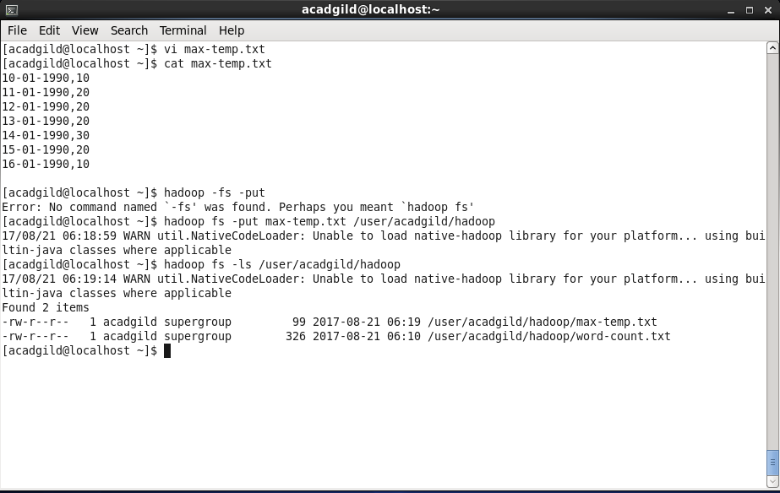

2) Change the Permission of max-temp file

