OpenAPI Implementation Specification for AMI Head-End Systems
Purpose: A vendor-facing specification for layering a CIM-compatible REST API on top of an existing AMI backend (Head-End System, MDM, Analytics). This document assumes the backend systems already exist and focuses exclusively on the HTTP interface, authentication, data shapes, and — critically — the asynchronous delivery promise pattern that decouples AMI communication latency from the REST request/response cycle.
Standards basis: IEC 61968-9:2024 (CIM for meter data exchange), ANSI C84.1 (voltage ranges), IEC 62056 DLMS/COSEM (meter protocol concepts).

1. Design Principles
Principle | Rationale
**Async-first for on-demand reads** | AMI communication networks (RF Mesh, PLC, Cellular) have 3–25 second latencies and non-trivial failure rates. The API must never block an HTTP connection waiting for a meter to respond.
**CIM-aligned data models** | Use IEC 61968-9 naming and structure (EndDevice, MeterReading, IntervalBlock, ReadingType, UsagePoint) so integrators can map directly to utility data standards.
**snake_case JSON** | Python/JS-friendly. CIM field names are adapted to snake_case (e.g., `mRID` → `mrid`, `flowDirection` → `flow_direction`).
**Paginated collections** | Every list endpoint returns `{ total, limit, offset, items[] }`. Default page size 20, max 100.
**Stateless auth** | API key in `X-API-Key` header. No sessions, no cookies. Health endpoint is unauthenticated.
**UTC everywhere** | All datetime fields are ISO 8601 with UTC timezone offset.

2. System Architecture
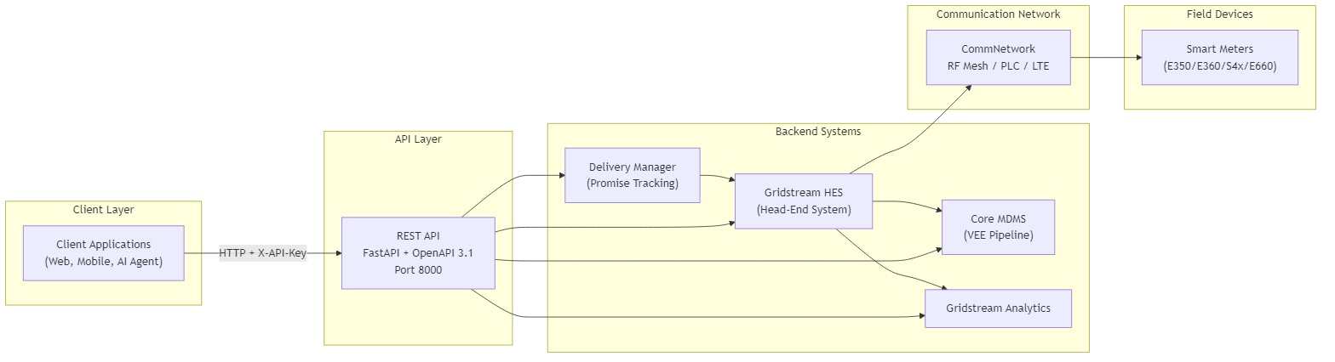

3. Authentication
All endpoints except GET /health require a static API key.
Header | Value
`X-API-Key` | Pre-shared secret configured in the backend
Error responses:
Condition | Status | Body
Header missing | `401` | `{"detail": "Missing API key. Provide X-API-Key header."}`
Key invalid | `401` | `{"detail": "Invalid API key."}`
Vendor note: Replace with OAuth 2.0 / mutual TLS in production. The API key pattern is sufficient for internal integrations and test environments.

4. Endpoint Summary
All paths are prefixed with a version segment (e.g., /api/v1).
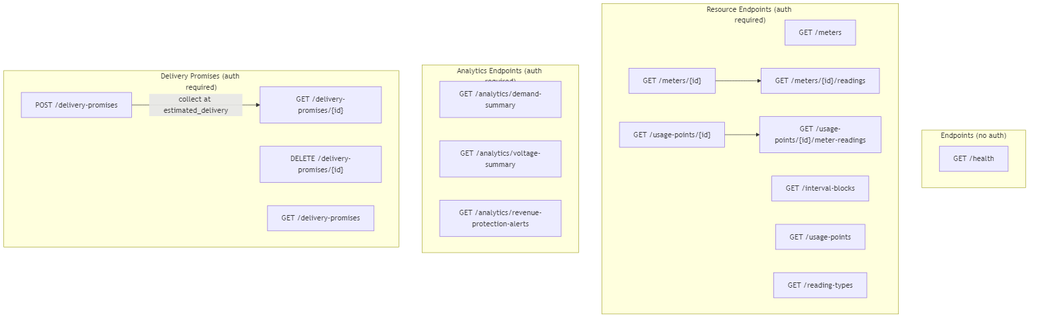
Method | Path | Auth | Description
GET | `/health` | No | Liveness check
GET | `/meters` | Yes | List meters (filterable)
GET | `/meters/{id}` | Yes | Single meter detail
GET | `/meters/{id}/readings` | Yes | Historical readings for a meter
GET | `/interval-blocks` | Yes | Cross-meter interval block query
GET | `/usage-points` | Yes | List usage points
GET | `/usage-points/{id}` | Yes | Single usage point detail
GET | `/usage-points/{id}/meter-readings` | Yes | Readings via usage point
GET | `/reading-types` | Yes | Catalog of reading type definitions
GET | `/analytics/demand-summary` | Yes | Demand analytics
GET | `/analytics/voltage-summary` | Yes | Voltage analytics
GET | `/analytics/revenue-protection-alerts` | Yes | Tamper / anomaly alerts
**POST** | **`/delivery-promises`** | **Yes** | **Create async on-demand read request**
**GET** | **`/delivery-promises/{id}`** | **Yes** | **Collect results at promised delivery time**
**DELETE** | **`/delivery-promises/{id}`** | **Yes** | **Cancel an expired or unneeded promise (optional)**
GET | `/delivery-promises` | Yes | List all promises

5. Core Data Models
Implement these as your response schemas. Field names are snake_case; types map to JSON primitives.

5.1 Entity Relationships
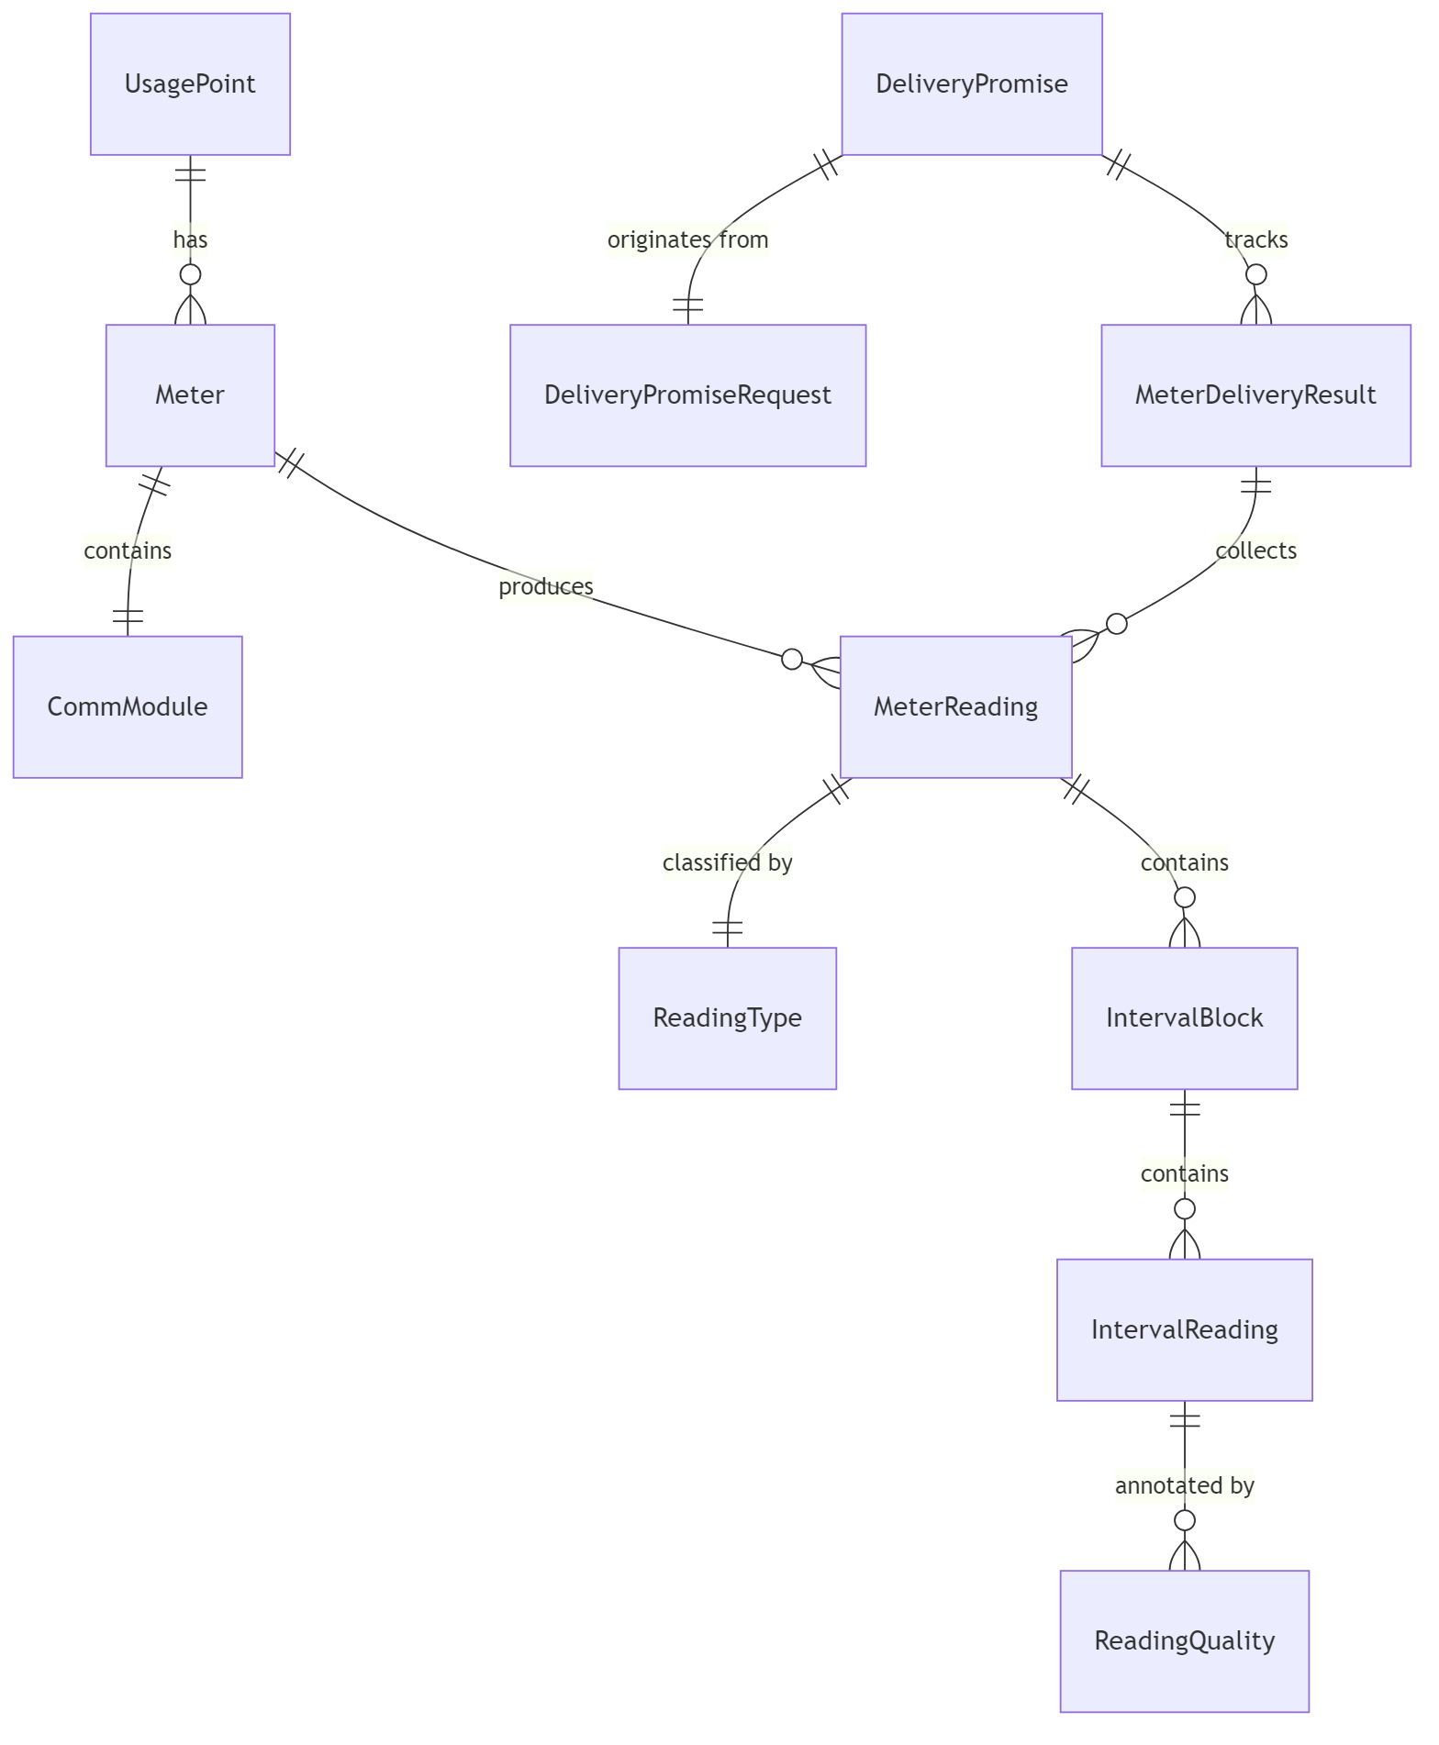

5.2 Meter (EndDevice)
mrid string UUID, primary key
serial_number string Manufacturer serial
manufacturer string e.g. "Landis+Gyr"
model string e.g. "E350", "S4x/E650"
firmware_version string
status enum active | commFailure | maintenance | inactive
connection_state enum connected | physicallyDisconnected | logicallyDisconnected
install_date datetime UTC
phase_code enum AN | ABCN | none | ... (IEC phase codes)
meter_type enum Vendor-specific model family
rated_power_w float Nameplate rating in watts
ct_ratio float Current transformer ratio (1.0 for residential)
form_number string ANSI meter form (2S, 9S, 16S, etc.)
demand_interval_minutes int Typically 15
usage_point_mrid string FK to UsagePoint
comm_module object Nested CommModule (see below)
CommModule (nested in Meter):
comm_type enum RF Mesh | PLC | Cellular LTE
firmware_version string
mac_address string
signal_strength float dBm
last_communication datetime UTC

5.3 ReadingType
CIM ReadingType defines *what* is being measured. Your backend likely has a fixed catalog.
mrid string UUID
name string Human-readable (e.g. "Forward Active Energy (Wh)")
accumulation enum deltaData | instantaneous | bulkQuantity | ...
flow_direction enum forward | reverse | net | none
commodity enum electricitySecondaryMetered | ...
measurement_kind enum energy | demand | voltage | current | ...
unit enum Wh | W | V | A | VA | VAr | Hz | none
phase enum Same as phase_code
measuring_period_minutes int Interval length (typically 15)
multiplier float Scale factor (typically 1.0)

5.4 IntervalReading / IntervalBlock / MeterReading
This is the core reading hierarchy (IEC 61968-9 structure):
MeterReading
├── mrid string UUID
├── meter_mrid string FK to Meter
├── usage_point_mrid string FK to UsagePoint
├── reading_type_mrid string FK to ReadingType
├── time_period object { start: datetime, end: datetime }
├── is_validated boolean True if VEE-processed
└── interval_blocks[]
└── IntervalBlock
├── mrid string
├── reading_type_mrid string
├── time_period object { start, end }
└── interval_readings[]
└── IntervalReading
├── timestamp datetime UTC
├── value float Reading value
└── quality[]
└── ReadingQuality
├── quality_type enum valid|estimated|suspect|missing|manuallyEdited
├── comment string|null
└── source string e.g. "HES", "VEE"

5.5 UsagePoint
mrid string
name string
connection_state enum
phase_code enum
rated_power_w float
rated_voltage_v float
service_category string residential | commercial | industrial
meter_mrids string[] Associated meter UUIDs
service_location_address string
customer_account_id string

5.6 Analytics Models
DemandSummary:
meter_mrid string|null null = fleet-wide
time_period object { start, end }
peak_demand_w float
peak_demand_timestamp datetime
average_demand_w float
min_demand_w float
load_factor float 0.0–1.0
data_points[] array [{ timestamp, demand_w }]
VoltageSummary:
meter_mrid string|null
time_period object
average_voltage_v float
max_voltage_v float
min_voltage_v float
std_dev_voltage_v float
ansi_c84_1_exceedance_count int Intervals outside ±5% nominal
data_points[] array [{ timestamp, voltage_v }]
RevenueProtectionAlert:
mrid string
meter_mrid string
alert_type enum tamper | bypass | reverse_flow | consumption_anomaly
severity enum low | medium | high | critical
detected_at datetime
description string
time_period object { start, end }

6. The Delivery Promise Pattern (Critical Path)
This is the most important part of the API. It solves a fundamental problem: AMI communication networks are slow and unreliable, but REST clients expect fast responses. The delivery promise is not a polling mechanism — the API tells the client exactly when to come back, and the client makes a single return trip to collect results.

6.1 The Problem
On-demand meter reads traverse a communication network with:
Comm Type | Latency | Failure Rate
Cellular LTE | 3–8 s | ~5%
RF Mesh | 8–20 s | ~10%
PLC | 12–25 s | ~15%
COMM_FAILURE meters | — | ~80%
A single-meter read could take 25 seconds. A batch of 50 meters could take 30+ seconds. HTTP connections should not block for that long. But continuous polling wastes bandwidth and complicates client logic. The solution is a time-of-delivery promise: the API calculates when data will be ready and tells the client when to return.

6.2 The Solution: Delivery Promises
The pattern has exactly two interactions:
- POST — Client requests an on-demand read. The API returns a promise with an estimated_delivery timestamp.
- GET (at the promised time) — Client returns at or after estimated_delivery to collect results. If readings are available, the promise resolves. If not, the promise is marked expired and the client may optionally send a DELETE to cancel.
There is no polling loop. The client trusts the promised delivery time.
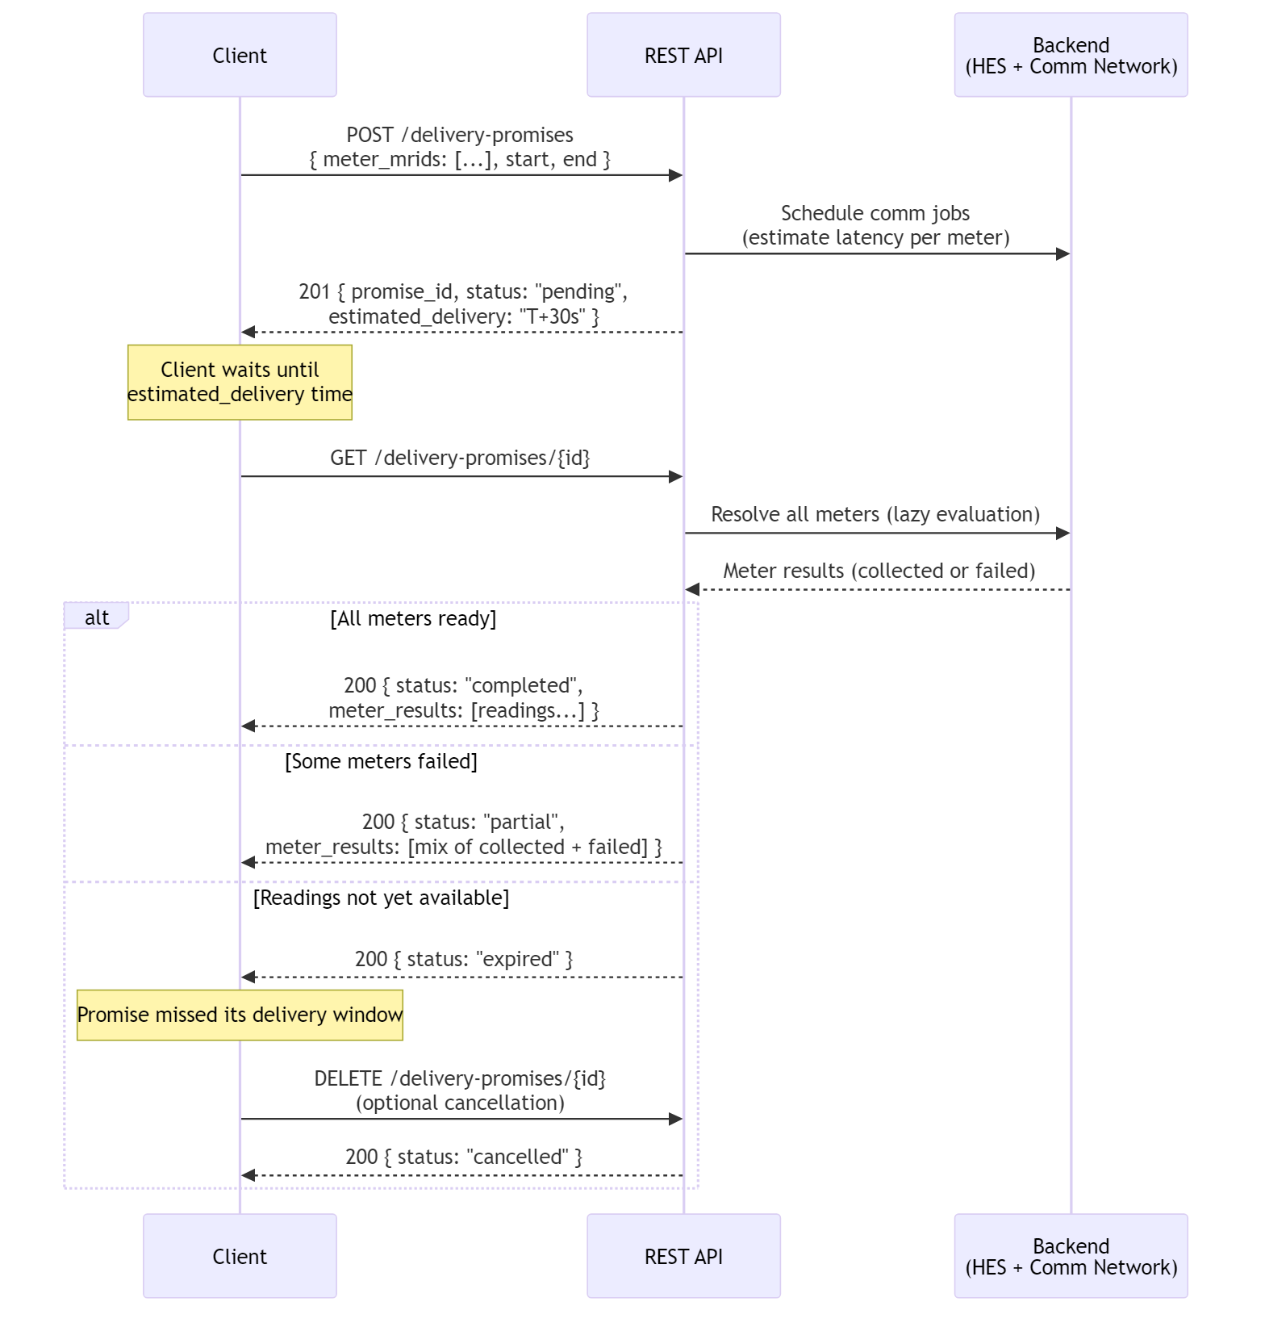
Key insight: The estimated_delivery timestamp is a contract. The backend commits to having data ready by that time. The client commits to not asking before that time. If the backend cannot fulfill the promise, it expires — the client does not retry or poll.

6.3 DeliveryPromise Model
Request (POST body):
meter_mrids string[] Required, non-empty. Meters to read.
start datetime Required. Reading window start.
end datetime Required. Reading window end. Must be > start.
reading_type_mrid string|null Optional. Restrict to one reading type.
validated_only boolean Optional (default false). Apply VEE before returning.
Response (DeliveryPromise):
promise_id string UUID assigned by the API.
status enum pending | completed | partial | failed | expired | cancelled
created_at datetime When the promise was created.
estimated_delivery datetime When to collect results. This is the promised time.
expires_at datetime Promise expiration (estimated_delivery + grace window).
request object Echo of the original request.
meters_total int Count of requested meters.
meters_collected int Count successfully collected so far.
meters_failed int Count that have failed.
meter_results[] array Per-meter status (see below).
failure_summary string|null Human-readable failure description.
MeterDeliveryResult (per-meter within the promise):
meter_mrid string Which meter this result is for.
status enum pending | collected | failed
readings MeterReading[]|null Populated when status = collected.
failure_reason string|null Populated when status = failed.

6.4 Promise Status Lifecycle
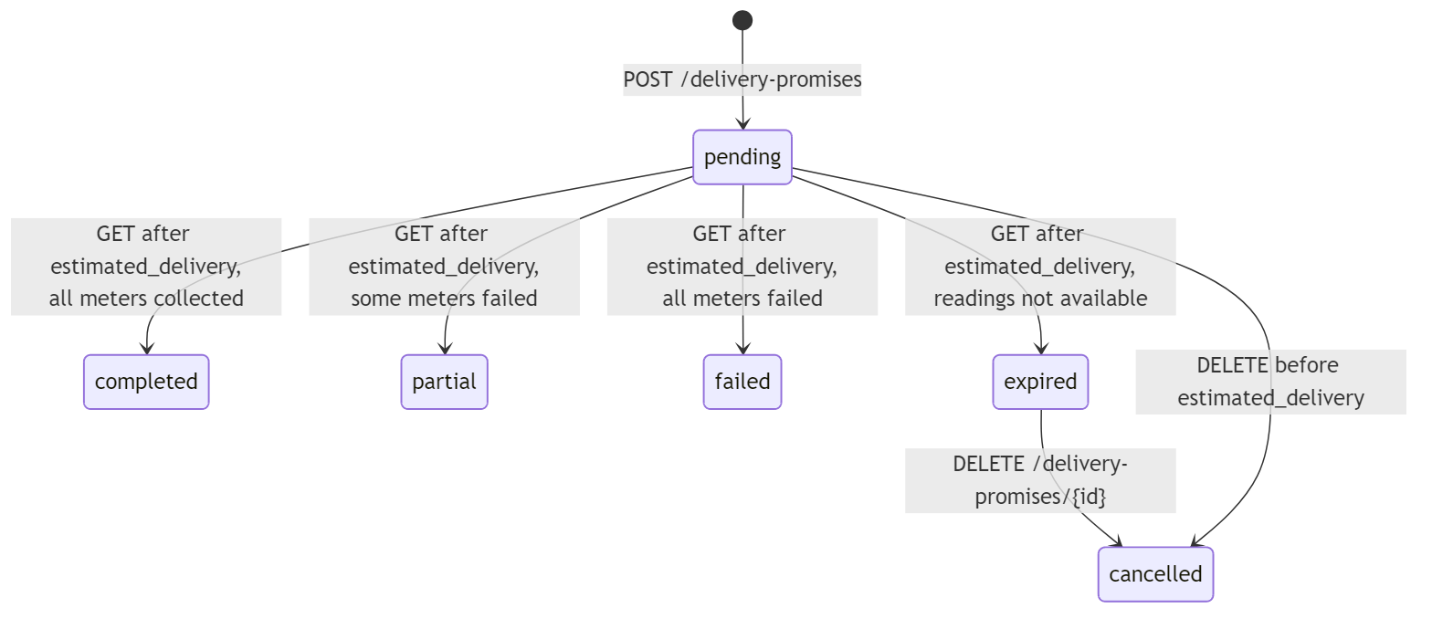
- pending: Promise created. Backend is collecting data. Client should wait until estimated_delivery.
- completed: Client collected at or after estimated_delivery. All meters returned readings.
- partial: Client collected at or after estimated_delivery. Some meters succeeded, some failed. Partial data available.
- failed: Client collected at or after estimated_delivery. All meters failed. No data.
- expired: Client collected at or after estimated_delivery but readings were not yet available (backend missed its promise). No retry — the promise is dead.
- cancelled: Client explicitly cancelled the promise via DELETE. This is optional cleanup.

6.5 Implementation Guidance for Vendors
Estimated delivery calculation:
estimated_delivery = created_at + max(per_meter_latency) + buffer
expires_at = estimated_delivery + grace_window
Where per_meter_latency is determined by each meter's communication type, buffer accounts for network variability (5 seconds is typical), and grace_window is a short period after the promised time during which the backend will still accept a collection request (e.g., 30 seconds). After expires_at, the promise is automatically expired.
Resolution on GET (single collection):
When the client sends GET /delivery-promises/{id}, the backend resolves all meters in a single pass. For each meter: if now >= collection_time, the meter transitions to collected (readings populated) or failed (failure_reason populated). If any meters are still pending after this resolution pass and now >= estimated_delivery, the promise transitions to expired — the backend missed its commitment. This is a lazy evaluation — no background threads or webhooks required.
Client contract: The client makes at most one GET request per promise, at or after estimated_delivery. The API does not expect or support repeated polling. If the client needs to retry, it creates a new promise.
Optional cancellation: The client may send DELETE /delivery-promises/{id} to explicitly cancel a promise that has expired or is no longer needed. This is housekeeping — the backend may garbage-collect expired promises automatically.
Backend integration pseudocode:
POST /delivery-promises:
1. For each meter_mrid in request:
a. Look up the meter's comm pathway
b. Estimate latency based on comm type
c. Determine success/failure based on comm type failure rate + meter status
d. Record { collection_time, will_succeed, failure_reason } per meter
2. Compute estimated_delivery from slowest meter + buffer
3. Compute expires_at from estimated_delivery + grace_window
4. Store promise (status = pending) and return 201
GET /delivery-promises/{id}:
1. If status is not "pending", return as-is (already resolved)
2. If now < estimated_delivery, return as-is (client is early, still pending)
3. If now > expires_at, set status = "expired" and return
4. Resolve all meters in a single pass:
a. For each meter: if now >= collection_time and will_succeed → collected
b. For each meter: if now >= collection_time and will_fail → failed
c. If any meters still pending → status = "expired" (backend missed promise)
d. If all collected → "completed"
e. If mix of collected + failed → "partial"
f. If all failed → "failed"
5. Return resolved promise
DELETE /delivery-promises/{id}:
1. Set status = "cancelled"
2. Return 200
Readings source: When a meter is "collected," the backend produces readings for the requested time window. This can come from a live meter read (real AMI), cached recent data, or a simulation engine. The API layer doesn't care — it just calls whatever the backend provides.

7. Endpoint Implementation Details

7.1 GET /health (no auth)
Return { "status": "healthy", "meter_count": N, "version": "1.0.0" }.

7.2 GET /meters
Query filters (all optional):
- meter_type — enum filter
- status — enum filter (alias for meter_status)
- comm_type — enum filter
- limit (1–100, default 20), offset (>=0, default 0)
Apply filters to the backend meter inventory, paginate, return PaginatedResponse[Meter].

7.3 GET /meters/{id}
Lookup by mRID. Return Meter or 404.

7.4 GET /meters/{id}/readings
Query parameters:
- start, end — datetime range filter (optional)
- reading_type_mrid — filter to specific measurement (optional)
- validated_only — boolean, if true return VEE-processed readings (optional, default false)
- limit, offset — pagination
Source: pre-collected historical data from HES (raw) or MDM (validated).

7.5 GET /interval-blocks
Cross-meter query. Accepts meter_mrids (comma-separated string), reading_type_mrid, start, end. Returns a flat list of IntervalBlocks across multiple meters. If meter_mrids is omitted, queries all meters.

7.6 GET /usage-points, GET /usage-points/{id}
Standard CRUD reads on usage points. Filter by connection_state. The /{id}/meter-readings sub-resource aggregates readings across all meters associated with the usage point. Accepts start, end, limit, offset.

7.7 GET /reading-types
Return the full catalog. No filtering needed — this is typically a small, fixed set (4–10 types). Wrap in PaginatedResponse for consistency.

7.8 Analytics endpoints
All accept optional start, end (default to last 7 days), optional meter_mrid. Delegate to the analytics backend. Return arrays (not paginated) since result sets are small.

7.9 Delivery Promises
See Section 6 above. This is the critical path. Three operations:
- POST /delivery-promises — Create a promise. Returns 201 with estimated_delivery timestamp.
- GET /delivery-promises/{id} — Collect results at or after estimated_delivery. Single call, not a poll. Returns completed, partial, failed, or expired.
- DELETE /delivery-promises/{id} — Optional. Cancel an expired or unneeded promise. Returns 200 with status: "cancelled".

8. Error Responses
Use standard HTTP status codes with a JSON detail field:
Status | Usage
`200` | Success
`201` | Promise created
`401` | Missing or invalid API key
`404` | Resource not found
`422` | Validation error (empty meter list, start >= end, etc.)
Body: { "detail": "Human-readable message" }

9. Pagination Convention
Every list endpoint uses the same shape:
{
"total": 142,
"limit": 20,
"offset": 0,
"items": [ ... ]
}
Query parameters: limit (1–100, default 20), offset (>=0, default 0).

10. Alternative: MCP (Model Context Protocol) Interface
For AI-agent and LLM-tool integration, the same backend can be exposed as an MCP server instead of (or alongside) the REST API. MCP is Anthropic's open protocol for connecting AI models to external tools and data sources.

10.1 Why MCP?
The delivery promise pattern maps naturally to MCP's tool-calling model:
- REST approach: The client must create a promise, note the estimated_delivery time, wait, then make a second HTTP call to collect. The client also handles expiration and optional cancellation. This two-step flow is straightforward but requires the client to manage timing.
- MCP advantage: The MCP server encapsulates the entire lifecycle — create, wait, collect — inside a single tool call. The AI agent calls read_meters_on_demand(meter_mrids=[...]) and the MCP server handles the timing internally, returning the final readings when ready.
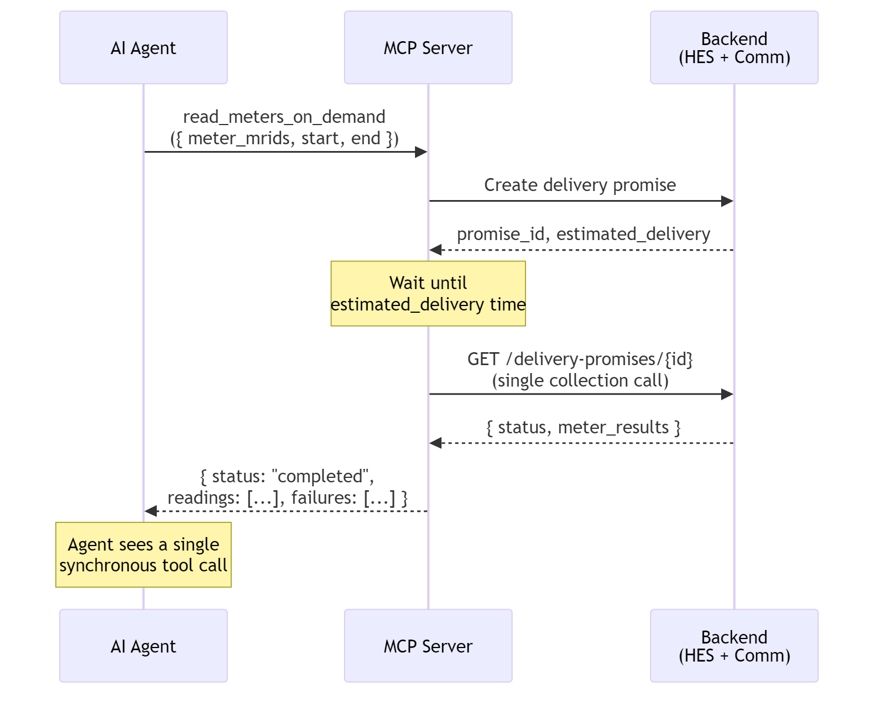

10.2 Recommended MCP Tools
Tool Name | Description | Maps to REST
`list_meters` | List/filter the meter fleet | `GET /meters`
`get_meter` | Get single meter detail | `GET /meters/{id}`
`get_meter_readings` | Historical readings for a meter | `GET /meters/{id}/readings`
`read_meters_on_demand` | **Synchronous on-demand read** — creates a delivery promise, waits for estimated delivery time, collects results | `POST + GET /delivery-promises`
`list_usage_points` | List service locations | `GET /usage-points`
`get_demand_summary` | Demand analytics for a period | `GET /analytics/demand-summary`
`get_voltage_summary` | Voltage analytics for a period | `GET /analytics/voltage-summary`
`get_revenue_alerts` | Revenue protection alerts | `GET /analytics/revenue-protection-alerts`
`list_reading_types` | Catalog of measurement types | `GET /reading-types`

10.3 The Key Tool: `read_meters_on_demand`
This is where MCP shines. The tool signature:
read_meters_on_demand(
meter_mrids: list[str], # Meters to read
start: str, # ISO 8601 datetime
end: str, # ISO 8601 datetime
reading_type_mrid: str | None, # Optional filter
validated_only: bool = False # Apply VEE?
) -> {
status: str, # completed | partial | failed
meters_collected: int,
meters_failed: int,
readings: list[MeterReading], # All collected readings
failures: list[{meter_mrid, reason}] # Any failures
}
Internal implementation:
- Call the backend's delivery promise creation (same logic as POST /delivery-promises)
- Wait until estimated_delivery time (sleep for the promised duration)
- Make a single collection call (GET /delivery-promises/{id})
- Aggregate all collected readings and failures into a single response
- Return to the AI agent
The agent never sees the promise lifecycle — it just gets readings or failure reasons.

10.4 MCP Server Implementation Sketch
from mcp.server import Server
from mcp.types import Tool
server = Server("ami-headend")
@server.tool()
async def read_meters_on_demand(
meter_mrids: list[str],
start: str,
end: str,
reading_type_mrid: str | None = None,
validated_only: bool = False,
) -> dict:
"""Read meters on-demand. Handles AMI communication latency internally."""
# 1. Create the delivery promise via your backend
promise = backend.create_delivery_promise(
meter_mrids=meter_mrids,
start=parse_datetime(start),
end=parse_datetime(end),
reading_type_mrid=reading_type_mrid,
validated_only=validated_only,
)
# 2. Wait until the promised delivery time
wait_seconds = (promise.estimated_delivery - datetime.now(UTC)).total_seconds()
if wait_seconds > 0:
await asyncio.sleep(wait_seconds)
# 3. Single collection call
promise = backend.get_delivery_promise(promise.promise_id)
# 4. Aggregate results
readings = []
failures = []
for result in promise.meter_results:
if result.status == "collected" and result.readings:
readings.extend(result.readings)
elif result.status == "failed":
failures.append({
"meter_mrid": result.meter_mrid,
"reason": result.failure_reason,
})
return {
"status": promise.status,
"meters_collected": promise.meters_collected,
"meters_failed": promise.meters_failed,
"readings": [r.model_dump() for r in readings],
"failures": failures,
}

10.5 The Downside: Agent–Server Coupling
The convenience of MCP comes at a cost. When the MCP server calls read_meters_on_demand, the agent's execution thread is blocked for the entire duration of the delivery promise — typically 8–30 seconds, potentially longer for large batches over RF Mesh or PLC. During this time, the agent is synchronized to the state of the MCP server, which is itself synchronized to the state of the AMI communication network. This creates a tight coupling chain:
Agent ←(blocked)→ MCP Server ←(waiting)→ Backend ←(collecting)→ Comm Network ←(transmitting)→ Meters
Every link in this chain must remain alive and responsive for the tool call to succeed. If any component stalls, the agent stalls with it.

10.5.1 Time-Bounded Response Problem
AI agents typically operate under strict time budgets. An LLM tool call that blocks for 25 seconds consumes a significant fraction of the agent's turn — time that could be spent reasoning, calling other tools, or responding to the user. The consequences compound:
Constraint | Impact of blocking MCP tool call
**Agent turn timeout** | Many agent frameworks enforce a per-turn time limit (e.g., 60–120 seconds). A single `read_meters_on_demand` for 10 PLC meters could consume half the budget, leaving no room for retries or follow-up queries.
**User-perceived latency** | The user sees the agent "thinking" with no intermediate output. Unlike REST — where the client receives the `estimated_delivery` time immediately and can display a countdown — the MCP agent appears frozen.
**Cascading failures** | If the MCP server's connection to the backend drops mid-wait, the agent receives a tool error after the full timeout. The agent has no way to distinguish "still waiting" from "something broke" until the call returns or times out.
**No concurrent work** | While blocked on one `read_meters_on_demand` call, the agent cannot issue parallel tool calls to other MCP servers, retrieve context, or perform intermediate reasoning. The agent's entire capability is serialized behind AMI latency.
**Retry amplification** | If the tool call fails (expired promise, network timeout), the agent must re-invoke from scratch — another 8–30 second wait. Two retries on a PLC batch could exhaust a 120-second turn budget with no data returned.

10.5.2 REST Avoids This Coupling
The delivery promise pattern over REST was designed precisely to avoid this problem. The two-step flow — POST to create, wait independently, GET to collect — means the client is never blocked:
- The POST returns immediately (~100 ms) with a promise and an estimated_delivery timestamp.
- The client is free to do other work during the wait period.
- The GET at estimated_delivery also returns immediately — with data, or with an expired status.
Neither HTTP call blocks on AMI communication. The latency is absorbed by the gap between the two calls, not by either call itself. The client and server are temporally decoupled.

10.5.3 Mitigation Strategies
If MCP is still the preferred interface despite the coupling, consider these mitigations:
- Timeout parameter. Add a timeout_seconds parameter to read_meters_on_demand. If the estimated delivery exceeds the timeout, return immediately with status: "timeout" and the promise_id so the agent can retrieve results later via a separate get_promise_result(promise_id) tool — effectively falling back to the two-step REST pattern.
- Split into two tools. Offer create_on_demand_read (non-blocking, returns promise_id + estimated_delivery) and collect_on_demand_read(promise_id) (non-blocking, returns current state). This gives agents the same temporal decoupling as REST while staying in the MCP tool paradigm. The trade-off is that the agent must now manage timing — exactly the complexity MCP was supposed to hide.
- Batch size limits. Restrict meter_mrids to a small count (e.g., 5) for the synchronous tool. For larger batches, require the two-tool pattern. This bounds worst-case blocking time.
- Streaming progress. Use MCP's streaming capabilities (if supported by the agent framework) to send intermediate progress updates — "3 of 5 meters collected" — so the agent can reason about partial results or decide to abort early.
Recommendation: For production deployments where agents operate under time budgets, use the two-tool split (strategy 2). Reserve the single synchronous read_meters_on_demand for interactive demos and small ad-hoc queries where simplicity outweighs latency concerns.

10.6 When to Use REST vs. MCP
Scenario | Recommended
Dashboard / web UI | REST (needs pagination, filtering, progressive loading)
Automated reporting pipeline | REST (scheduled collection, batch processing)
AI agent — small ad-hoc queries | **MCP** (hides async complexity, natural tool-call pattern)
AI agent — time-bounded turns | **REST** or **MCP two-tool split** (avoids blocking on AMI latency)
Interactive data exploration | **MCP** (agent can chain queries based on results)
System-to-system integration | REST (standard, auditable, cacheable)
Both human and AI consumers | Both — MCP server wraps the REST API internally

10.7 MCP Resources (Optional)
In addition to tools, expose frequently-accessed data as MCP resources:
- ami://meters — Full meter inventory (for agent context)
- ami://reading-types — Reading type catalog
- ami://meters/{mrid}/status — Live meter status
Resources are read-only data the agent can pull into its context window without making a tool call.

11. Implementation Checklist
For a vendor layering this API on an existing backend:
- ☐ Auth middleware — Validate X-API-Key on all non-health routes
- ☐ Meter inventory endpoint — Map your meter database to the Meter schema
- ☐ Reading types catalog — Define your fixed set of ReadingType objects
- ☐ Historical readings — Query your HES/MDM for stored interval data
- ☐ Usage points — Map your service location / CIS data
- ☐ Delivery promise store — In-memory dict or Redis for promise state
- ☐ Comm network latency model — Map your actual comm type latencies into the promise ETA calculation
- ☐ Promise resolution logic — Lazy evaluation on single GET at estimated_delivery, expiration handling, optional DELETE cancellation
- ☐ Analytics aggregation — Demand, voltage, revenue protection queries against your data warehouse
- ☐ Pagination — Consistent { total, limit, offset, items } wrapper
- ☐ OpenAPI spec generation — Use your framework's built-in spec generation (FastAPI, Spring, etc.)
- ☐ CORS — Allow dashboard and client origins
- ☐ MCP server (optional) — Wrap REST endpoints as MCP tools for AI integration

Companion Document
The machine-readable implementation specification — a self-contained document that an AI coding agent can consume to produce a working API layer — is maintained separately:
[AMI OpenAPI Agent Implementation Spec](./AMI_OPENAPI_AGENT_SPEC.md)
That document contains the complete project structure, all Pydantic models, all router signatures, the delivery promise backend logic, the backend interface contract, and verification steps.

