**DATE OF SUBMISSION**- 14-07-2023

**ABSTRACT**

Industrialization of transportation system has derived serious accidents that resulted in thousands of deaths. To solve the problem, vision based pothole detection for advanced driver assistance system has been researched. In this study, we provide experimentations of pothole detection and localization in on-road environment using deep learning. In India as poor quality of construction materials get used in road drainage system construction. Due to the above problems, roads get damaged early and potholes appear on the roads which cause accidents. According to a report submitted by the Ministry of Road Transport and Highways transport research wing New Delhi in 2022, approximately 1,55,622 accident deaths happen in India. This project proposed a deep learning-based model that can detect potholes early using images and videos which can reduce the chances of an accidents. For developing this project we have used YoloV4-Tiny and OpenCV.

**INTRODUCTION**

Roads form a basis for people transportation and joining between different places. The size of roads varies based on their functionality. For instance, highways are large enough to contain many lanes designed for massive traffic. However, roads inside towns are constructed to be smaller and made up of one or two lanes. Roads are vital in people’s daily life, so periodic maintenance shall be made to keep them functional and safe. The many roads that exist within a given country make it difficult to have a continuous assessment of roads; therefore, one can’t predict the formation of potholes. Pavement distress is the main cause of defects of roads. Pavement distress can be classified into three classes. Pavement distortion (shoving, corrugation, and rutting), fracture (fatiguing, spalling, and cracking), and disintegration (raveling and stripping). This work focuses on potholes which are considered the worst pavement distress, and their

creation is unpredictable. The main reason behind such distortions can be related to a combination of environmental conditions and traffic pavement stresses. Potholes are a worldwide problem as they cost governments and citizens billions of dollars yearly. 1.25 million people die each year because of road traffic accidents, 34% of which are related to road potholes.

Pothole detection can be categorized into three approaches Vibration-technique approach, 3D reconstruction technique approach (with laser scanner method, stereo vision method, and Kinect sensor method, and Vision technique approach. Many different pothole detection approaches are based on technology used, response and sense time, processing, cost, pothole characterization, and accuracy of detection. One of the prevention technique to prevent roads from additional damage is sealing. Crack sealing and slurry sealing keep water from penetrating the surface by sealing small cracks.

**MOTIVATION**

The number of reported accidents is exponentially increasing due to poor road conditions. The roads are deteriorating with more usage and lesser maintenance. Due to the poor road conditions drivers find it difficult to as certain the manholes, bumps etc. which leads to major accidents. During the rainy season, potholes get filled with water and the driver is unable to distinguish its presence or depth which can lead to life threatening calamities. It is hazardous to travel by road without any warning sign, especially during night. In order to avoid this accidents, a warning system is required which will detect and distinguish the potholes, manholes, bumps etc. on road surface before it is encountered with so that the driver gets enough response time. For this a system should be developed which will detect the defects on the road. The prime motivation behind making a pothole detection method is to aid drivers in various aspects and thus assist them in avoiding a possible accident. All these reasons urge the need to get information of such bad road conditions that can warn the driver. A system that warns the driver about potholes in its path, well in advance so that driver gets a reasonable response time is being proposed here.

**PRIOR WORKS**

The below mentioned works are unoptimized versions. Most of these works used open CV This section features and highlights some works related to road object detection using deep learning. A heft of work recently focused on the classification of objects and detecting them involving deep learning are also discussed. Detection of potholes done using deep learning is considered as a part of road object detection. The detected objects are localized and classified based on their shape with the help of a predefined model.According to the literature review that was done, there are various methods for identifying potholes. The tendency of cars to slow down when they encounter potholes causes accelerometer data to be unreliable. In addition, potholes were being used to describe speed bumps. The R-CNN-based algorithm requires a lot of processing time and takes a while to detect potholes. There is no data set and the potholes have not been detected for muddy roads.

**OUR APPROACH**

1)We have downloaded the YOLO (you only look once) it is a pre-trained model which can be used to detect objects from digital images.

2)Our sub topic is about potholes in road object detection so we have downloaded the datasets from internet.

**TRAINING AND ANNOTATING**

3)And then we have trained our model using the dataset which have taken from internet by YOLO V4.

4)By training the model with above dataset and the executed output has low accuracy.so we have tried to add more efficient data sets.

5)So we also used OpenCV along with YOLO V4.

6)OpenCV is used to process images and videos to identify objects, faces, or even handwriting of a human.

**ACCURACY**

7)After combining our own dataset to the existing dataset the accuracy has been improved.

**OUTPUT**

8)Now the results are so accurate.

9)This is our approach towards this project.

**FLOW CHAT**

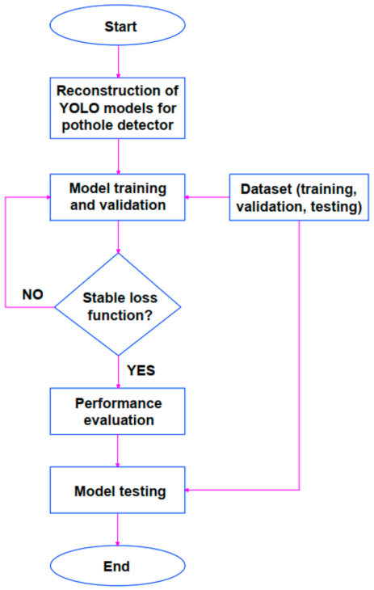*Fig-1.0 Flow Chart*

**RESULTS**

**OUTPUT**

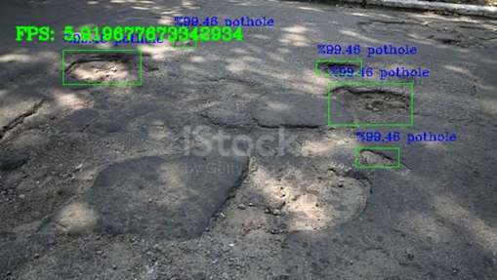

*Fig-2.0.1*

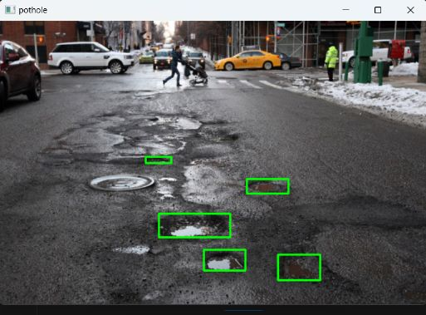

*Fig-2.0.2*

**VIDEO OUTPUT**

[**https://drive.google.com/file/d/1JngWI_jKfCVXMEz8lmB1RwTNwo5aI473/view?usp=sharing**](https://drive.google.com/file/d/1JngWI_jKfCVXMEz8lmB1RwTNwo5aI473/view?usp=sharing)

**CONCLUSION**

We have used the YOLOv4 object detection model to this project because this YOLOv4 object detection model can be used effectively for detecting potholes in both images and videos. The model has demonstrated its ability to accurately identify and locate potholes within an image or a frame of a video. Using YOLOv4 was great idea because the biggest advantage of using YOLO is its superb speed, YOLO also understands generalized object representation and this YOLO has good accuracy while detecting the potholes.

**REFERENCES**

1.S. Hegde, H. V. Mekali and G. Varaprasad, "Pothole detection and inter vehicular communication," 2014 IEEE International Conference on Vehicular Electronics and Safety, 2014, pp. 84-87, Doi: 10.1109/ICVES.2014.7063729.

2. G. Singal, A. Goswami, S. Gupta, T Choudhury “PITFREE: Potholes Detection on Indian Roads Using Mobile sensors” IEEE 8th International Advance Computing Conference (IACC), 14th-15th dec. 2018.

3. <https://www.thehindu.com/opinion/op-ed/fix-the-pothole-problem/article24436287.ece>.

**GITHUB URL**

[**https://github.com/pjmanohar/intelunnati_ZEUS.git**](https://github.com/pjmanohar/intelunnati_ZEUS.git)