|  |  |  |  |  |
| --- | --- | --- | --- | --- |
| **INDRIANI SAVITRI** | | | | |
|  | | | | |
|  |  |  | **Personal Details** |  |
|  |  |  | Name | : Indriani Savitri |
|  |  |  | Date of Birth | : Sumbawa, 1 Juni 1993 |
|  |  |  | Nationality | : Indonesian |
|  |  |  | Gender | : Female |
|  |  |  | Marital Status | : Single |
|  |  |  | Address | : Panto Daeng Gg. 8 No.5 RT 03 RW 07 Sumbawa Besar, Sumbawa, Nusa  Tenggara Barat. |
|  |  |  | Phone | : (0371) 625-445  082221467725 |
|  |  |  | Email | : [in.savitri@gmail.com](mailto:in.savitri@gmail.com) |
|  |  |  | Driving Licence | : SIM C |
| **Education**  2018- Geophysics Sub  2011 Department Universitas Gadjah Mada  2011- Senior High  2008 School 2 Sumbawa  2008- Junior High  2005 School 1 Sumbawa  2005- Elementary  1999 School 2 Sumbawa  **Languange Skill**   1. Indonesian (Native Language) 2. English (Speaking, Reading, Writing)   **Personal Skill**   1. Problem Solving 2. Commitment to outcome 3. Teamwork 4. Analytical 5. Helpful Attitude |  |  | **Job Experience**   1. Facilitator Cons houses due to t 2019 2. Geophysics Fie 2015 3. Volcanology F 2015.Practical UGM Physics 4. Internship at P Geotechnology 5. KKN PPM UG Sumbawa Rege   **Software:**  MS Word, MS Excel,  MS Power Point, Surfer 11,  Oasis Montaj, IP2WIN software, Geopsy Software, HRS Software | truction for moderate and light damaged he earthquake in West Sumbawa Regency,  ld Camp UGM Magelang, Jawa Tengah ieldwork, Dieng, Jawa Tengah,  Assistant for Geophysical Seismic Method Department, 2014  T Newmont Nusa Tenggara Department of 2014  M Seran Village Seteluk District, West ncy, 2014  **Geophysics Method:**  Seismic Refraction,  Magnetic Method and Gravity Method,  Microseismic Method,  Audio Magnetotelluric or MT Method.  Very Low Frequency Method , |

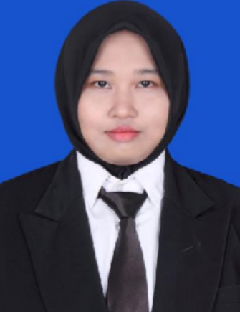

Organization Experience

1. Secretary of the UGM Geophysics Field Camp, 2015
2. KKN PPM UGM in Seran Village, Seteluk, West Sumbawa Regency, 2014
3. UGM Non Seismic Geophysics Fieldwork, 2013
4. Management of the UGM MIPA Faculty Bulletin, 2011-2013
5. American Petroleum Association Geology Student Chapter UGM, 2011-2014
6. UGM Geophysical Student Association 2011-2014