

**BIRLA INSTITUTE OF TECHNOLOGY & SCIENCE, PILANI**

**WORK INTEGRATED LEARNING PROGRAMMES**

## Stream Processing and Analytics

**Assignment 2**

**Assignment Group Number: 27**

**Contribution Table:**

|  |  |  |  |
| --- | --- | --- | --- |
| **Sl. No.** | **Name (as appears in Canvas)** | **ID NO** | **Contribution (%)** |
| 1 | Jagadeesh Panthati | 2019hc04101 | 100% |
| 2 | G V A SATISH KUMAR VEMPATI | 2019hc04401 | 100% |
| 3 | Srutakirti Mangaraj | 2019hc04106 | 100% |

**Software Used:**

Kafka - kafka_2.12-2.8.0

Spark - spark-2.4.8-bin-hadoop2.7

python3.7

**Simulator program for the truck data movement over the period of time:**

SimulatorAndP1.py

SimulatorAndP2.py

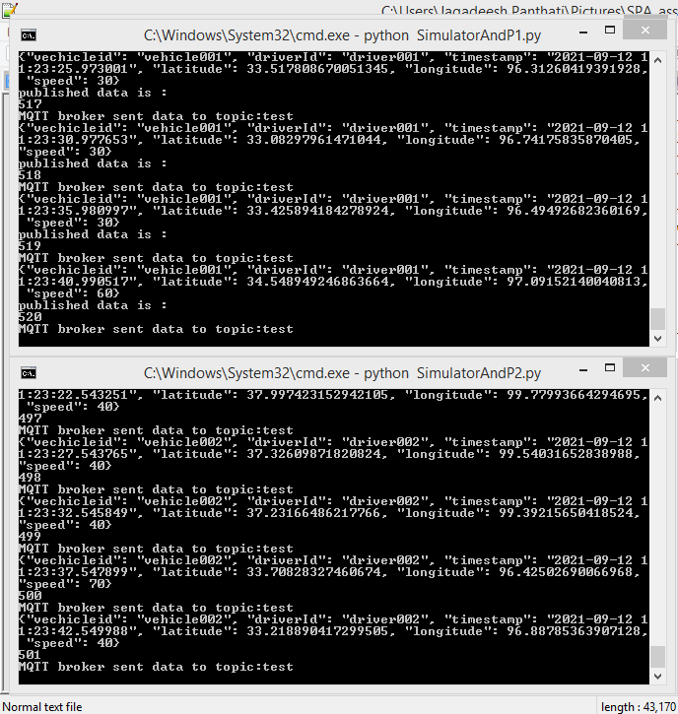

**Data Transfer program moving the data from the truck to central server like Mosquito broker through MQTT protocol:**

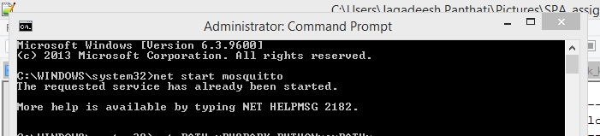

**Start** 🡪 **Kafka, Zookeper -- Data Flow tier:**

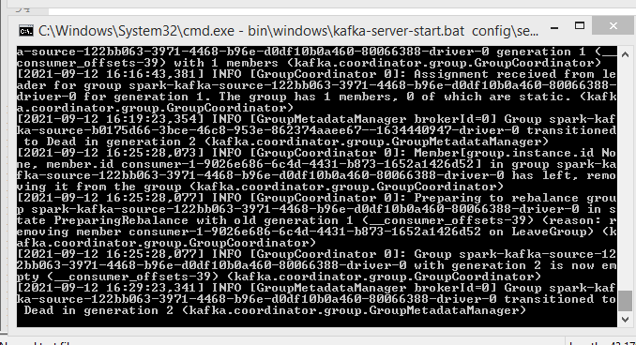

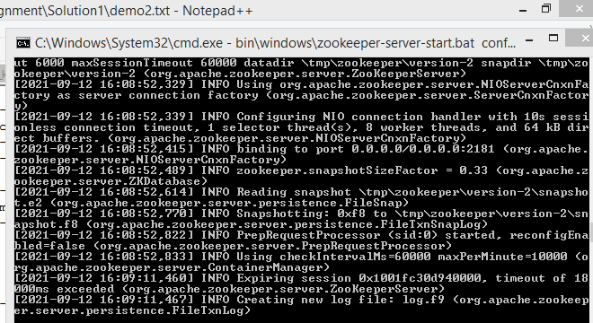

**Create Kafka Topic :**

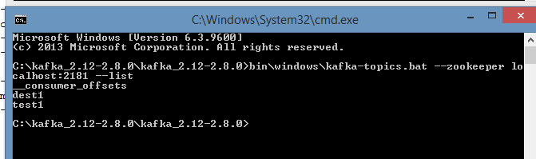

**Data transfer program from Mosquito broker to Kafka Topic :**

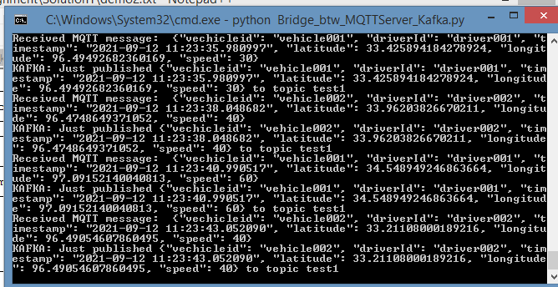

**Processing of data to identify the drivers exceeding the speed limits:**

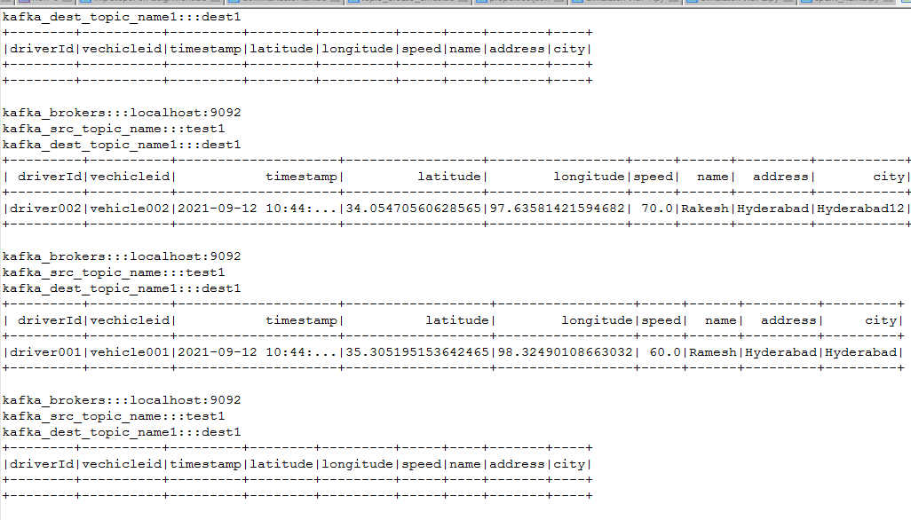

**Program to keep statistics about over speeding cases over the period of time, for different routes, for different trucks:**

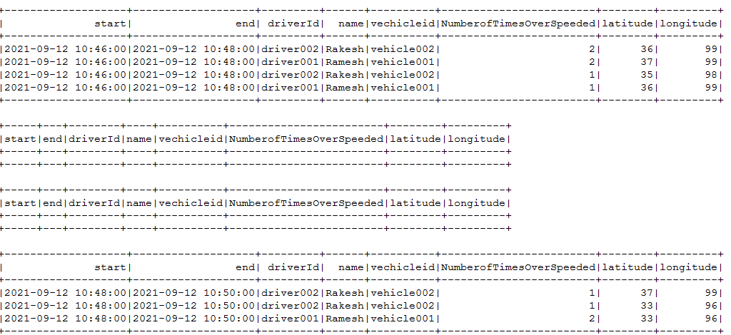

**A simple interface for showing over speeding statistics to the end consumers:**

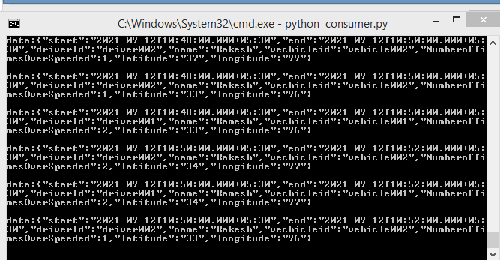

**Commands to Run:**

**while running spark set the paths:**

set PATH=%PYSPARK_PYTHON%;%PATH%

set PATH=%SPARK_HOME%\bin;%PATH%

set PATH=%HADOOP_HOME%\bin;%PATH%

set PATH=%JAVA_HOME%\bin;%PATH%

set PYSPARK_DRIVER_PYTHON=python

set PATH=C:\apache-maven-3.8.2\bin;%PATH%

set TMP=C:/tmp99

**MQTT start [cmd with admin permissions] -- data ingestion tier :**

net start mosquitto

**Kafka, Zookeper -- Data Flow tier**

"Go to Kafka directory where kafka is installed"

bin\windows\zookeeper-server-start.bat config\zookeeper.properties

bin\windows\kafka-server-start.bat config\server.properties

**Note: create source topic and dest topic in kafka -- Data Store tier // processed data will be saved here:**

bin\windows\kafka-topics.bat --create --zookeeper localhost:2181 --replication-factor 1 --partitions 1 --topic test1

bin\windows\kafka-topics.bat --create --zookeeper localhost:2181 --replication-factor 1 --partitions 1 --topic dest1

To check:

bin\windows\kafka-topics.bat --zookeeper localhost:2181 --list

-- run simulator code

-- run Bridge_btw_MQTTServer_Kafka

**streaming analysis tier:**

spark-submit --conf spark.jars.ivy=/C:/.ivy --packages org.apache.spark:spark-sql-kafka-0-10_2.11:2.4.8 spark_kafka_q6.py >> demo1.txt

spark-submit --conf spark.jars.ivy=/C:/.ivy --packages org.apache.spark:spark-sql-kafka-0-10_2.11:2.4.8 spark_kafka.py >> demo2.txt

**Delivary/reporting Tier:**

run consumer.py

bin\windows\kafka-console-consumer.bat --bootstrap-server localhost:9092 --topic dest1