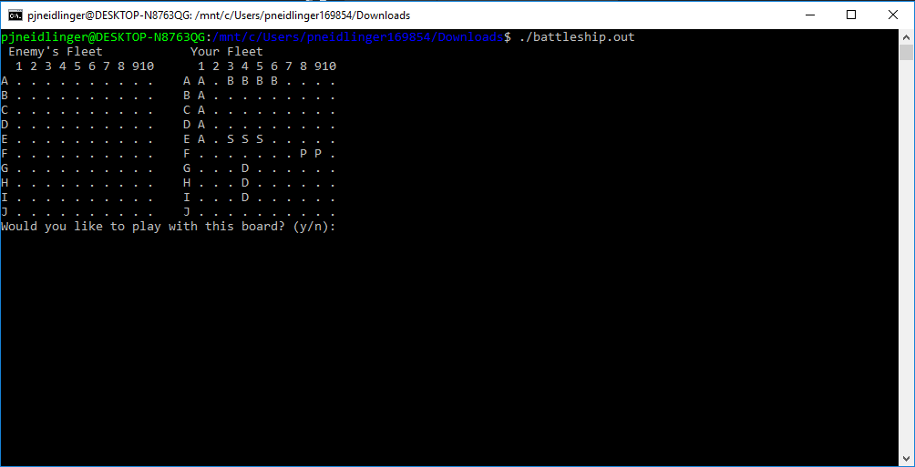  
  
A screenshot of the beginning of the game, where you can choose whether you would like to play with the given board.

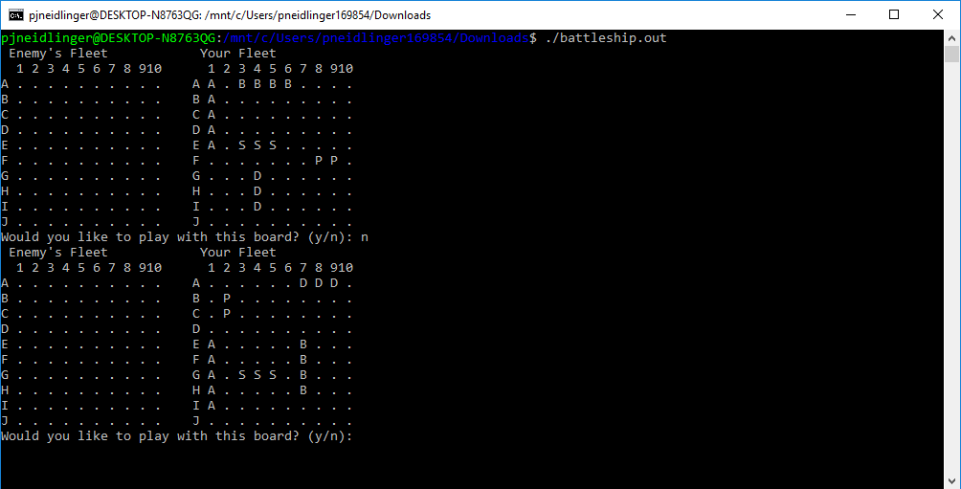

A screenshot of the second board a player is offered, when they declined the first one.

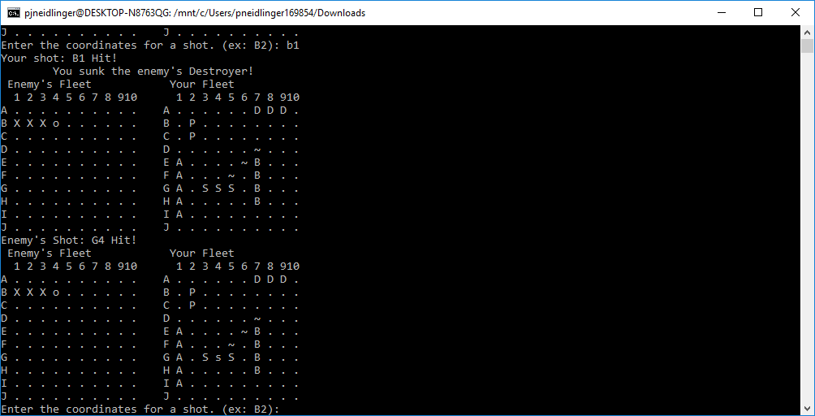

A screenshot of the game, right after the user has sunk an enemy ship. The enemy ship is shown with the three capital ‘X’ characters, and a sunken message is output.

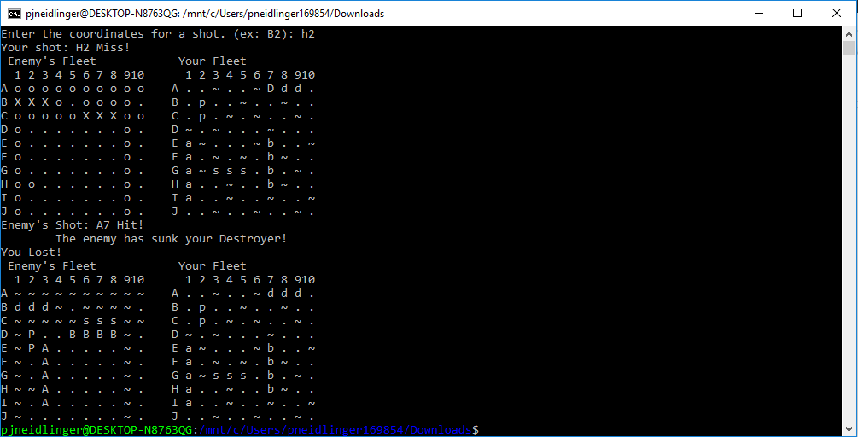

A screenshot of the end of the game, right after the enemy has beaten the user. Both boards are shown, and an ending message is output.